

**数字信号处理**

**实 验 报 告**

|  |  |
| --- | --- |
| **课程名称：** | **数字信号处理实验** |
| **学生姓名：** | **林烁挺** |
| **学生学号：** | **201430252117** |
| **学生专业：** | **信息工程** |
| **开课学期：** | **2016年~2017年第二学期** |
| **实验成绩：** |  |

**电子信息学院**

**2017年4月**

## Part One 编写程序

**题目一：绘出信号x[n]=e^Zn，当Z=(1/12)+jπ/6、Z= -(1/12)+jπ/6时、Z=(1/12)、 Z=2+jπ/6时的信号实部和虚部图；当时Z=jπ/6呢？此时信号周期为多少？**

1. 代码：

% declare a complex exponential function %  
N = 100;  
n = 0:N-1;  
  
% while alpha = 1/12, w = pi/6 %  
alpha = 1/12;  
w = pi/6;  
x = exp((alpha+w*1i)*n);  
ReZ = real(x);  
ImZ = imag(x);  
% print figure %  
subplot(5,2,1) ;  
stem(n,ReZ);  
title('ex1-1');  
subplot(5,2,2) ;  
stem(n,ImZ);  
title('ex1-2');  
disp(ReZ);  
disp(ImZ);  
% while alpha = -1/12, w = pi/6 %  
alpha = -1/12;  
w = pi/6;  
x = exp((alpha+w*1i)*n);  
ReZ = real(x);  
ImZ = imag(x);  
  
subplot(5,2,3);  
stem(n,ReZ);  
title('ex2-1');  
subplot(5,2,4);  
stem(n,ImZ);  
title('ex2-2');  
disp(ReZ);  
disp(ImZ);  
% while alpha = 1/12, w = 0 %  
alpha = 1/12;  
w = 0;  
x = exp((alpha+w*1i)*n);  
ReZ = real(x);  
ImZ = imag(x);  
  
subplot(5,2,5);  
stem(n,ReZ);  
title('ex3-1');  
subplot(5,2,6);  
stem(n,ImZ);  
title('ex3-2');  
disp(ReZ);  
disp(ImZ);  
% while alpha = 2, w = pi/6 %  
alpha = 2;  
w = pi/6;  
x = exp((alpha+w*1i)*n);  
ReZ = real(x);  
ImZ = imag(x);  
  
subplot(5,2,7);  
stem(n,ReZ);  
title('ex4-1');  
subplot(5,2,8);  
stem(n,ImZ);  
title('ex4-2');  
disp(ReZ);  
disp(ImZ);  
% while alpha = 0, w = pi/6 %  
alpha = 0;  
w = pi/6;  
x = exp((alpha+w*1i)*n);  
ReZ = real(x);  
ImZ = imag(x);  
  
subplot(5,2,9);  
stem(n,ReZ);  
title('ex5-1');  
subplot(5,2,10);  
stem(n,ImZ);  
title('ex5-2');  
disp(ReZ);  
disp(ImZ);

1. 运行结果：

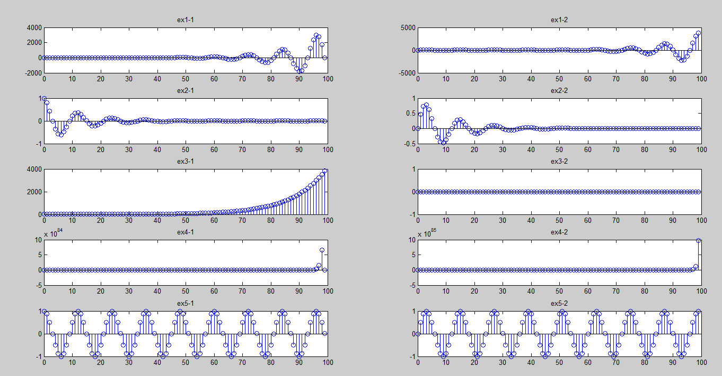

**题目二：信号x(t)=1.5sin(2π*20t)，对其进行采样，采样频率为800hz。**

1）试画出采样后的信号x[n],采样后信号的频率是多少？周期是多少？   
2）产生一个数字频率为0.9的正弦序列，并显示该信号，说明其周期。

1. 代码：

% declare a sin function %  
t = 0:0.001:1;  
x = 1.5*sin(2*pi*20*t);  
subplot(2,1,1);  
plot(t,x);  
title('sin function');  
  
% declare a sampling function %  
fs = 800;  
dt = 0:1/fs:1;  
y = 1.5*sin(2*pi*20*dt);  
subplot(2,1,2);  
stem(dt,y);  
title('sample function');

1. 运行结果：

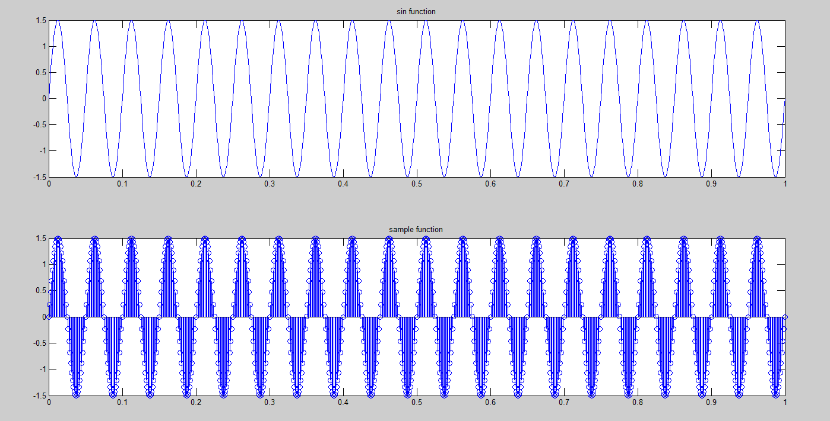

**题目三：绘出下面5种信号的波形 ：**

单位冲激信号，单位阶跃信号，实指数信号，复指数信号，正弦信号

1.代码

% define config variable %  
N1 = -10;  
N2 = 10;  
m = 0:0.1:1;  
B = 5;  
w = pi/6;  
n = N1:N2;  
  
% Unit impulse function %  
y1 = [(n-0)==0];  
subplot(3,2,1);  
plot(n, y1);  
title('Unit impulse function');  
  
% Unit step function %  
y2 = [(n-0)>=0];  
subplot(3,2,2);  
plot(n, y2);  
title('Unit impulse function');  
  
% Real exponential function %  
y3 = exp(3*m);  
subplot(3,2,3);  
plot(m, y3);  
title(' Real exponential function');  
  
% complex exponential function %  
y4 = exp((B*w)*n);  
ReZ = real(y4);  
ImZ = imag(y4);  
subplot(3,2,4);  
plot(n, ReZ);  
title(' Complex exponential function ReZ');   
subplot(3,2,5);   
plot(n, ImZ);  
title(' Complex exponential function ImZ');

% sin function %  
y5 = sin(pi/6*n);  
subplot(3,2,6)  
plot(n,y5);  
title(‘sin function’)

1. 运行结果：

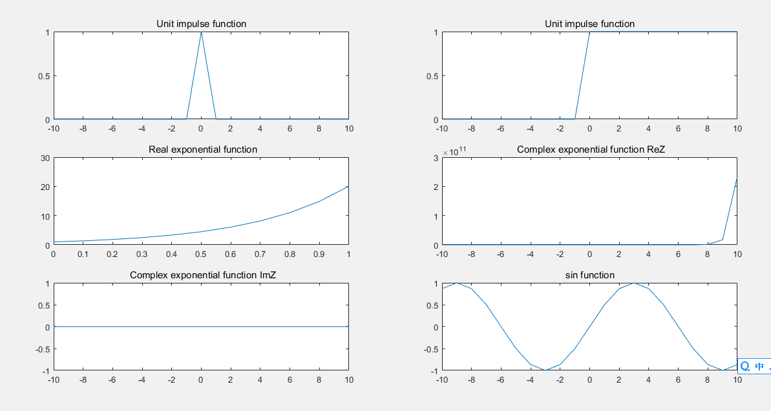

**Part Two 阅读代码**

**program2_1**

1.代码

% Program 2_1  
% Generation of the ensemble average  
%  
R = 50;  
m = 0:R-1;  
s = 2*m.*(0.9.^m); % Generate the uncorrupted signal  
d = rand(R,1)-0.5; % Generate the random noise  
x1 = s+d';  
stem(m,d);  
xlabel('Time index n');ylabel('Amplitude'); title('Noise');  
pause  
for n = 1:50;  
d = rand(R,1)-0.5;  
x = s + d';  
x1 = x1 + x;  
end  
x1 = x1/50;  
stem(m,x1);  
xlabel('Time index n');ylabel('Amplitude'); title('Ensemble average');

2.运行结果





3.理解

在原信号上加一个随机信号进行干扰，多次加干扰信号后求平均，可以得到光滑的、与原信号接近的信号。

**program2_2**

1.代码

% Program 2_2  
% Illustration of Convolution  
%  
a = input('Type in the first sequence = ');  
b = input('Type in the second sequence = ');  
c = conv(a, b);  
M = length(c)-1;  
n = 0:1:M;  
disp('output sequence =');disp(c)  
stem(n,c)  
xlabel('Time index n'); ylabel('Amplitude');

2.运行结果



3.理解

改程序主要功能是分别输入两个有限长序列a和b，计算a和b的卷积

**program2_3**

1.代码

% Program 2_3  
% Generation of complex exponential sequence  
%  
clear;  
clc;  
a = input('Type in real exponent = ');  
b = input('Type in imaginary exponent = ');  
c = a + b*i;  
K = input('Type in the gain constant = ');  
N = input ('Type in length of sequence = ');  
n = 1:N;  
x = K*exp(c*n);%Generate the sequence  
stem(n,real(x));%Plot the real part  
xlabel('Time index n');ylabel('Amplitude');  
title('Real part');  
disp('PRESS RETURN for imaginary part');  
pause  
stem(n,imag(x));%Plot the imaginary part  
xlabel('Time index n');ylabel('Amplitude');  
title('Imaginary part');

2.运行结果

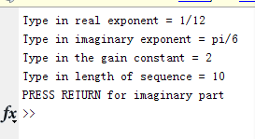

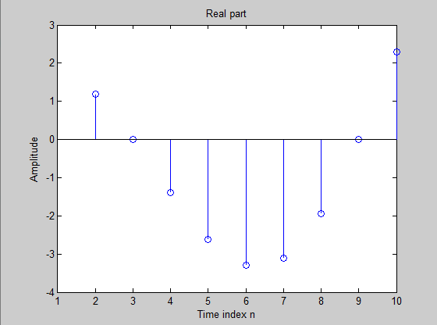



3.理解

输入一个复指数序列的各个参数，分别输出这个复指数序列的实部和虚部的散点图。

**program2_4**

1.代码

% Program 2_4  
% Generation of real exponential sequence  
%  
a = input('Type in argument = ');  
K = input('Type in the gain constant = ');  
N = input ('Type in length of sequence = ');  
n = 0:N;  
x = K*a.^n;  
stem(n,x);  
xlabel('Time index n');ylabel('Amplitude');  
title(['\alpha = ',num2str(a)]);

2.运行结果

]TCQ@EU}S%]W`O76C`KJDPJ.png



3.理解

输入一个实指数序列的参数，输出这个实指数序列的图像。

**program2_5**

1.代码

% Program 2_5  
% Computation of Cross-correlation Sequence  
%  
clear;  
clc;  
x = input('Type in the reference sequence = ');  
y = input('Type in the second sequence = ');  
% Compute the correlation sequence  
n1 = length(y)-1; n2 = length(x)-1;  
r = conv(x,fliplr(y));  
k = (-n1):n2';  
stem(k,r);  
xlabel('Lag index'); ylabel('Amplitude');  
v = axis;  
axis([-n1 n2 v(3:end)]);

2.运行结果



3.理解

输入两个有限长序列x和y，计算这两个有限长序列的互相关序列。

**program2_6**

1.代码

% Program 2_6  
% Computation of Autocorrelation of a  
% Noise Corrupted Sinusoidal Sequence  
%  
clear;  
clc;  
N = 96;  
n = 1:N;  
x = cos(pi*0.25*n); % Generate the sinusoidal sequence  
d = rand(1,N) - 0.5; % Generate the noise sequence  
y = x + d; % Generate the noise-corrupted sinusoidal sequence  
r = conv(y, fliplr(y)); % Compute the correlation sequence  
k = -28:28;  
stem(k, r(68:124));  
xlabel('Lag index'); ylabel('Amplitude');

2.运行结果



3.理解

模拟一个受噪声干扰的周期序列，通过求这个序列的自相关序列来观察周期函数的周期。