TAP — FortiGate 400F syslog to Coralogix
Device configuration only. FortiGate 400F must send RFC5424 over UDP to the TAP collector. GUI turns syslog on and sets the server IP. CLI is required for the port and the RFC5424 format.
1. Where this device must send
The collector is already a separate Compose service. This guide only covers the device. Point the device at the Compose host IP, never 127.0.0.1.
Setting | Value
Transport | UDP
Port | 5514
Format | RFC5424 (not the FortiOS default)
Coralogix application | fortigate
Coralogix subsystem | firewall
Replace <COMPOSE_HOST_IP> with the address this device can route to. If the host port in .env was changed, use that port, not the default below.
2. Before you touch the firewall
- Collector is up and UDP 5514 is open on the host firewall / NSG.
- You can reach the FortiGate CLI (SSH or console). Multi-VDOM: use the global VDOM.
- If syslogd is already used by another server, use syslogd2 instead of syslogd. Same keywords.
- Match keywords to your FortiOS version. 400F runs FortiOS; the syslogd block below is the 7.x form.
3. GUI — enable syslog and set the server
- Log & Report → Log Settings. On FortiOS 7.4+ this may be Global Settings → Syslog Logging.
- Enable Send Logs to Syslog.
- IP address / FQDN = <COMPOSE_HOST_IP>. Apply.
The GUI does not set format rfc5424 or port 5514. Do not stop after Apply. The screenshots are from the official Fortinet knowledge base technical tip; they show enable + server IP only. TAP uses port 5514, not 514.
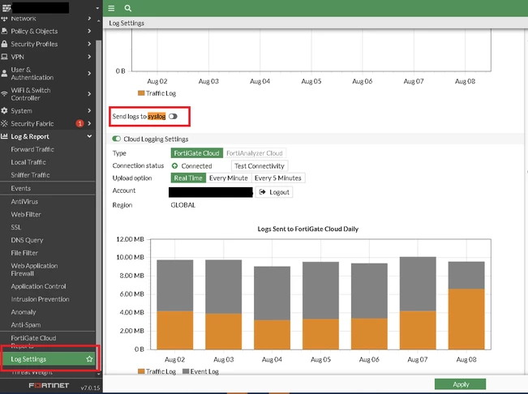
Figure 1: Log & Report > Log Settings. The Syslog toggle (boxed) is off by default.
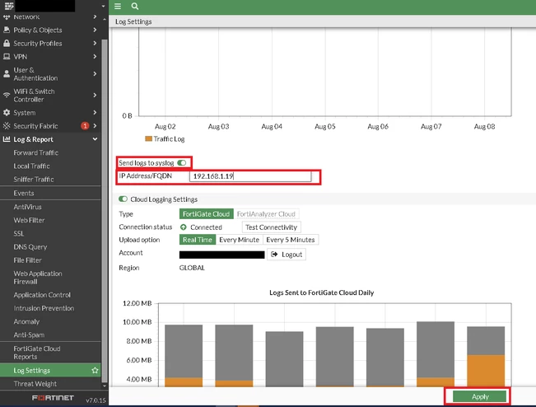
Figure 2: Send logs to syslog toggled on, IP Address / FQDN set to the collector, then Apply.
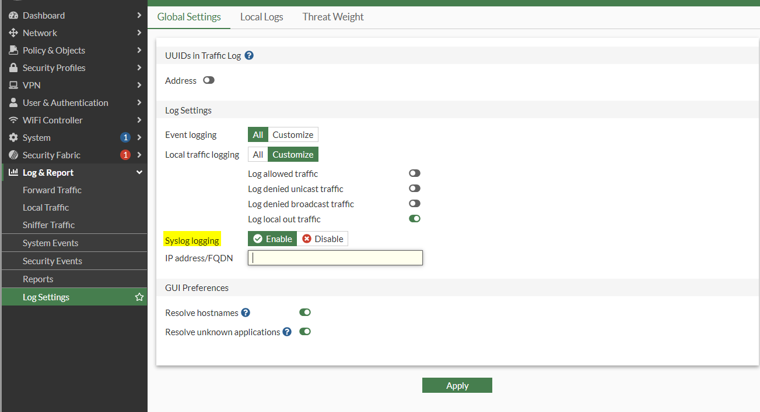
Figure 3: FortiOS 7.4+ path — Log Settings > Global Settings > Syslog logging: Enable, then IP address / FQDN.
4. CLI — port and RFC5424 (required)
Paste in the global VDOM. This is the setting the collector accepts.
config log syslogd setting
set status enable
set server "<COMPOSE_HOST_IP>"
set mode udp
set port 5514
set format rfc5424
end
If syslogd is already taken:
config log syslogd2 setting
set status enable
set server "<COMPOSE_HOST_IP>"
set mode udp
set port 5514
set format rfc5424
end
4.1 Confirm what is actually set
show log syslogd setting
execute ping <COMPOSE_HOST_IP>
diagnose log test
show must print mode udp, port 5514, and format rfc5424. Default FortiOS syslog is a priority plus key=value line. That format is rejected by this collector.
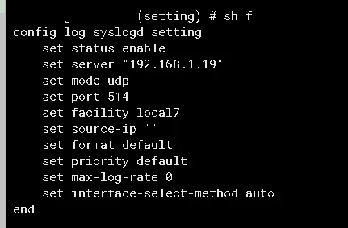
Figure 4: The same config log syslogd setting block on the FortiGate CLI. The KB example shows port 514 / format default — for TAP you must set port 5514 and format rfc5424.
5. Which logs to send
- Keep traffic, event, and UTM (virus, IPS, web filter) enabled if those policies already log.
- Do not enable a debug-level filter. It will flood UDP and the collector does not queue.
- Reliable logging (store-and-forward) is off in this template. If the collector is down, FortiGate drops the datagram.
6. Check from the firewall
- execute ping <COMPOSE_HOST_IP> succeeds.
- diagnose log test generates a test event. It should appear under application fortigate / subsystem firewall.
- A real session (policy with logtraffic all) is the better check than the test event alone.
7. If nothing arrives
What you see | Fix on the FortiGate
show still says port 514 or format default | Re-enter section 4. GUI Apply does not set these.
Ping fails | Wrong IP, or no route from the FortiGate to the Compose host.
Ping works, no logs | UDP 5514 blocked on the collector host, or mode is tcp.
Collector reports an RFC5424 parse error | format is not rfc5424. Do not change the collector.
Logs land in another Coralogix app | Wrong server IP, or another syslogd# is the one that is enabled.
Source: Fortinet Technical Tip — How to configure syslog on FortiGate; FortiOS syslogd mode udp + format rfc5424. TAP collector listens on UDP 5514.

