TAP — MikroTik RouterOS syslog to Coralogix
Device configuration only. RouterOS must send BSD syslog (RFC3164) over UDP. TCP and TLS on RouterOS apply to CEF, not to this format. RFC5424 is not supported.
1. Where this device must send
The collector is already a separate Compose service. This guide only covers the device. Point the device at the Compose host IP, never 127.0.0.1.
Setting | Value
Transport | UDP only
Port | 5516
Format | remote-log-format=syslog (RFC3164)
Facility | daemon
Coralogix application | mikrotik
Coralogix subsystem | routeros
Replace <COMPOSE_HOST_IP> with the address this device can route to. If the host port in .env was changed, use that port, not the default below.
2. WinBox / WebFig
- System → Logging → Actions.
- Add an action. Name: remote-coralogix. Type: remote.
- Remote Address = <COMPOSE_HOST_IP>. Remote Port = 5516.
- Remote Log Format = syslog. Do not leave this on default, and do not select cef.
- Syslog Facility = daemon. Syslog Time Format = bsd-syslog.
- System → Logging → Rules. Add one rule per topic, all using action remote-coralogix.
- Minimum rules: info, warning, error, critical. Add firewall, account, and wireless only if you want those streams.
One rule with topics info,warning,error matches nothing. RouterOS ANDs topics on a single rule. Use a separate rule per topic.
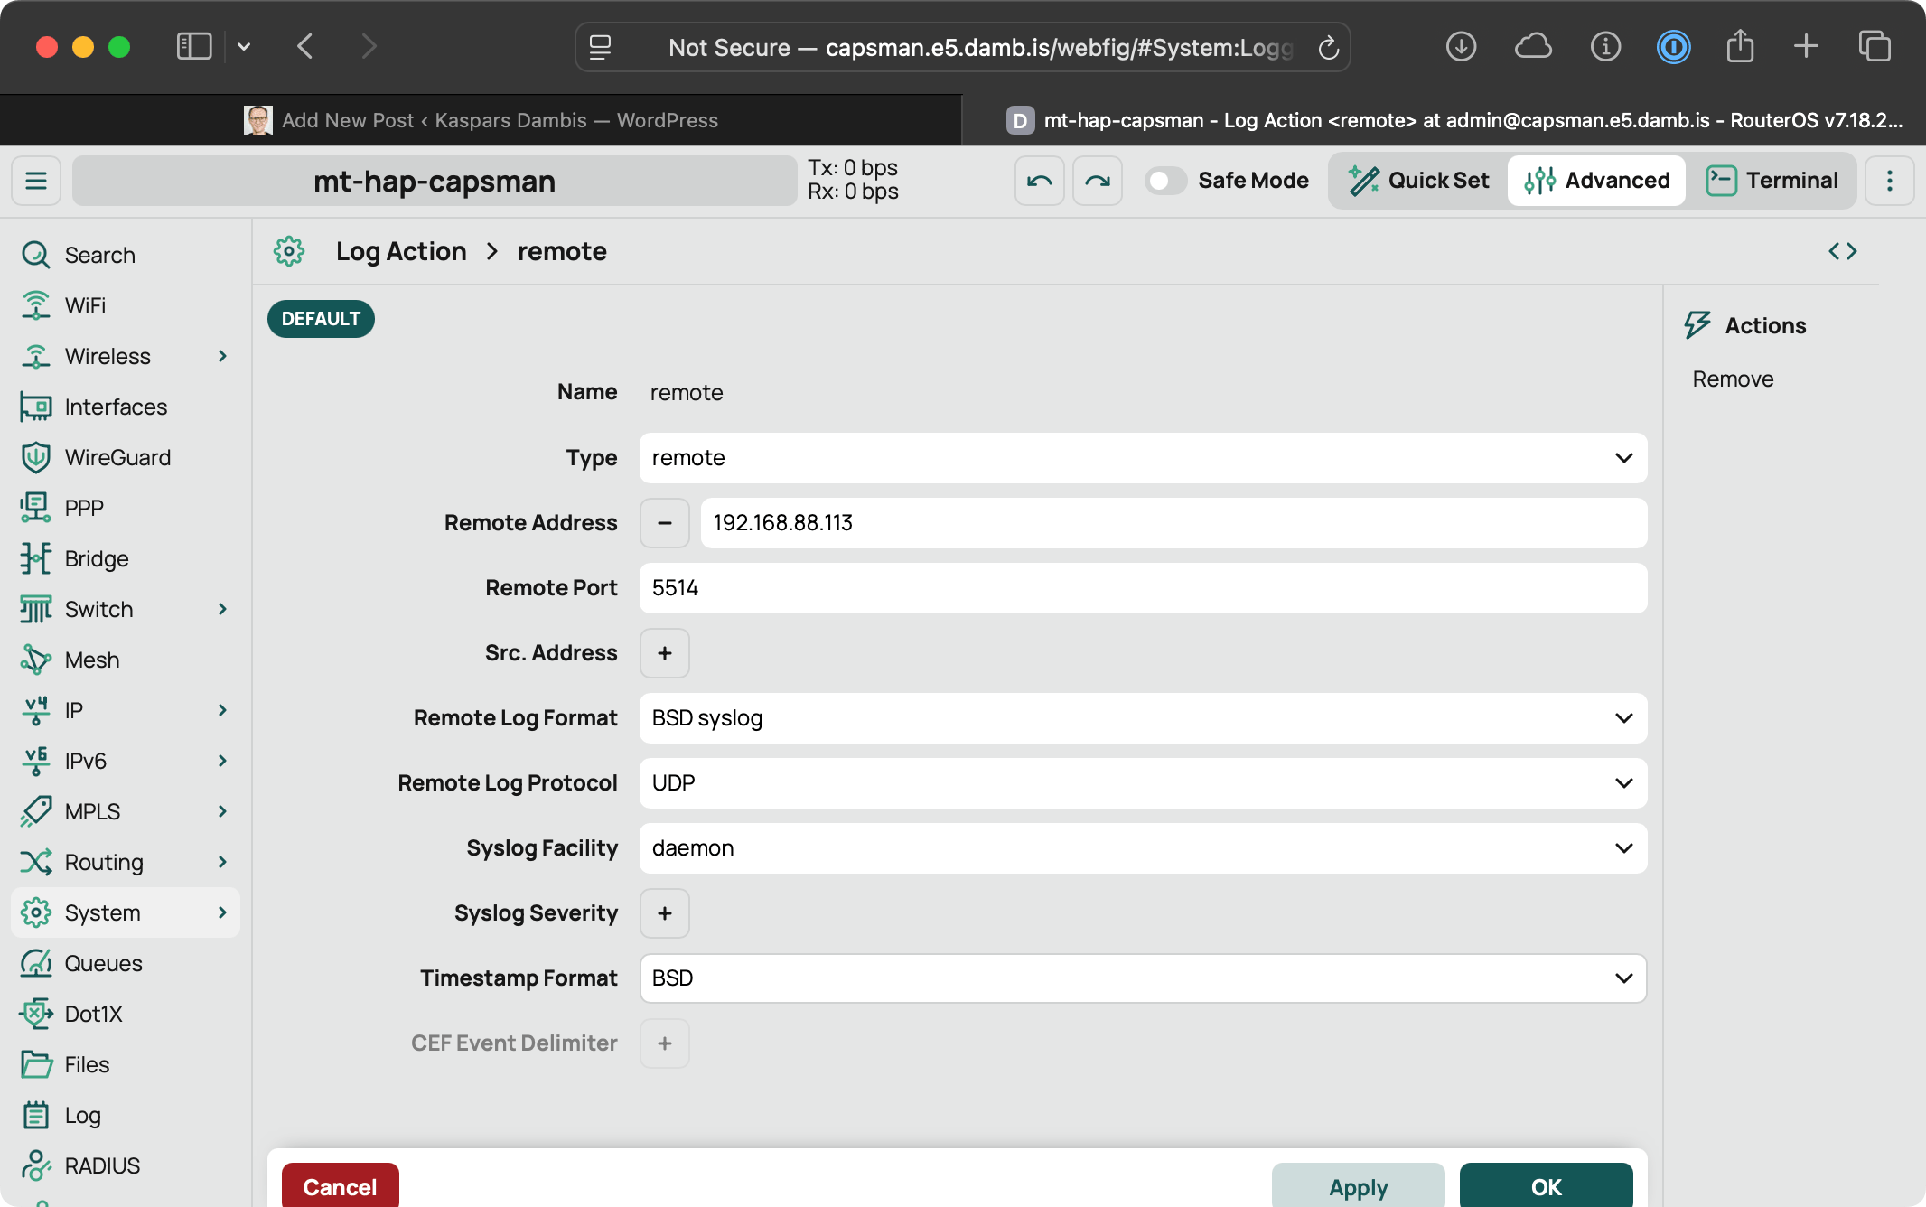
Figure 1: System > Logging > Actions — remote action with Remote Address, Remote Port, Remote Log Format (BSD syslog), Protocol UDP, Syslog Facility daemon. Set the port to 5516 for TAP.
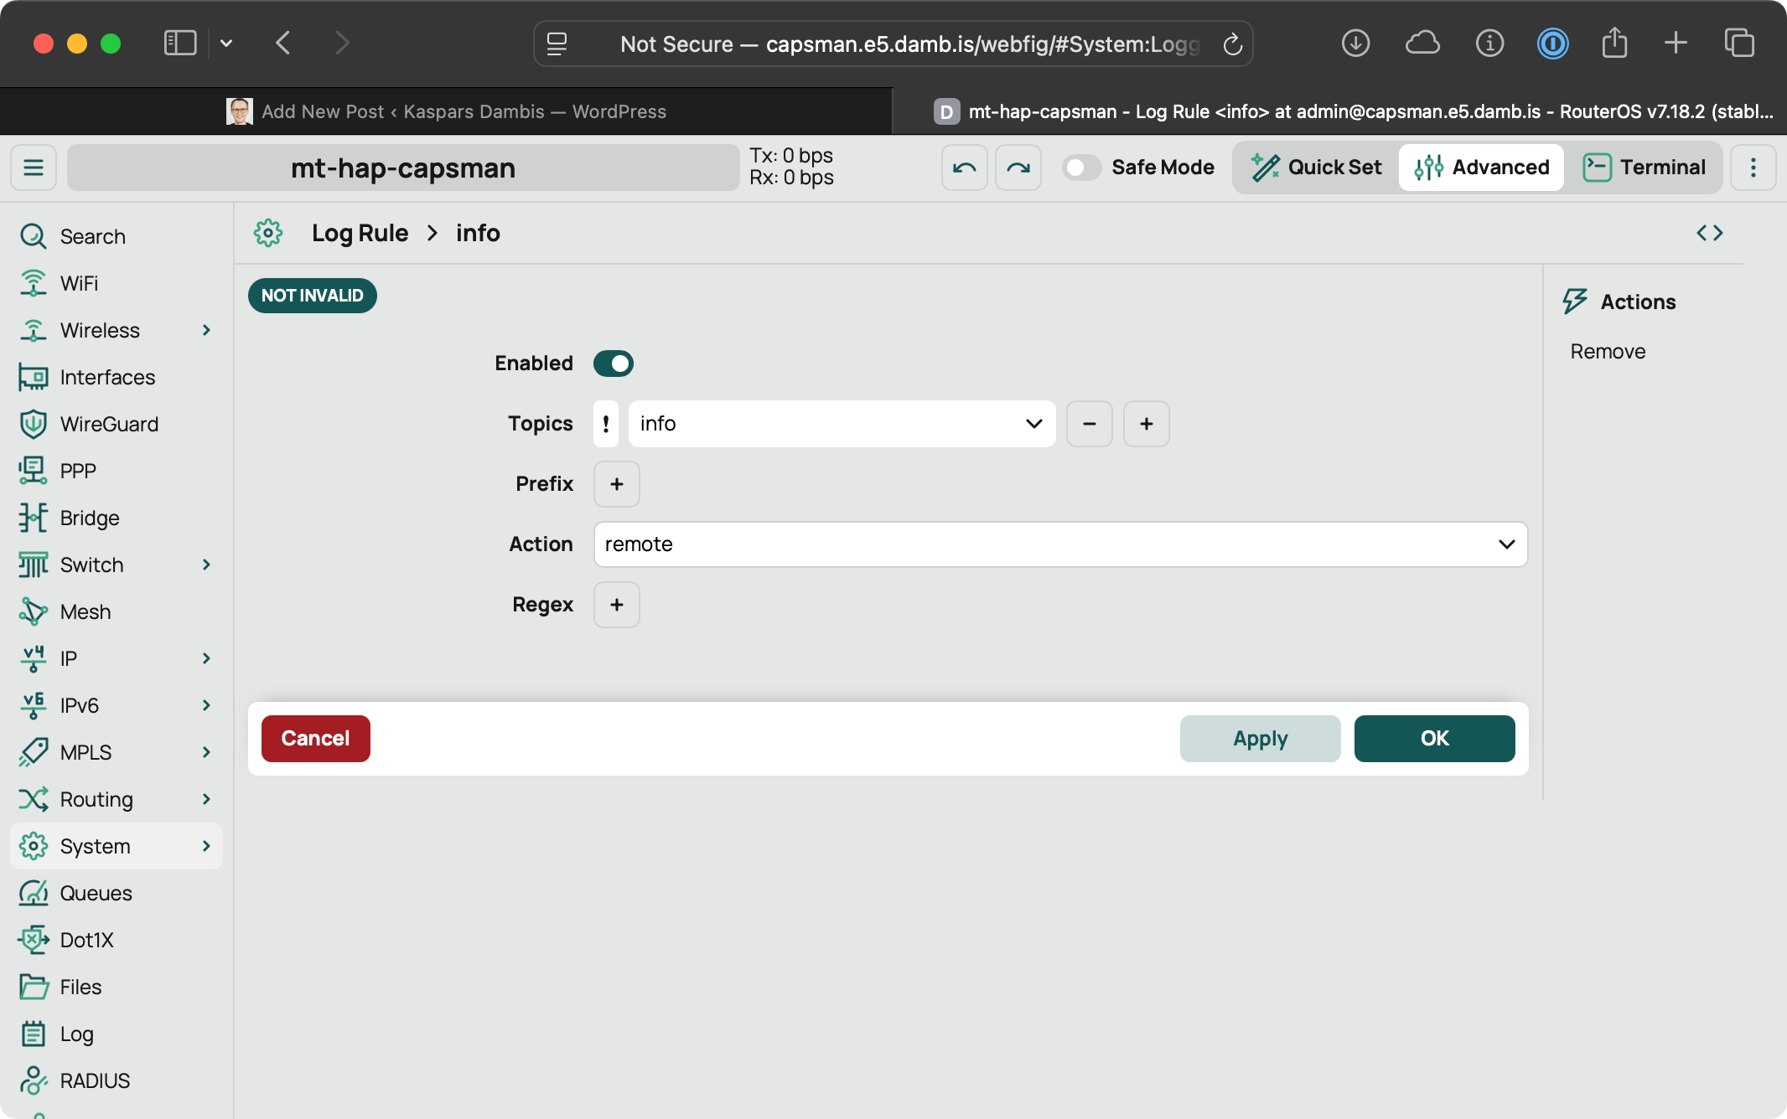
Figure 2: System > Logging > Rules — one rule per topic (here topics=info, action=remote).
3. CLI (same result)
Paste on the router. This creates a new action so the built-in remote action is left alone.
/system logging action add name=remote-coralogix target=remote \
remote=<COMPOSE_HOST_IP> remote-port=5516 \
remote-log-format=syslog syslog-facility=daemon \
syslog-time-format=bsd-syslog
/system logging add topics=info action=remote-coralogix
/system logging add topics=warning action=remote-coralogix
/system logging add topics=error action=remote-coralogix
/system logging add topics=critical action=remote-coralogix
3.1 Optional topics
/system logging add topics=firewall action=remote-coralogix
/system logging add topics=account action=remote-coralogix
/system logging add topics=wireless action=remote-coralogix
firewall only emits lines for rules that already have log=yes. Adding the topic does not turn on firewall logging by itself.
4. Confirm what is actually set
/system logging action print detail where name=remote-coralogix
/system logging print where action=remote-coralogix
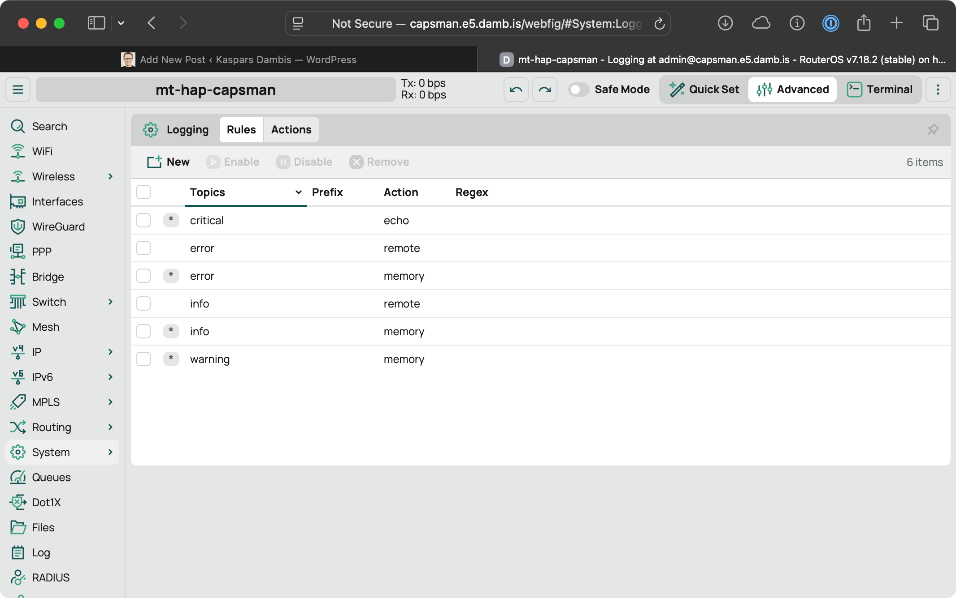
Figure 3: System > Logging > Rules — separate row per topic (RouterOS ANDs topics on one row). Every row for a topic you want forwarded must point at your remote action.
The action print must show remote-log-format=syslog, remote-port=5516, and the Compose host address. remote-protocol stays udp.
A correct on-wire line looks like this (priority, BSD time, identity, message):
<30>Oct 7 12:00:00 <identity> system,info,account user admin logged in from <ip> via winbox
Identity is /system identity. If that name is empty or duplicated across routers, set it before you rely on the hostname in Coralogix.
5. Do not do these
- Do not set remote-log-format=default. That line has no timestamp and no hostname. The collector still accepts it, but you cannot tell routers apart.
- Do not set remote-log-format=cef. CEF is a different pipeline. This collector expects BSD syslog.
- Do not set remote-protocol=tcp or tls for this action. RouterOS sends the syslog format over UDP only. TCP/TLS is for CEF.
- Do not add topics=debug or topics=packet. That is a firehose.
- Do not put several topics on one rule.
6. Check from the router
- Ping <COMPOSE_HOST_IP> from the router (or /ping <COMPOSE_HOST_IP>).
- Log in and out of WinBox. An account line should appear under application mikrotik / subsystem routeros.
- If you added the firewall topic, touch a rule that has log=yes. A firewall,info line should follow.
7. If nothing arrives
What you see | Fix on the router
Action exists, print shows no rules | The action does nothing until a /system logging rule points at it.
One rule with topics=info,warning,error | Delete it. Add one rule per topic.
remote-log-format=cef or default | Set syslog. Restart is not required; the next log uses the new format.
remote-protocol=tcp | Set udp. Syslog format will not use the TCP session.
Ping fails | Wrong address, or the router has no route to the Compose host. Set src-address on the action if the router has several WAN IPs.
Ping works, no logs | UDP 5516 blocked on the collector host, or the rule topics never occur.
Source: MikroTik RouterOS Log manual. Remote syslog format is RFC 3164 over UDP. TAP collector listens on UDP 5516, protocol rfc3164.

