TAP — Ruckus SmartZone syslog to Coralogix
Device configuration only. SmartZone and its APs must send traditional syslog (RFC3164) over UDP to the TAP collector. The controller can do TCP; this template does not. Use UDP.
1. Where this device must send
The collector is already a separate Compose service. This guide only covers the device. Point the device at the Compose host IP, never 127.0.0.1.
Setting | Value
Transport | UDP (not TCP)
Port | 5515
Format | RFC3164 / BSD syslog (controller default)
Coralogix application | ruckus
Coralogix subsystem | access-point
Replace <COMPOSE_HOST_IP> with the address this device can route to. If the host port in .env was changed, use that port, not the default below.
2. Two places, same destination
SmartZone has a controller syslog and a per-zone AP external syslog. Point both at the same host, port 5515, UDP. Controller-only syslog misses AP client events.
What | Where | Sends
Controller syslog | System → General Settings → Syslog | Controller events
AP external syslog | Zone edit → Syslog, or Services → AP External Syslog | AP client join / auth / disconnect
3. Controller syslog
- SmartZone web UI → System → General Settings → Syslog.
- Enable logging to remote syslog server.
- Primary server address = <COMPOSE_HOST_IP>.
- Port = 5515. Protocol = UDP. Do not leave this on TCP.
- Click Ping Syslog Server. Expect Success before you save.
- Facility: leave default, or 0–7 if your site standard requires a facility.
- Filter severity: Informational is enough for client join/auth. Debug floods the link.
- Event filter: All events for a first integration. Later you can drop client association/disassociation if volume is too high.
- OK / Apply.
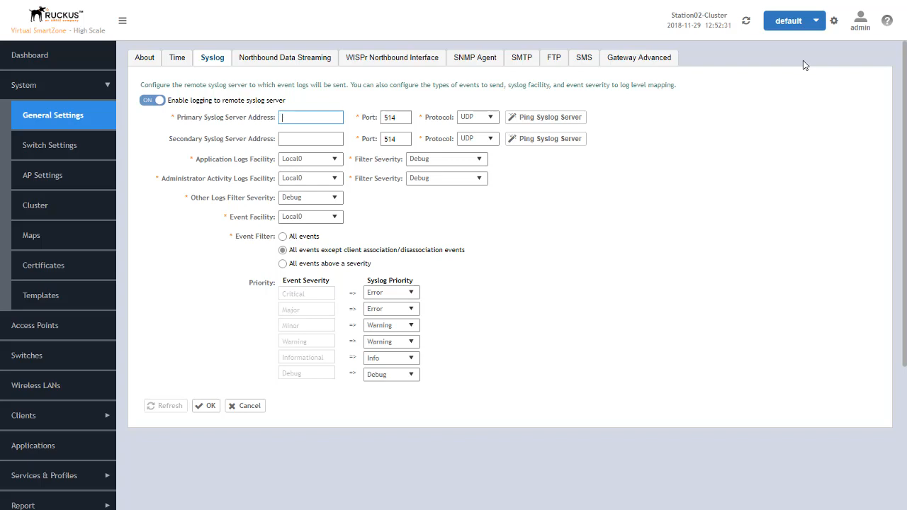
Figure 1: System > General Settings > Syslog — enable checkbox, primary server, port, protocol UDP, facilities and event filter. Example values shown; for TAP use <COMPOSE_HOST_IP> and port 5515.
Menu names drift by SmartZone version (SZ100 / vSZ / SZ300). If General Settings → Syslog is not there, search the UI for Syslog. The fields that matter are address, port 5515, and protocol UDP.
4. AP external syslog (required for client events)
- Services → AP External Syslog Server (wording may be AP External Syslog).
- Create or edit a profile: same <COMPOSE_HOST_IP>, port 5515, UDP. Send Logs = All Logs for the first test.
- Access Points → select the AP zone → Edit → Syslog.
- Enable external syslog server for APs. Select that profile. OK.
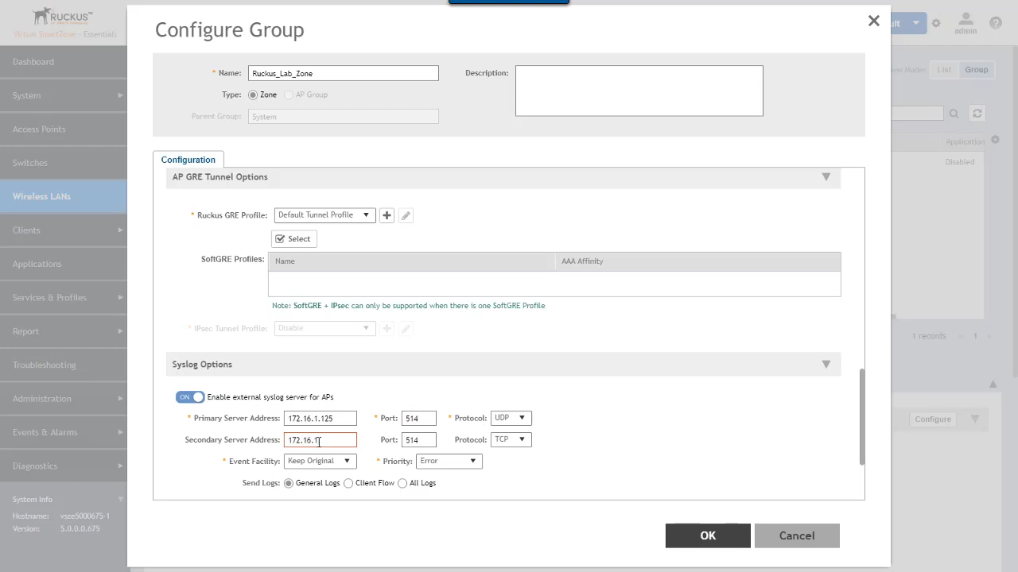
Figure 2: Zone (Configure Group) > Configuration > Syslog Options — enable toggle, primary server, port, protocol, Send Logs. This is the zone-level panel that forwards AP client events.
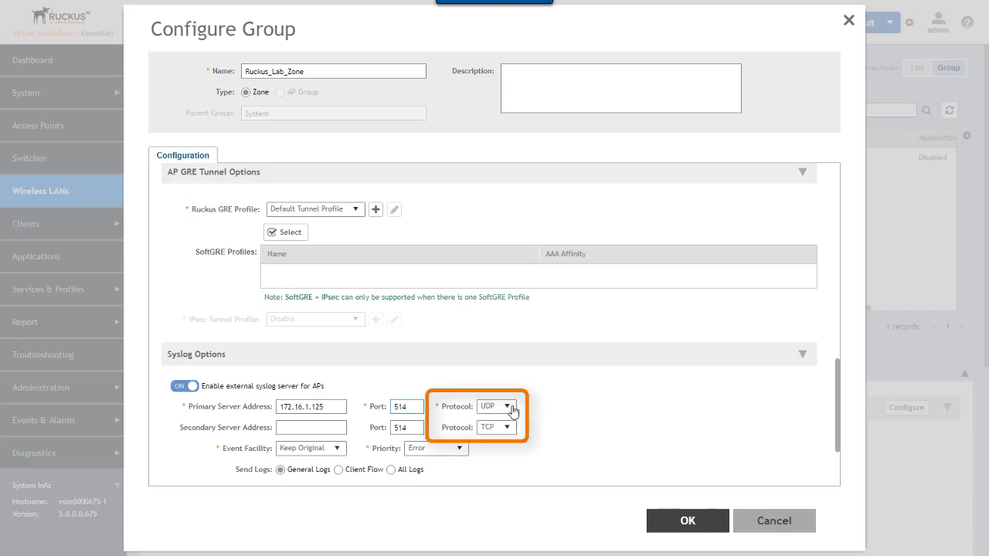
Figure 3: Same panel with the Protocol fields (boxed) — set primary to UDP for this template.
A zone that does not have this toggle on will not forward AP client syslog, even if the controller syslog ping succeeded.
5. What a good line looks like
You do not type these. They are the shapes the controller actually emits, so you can recognise a successful send:
User[<mac>] fails authentication in WLAN[<wlan>] from AP[<ap>]
User[<mac>] joins WLAN[<wlan>] at AP[<ap>]
Client [<user>@<ip>@<mac>] joined WLAN [<wlan>] from AP [<ap>@<mac>]
6. Check from SmartZone
- Ping Syslog Server in the syslog page returns Success.
- Join a test client to a WLAN in the zone you edited. A join or auth-fail line should appear under application ruckus / subsystem access-point.
- If only controller alarms arrive and client lines do not, section 4 is not applied on that zone.
7. If nothing arrives
What you see | Fix on SmartZone
Ping Syslog Server fails | Wrong IP, or UDP 5515 blocked between the controller and the Compose host.
Protocol is TCP | Switch the primary server to UDP. This collector listens on UDP only.
Ping succeeds, no client logs | AP external syslog is not enabled on the zone.
Logs appear, then stop | Event filter excludes association, or severity is above Informational.
Collector parse error | Do not change the collector to RFC5424. SmartZone remote syslog is BSD/RFC3164.
Source: Ruckus SmartZone administrator guide (System → General Settings → Syslog; protocol TCP or UDP) and SmartZone AP external syslog (zone → Syslog). TAP collector listens on UDP 5515, RFC3164.

