Assignment 4 Report – CSD-3353 Web Applications in C#.NET
Student: Qi Chen Weight: 15%
Topic: Final Enhancements – UI + Testing + Deployment

Course Learning Outcomes
CLO 1: Improve frontend styling using Bootstrap
CLO 5: Debug and test application and deploy web application locally

1. Bootstrap Styling
Bootstrap 5 was applied throughout the application to improve layout, readability, and visual clarity. Key changes include: a dark table header (table-dark), hover and striped rows, color-coded rating badges (green ≥8.0, yellow ≥6.0, red <6.0), genre displayed as badges, and Card-based layouts for Create, Edit, and Delete forms.

1.1 Home Page
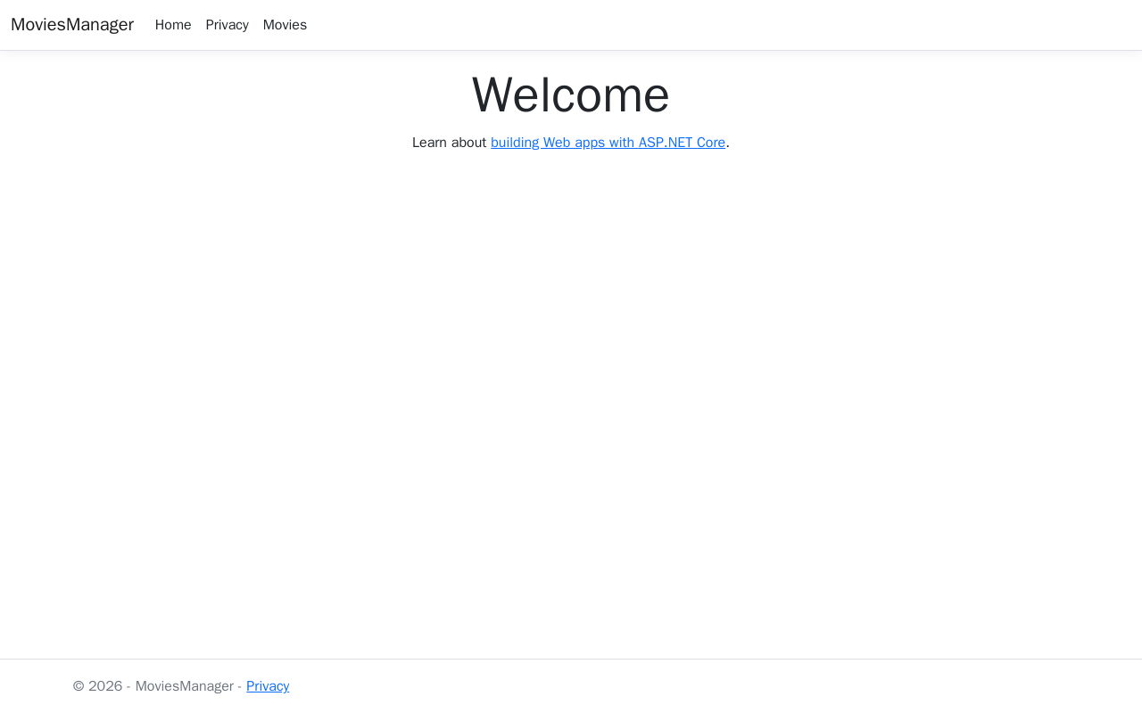
Figure 1 – Home Page

1.2 Movies List
Responsive Bootstrap table with color-coded rating badges and styled action buttons.
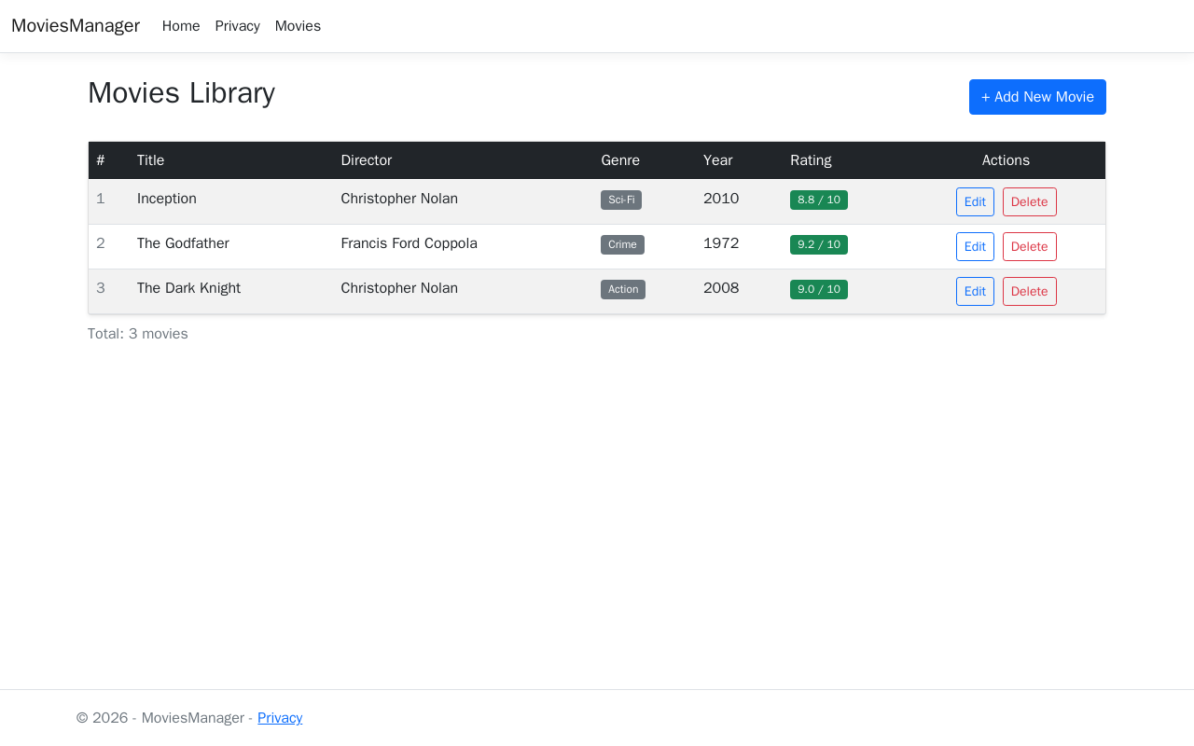
Figure 2 – Movies List

1.3 Create Movie Form
Card component with a blue header and placeholder text for each input field.
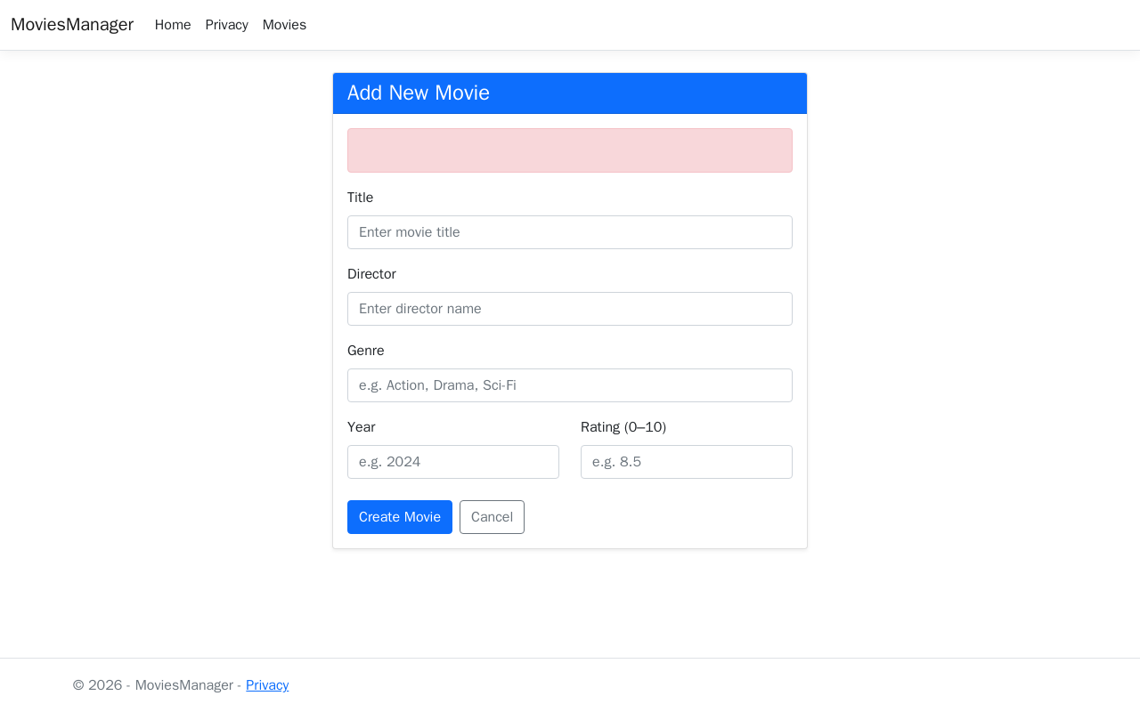
Figure 3 – Create Form

1.4 Create Form – Filled In
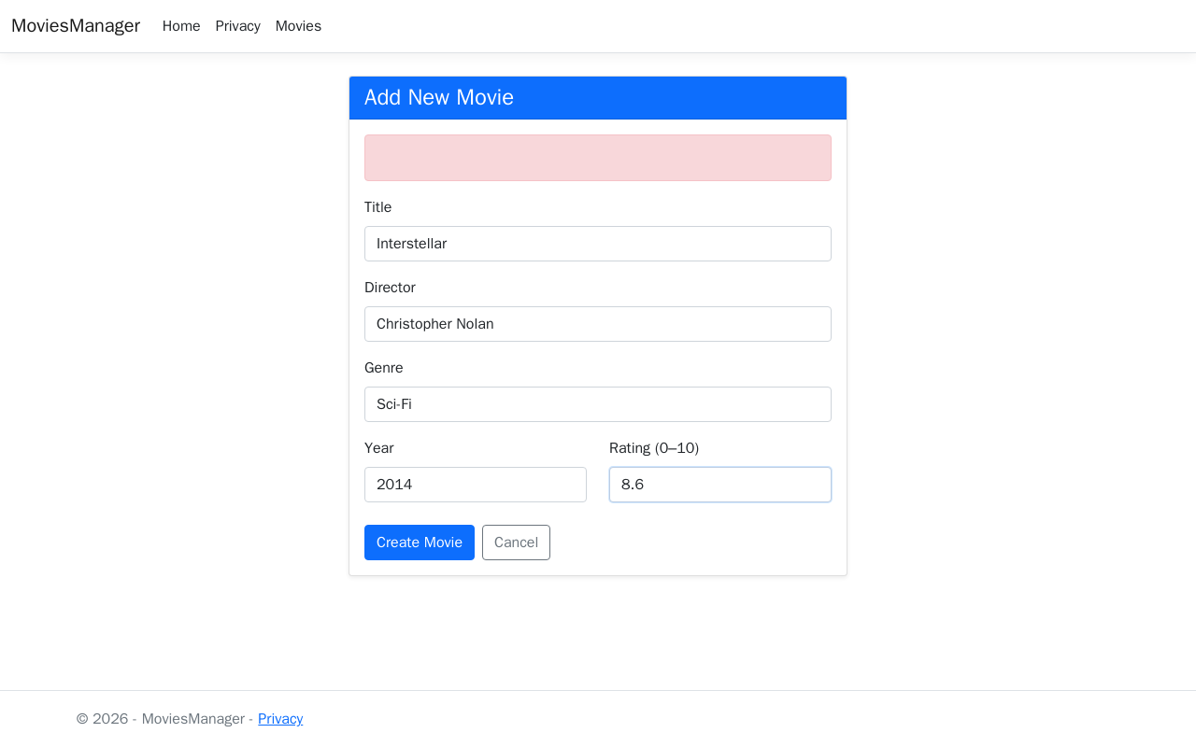
Figure 4 – Create Form (filled)

1.5 Movies List After Creating a Movie
After successful submission the user is redirected to the updated movies list.
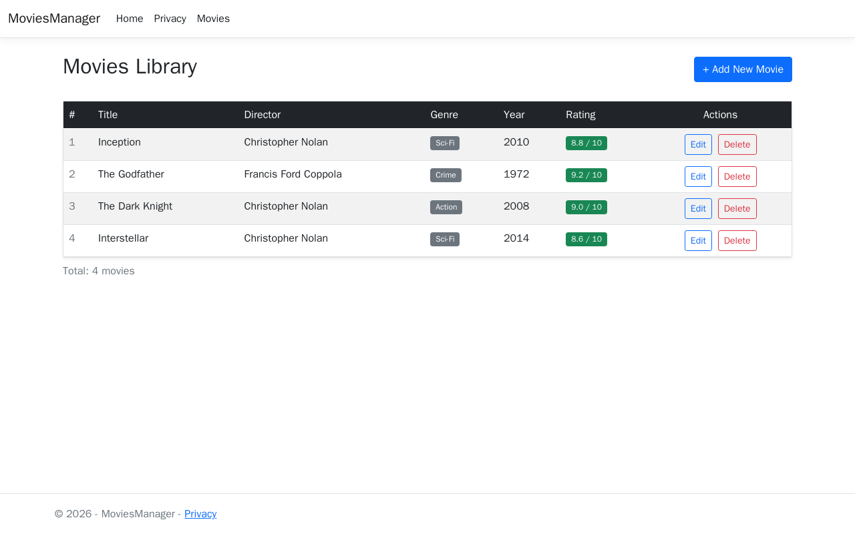
Figure 5 – After Create

1.6 Edit Movie Form
Card component with a yellow header and pre-populated fields.
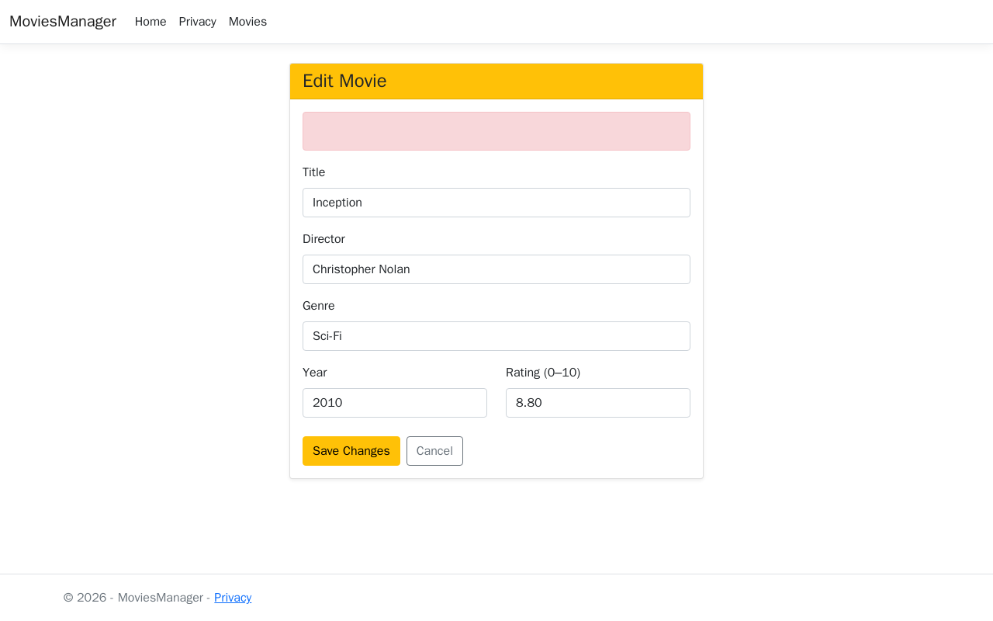
Figure 6 – Edit Form

1.7 Delete Confirmation Page
Danger-styled Card with a warning alert and full movie details before confirmation.
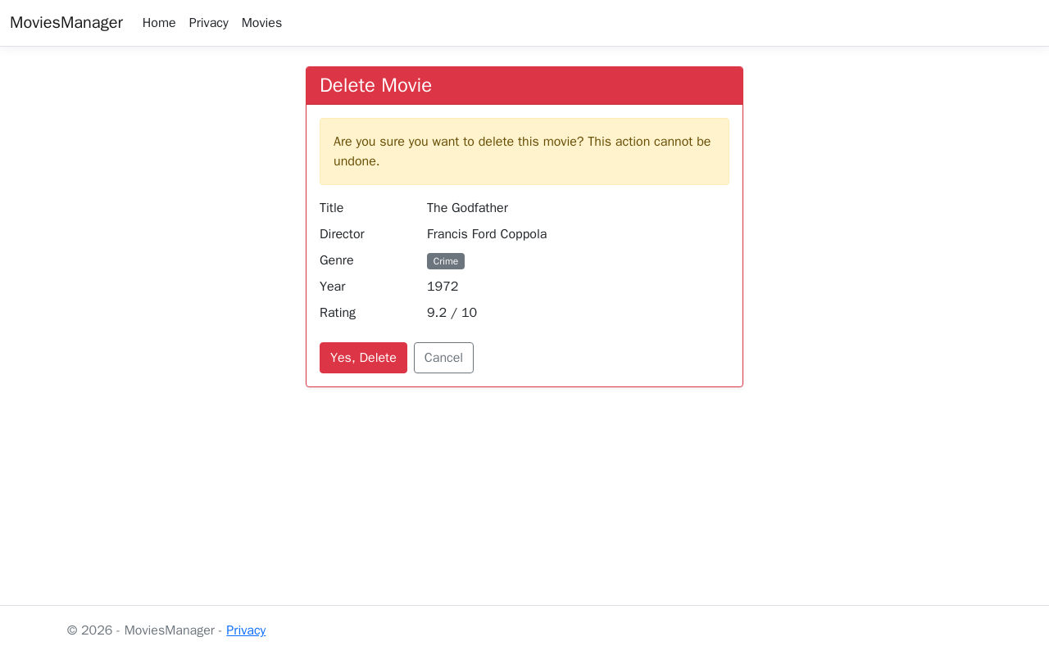
Figure 7 – Delete Confirmation

1.8 Form Validation Errors
Client-side and server-side validation errors shown inline using Bootstrap alert and text-danger spans.
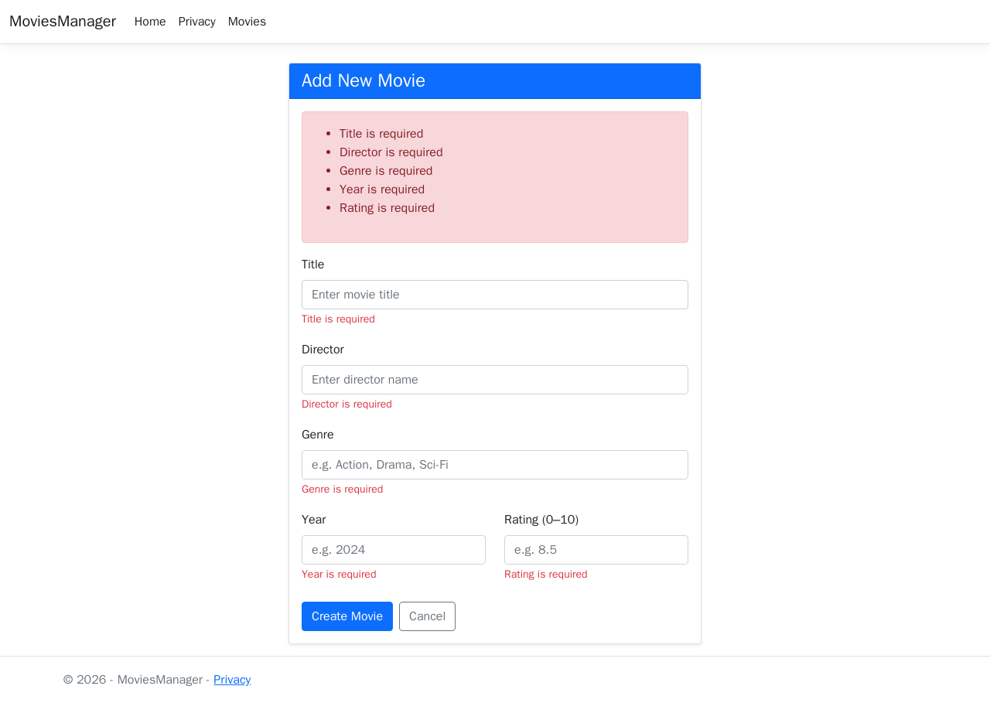
Figure 8 – Validation Errors

2. Logging with ILogger
ILogger<MovieController> was injected into the MovieController constructor and used across all actions with three log levels:
• LogInformation – successful fetch, create, update, delete operations
• LogWarning – null IDs, missing records, validation failures
• LogError – database concurrency exceptions

Code sample
public MovieController(MovieDbContext context, ILogger<MovieController> logger)
{
_context = context;
_logger = logger;
}
public async Task<IActionResult> Index()
{
_logger.LogInformation("Fetching all movies from database");
var movies = await _context.Movies.ToListAsync();
_logger.LogInformation("Retrieved {Count} movies", movies.Count);
return View(movies);
}

Example console output
2026-04-08 17:09:36 info: MoviesManager.Controllers.MovieController
Fetching all movies from database
2026-04-08 17:09:36 info: MoviesManager.Controllers.MovieController
Retrieved 3 movies
2026-04-08 17:09:40 info: MoviesManager.Controllers.MovieController
Created new movie: Interstellar (Id=4)

3. xUnit Testing
A separate test project MoviesManager.Tests was created using xUnit, EF Core InMemory database, and Moq for logger mocking. 18 tests are provided across two files.

3.1 Model Validation Tests (MovieModelTests.cs) – 8 tests
# | Test | Expected Result
1 | Valid movie with all fields | Passes validation
2 | Empty Title | Fails – Title required
3 | Rating above 10 | Fails – out of range
4 | Year before 1888 | Fails – out of range
5 | Title shorter than 2 characters | Fails – minimum length
6 | Rating of exactly 0.0 | Passes validation
7 | Rating of exactly 10.0 | Passes validation
8 | Empty Director | Fails – Director required

3.2 Controller Tests (MovieControllerTests.cs) – 10 tests
# | Test | Expected Result
1 | Index() returns all movies | View with 2 seeded movies
2 | Create() GET | Returns view
3 | Create() POST with valid data | Saves to DB, redirects
4 | Edit() GET with valid id | Returns view with movie
5 | Edit() GET with null id | NotFound
6 | Edit() GET with non-existent id | NotFound
7 | Delete() GET with valid id | Returns view with movie
8 | DeleteConfirmed() POST | Removes movie, redirects
9 | Create() POST with invalid model | Returns view (no redirect)
10 | Delete() GET with null id | NotFound

Run tests
dotnet test MoviesManager.Tests/

4. Deployment

4.1 dotnet publish
dotnet publish -c Release -o ./publish
cd publish
dotnet MoviesManager.dll

4.2 Docker
docker build -t movies-manager:a4 .
docker run -d --name movies-app -p 8080:5000 \
-e ASPNETCORE_URLS=http://+:5000 \
movies-manager:a4
Application accessible at: http://localhost:8080

4.3 Swagger API
The REST API is documented and accessible at http://localhost:8080/swagger
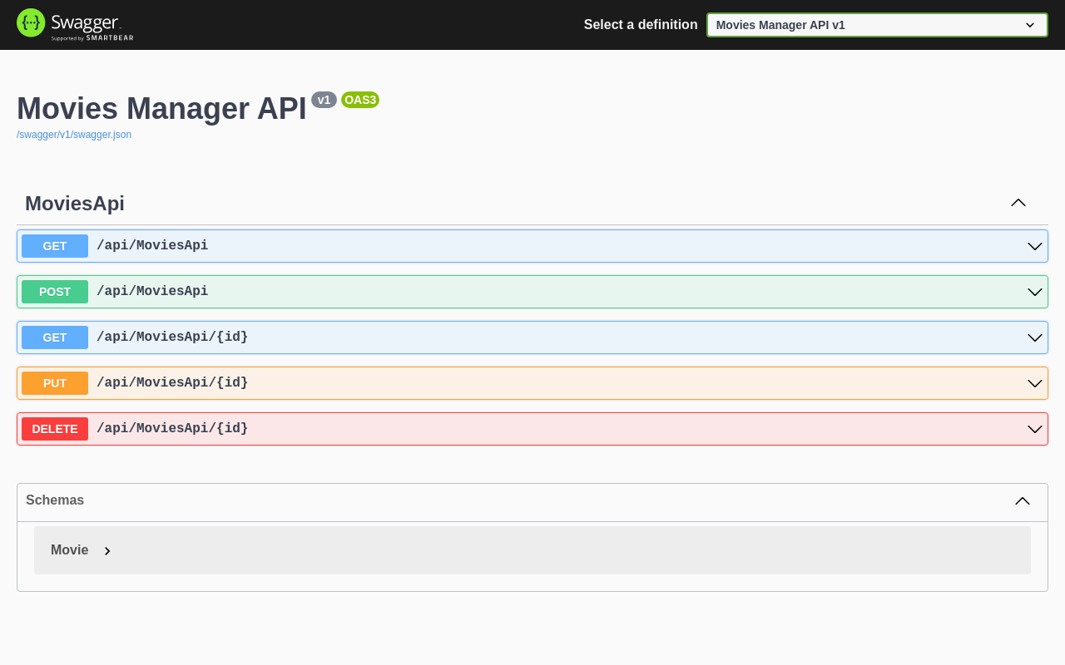
Figure 9 – Swagger UI

