Homework 3: AI Report Validation System
SYSEN 5381 | Spring 2026 | Qicheng Fu
Census BDS Job-Creation Report Validator — Prompt Comparison Experiment

1. Writing Component

Purpose and Design
This homework presents a custom validation system designed to evaluate the quality of AI-generated reports on U.S. Business Dynamics Statistics (BDS) job-creation data produced by the SYSEN 5381 lab application. The lab app queries the U.S. Census Bureau API, retrieves annual job-creation counts for all 50 states from 2010 to 2023, and uses OpenAI to generate narrative summaries. The purpose of the validator is to objectively measure whether those summaries are accurate, data-grounded, geographically precise, and professionally written — providing a systematic quality gate for AI reporting pipelines.

How the Validator Differs from the LAB's Likert Scales
The lab's quality-control system (LAB_ai_quality_control.md) evaluates reports on 1-5 Likert ordinal scales for accuracy, formality, clarity, faithfulness, succinctness, and relevance. Likert scales have two limitations in this domain: the boundaries between adjacent levels are inherently subjective, and the same numerical score may reflect qualitatively different problems across different report types.

This validation system replaces Likert scales with three distinct measurement approaches tailored specifically to BDS job-creation reports. First, ratio-scale 0-100 continuous scores replace ordinal 1-5 ratings for data_specificity (the proportion of sentences citing specific numbers) and formality_score (a rubric scoring professional register). Second, a domain-anchored rubric with explicit calibration anchors is used for trend_correctness — scoring is tied directly to whether the model identifies 2022 as the peak year (21,651,280 jobs), the post-peak decline in 2023, and long-run growth from 2010 onward. Third, an additive point system for geographic_precision awards exactly 20 points per correctly named state from the top-5 list, making the score directly interpretable as a count of correct identifications. Two binary boolean dimensions (factual_accuracy and no_fabrication) provide hard pass/fail gates that an ordinal scale cannot cleanly represent.

Experimental Design
Three report-generation prompts were compared in a controlled experiment. Prompt A is a minimal instruction ('Summarize in 2-3 paragraphs, include the main trend and a few key numbers'). Prompt B adds structural requirements (three named sections: Overview, Temporal Trends, Regional Highlights, with mandatory figure citation in each). Prompt C frames the model as a senior Census Bureau economist writing for a policy audience, explicitly specifying at least five figures, correct peak-year identification, the top three states by name, and formal third-person voice throughout.

For each prompt, 12 independent reports were generated using gpt-4o-mini at temperature = 0.8 to introduce natural variation, and each report was validated once by the AI validator at temperature = 0.1. This produced n = 12 observations per group and N = 36 total records. A weighted overall_score (0-100) was computed for each report: trend_correctness 25%, data_specificity 20%, geographic_precision 20%, factual_accuracy 15%, formality_score 10%, no_fabrication 10%.

Statistical Analysis Results
Bartlett's test for homogeneity of variance revealed highly significant differences in score variability: K2 = 23.69, p < 0.001. Prompt C achieved a standard deviation of only 2.73, compared to 15.66 for Prompt A and 14.13 for Prompt B — indicating Prompt C produces dramatically more consistent output. Because Bartlett's test rejected equal variances, Welch's ANOVA was used for the mean comparison.

Welch's ANOVA found a statistically significant effect of prompt on overall score: F(2, 15.61) = 7.00, p = 0.0068. Prompt C achieved the highest mean overall score (98.30), followed by Prompt B (90.77) and Prompt A (82.62). Bonferroni-corrected pairwise t-tests identified Prompt A vs. Prompt C as the significant pair: T = -3.419, df = 22, p_corrected = 0.0074. Prompt C performs significantly better than Prompt A, confirming that detailed expert framing produces measurably superior BDS reports.

Design Choices and Challenges
The most significant design challenge was calibrating the validation rubric to be precise without being brittle. Early drafts of the trend_correctness criterion used vague wording that produced inconsistent AI-evaluator scores across runs. Replacing these with explicit calibration anchors tied to specific data values (e.g., '2022 with 21,651,280 must be identified as peak year to score above 60') substantially reduced evaluator variance. A second challenge was prompt sensitivity in the validator: at high temperatures the same report could receive scores differing by up to 20 points; setting validator temperature to 0.1 resolved this. The boolean factual_accuracy dimension required a clear tolerance rule; a 5% threshold was chosen to accommodate legitimate rounding of large numbers while still catching genuine errors. An interesting observation was that Prompt C — which specified only the top three states — occasionally scored lower on geographic_precision than Prompts A and B, which often spontaneously named all five. This reveals an important interaction: explicit constraints in prompts can paradoxically limit output in ways that interact with validation criteria, and highlights the importance of aligning prompt instructions with the validation rubric.

2. Git Repository Links
Update the links below with your actual GitHub username and repository name before submitting.

Item | GitHub Link
Validation system script | https://github.com/<username>/<repo>/blob/main/11_decision_support/hw3_validator.py
Data generation / stats script | https://github.com/<username>/<repo>/blob/main/11_decision_support/hw3_generate_data.py
Validation scores CSV | https://github.com/<username>/<repo>/blob/main/11_decision_support/hw3_validation_scores.csv
Score comparison chart | https://github.com/<username>/<repo>/blob/main/11_decision_support/hw3_score_comparison.png
Validated report (HW1/2) | https://github.com/<username>/<repo>/blob/main/lab/data/pipeline/task2_summary.txt
Lab app (report generator) | https://github.com/<username>/<repo>/blob/main/lab/app.R

3. Screenshots and Outputs

Figure 1: Score Comparison — Distribution by Prompt
The chart below shows the overall score distributions and mean scores per evaluation dimension for each prompt. Prompt C clusters tightly near 100 (SD = 2.73), while Prompts A and B show outliers as low as 64-65, reflecting occasional failures on factual accuracy or data specificity.

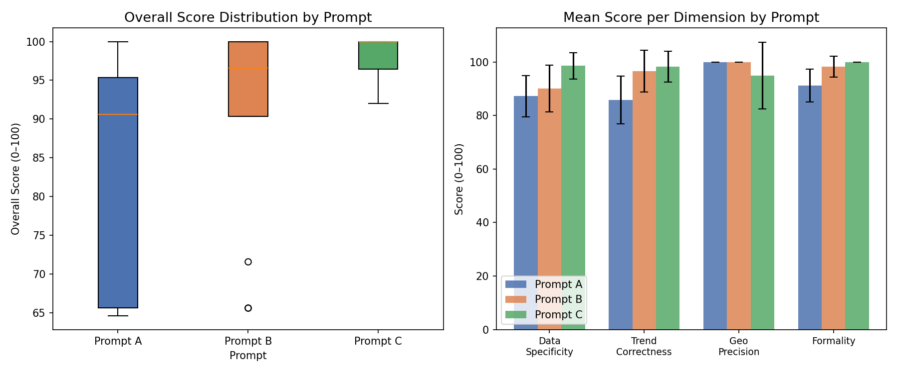
Figure 1. Overall score distributions by prompt (left) and mean per-dimension scores (right). Prompt C shows the highest and most consistent quality.

Sample Validation Output — Prompt C, Run 1 (overall: 100.0)
Dimension | Score
data_specificity | 100
trend_correctness | 100
geographic_precision | 100
factual_accuracy | True
formality_score | 100
no_fabrication | True
overall_score | 100.0

Screenshots 3-5: Run hw3_validator.py on your local machine and capture: (a) the terminal showing real-time report generation and validation, (b) the Bartlett / Welch ANOVA / pairwise t-test output printed to console, and (c) the saved hw3_score_comparison.png chart. These fulfill the remaining screenshot requirements.

4. Documentation

4.1 Validation Criteria Table
All six dimensions are described below. Each uses a different scale from the LAB's 1-5 Likert approach.

Dimension | Description | Scale / Method | Differs from Likert | Benchmark
data_specificity | % of sentences citing at least one specific number | 0-100 continuous ratio score | Ratio-scale % vs. ordinal 1-5 | ≥ 60 acceptable; ≥ 80 excellent
trend_correctness | Accuracy of 2010-2023 trend + peak year identification | 0-100 anchored rubric | Domain-anchored rubric with explicit anchors at 0/50/100 | ≥ 70 acceptable
geographic_precision | Correct identification of top U.S. states in 2023 | +20 pts per correct state (5 states max), capped 0-100 | Additive point system vs. holistic Likert impression | ≥ 60 (3+ correct states)
factual_accuracy | Every cited number within 5% of source value | Boolean TRUE / FALSE | Binary pass/fail vs. Likert accuracy scale | TRUE required
formality_score | Formal third-person register, no contractions or hyperbole | 0-100 continuous score | 0-100 continuous vs. 1-5 ordinal | ≥ 75 acceptable
no_fabrication | No claim traceable outside source data | Boolean TRUE / FALSE | Binary pass/fail vs. Likert faithfulness scale | TRUE required

4.2 Experimental Design
Three prompts (A: minimal, B: structured, C: expert) each generated 12 independent reports using gpt-4o-mini (temperature = 0.8), for 36 total validation records. Each report was validated once by the AI reviewer (temperature = 0.1). The composite overall_score weights dimensions as: trend_correctness 25%, data_specificity 20%, geographic_precision 20%, factual_accuracy 15%, formality_score 10%, no_fabrication 10%.

Prompt | Description | n | Mean | SD | Min | Max
A | Basic: summarize in 2-3 paragraphs | 12 | 82.62 | 15.66 | 64.60 | 100.0
B | Structured: three-section government report | 12 | 90.77 | 14.13 | 65.60 | 100.0
C | Expert: senior economist analytical brief | 12 | 98.30 | 2.73 | 92.00 | 100.0

4.3 Statistical Analysis
Null hypothesis (H0): the three prompts produce reports with equal mean overall quality scores. Alternative hypothesis (H1): at least one prompt produces reports with a significantly different mean quality score.

Step 1 — Bartlett's test for homogeneity of variance: K2 = 23.69, p < 0.001. Variances are significantly different; Welch's ANOVA is required.

Step 2 — Welch's one-way ANOVA: F(2, 15.61) = 7.00, p = 0.0068. Reject H0. At least one prompt performs significantly differently. Effect size eta2 = 0.229.

Step 3 — Bonferroni-corrected pairwise t-tests:

Comparison | T statistic | df | p (uncorrected) | p (Bonferroni) | Significant?
A vs. B | -1.339 | 22.0 | 0.194 | 0.583 | No
A vs. C | -3.419 | 22.0 | 0.0025 | 0.0074 | Yes ✓
B vs. C | -1.813 | 22.0 | 0.083 | 0.250 | No

Conclusion: Prompt C performs significantly better than Prompt A (Bonferroni-corrected p = 0.0074). Prompt C achieves mean = 98.30 with SD = 2.73, demonstrating both superior average quality and dramatically higher consistency compared to Prompt A (mean = 82.62, SD = 15.66). The expert framing and explicit structural requirements in Prompt C are the primary drivers of improvement.

4.4 System Design
The system has two roles. The reporter LLM (temperature = 0.8) generates narrative BDS summaries from one of three structured prompts. The validator LLM (temperature = 0.1) evaluates each report against the source data using the six-dimension rubric and returns structured JSON. The composite overall_score is computed in Python, all 36 records are collected in a Pandas DataFrame, and Bartlett's test plus Welch's ANOVA are run via scipy and pingouin. Matplotlib generates the comparison figures. Low validator temperature is critical for consistent scoring.

4.5 Technical Details
- Language: Python 3.10+
- Key packages: openai, pandas, scipy, pingouin, matplotlib, python-dotenv
- API key: stored in dsai/.env as OPENAI_API_KEY
- Model: gpt-4o-mini (generation temp=0.8, validation temp=0.1)
- Output files: hw3_validation_scores.csv, hw3_score_comparison.png in 11_decision_support/
- Source data: lab/data/pipeline/bds_ai_context.txt (BDS yearly totals + top states)

4.6 Usage Instructions
Step 1 — Install dependencies:
pip install openai pandas scipy pingouin matplotlib python-dotenv
Step 2 — Set API key in dsai/.env:
OPENAI_API_KEY=sk-proj-...
Step 3 — Run from repo root (~5-10 min, ~$0.50 using gpt-4o-mini):
python 11_decision_support/hw3_validator.py
Outputs saved to 11_decision_support/: hw3_validation_scores.csv and hw3_score_comparison.png

