Dashboard: 主题颜色（亮橙色）
Home page: About the company
Example: https://www.vareto.com/
https://www.retellai.com/?utm_term=retell%20ai&utm_campaign=Brand&utm_source=adwords&utm_medium=ppc&hsa_acc=4818002764&hsa_cam=22699665059&hsa_grp=179109022057&hsa_ad=759514630782&hsa_src=g&hsa_tgt=kwd-2282089565983&hsa_kw=retell%20ai&hsa_mt=p&hsa_net=adwords&hsa_ver=3&gad_source=1&gad_campaignid=22699665059&gbraid=0AAAAA-CHgsaMuPBBEQ5SMzusSix3LftbS&gclid=Cj0KCQiAm9fLBhCQARIsAJoNOcuDq3Aab43GC5b-_Knvpxl2vluSEMIJRen3qqVaY9iUVuNRAMEdDwEaAs2EEALw_wcB

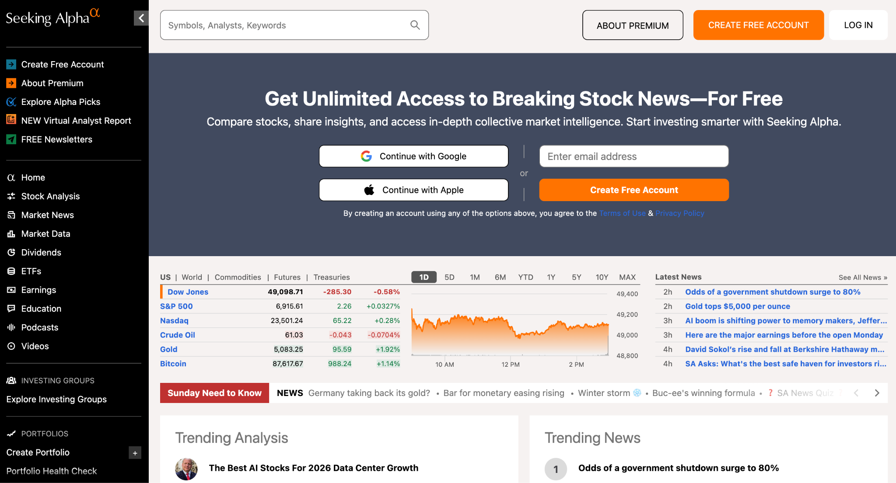
- about=home page

Research tab
- Theoretical research, 放paper，参考https://www.aqr.com/Insights/Research
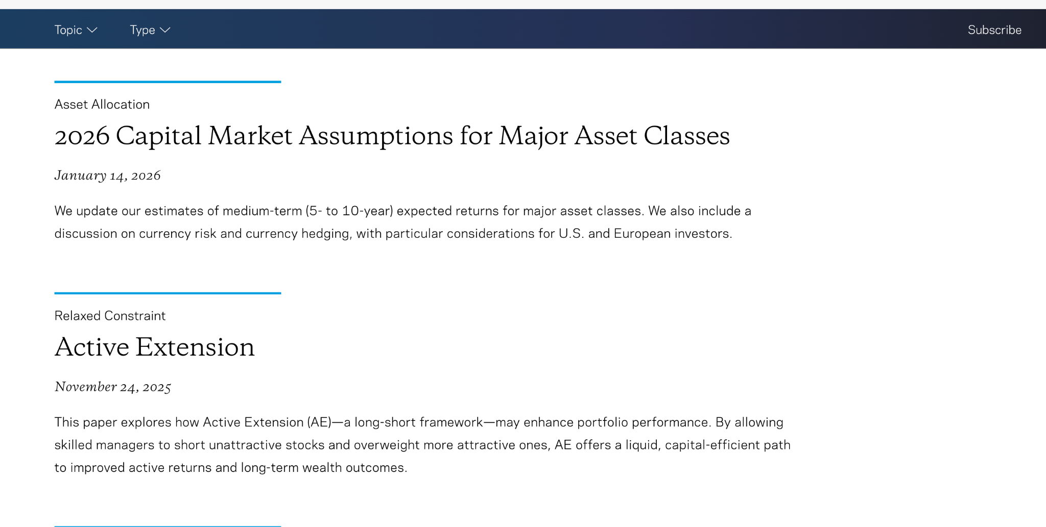
- Ongoing thesis, 跟research tab类似，更多总结
https://seekingalpha.com/etfs-and-funds/etf-tables/key_markets，
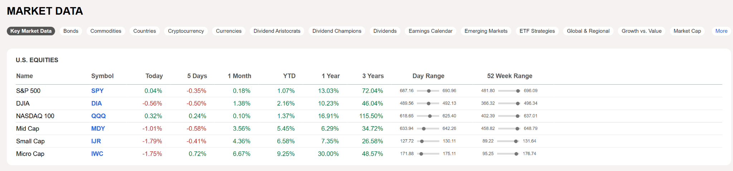
General market data, Our picks and thesis

Our Strategies
- Home: Strategy description
https://seekingalpha.com/symbol/SPY

- US Options Fundamental-Biased Strategy
- NAV
- Holdings
- US Options Technical-Biased Strategy
- NAV
- Holdings
- US Options Multi-Strat
- NAV
- Holdings

Prediction Markets
Coming Soon

