AI for inventory management
Description: this is a tool kit for companies in almost in every industry will need to use to manage their inventory. This tool kit should include real time inventory tracking system, reorder management, demand forecasting, safety stock optimization, etc. mainly present by a dashboard showing all the inventory info.

workflow:

[User Uploads Historical Sheet]
│ (CSV/XLSX, via browser drag-drop or S3 link)
▼
[Ingestion Service]
├─ File parsing (CSV/XLSX)
├─ Schema mapping (column auto-detect + user mapping UI)
└─ Basic data QA (missing dates/SKU, duplicates)
▼
[Data Validation & Harmonization]
├─ Time-series reconstruction per SKU (daily/weekly)
├─ Outlier & anomaly checks (z-score/IForest)
├─ Intermittent-demand tagging (ADId/ADI²)
└─ Feature store build (seasonality, trend, promos, lead time)
▼
[Forecast Engine]
├─ Model selection per SKU class:
│ • Intermittent: Croston / SBA / ADIDA
│ • Continuous: Prophet / ARIMA / XGBoost / LSTM
├─ Hierarchical reconciliation (SKU → category → plant)
└─ Forecast accuracy backtest (rolling-origin; MAPE, sMAPE)
▼
[Replenishment Optimizer]
├─ Safety stock (service-level target z)
├─ Reorder point ROP = μL + z·σL
├─ Order quantity: EOQ or (s, S) policy
└─ Supplier-lead-time risk uplift (optional)
▼
[Inventory Health Index & KPIs]
├─ Turnover, Fill rate, Stockout rate
├─ Excess & Dead stock %, Accuracy, MAPE
└─ Composite score (0–100) with weights
▼
[Reporting & Actions]
├─ Dashboard (alerts, what-if sliders)
├─ Recommended POs / restock points
└─ Exports & API (ERP/WMS integration)

Inventory Intelligence — Project Blueprint v1
Last updated: Nov 3, 2025

1) Vision & Value Proposition
Inventory Intelligence is a SaaS platform that ingests companies’ historical inventory and transaction data, auto-computes the metrics leaders care about, forecasts demand, and recommends replenishment actions—continuously updated by AI as market signals change. Target users are operations leaders at SMB manufacturers/wholesalers/retailers who don’t have data teams but want enterprise-grade planning.
Core value: faster, smarter stocking decisions that raise service level and cash flow while lowering stockouts and excess.

2) MVP Scope (first shippable version)
- Secure file upload: CSV/Excel template & validator; S3/GCS storage.
- Data hygiene: schema checks, type coercion, dedupe, outlier & intermittent-demand handling.
- ABC–XYZ segmentation: classifies SKUs by value & demand variability.
- Forecasts: Naïve, Moving Avg, Exponential Smoothing (SES/Holt), Croston (for intermittent). Auto-select baseline; horizon 1–26 weeks.
- Replenishment: Safety stock + Reorder point + Order qty rules; supports MOQ, lead time, service-level targets.
- KPI dashboard: inventory turnover, fill rate, stockout rate, GMROI, weeks of supply, backorder rate, forecast accuracy (MAPE, sMAPE, WAPE), bias, CSL.
- Action queue: ranked “Buy/Defer/Clearance” recommendations per SKU + rationale.
- Narrative insights (AI): auto-generated weekly summary and Q&A over your data.

3) Personas & Jobs-to-be-Done
- Ops/Inventory Manager: upload monthly snapshot + transactions; wants clear buy lists and risk alerts.
- Supply Planner: needs item-level forecasts & constraints (MOQ, supplier LT).
- Finance: cash tied in inventory, GMROI, DOH.
- Founder/GM: high-level trends and exceptions.

4) Data Model

4.1 Required minimal columns (per transaction or period):
- sku_id, sku_name
- location_id (or fc_id/store_id)
- date (ISO 8601)
- Demand signal: qty_sold or qty_issued
- On-hand snapshot: on_hand_end (if periodic) or separate stock snapshot table
- Lead time: supplier_lead_time_days (can default per supplier)

4.2 Recommended columns:
- supplier_id, supplier_name, moq, order_multiple
- unit_cost, unit_price, gross_margin
- on_order_qty, backorder_qty
- min_level, max_level
- discontinued_flag, new_item_flag
- category, brand, uom

4.3 Tables (logical schema)
- Items(sku_id, sku_name, uom, category, unit_cost, unit_price, discontinued_flag, new_item_flag)
- Locations(location_id, name, type)
- Suppliers(supplier_id, supplier_name, default_lt_days, moq, order_multiple)
- InventorySnapshots(sku_id, location_id, date, on_hand, on_order, backorder)
- Transactions(sku_id, location_id, date, qty, type['sale','issue','receipt','adjustment'])
- Parameters(sku_id, location_id, target_csl, review_period_days)
- MarketSignals(date, sku_id/category, signal_name, signal_value) // optional

5) KPI & Formula Reference
- Inventory Turnover = COGS / Avg Inventory.
- Days/Weeks of Supply (DOS/WOS) = On-hand / Avg Daily/Weekly Demand.
- Fill Rate = 1 - (Backorders / Demand).
- Stockout Rate = Stockout Days / Period Days.
- GMROI = Gross Margin / Avg Inventory Cost.
- Forecast Accuracy: MAPE, sMAPE, WAPE, MASE; Bias = mean(Forecast - Actual).
- ABC: rank by annual $ usage (Demand × Cost). XYZ: variability via CV or demand intermittency index.

6) Forecasting Module
Model pool: Naïve, Moving Average (k=4/8/12), SES, Holt (trend), Croston & SBA for intermittent, ETS (A/Ad/A), and (Phase 2) ML boosters (XGBoost/LightGBM w/ covariates like promo flags, price, macro signals).
Auto-selection: rolling-origin cross-validation on last N periods using WAPE; tie-break with sMAPE & bias.
Cold-start: similarity-based pooling (category-level), hierarchy reconciliation (SKU→Category→All), shrinkage priors.
Intermittent demand: Croston/SBA, demand-interval modeling, quantile forecasts for CSL targeting.

7) Replenishment Engine
Let demand over lead time be (D_L), mean (\mu_L), std (\sigma_L), target cycle service level CSL.
- Safety Stock (Normal): (SS = z_{CSL} \cdot \sigma_L).
- Reorder Point: (ROP = \mu_L + SS).
- Order Quantity: (Q = \max( MOQ, \text{round to multiple}, \text{policy like EOQ})).
- EOQ: (\sqrt{\tfrac{2DS}{H}}) (annual demand D, order cost S, holding cost H).
- Lead-time variability: (\sigma_L = \sqrt{ L\sigma^2 + \mu^2\sigma_L^2 }) (time-varying demand & LT).
- Service constraints: choose z via CSL target (e.g., 95% → z≈1.645).
- Poisson/Intermittent: use quantiles via Poisson/Negative Binomial or bootstrap over simulated lead-time windows.
- Business constraints: capex budget, storage capacity, vendor calendars, MOQ/price breaks.
Output: For each SKU/location per review: ROP, SS, Q_recommend, next_buy_date, rationale (driver metrics & constraints).

8) AI Layer
- Narrative Insights: auto-written weekly digest (top movers, stockout risks, overstock candidates, slow movers for clearance).
- Explain-My-Rec: natural-language rationale for each buy/hold/clear recommendation.
- Conversational Q&A: “Why did forecast jump for SKU X at Store 12?”
- What-if Simulator: tweak CSL, MOQ, LT; see KPIs & cash impact.
- Anomaly Detection: sudden demand spikes/drops, data errors, negative on-hand, implausible LT.

9) System Architecture (proposed)
- Frontend: Next.js (React), shadcn/ui, auth via OAuth/SAML; file upload; dashboards; action queue.
- Backend API: Python FastAPI.
- Data Store: PostgreSQL (OLTP) + DuckDB/Parquet (analytics lake). Object store S3/GCS for raw files.
- Pipelines: Prefect/Airflow for ETL + model training. Pandas/Polars for transforms.
- ML/MLOps: statsmodels/Prophet (optional)/sktime; MLflow for experiment tracking; Docker; CI via GitHub Actions.
- Queues/Cache: Redis for jobs & rate limiting.
- Infra: AWS (S3, RDS, ECS/EKS or Fargate, CloudFront), IaC via Terraform.
- Security: VPC, least-privilege IAM, KMS encryption, row-level tenancy.
Multi-tenancy: schema-per-tenant in Postgres or row-level security with tenant_id; isolate S3 prefixes by tenant.

10) API Sketch (v0)
Auth: JWT (OIDC). All endpoints are tenant-scoped.
POST /v0/uploads
- body: multipart form (file, file_type: [csv,xlsx], dataset: [transactions, snapshots, items, suppliers])
- returns: upload_id

POST /v0/ingest/{upload_id}/validate
GET /v0/ingest/runs/{run_id}

POST /v0/forecast/run
- body: { horizon_weeks: 12, hierarchy: [sku_id, location_id], method_pool: ["auto"] }
- returns: run_id

GET /v0/plan/replenishment?location_id=...&as_of=2025-11-03
- returns: list of { sku_id, ROP, SS, Q_recommend, reason }

GET /v0/kpi/summary?period=last_90d
GET /v0/insights/weekly

11) File Template & Validation
Accepted: CSV/Excel. UTF-8. 1 header row. Date YYYY-MM-DD.
Transactions template (minimal):
sku_id,sku_name,location_id,date,qty
A123,Widget A,WH1,2025-01-05,12
A123,Widget A,WH1,2025-01-12,9
Snapshots template:
sku_id,location_id,date,on_hand,on_order,backorder
A123,WH1,2025-01-31,104,20,0
Validation rules: non-null keys, no future dates, qty integers, dedupe exact-duplicate rows, reconcile negative on-hand by adjustment queue; generate a human-readable error report.

12) Dashboard Layout (MVP)
- Header KPIs: Turnover, WOS, Fill Rate, Stockout Rate, GMROI, Forecast Accuracy.
- Segmentation: ABC–XYZ bubble (value vs variability).
- Risk Cards: stockout in <7 days, excess > 90 DOS, slow movers.
- Recommendations Table: SKU, location, ROP, SS, Q, next buy date, reason, savings.
- Trend Charts: demand, forecast vs actual, bias, backorders, on-hand.

13) Evaluation & Benchmarks
- Backtests: rolling-origin CV with horizons 1–13 weeks; report WAPE, sMAPE, bias by SKU and segment.
- Uplift tests: compare CSL/stockouts/DOH before vs after adoption.
- Latency SLOs: upload→validated < 2 min; forecast run < 10 min per 10k SKU-locations (target).

14) Security, Privacy, Compliance
- PII minimization: SKU & ops data only; optional hashing for customer names.
- Encryption: at rest (S3 SSE-KMS, RDS AES-256), in transit (TLS 1.2+).
- Access: RBAC (Owner, Analyst, Viewer); per-tenant isolation.
- Audit logs: uploads, changes, recommendations accepted/overridden.
- Retention: configurable; soft-delete & legal hold.

15) Pricing & Packaging (draft)
- Starter: up to 2 locations, 2k SKUs, weekly forecasts, $199/mo.
- Growth: up to 10 locations, 20k SKUs, daily updates, API access, $999/mo.
- Enterprise: custom limits, SSO/SAML, sandbox-to-prod pipelines, SOC 2.

16) Roadmap
0–30 days (MVP): ingestion, validation, baseline forecasts, ROP/SS, ABC–XYZ, dashboard, weekly insights.
31–60 days: MLflow, XGBoost booster (optional), what-if simulator, supplier constraints (MOQ/multiples), export CSV/Excel.
61–90 days: multi-location logic (transship/MEIO-lite), promotions flags, budget & capacity constrained buy plan, approval workflow.

17) Implementation Tasks (first sprint)
- Repo bootstrap: monorepo (frontend apps/web, backend apps/api, packages/shared).
- Auth & tenants: OIDC, tenant middleware, RLS in Postgres.
- Upload service: presigned URLs to S3, virus scan (ClamAV), schema validator.
- ETL: Pandas/Polars pipeline; dimension & fact builders.
- Forecast service: sktime/statsmodels library wrapper; rolling CV; model registry.
- Replenishment service: formulas + constraint resolver; expose as API.
- Dashboard v1: KPIs, segmentation, recs table, download buttons.
- Insight writer: LLM prompt template over computed metrics.

18) Stretch Features
- MEIO (multi-echelon) simulation; pooling benefits.
- Dynamic pricing guidance (opt-in).
- Computer vision for shelf recognition (retail).
- Vendor scorecards (OTIF, price, variability).

19) Lean Six Sigma Hooks
- SPC charts on demand & lead times ((\bar{X})/R, EWMA for shifts).
- Pareto by root causes of stockouts/excess.
- A3 auto-report for continuous improvement cycles.

20) Risks & Mitigations
- Data quality variance: robust validators, imputation, user feedback loop.
- Cold-start for new SKUs: category pooling, Bayesian shrinkage.
- User trust: show math & explain recommendations; allow overrides with learning.
- Compute cost: tiered cadences; async batch; caching.

21) Appendix

21.1 Reorder Policy Cheat Sheet
- Periodic review (R,S): order to S every R days.
- Continuous review (s,Q): when stock ≤ s, order Q.

21.2 Sample Data Dictionary (excerpt)
- qty: integer, units per transaction; positive issue/sale, negative return.
- on_hand: nonnegative integer; snapshot end-of-day.
- supplier_lead_time_days: float; avg days from PO to receipt.
- target_csl: float in [0.80, 0.99].

21.3 Starter Prompt (Insight Writer)
“Summarize top 10 risks and 10 savings opportunities this week. Use DOS, CSL, WAPE, and ABC–XYZ segments. Keep it to 200 words with bullet points and cite 3 SKUs as examples.”

Task list 1:
- Find sample inventory sheet, recognize frequent used variables and what output that a inventory control sheet usually looking for
- Create a data extraction algorithm to extract data from datasheet provide by the customer
- Know what the output will be, what I would like to present to the customer
- Learn how to apply AI into the model
- Learn general inventory demand, like what data they are really likely to see, what variable they care about the most for different department

Product Name: Inventory Intelligence (I&I)
Products develop tool: ShinyApp, R
Coding platform: Cursor
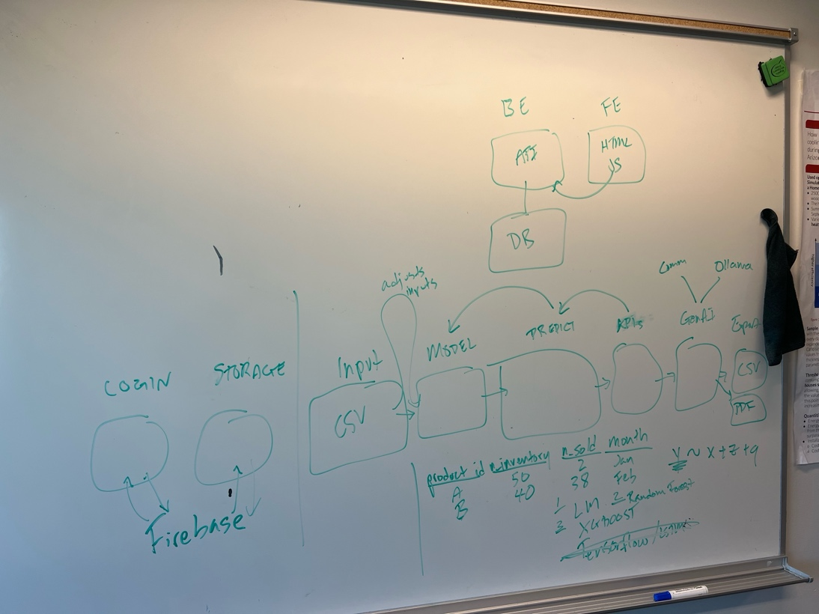
General Flowchart:
