HAQ: Hardware-Aware Automated Quantization with Mixed Precision

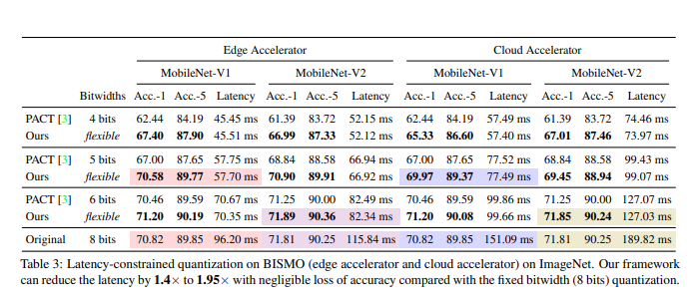

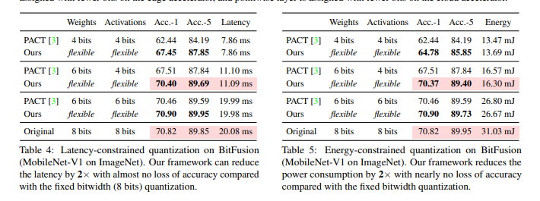

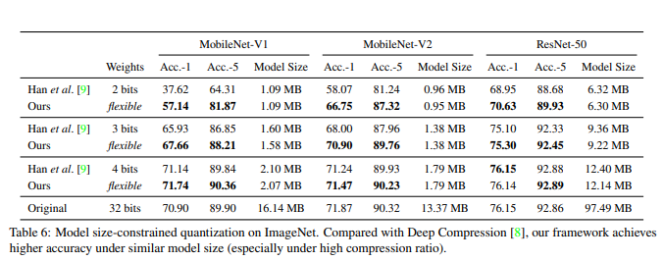

Differentiable Soft Quantization: Bridging Full-Precision and Low-Bit Neural Networks

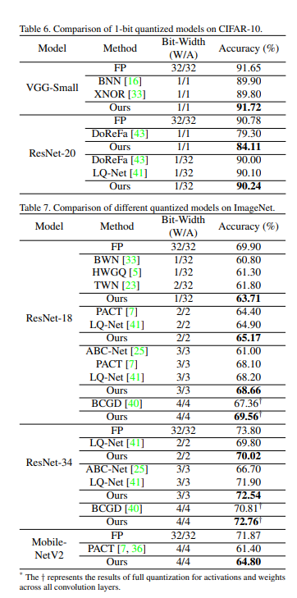

KCNN: Kernel-wise Quantization to Remarkably Decrease Multiplications in Convolutional Neural Network

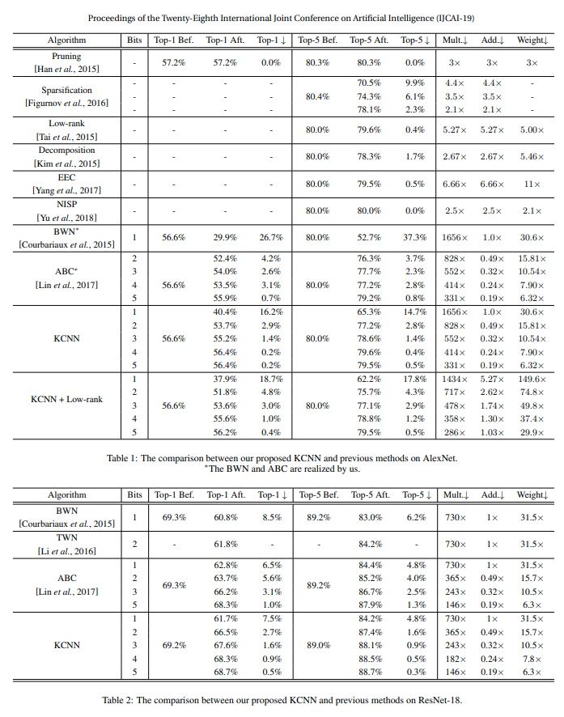

HAWQ: Hessian AWare Quantization of Neural Networks with Mixed-Precision

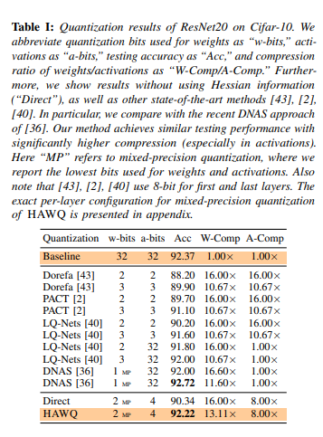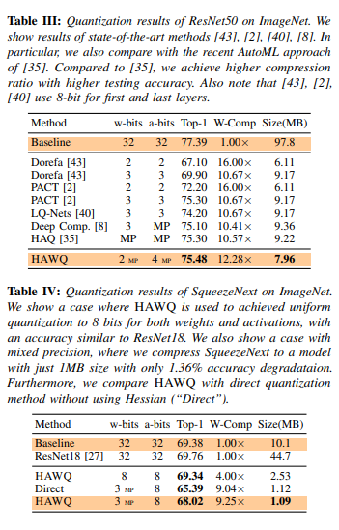HAWQ-V2: Hessian Aware trace-Weighted Quantization of Neural Networks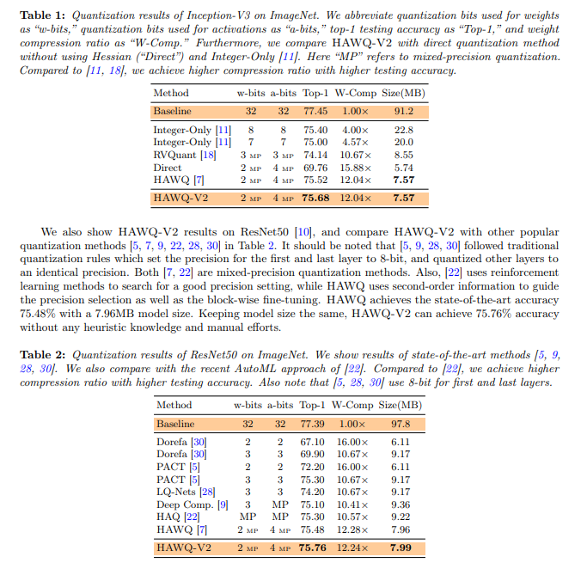

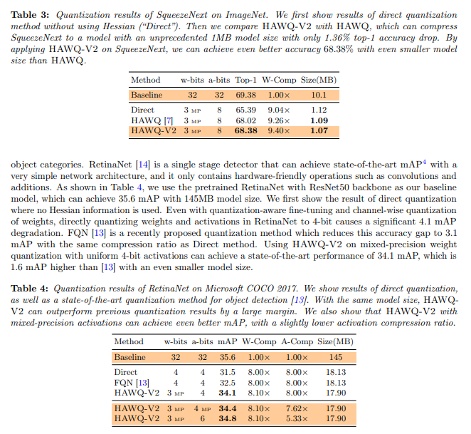

AdaBits: Neural Network Quantization with Adaptive Bit-Widths

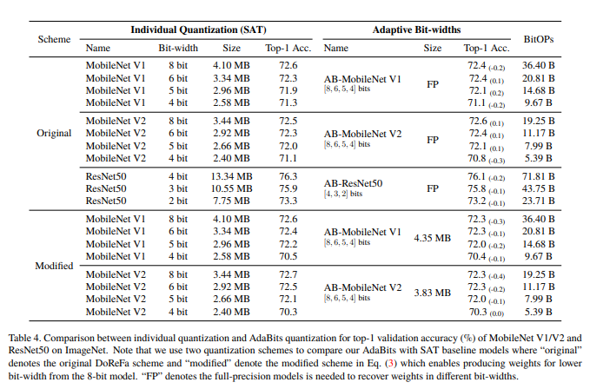

Towards Efficient Training for Neural Network Quantization

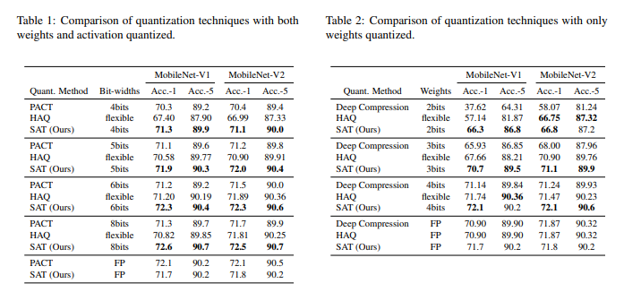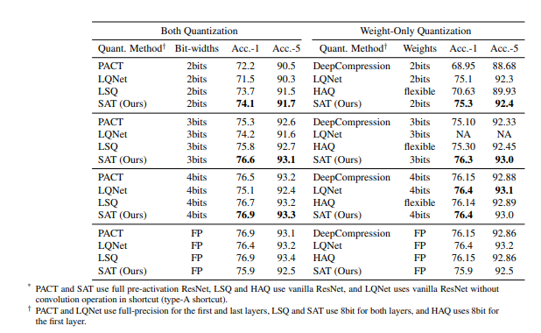

Learning to Quantize Deep Networks by Optimizing Quantization Intervals with Task Loss

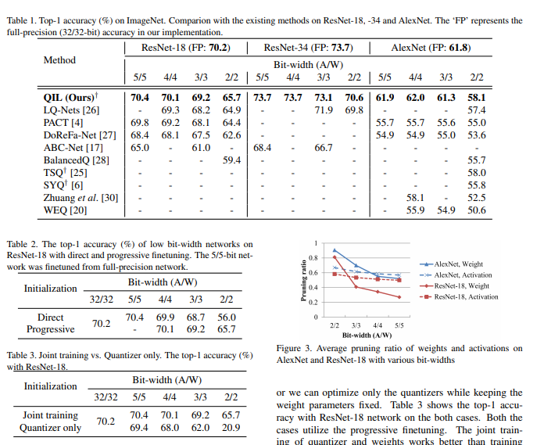

AUTOQ: AUTOMATED KERNEL-WISE NEURAL NETWORK QUANTIZATION∗

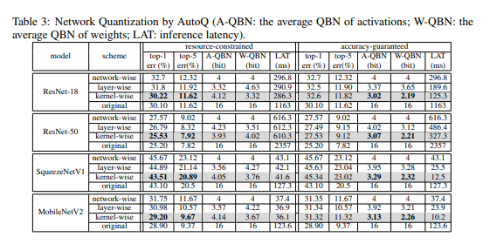

MIXED PRECISION DNNS: ALL YOU NEED IS A GOOD PARAMETRIZATION

