Qing Huang

CSE 150 HW4

4.2 Statistical language modeling

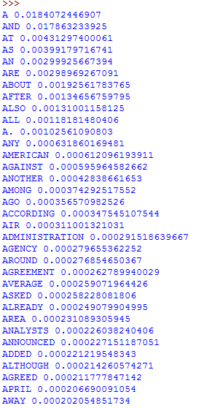 a)

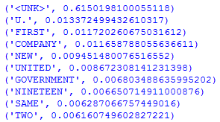b)

c)

So in this case, the log-likelihoods under bigram is bigger than under unigram

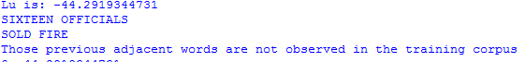d)

These will casue the log-likelihood from the bigram model become to 0, since the numerator is 0.

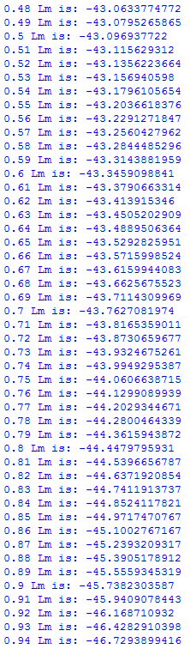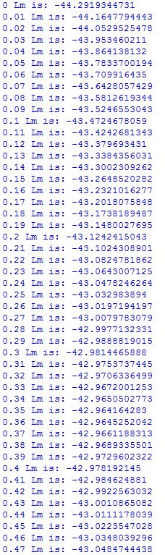

e)

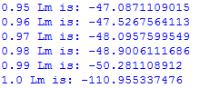

Plot: