

S U R A T - K E P U T U S A N
Nomor : SKEP / / P / BD / / 2026

Tentang

………………………….

-----------------------------

DIREKSI PT PINDAD (PERSERO)
Menimbang | : | - ………………………………………………………………………………………………………………………………………………………………………………………………………………………………………  - ………………………………………………………………………………………………………………………………………………………………………………………………………………………………………
Mengingat | : | - ………………………………………………………………………………………………………………………………………………………………………………………………………………………………………  - ………………………………………………………………………………………………………………………………………………………………………………………………………………………………………  - ……………………………………………………………………………………………………………………………………………………………………………………………………………………………………...
M E M U T U S K A N

Menetapkan | : | - …………………………………………………………………………………………………………………………………………………………………………………………………………………………….....  - ……………………………………………………………………………………………………………………………………………………………………………………………………………………………….  - ………………………………………………………………………………………………………………………………………………………………………………………………………………………………  - ……………………………………………………………………………………………………………………………………………………………………………………………………………………………….

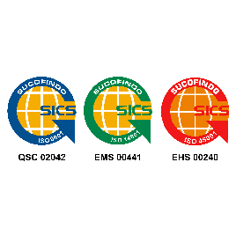
Head Office Representative Office
Jl. Jend Gatot Subroto No. 517 P +62 22 7312073 Jl. Batu Ceper No. 28 P +62 21 3806929
Bandung 40284 F +62 22 7301222 Jakarta 10120 F +62 21 3814039
Indonesia E info@pindad.com Indonesia E pindadjkt@pindad.com www.pindad.com

Ditetapkan di : B a n d u n g
Pada tanggal : .
PT PINDAD (PERSERO)
DIREKSI
SIGIT P. SANTOSA
DIREKTUR UTAMA

Kepada Yth.:
- Direksi
- Senior Vice President
- Sekretaris Perusahaan
- Ka. SPI
- Para Vice President
- Para General Manager
- Senior Principal Expert

