**Title of Abstract for ICOC2016**

**San Zhang**a) and Jane Roeb)*

*a)Department of Science, ABC University, City, Country  
b)Department of Nature, DEF University, City, Country*

E-mail: username@mailsever

This is an abstract template for the *Proceedings of International Symposium of Computational Organometallic Catalysis (ICOC2016)*. The language of the abstracts is in English. To maintain a coherent layout of the proceedings, all authors should kindly write the abstracts using the templates provided in the conference web pages.

The template is designed to reproduce correctly when A4 paper and 3 cm margins are used. Please do not change these settings! The font should be Times New Roman 12pt. The users of OpenOffice should check that they have this font installed, since otherwise OpenOffice will silently substitute it with a similar, but alas incompatible, font.

Abstracts will be submitted to the organizers electronically. Both, a filled in TeX/MS Word/OpenOffice template, and the resulting PDF file should be submitted. When using TeX template, please send any possible pictures separately. With OpenOffice and MS Word templates pictures should be inserted directly to the document. Submitted files will be published as they are.

In the list of authors, underline the name of the author responsible for the presentation of the paper. The abstract text should be justified. References are cited in the text like this [1]. The reference list should use the format shown at the bottom of the page. Formulas should be centered and, if numbering is necessary, the number should be placed on the right in parentheses. Here is an example of an equation with numbering:

 (1)

Equation (1) is the Pythagorean theorem.

You can also include figures in your abstract. The beautiful building in figure 1 is the ICOC venue, namely, the report hall of library in Beijing University of Chemical Technology.

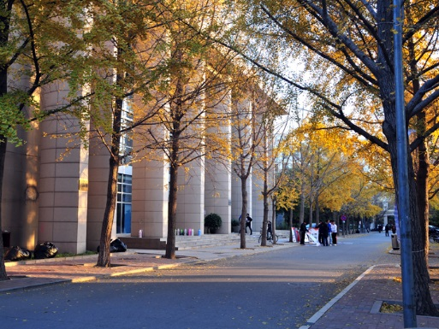

Figure 1: An example figure.

[1] S. Chang, J. Roe, *Abb. Journal*. **138**, 214102 (2013).

[2] C.S. Yang, T. Lee, A.B. Smith, *Abb. Journal*. **16**, 3999 - 4008 (2014).