**Supplementary 1a**. Flow chart of systematic search of TNF and IL17A from May 2020

TNF and IL17A (from May 2020)

Records identified

(N = 796)

Records screened

(n = 796)

Studies assessed for eligibility (n = 24)

Studies included from search (n = 1)

**Identification**

**Screening**

**Included**

Previous systematic review

(n = 34)

Reports excluded:

* Open label n=1

Records excluded (n = 772)

* Duplicates n=319
* Language not English n=11
* Mixed disease cohort n=299
* Inappropriate design n=124
* Unsuitable comparator n=19

**Screening**

Reports excluded (n=23)

* Mixed disease population n=9
* Open label n=8
* No placebo arm n=3
* Abstract only n=3

Studies included from previous review

(n = 33)

Studies prior May 2020 missed from previous review

(n=1)

**Included**

**Supplementary 1b**. Flow chart of systematic search of IL17F and JAKi from inception

Records identified

(n = 263)

Records screened

(n = 263)

Studies assessed for eligibility

(n = 15)

Studies included in review

(n = 9)

IL17F and JAKi (from inception)

**Identification**

**Screening**

**Included**

Reports excluded (n=6)

* Open label n=2
* Long-term analysis n=1
* Abstract only n=3

Records excluded (n = 248)

* Duplicates n=71
* Language not English n=15
* Mixed disease cohort n=102
* Inappropriate design n=60

**Supplementary 2.** Randomised controlled trials bias assessment using (Risk of bias 2 (RoB2) tool).

| Study | Random sequence generation | Allocation concealment | Blinding patients and personnel | Blinding outcome assessment | Incomplete outcome data | Selective reporting | Overall |
| --- | --- | --- | --- | --- | --- | --- | --- |
| Van der Heijde D. 2006 |  |  |  |  |  |  |  |
| Sieper J. (AILITY-1) 2012 |  |  |  |  |  |  |  |
| Huang F. 2013 |  |  |  |  |  |  |  |
| Haibel H. 2008 |  |  |  |  |  |  |  |
| Landewé R. (RAPID-axSpA) 2013 |  |  |  |  |  |  |  |
| Deodhar A. (C-axSpAnd) 2019 |  |  |  |  |  |  |  |
| Inman R (GO-RAISE) 2008 |  |  |  |  |  |  |  |
| Deodhar A (GO-ALIVE) 2017 |  |  |  |  |  |  |  |
| Sieper J. (GO-AHEAD) 2015 |  |  |  |  |  |  |  |
| Bao C. 2014 |  |  |  |  |  |  |  |
| Van der heijde D. (ASSERT) 2005 |  |  |  |  |  |  |  |
| Barkham N. 2009 |  |  |  |  |  |  |  |
| Inman R. 2010 |  |  |  |  |  |  |  |
| Marzo-Ortega H. 2005 |  |  |  |  |  |  |  |
| Sieper J. (INFAST) 2012 |  |  |  |  |  |  |  |
| Braun J. 2002 |  |  |  |  |  |  |  |
| Gorman JD. 2002 |  |  |  |  |  |  |  |
| Davis JC. 2003 |  |  |  |  |  |  |  |
| Brandt J. 2003 |  |  |  |  |  |  |  |
| Calin A. 2004 |  |  |  |  |  |  |  |
| Van der Heijde D. 2006 |  |  |  |  |  |  |  |
| Barkham N. 2010 |  |  |  |  |  |  |  |
| Dougados M. (SPINE) 2011 |  |  |  |  |  |  |  |
| Dougados M. 2014 |  |  |  |  |  |  |  |
| Dougados M. (SPARSE) 2014 |  |  |  |  |  |  |  |
| Deodhar A. (COAST-W) 2019 |  |  |  |  |  |  |  |
| Van der Heijde D. (COAST-V) 2018 |  |  |  |  |  |  |  |
| Deodhar A. (COAST-X) 2019 |  |  |  |  |  |  |  |
| Baeten D. 2013 |  |  |  |  |  |  |  |
| Baeten D. (MEASURE1) 2015 |  |  |  |  |  |  |  |
| Baeten D. (MEASURE2) 2015 |  |  |  |  |  |  |  |
| Pavelka K. (MEASURE3) 2017 |  |  |  |  |  |  |  |
| Kivitz A. (MEASURE4) 2018 |  |  |  |  |  |  |  |
| Deodhar A. (PREVENT) 2019 |  |  |  |  |  |  |  |
| Huang F. (MEASURE5) 2020 |  |  |  |  |  |  |  |
| Van der Heijde D. (BE MOBILE1) 2023 |  |  |  |  |  |  |  |
| Van der Heijde D. (BE MOBILE2) 2023 |  |  |  |  |  |  |  |
| Van der Heijde D. (BE AGILE) 2020 |  |  |  |  |  |  |  |
| Deodhar A. 2021 |  |  |  |  |  |  |  |
| Van der Heijde D. 2017 |  |  |  |  |  |  |  |
| Van der Heijde D. (SELECT-AXIS 1) 2019 |  |  |  |  |  |  |  |
| Deodhar A. (SELECT-AXIS 2) 2022 |  |  |  |  |  |  |  |
| Van der Heijde A. (SELECT-AXIS 2) 2022 |  |  |  |  |  |  |  |
| Van der Heijde A. (TORTUGA) 2018 |  |  |  |  |  |  |  |

Bias assessed using Cochrane risk of bias tool. Green = low risk of bias, Red = high risk of bias, Yellow = some concerns risk of bias.

**Supplementary 3.** SUCRA ranking.

A probability of treatment superiority was calculated based on estimated probabilities using the parameters derived from the NMA and reported as a rank according to the surface under the cumulative ranking curves (SUCRA). A SUCRA value of 1 indicates the treatment is certain to be the most effective in the network, while a value of 0 indicates it is certain to be the least effective.

**Table**. SUCRA ranking of each treatment.

|  |  |  |  |  |  |
| --- | --- | --- | --- | --- | --- |
| Rank | PBO | ETN | Anti-IL17 | JAKi | Anti-TNF mAbs |
| Best | 0 | 0.23 | 0.12 | 0.34 | 0.31 |
| Second | 0 | 0.21 | 0.27 | 0.24 | 0.27 |
| Third | 0.02 | 0.21 | 0.32 | 0.18 | 0.25 |
| Fourth | 0.22 | 0.20 | 0.26 | 0.15 | 0.14 |
| Worse | 0.75 | 0.13 | 0.02 | 0.07 | 0.01 |
| RANK | 4.7 | 2.9 | 2.8 | 2.4 | 2.3 |
| SUCRA | 0.1 | 0.6 | 0.6 | 0.7 | 0.7 |

**Figure**. SCURA plot showing for each treatment, the cumulative probability of being ranked 1st through 5th.

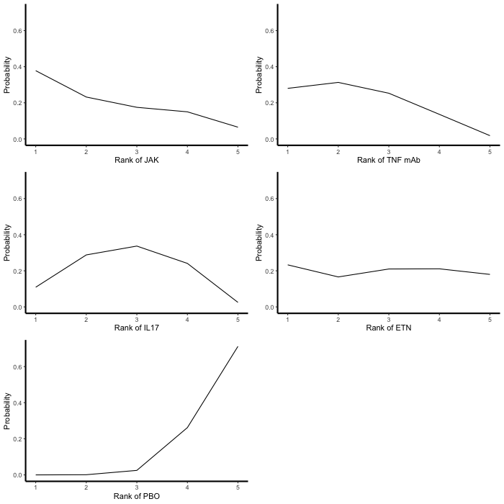

**Supplementary 4**. Pairwise meta-analysis, using a per protocol approach to calculated exposure.

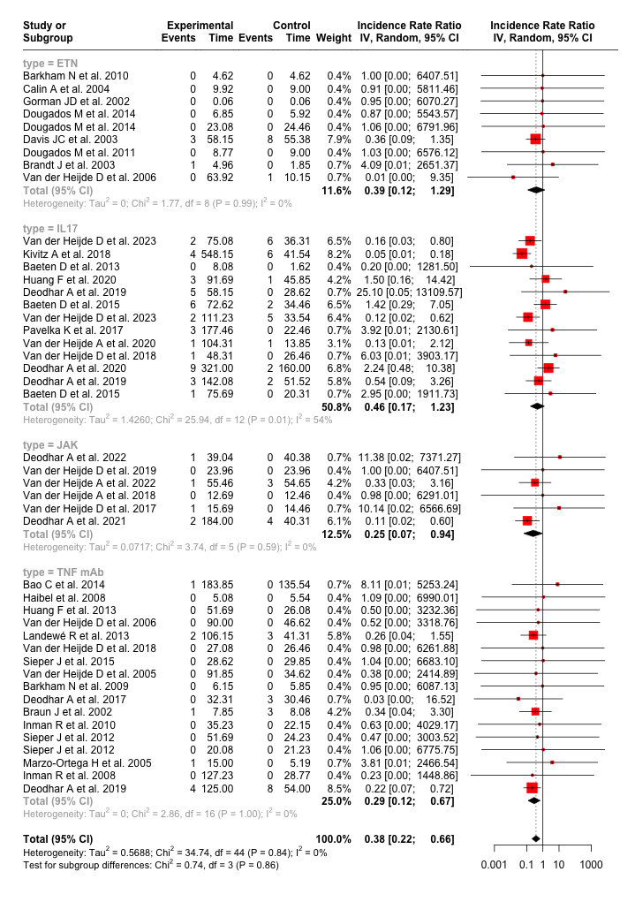

.

**Supplementary 5.** The ‘leave-one-out’ analysis, which systematically removes one study at a time and presents the summary effect estimates without that study.

**Supplementary 6i.** Funnel plot.

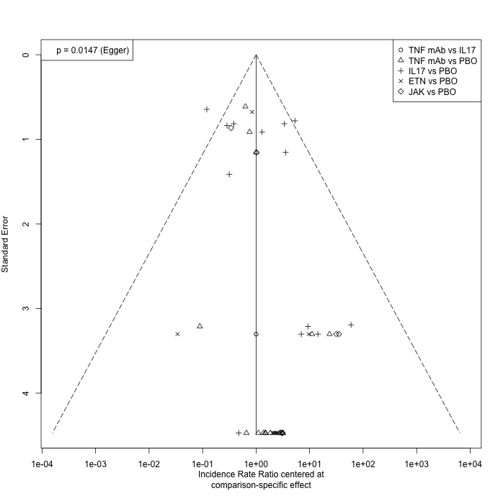

**Supplementary 6ii.** PET PEESE estimates

When adjusting for small sample effects using the PET-PEESE the pooled effects remained statistically significance.

PET PEESE Estimates

|  |  |  |  |  |  |
| --- | --- | --- | --- | --- | --- |
| Anti-TNF mAbs | Anti-IL17 | ETN | JAK |  |  |
| 0.19 (0.12, 0.30) | 0.13 (0.11, 0.72) | 0.31 (0.18, 0.65) | 0.06 (0.06, 0.38) | Placebo |  |

Legend: In the summary table, the referent group for all comparison is placebo

**Supplementary 7**. Sensitivity network metanalysis using an intention to treatment (ITT) model to calculate exposure.

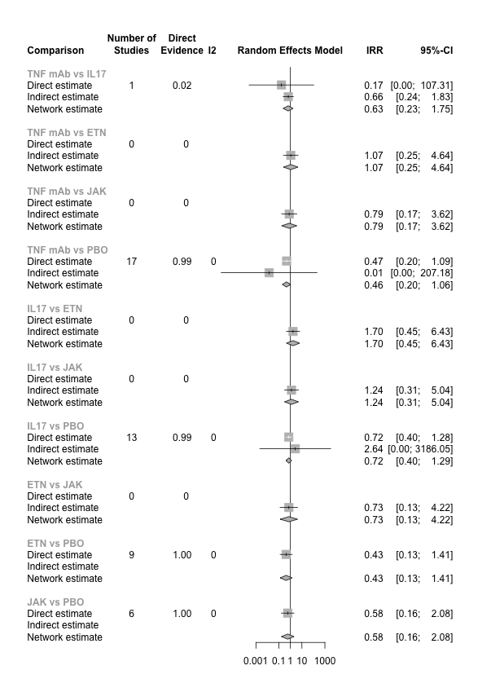i. ii.

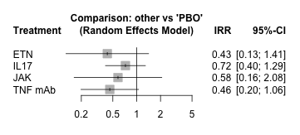

iii.

|  |  |  |  |  |  |
| --- | --- | --- | --- | --- | --- |
| Anti-TNF mAbs |  |  |  |  |  |
| 0.63 (0.23; 1.75) | Anti-IL17 |  |  |  |  |
| 1.07 (0.25; 4.64) | 1.70 (0.45; 6.43) | ETN |  |  |  |
| 0.79 (0.17; 3.62) | 1.24 (0.31; 5.04) | 0.73 (0.13; 4.22) | JAK |  |  |
| 0.46 (0.20; 1.06) | 0.72 (0.40; 1.29) | 0.43 (0.13; 1.41) | 0.58 (0.16, 2.08) | Placebo |  |

Legend. i. Forest plot of direct, indirect and network IRR estimates of comparisons between all treatments. ii. Forest plot of network IRR estimates of comparisons between treatments and placebo iii. Summary table of network IRR estimates of comparisons between treatments. The referent group for comparisons is the treatment arm appearing at the end of the row i.e., in the 1st row of estimates the referent is anti-IL17, in the 2nd row the referent is ETN, in the 3rd row the referent is JAK and in the 4th row the referent is placebo.

**Supplementary 8.** Sensitivity network meta-analysis restricting analyses to studies with low risk of bias (n=26 studies).

i. ii

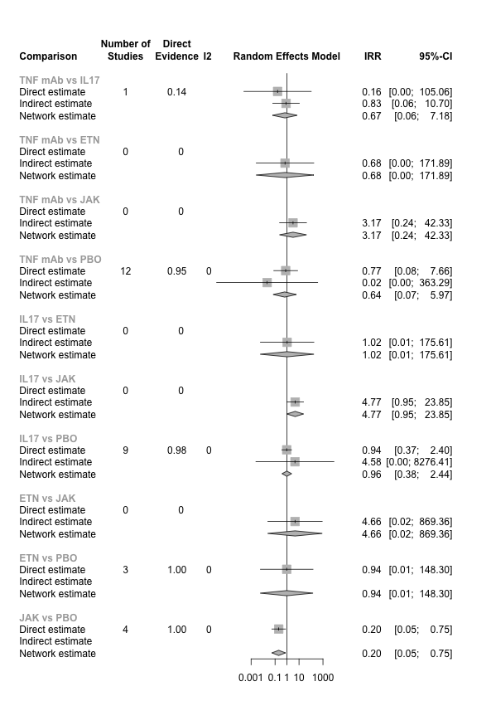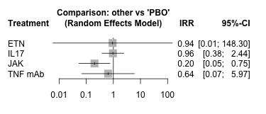

iii

|  |  |  |  |  |  |
| --- | --- | --- | --- | --- | --- |
| Anti-TNF mAbs |  |  |  |  |  |
| 0.67 (0.06; 7.18) | Anti-IL17 |  |  |  |  |
| 0.68 (0.00; 171.9) | 1.02 (0.01; 175.6) | ETN |  |  |  |
| 3.17 (0.24; 42.3) | 4.77 (0.95; 23.6) | 4.66 (0.02; 869.4) | JAK |  |  |
| 0.64 (0.07; 5.97) | 0.96 (0.38; 2.44) | 0.94 (0.01; 148.3) | 0.20 (0.05, 0.75) | Placebo |  |

Legend. i. Forest plot of direct, indirect and network IRR estimates of comparisons between all treatments. ii. Forest plot of network IRR estimates of comparisons between treatments and placebo iii. Summary table of network IRR estimates of comparisons between treatments. The referent group for comparisons is the treatment arm appearing at the end of the row i.e., in the 1st row of estimates the referent is anti-IL17, in the 2nd row the referent is ETN, in the 3rd row the referent is JAK and in the 4th row the referent is placebo.

**Supplementary 9.** Sensitivity network metanalysis restricting analyses to studies that reported on uveitis events (n=26 studies).

i. ii

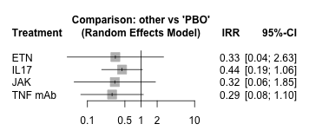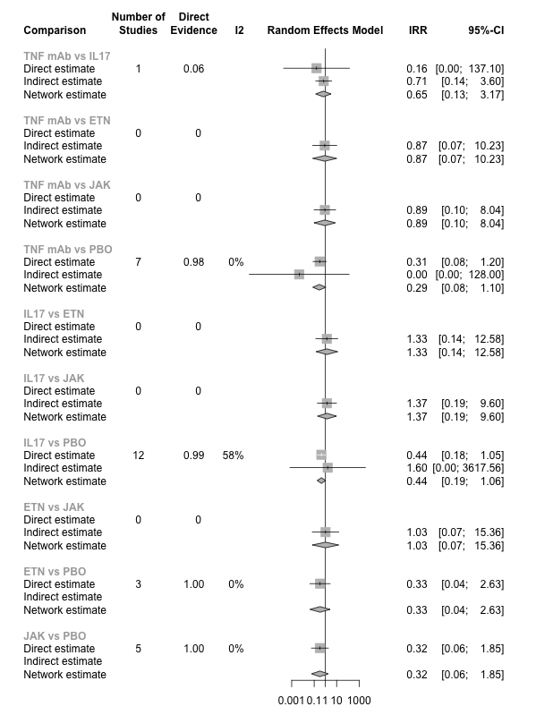

iii

|  |  |  |  |  |  |
| --- | --- | --- | --- | --- | --- |
| Anti-TNF mAbs |  |  |  |  |  |
| 1.65 (0.13; 3.17) | Anti-IL17 |  |  |  |  |
| 0.87 (0.07; 10.2) | 1.33 (0.14; 12.6) | ETN |  |  |  |
| 0.89 (0.10; 8.04) | 1.37 (0.19; 9.60) | 1.03 (0.07; 15.4) | JAK |  |  |
| 0.29 (0.08; 1.10) | 0.44 (0.19; 1.06) | 0.33 (0.04; 2.63) | 0.32 (0.06, 1.85) | Placebo |  |

Legend. i. Forest plot of direct, indirect and network IRR estimates of comparisons between all treatments. ii. Forest plot of network IRR estimates of comparisons between treatments and placebo iii. Summary table of network IRR estimates of comparisons between treatments. The referent group for comparisons is the treatment arm appearing at the end of the row i.e., in the 1st row of estimates the referent is anti-IL17, in the 2nd row the referent is ETN, in the 3rd row the referent is JAK and in the 4th row the referent is placebo.

**Supplementary 10.** Sensitivity network metanalysis restricting analyses to studies with >10% of the study population reporting past or concurrent uveitis (n=21 studies).

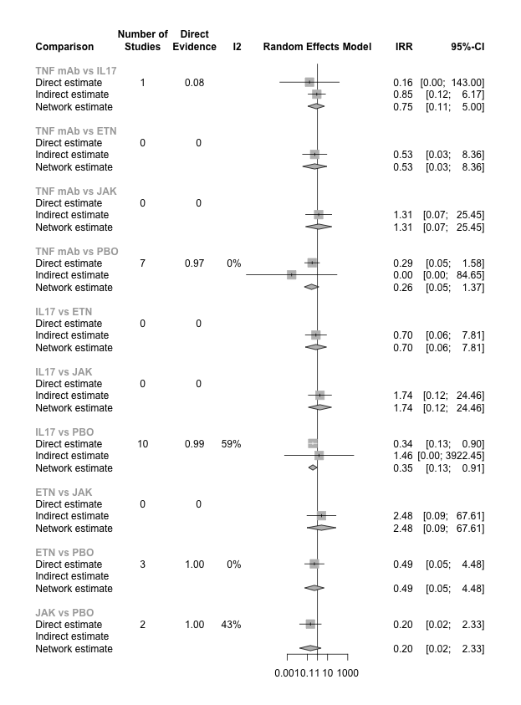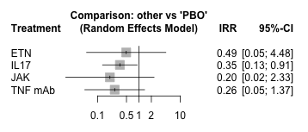i. ii

|  |  |  |  |  |  |
| --- | --- | --- | --- | --- | --- |
| Anti-TNF mAbs |  |  |  |  |  |
| 0.75 (0.11; 5.00) | Anti-IL17 |  |  |  |  |
| 0.53 (0.03; 8.36) | 0.70 (0.06; 7.81) | ETN |  |  |  |
| 1.31 (0.07; 25.5) | 1.74 (0.12; 24.5) | 2.48 (0.09; 67.6) | JAK |  |  |
| 0.26 (0.05; 1.37) | 0.35 (0.13; 0.91) | 0.49 (0.05; 4.48) | 0.20 (0.02, 2.33) | Placebo |  |

iii.

Legend. i. Forest plot of direct, indirect and network IRR estimates of comparisons between all treatments. ii. Forest plot of network IRR estimates of comparisons between treatments and placebo iii. Summary table of network IRR estimates of comparisons between treatments. The referent group for comparisons is the treatment arm appearing at the end of the row i.e., in the 1st row of estimates the referent is anti-IL17, in the 2nd row the referent is ETN, in the 3rd row the referent is JAK and in the 4th row the referent is placebo.