CSC 352 / 452: Database Programming

Project  
(260 Points)

**Due on Monday, 11/21/2016 at midnight**

**Late projects will not be accepted or graded.**

**You’ll receive no points if your programs do not compile.**

* **Please, remember that this is NOT a group project. So do not consult with anybody in class or outside class.**
* **Please submit a text file containing all your programs to D2L before or on due date.**
* **Please review your file before submitting it to make sure you have the correct one. It is your responsibility to ensure that you upload the correct file. If you submit a blank/wrong file, you will simply receive a grade of zero.**
* **The project is due by 11:59 pm Monday, November 21, 2016. Do not wait until the last day to submit your file! Submit ahead in case of unforeseen circumstances such as a computer crash or illness. There are no exceptions to the deadline.**

Your task is to build a PL/SQL-based application to insert and update records in a video rental store database and generate some reports.

The database consists of only the following essential tables.

* CUSTOMER(**CUSTOMER_ID,** CUSTOMER_NAME, EMAIL, PHONE_NUMBER,

REGISTRATION_DATE, EXPIRATION_DATE, LAST_UPDATE_DATE);

* VIDEO(**VIDEO_ID**, VIDEO_NAME, FORMAT, PUBLISH_DATE,

MAXIMUM_RENTAL_DAYS);

* VIDEO_COPY(**COPY_ID**, VIDEO_ID*, COPY_STATUS, NOTE);
* RENTAL_HISTORY (**CUSTOMER_ID*, COPY_ID*, CHECKOUT_DATE,**

DUE_DATE, RETURN_DATE);

The primary keys are marked in red and the foreign keys are marked with asterisks.

VIDEO_COPY(COPY_STATUS): A – Available, R – Rented, D – Damaged

Each video in the VIDEO table has at least one video copy in the VIDEO_COPY table.

**Part 1)**

Create and populate the CUSTOMER, VIDEO, VIDEO_COPY, and RENTAL_HISTORY tables by using the following SQL statements.

CREATE TABLE customer

( CUSTOMER_ID NUMBER PRIMARY KEY,

CUSTOMER_NAME VARCHAR2(30) NOT NULL,

EMAIL VARCHAR2(50) NOT NULL,

PHONE_NUMBER VARCHAR2(15) NOT NULL,

REGISTRATION_DATE DATE NOT NULL,

EXPIRATION_DATE DATE NOT NULL,

LAST_UPDATE_DATE DATE NOT NULL);

/

INSERT INTO customer SELECT * FROM **hchen**.customer;

COMMIT;

/

SELECT COUNT(*) FROM customer;

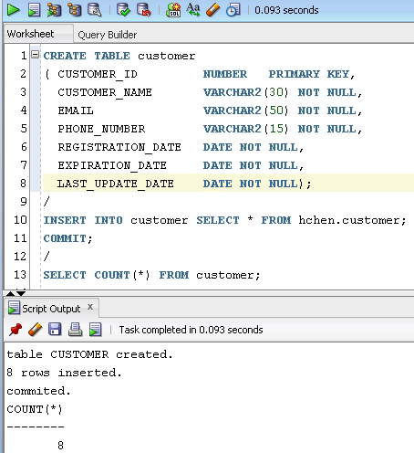

Please make sure that there are 8 rows in your customer table.

CREATE TABLE video

( VIDEO_ID NUMBER PRIMARY KEY,

VIDEO_NAME VARCHAR2(100) NOT NULL,

FORMAT VARCHAR2(100) NOT NULL,

PUBLISH_DATE DATE NOT NULL,

MAXIMUM_RENTAL_DAYS NUMBER(3) NOT NULL

);

/

INSERT INTO video SELECT * FROM **hchen**.video;

COMMIT;

/

SELECT COUNT(*) FROM video;

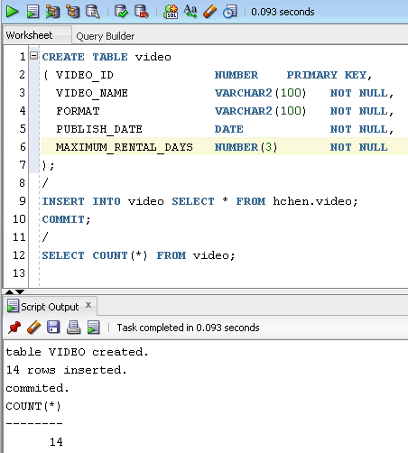

Please make sure that there are 14 rows in your video table.

CREATE TABLE video_copy

( COPY_ID NUMBER PRIMARY KEY,

VIDEO_ID NUMBER NOT NULL REFERENCES VIDEO (VIDEO_ID),

COPY_STATUS CHAR NOT NULL CONSTRAINT ck_item

CHECK (COPY_STATUS in ('A', 'R', 'D')),

NOTE VARCHAR2(200));

/

INSERT INTO video_copy SELECT * FROM **hchen**.video_copy;

COMMIT;

/

SELECT COUNT(*) FROM video_copy;

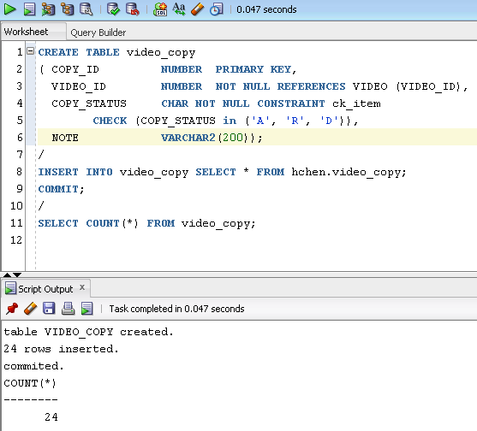

Please make sure that there are 24 rows in your video_copy table.

CREATE TABLE rental_history

( CUSTOMER_ID NUMBER REFERENCES CUSTOMER (CUSTOMER_ID),

COPY_ID NUMBER REFERENCES VIDEO_COPY (COPY_ID),

CHECKOUT_DATE DATE NOT NULL,

DUE_DATE DATE NOT NULL,

RETURN_DATE DATE,

NOTE VARCHAR2(200),

CONSTRAINT pk_rental PRIMARY KEY

(CUSTOMER_ID, COPY_ID, CHECKOUT_DATE));

/

INSERT INTO rental_history SELECT * FROM **hchen**.rental_history;

COMMIT;

/

SELECT COUNT(*) FROM rental_history;

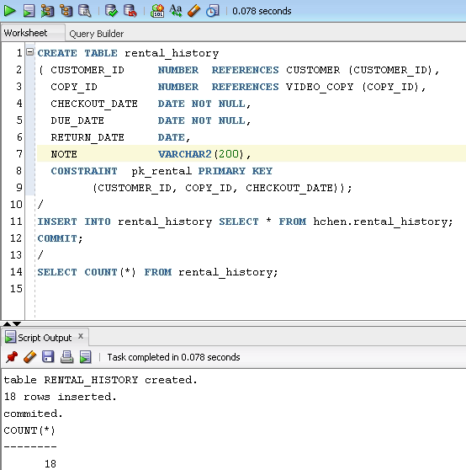

Please make sure that there are 18 rows in your video_copy table.

**Part 2) [260 Points]**

* You are not allowed to create temporary tables/views/triggers.
* You can only use the CUSTOMER, VIDEO, VIDEO_COPY, and RENTAL_HISTORY tables. You will get a zero point if you use a different table (e.g., different table names, column names, or data types).
* You cannot change the procedure headers. You will get a zero point if you use a different procedure header (e.g., different procedure names, parameter names, data types, or default values).

1) [0 Point] **– new_customer_registration()**

Create a procedure called new_customer_registrationto add a new customer to the CUSTOMER table.

**(You may use my example in your project.)**

The procedure header is

CREATE OR REPLACE PROCEDURE new_customer_registration

(

in_customer_id NUMBER,

in_customer_name VARCHAR2,

in_email VARCHAR2,

in_phone_number VARCHAR2,

in_registration_date DATE,

in_expiration_date DATE

)

Consider the following special cases:

* The in_customer_id is invalid.
* The in_customer_name is empty.
* The in_email is empty.
* The value of in_registration_date is greater than the current date.
* The value of in_registration_date is greater than the value of in_expiration_date.

**Example**

***CREATE OR REPLACE PROCEDURE new_customer_registration***

***(***

***in_customer_id NUMBER,***

***in_customer_name VARCHAR2,***

***in_email VARCHAR2,***

***in_phone_number VARCHAR2,***

***in_registration_date DATE,***

***in_expiration_date DATE)***

***IS***

***v_count NUMBER;***

***BEGIN***

***IF in_customer_id <= 0 THEN***

***DBMS_OUTPUT.PUT_LINE('Invalid customer ID!');***

***RETURN;***

***END IF;***

***SELECT COUNT(*)***

***INTO v_count***

***FROM customer***

***WHERE customer_id = in_customer_id;***

***IF v_count != 0 THEN***

***DBMS_OUTPUT.PUT_LINE('Invalid customer ID!');***

***RETURN;***

***END IF;***

***IF in_customer_name is NULL THEN***

***DBMS_OUTPUT.PUT_LINE('Invalid customer name!');***

***RETURN;***

***END IF;***

***IF in_email is NULL THEN***

***DBMS_OUTPUT.PUT_LINE('Invalid email address!');***

***RETURN;***

***END IF;***

***IF in_registration_date IS NULL OR***

***TO_CHAR(in_registration_date, 'yyyymmdd') >***

***TO_CHAR(sysdate, 'yyyymmdd') THEN***

***DBMS_OUTPUT.PUT_LINE('Invalid registration date!');***

***RETURN;***

***END IF;***

***IF in_expiration_date IS NULL OR***

***TO_CHAR(in_expiration_date, 'yyyymmdd') <***

***TO_CHAR(in_registration_date, 'yyyymmdd') THEN***

***DBMS_OUTPUT.PUT_LINE('Invalid expiration date!');***

***RETURN;***

***END IF;***

***INSERT INTO customer***

***VALUES(in_customer_id, UPPER(in_customer_name), in_email,***

***in_phone_number, in_registration_date, in_expiration_date,***

***sysdate);***

***COMMIT;***

***DBMS_OUTPUT.PUT_LINE***

***(INITCAP(in_customer_name) ||***

***' has been added into the customer table.');***

***EXCEPTION***

***WHEN OTHERS THEN***

***DBMS_OUTPUT.PUT_LINE('My exception: ' ||***

***TO_CHAR(SQLCODE) || ' ' || SQLERRM);***

***END;***

**Testing the procedure**

* EXEC new_customer_registration(2009, 'Adams', 'adams_1@yahoo.com', '3123621111', '02-OCT-2016', '01-OCT-2018')

Dbms Output: Adams has been added into the customer table.

* EXEC new_customer_registration(2010, '', 'ford1@yahoo.com',

'3123622222', '02-OCT-2016', '01-OCT-2018')

Dbms Output: Invalid customer name!

* ……

2) [CSC 352 - 25 points | CSC 452 – 15 points] **– reset_expiration_date()**

Create a procedure called reset_expiration_date to reset an existing customer’s expiration date.

The procedure header is

CREATE OR REPLACE PROCEDURE reset_expiration_date

(

in_customer_id NUMBER,

in_new_expiration_date DATE

)

You need to consider the following cases:

* The value of in_customer_id is not in the CUSTOMER_ID column of the CUSTOMER table.

Dbms Output: Invalid customer ID!

* The value of in_customer_id is in the CUSTOMER_ID column of the CUSTOMER table.
* Update the CUSTOMER table (the EXPIRATION_DATE and LAST_UPDATE_DATE columns).
* Dbms Output: The expiration date has been updated.

3) [CSC 352 – 90 points | CSC 452 - 70 points] **– video_search()**

Create a procedure called video_search to search a video and display the name, copy ID, format, and status of the video’s copies. In addition, the checkout dates and due dates are also displayed for unreturned copies. The damaged copies (COPY_STATUS = 'D') are excluded in your output. Sort your output by the video name (NAME) and then the copy ID (COPY_ID).

The video name is not case-sensitive (e.g., Ocean = ocean). The format of a video is not case-sensitive (e.g., DVD = dvd).

The procedure header is

CREATE OR REPLACE PROCEDURE video_search

(

in_video_name VARCHAR2,

in_format VARCHAR2 DEFAULT NULL

)

Hint: WHERE UPPER(video_name) like '%' || UPPER(in_video_name) || '%';

**Testing the procedure**

(If your output does not match mine EXACTLY, you will lose some points.)

* EXEC video_search('ocean')

Dbms Output:

***** 0 results found for ocean. *****

* EXEC video_search('PRETTY WOMAN', 'Blu-Ray')

Dbms Output:

***** 0 results found for PRETTY WOMAN (Blu-Ray). *****

* EXEC video_search('Pretty Woman')

Dbms Output:

***** 3 results found for Pretty Woman. (Available copies: 3) *****

VIDEO NAME COPY ID FORMAT COPY STATUS CHECKOUT DATE DUE DATE

---------------------------------------------------------------------------------------------

PRETTY WOMAN 6000 VHS TAPE Available

PRETTY WOMAN 6001 VHS TAPE Available

PRETTY WOMAN 6015 DVD Available

* EXEC video_search('Another')

Dbms Output:

***** 4 results found for Another. (Available copies: 2) *****

VIDEO NAME COPY ID FORMAT COPY STATUS CHECKOUT DATE DUE DATE

---------------------------------------------------------------------------------------------

DIE ANOTHER DAY 6010 VHS TAPE Available

DIE ANOTHER DAY 6011 VHS TAPE Rented 20-APR-2016 04-MAY-2016

DIE ANOTHER DAY 6014 DVD Available

DIE ANOTHER DAY 6016 BLU-RAY Rented 01-OCT-2016 04-OCT-2016

* EXEC video_search('ANOTHER', 'Dvd')

Dbms Output:

***** 1 result found for ANOTHER (Dvd). (Available copies: 1) *****

VIDEO NAME COPY ID FORMAT COPY STATUS CHECKOUT DATE DUE DATE

---------------------------------------------------------------------------------------------

DIE ANOTHER DAY 6014 DVD Available

* EXEC video_search('Story')

Dbms Output:

***** 7 results found for Story. (Available copies: 4) *****

VIDEO NAME COPY ID FORMAT COPY STATUS CHECKOUT DATE DUE DATE

---------------------------------------------------------------------------------------------

TOY STORY 6002 VHS TAPE Rented 09-APR-2016 23-APR-2016

TOY STORY 6003 VHS TAPE Available

TOY STORY 6017 DVD Rented 01-OCT-2016 08-OCT-2016

TOY STORY 2 6009 VHS TAPE Available

TOY STORY 2 6018 DVD Rented 28-APR-2016 05-MAY-2016

TOY STORY 2 6019 DVD Available

TOY STORY 2 6020 BLU-RAY Available

4) [CSC 352 – 75 points | CSC 452 - 65 Points] **–** **video_checkout()**

Create a procedure called video_checkout to record a new rental. When the video is successfully checked out, you need to insert a new row (record) into the RENTAL_HISTORY table and update the corresponding row (record) in the VIDEO_COPY table. Otherwise, the action is denied.

The procedure header is

CREATE OR REPLACE PROCEDURE video_checkout

(

in_customer_id NUMBER,

in_copy_id NUMBER,

in_video_checkout_date DATE

)

A customer whose expiration date is less than the current date (sysdate) is not able to make a rental.

Consider the following special cases:

* The value of in_customer_id is not in the CUSTOMER_ID column of the CUSTOMER table.
* The customer’s expiration date is less than the current date.
* The copy is not available (COPY_STATUS = 'R' or 'D').
* The value of in_video_checkout_date is greater than the current date.
* Checkout periods are determined by the values in the MAXIMUM_RENTAL_DAYS column. The due date is in_video_checkout_date plus the corresponding MAXIMUM_RENTAL_DAYS. Hard coding (e.g., 3, 7, or 14) is not allowed.
* A customer may have up to **eight (8)** copies checked out at any one time.

(For example, Tom has eight copies checked out; he cannot rent a copy before he returns one of the eight copies he checked out.)

* (**CSC 452 only**) Before a customer returns a copy, he/she cannot rent a second copy of the same video (**VIDEO_ID**).

(For example, Mary has the copy with ID 6000 (COPY_ID = **6000**) checked out. She cannot rent the copy with ID 6001 (COPY_ID = **6001**) before she returns the copy with ID 6000. The reason is that both copies have the same VIDEO_ID (VIDEO_ID = 1000, 'PRETTY WOMAN', 'VHS TAPE')).

**You need to create/run some test cases.**

5) [CSC 352 – 45 points | CSC 452 - 40 points] **–** **video_return()**

Create a procedure called video_return to change the rental status for that returned copy. When the copy is successfully checked in, you need to update the corresponding rows (records) in the RENTAL_HISTORY and VIDEO_COPY tables. Otherwise, the action is denied.

The procedure header is

CREATE OR REPLACE PROCEDURE video_return

(

in_copy_id NUMBER,

in_video_return_date DATE

)

Consider the following special cases:

* The value of in_copy_id does not exist in the corresponding column of the VIDEO_COPY table.
* The status of that copy is not “R” (COPY_STATUS != 'R').
* The value of in_video_return_date is greater than the current date.

**You need to create/run some test cases.**

6) [CSC 452 only - 45 points] - **print_unreturned_video()**

Create a procedure called print_unreturned_video to retrieve all the copies that a customer hasn't returned. The output should include the customer's ID, name, email, phone number, expiration date, first checkout date, last checkout date, the number of unreturned copies, video name, copy ID, format, checkout date, and due date of the rentals. Sort the data by due date and then the video name. The procedure header is

CREATE OR REPLACE PROCEDURE print_unreturned_video

(

in_customer_id NUMBER

)

**Testing the procedure**

(If your output does not match mine EXACTLY, you will lose some points.)

* EXEC print_unreturned_video(90)

Dbms Output:

The customer (id = 90) is not in the customer table.

* EXEC print_unreturned_video(2004)

Dbms Output:

----------------------------------------

Customer ID: 2004

Customer Name: JOHNSON

Email: jo12@gmail.com

Phone Number: 7732015678

Expiration Date: 21-APR-2017

First Checkout Date: 01-MAY-2015

Last Checkout Date: 01-MAY-2015

----------------------------------------

Number of Unreturned Videos: 0

----------------------------------------

* EXEC print_unreturned_video(2008)

Dbms Output:

----------------------------------------

Customer ID: 2008

Customer Name: SCOTT

Email: scott@hotmail.com

Phone Number: 7701239876

Expiration Date: 30-DEC-2011

First Checkout Date: N/A

Last Checkout Date: N/A

----------------------------------------

Number of Unreturned Videos: 0

----------------------------------------

* EXEC print_unreturned_video(2002)

Dbms Output:

----------------------------------------

Customer ID: 2002

Customer Name: JONES

Email: jones@hotmail.com

Phone Number: 6302077890

Expiration Date: 02-MAR-2017

First Checkout Date: 04-MAR-2015

Last Checkout Date: 01-OCT-2016

----------------------------------------

Number of Unreturned Videos: 3

----------------------------------------

Copy ID: 6007

Title: TARZAN

Format: VHS TAPE

Checkout Date: 22-APR-2016

Due Date: 06-MAY-2016

----------------------------------------

Copy ID: 6016

Title: DIE ANOTHER DAY

Format: BLU-RAY

Checkout Date: 01-OCT-2016

Due Date: 04-OCT-2016

----------------------------------------

Copy ID: 6017

Title: TOY STORY

Format: DVD

Checkout Date: 01-OCT-2016

Due Date: 08-OCT-2016

----------------------------------------

7) [CSC 352 - 25 points | CSC 452 – 25 points] **–** Package **video_rental_pkg**

Group all the above subprograms (new_ustomer_registration, reset_expiration_date, video_search, video_checkout …) together in a package (package specification and package body) called video_rental_pkg.

5 points - package specification

20 points - package body

You need to test your package.

Please submit a text file containing all the source codes to D2L before or on due date.