--生态监测员视图创建代码：
CREATE VIEW v_ecological_monitor AS
SELECT
mr.record_id,
sp.species_name_cn,
mr.monitor_time,
mr.monitor_lng,
mr.monitor_lat,
mr.monitor_content,
mr.data_status,
ai.area_name AS 区域名称,
COUNT(mr.record_id) OVER (PARTITION BY ai.area_name) AS 区域监测总数,
SUM(CASE WHEN mr.data_status = '待核实' THEN 1 ELSE 0 END) OVER (PARTITION BY ai.area_name) AS 待核实数
FROM tb_monitor_record mr
JOIN tb_species_info sp ON mr.species_id = sp.species_id
JOIN tb_monitor_device md ON mr.device_id = md.device_id
JOIN tb_area_info ai ON md.deploy_area_id = ai.area_id
JOIN tb_staff_info si ON mr.recorder_id = si.staff_id
WHERE
si.staff_role = '生态监测员' ;
GO

--生态监测员视图验证代码：
USE national_park_db;
GO
SELECT
record_id AS 监测记录编号,
species_name_cn AS 物种名称,
monitor_time AS 监测时间,
monitor_lng AS 监测经度,
monitor_lat AS 监测纬度,
monitor_content AS 监测内容,
data_status AS 数据状态,
区域名称,
区域监测总数,
待核实数
FROM v_ecological_monitor;
GO

SELECT
record_id AS 监测记录编号,
species_name_cn AS 物种名称,
monitor_time AS 监测时间,
data_status AS 数据状态,
区域名称,
待核实数
FROM v_ecological_monitor
WHERE data_status = '待核实'
ORDER BY monitor_time DESC;
GO
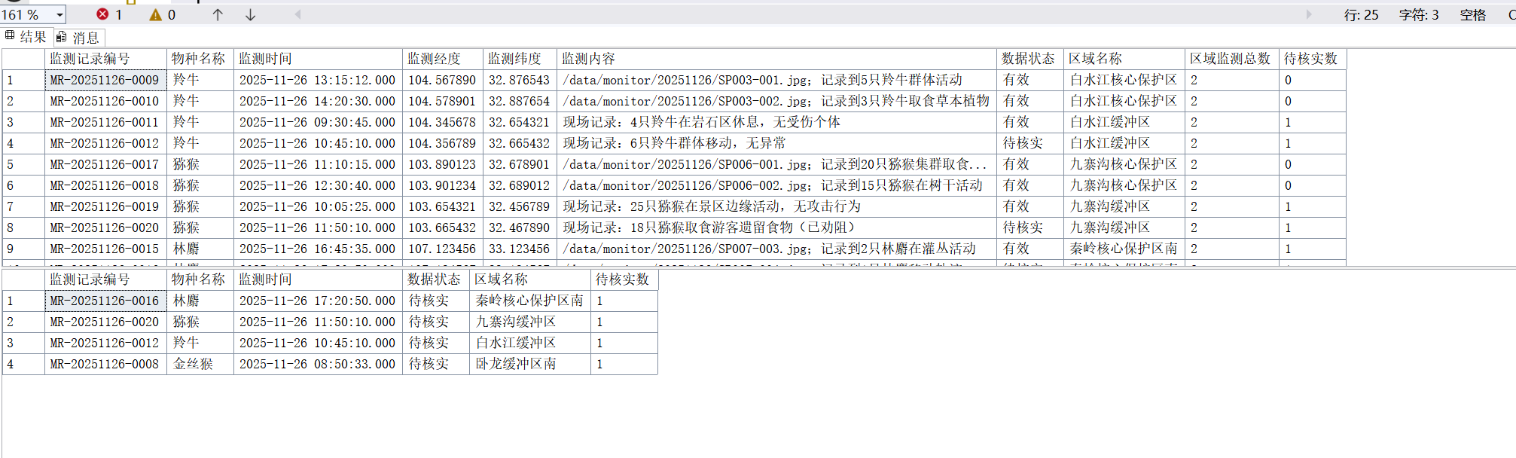
验证视图功能的截图

-- 物种区域分布统计视图
CREATE VIEW v_ecological_species_distribution AS
SELECT
sp.species_id AS 物种编号,
sp.species_name_cn AS 物种名称,
sp.protection_level AS 保护级别,
ai.area_name AS 监测区域,
COUNT(mr.record_id) AS 区域监测次数,
SUM(CASE WHEN mr.data_status = '有效' THEN 1 ELSE 0 END) AS 有效监测次数,
MAX(mr.monitor_time) AS 最新监测时间
FROM tb_species_info sp
JOIN tb_monitor_record mr ON sp.species_id = mr.species_id
JOIN tb_monitor_device md ON mr.device_id = md.device_id
JOIN tb_area_info ai ON md.deploy_area_id = ai.area_id
JOIN tb_staff_info si ON mr.recorder_id = si.staff_id
WHERE si.staff_role = '生态监测员'
GROUP BY
sp.species_id, sp.species_name_cn, sp.protection_level, ai.area_name;
GO

-- 物种区域分布统计视图验证代码
SELECT 物种名称, 保护级别, 监测区域, 区域监测次数
FROM v_ecological_species_distribution;

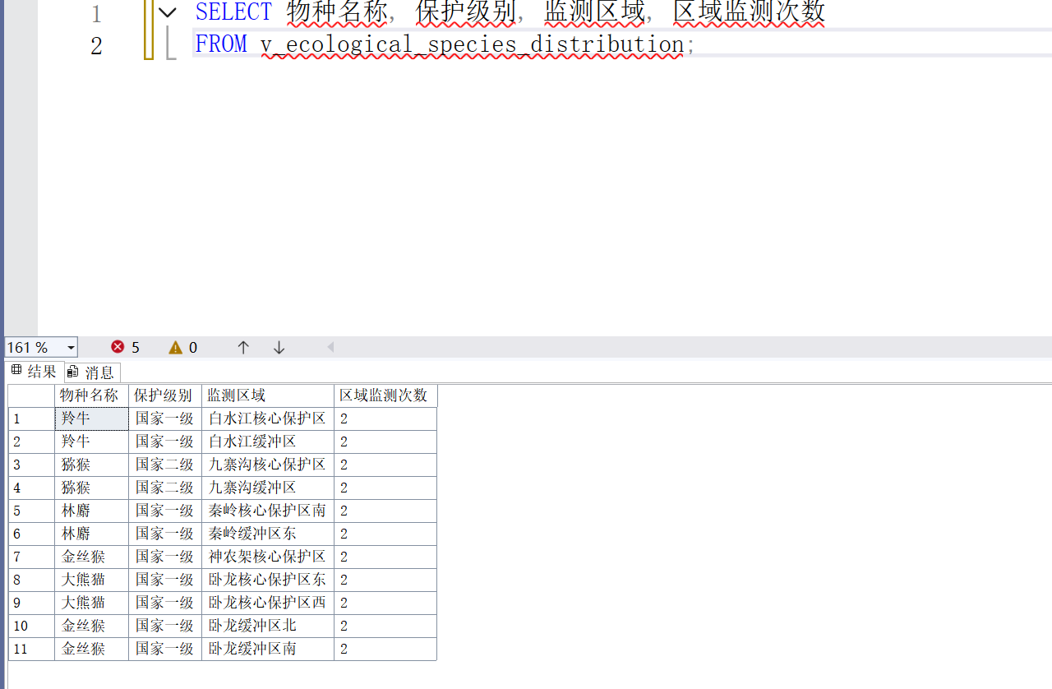
验证视图功能的截图

--监测员工作绩效视图创建代码
USE national_park_db;
GO

CREATE VIEW v_ecological_monitor_performance AS
SELECT
si.staff_id AS 监测员编号,
si.staff_name AS 监测员姓名,
si.department AS 所属部门,
si.contact_phone AS 联系电话,
COUNT(mr.record_id) AS 总监测记录数,
SUM(CASE WHEN mr.data_status = '有效' THEN 1 ELSE 0 END) AS 有效记录数,
-- 有效记录率：确保分母>0，保留2位小数
CASE
WHEN COUNT(mr.record_id) > 0
THEN ROUND(SUM(CASE WHEN mr.data_status = '有效' THEN 1 ELSE 0 END) * 100.0 / COUNT(mr.record_id), 2)
ELSE 0.00
END AS 有效记录率_,
SUM(CASE WHEN mr.data_status = '待核实' THEN 1 ELSE 0 END) AS 未处理待核实数,
SUM(CASE WHEN mr.data_status = '紧急核实' THEN 1 ELSE 0 END) AS 紧急待核实数,
MIN(mr.monitor_time) AS 最早监测时间,
MAX(mr.monitor_time) AS 最近监测时间,
-- 统计负责区域数：关联设备与区域，去重后计数
COUNT(DISTINCT ai.area_name) AS 负责区域数,
COUNT(DISTINCT sp.species_name_cn) AS 监测物种数
FROM tb_staff_info si
JOIN tb_monitor_record mr
ON si.staff_id = mr.recorder_id
JOIN tb_species_info sp
ON mr.species_id = sp.species_id
JOIN tb_monitor_device md
ON mr.device_id = md.device_id
JOIN tb_area_info ai
ON md.deploy_area_id = ai.area_id
WHERE si.staff_role = '生态监测员'
-- GROUP BY包含所有非聚合字段（si.staff_id为主键，其他字段与主键一一对应）
GROUP BY
si.staff_id, si.staff_name, si.department, si.contact_phone;
GO

-- 监测员工作绩效视图验证代码
SELECT 监测员姓名, 总监测记录数, 有效记录率_, 监测物种数
FROM v_ecological_monitor_performance;

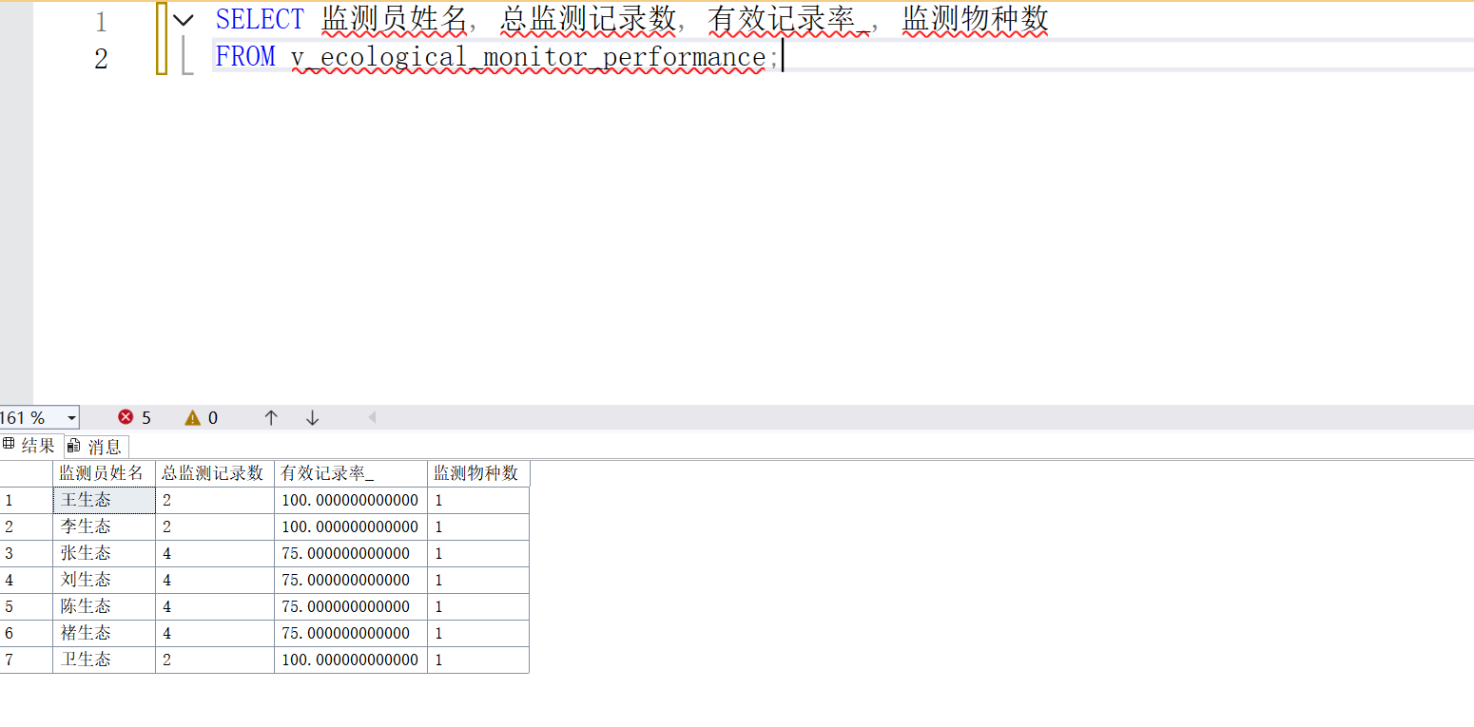
验证视图功能的截图

