技术人员视图创建代码
CREATE VIEW v_technician_comprehensive
AS
-- 整合监测设备状态、故障提醒、执法设备维护、数据采集效率
SELECT
-- 监测设备状态与维护字段
'monitor_device' AS 设备类型,
md.device_id AS 设备编号,
md.device_type AS 设备类别,
a.area_name AS 部署区域,
md.install_time AS 安装时间,
md.calibration_cycle AS 校准周期_天,
md.running_status AS 运行状态,
md.communication_protocol AS 通信协议,
DATEADD(DAY, md.calibration_cycle, md.install_time) AS 下次校准时间, -- SQL Server 日期加函数
COUNT(ed.data_id) AS 总采集数据量,
SUM(CASE WHEN ed.data_quality IN ('优','良') THEN 1 ELSE 0 END) AS 高质量数据量,
-- 处理无采集数据的情况，避免除以0错误
CONCAT(
ROUND(
CASE WHEN COUNT(ed.data_id) = 0 THEN 0
ELSE SUM(CASE WHEN ed.data_quality IN ('优','良') THEN 1 ELSE 0 END) * 1.0 / COUNT(ed.data_id) * 100
END,
2
),
'%'
) AS 高质量数据占比,
'' AS 执法设备专属字段_上次校验时间
FROM
tb_monitor_device md
LEFT JOIN tb_area_info a ON md.deploy_area_id = a.area_id
LEFT JOIN tb_environment_data ed ON md.device_id = ed.device_id
GROUP BY
md.device_id, md.device_type, a.area_name, md.install_time,
md.calibration_cycle, md.running_status, md.communication_protocol

UNION ALL

SELECT
-- 执法设备状态字段
'law_enforce_device' AS 设备类型,
led.device_id AS 设备编号,
led.device_type AS 设备类别,
'' AS 部署区域, -- 执法设备无部署区域字段，统一结构
CAST('' AS DATE) AS 安装时间, -- 统一日期类型
CAST('' AS INT) AS 校准周期_天, -- 统一数值类型
led.device_status AS 运行状态,
'' AS 通信协议, -- 执法设备无通信协议字段，统一结构
CAST('' AS DATE) AS 下次校准时间,
0 AS 总采集数据量, -- 执法设备无数据采集量字段，统一结构
0 AS 高质量数据量,
'N/A' AS 高质量数据占比,
CONVERT(VARCHAR(10), led.last_check_time, 23) AS 执法设备专属字段_上次校验时间 -- 格式化日期
FROM
tb_law_enforce_device led;
技术人员视图查询代码
-- 场景1：查询故障/离线设备及关联数据（优先处理核心区域设备）
SELECT
设备编号,
设备类别,
部署区域,
运行状态,
总采集数据量
FROM v_technician_comprehensive
WHERE 运行状态 IN ('故障', '离线')
ORDER BY
CASE WHEN 部署区域 LIKE '%核心保护区%' THEN 1 ELSE 2 END, -- 核心区域设备优先
设备类型;

-- 场景2：查询7天内需校准的监测设备（按校准时间正序，优先处理临近到期设备）
SELECT
设备编号,
设备类别,
部署区域,
下次校准时间,
运行状态
FROM v_technician_comprehensive
WHERE 设备类型 = 'monitor_device'
AND 下次校准时间 <= DATEADD(DAY, 7, GETDATE())
ORDER BY 下次校准时间 ASC;

-- 场景3：分析低效率数据采集设备（高质量数据占比<80%）
SELECT
设备编号,
设备类别,
部署区域,
总采集数据量,
高质量数据占比
FROM v_technician_comprehensive
WHERE 设备类型 = 'monitor_device'
AND 高质量数据占比 != 'N/A'
-- 提取百分比数值并转换为decimal
AND CAST(SUBSTRING(高质量数据占比, 1, CHARINDEX('%', 高质量数据占比) - 1) AS DECIMAL(5,2)) < 80
ORDER BY CAST(SUBSTRING(高质量数据占比, 1, CHARINDEX('%', 高质量数据占比) - 1) AS DECIMAL(5,2)) ASC;

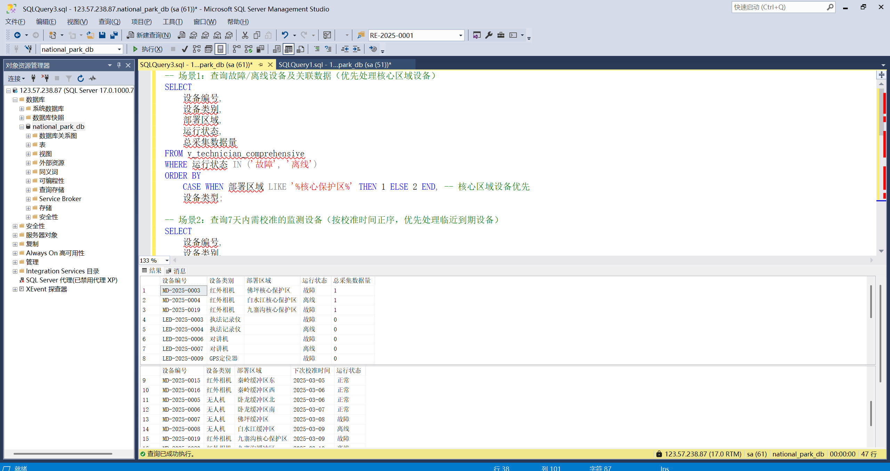
查询结果截图

数据分析师视图创建代码
CREATE VIEW v_data_analyst_comprehensive
AS
-- 1. 生物多样性监测数据审核分支
SELECT
'biodiversity' AS 数据类型,
mr.record_id AS 核心编号,
si.species_name_cn AS 物种名称,
mr.monitor_time AS 监测_采集时间,
mr.monitor_method AS 监测方式,
mr.monitor_content AS 监测内容,
mr.data_status AS 数据状态,
s.staff_name AS 记录人,
a1.area_name AS 关联区域,
'' AS 监测指标,
CAST(NULL AS DECIMAL(10,2)) AS 监测值,
CAST(NULL AS DECIMAL(10,2)) AS 阈值上限,
CAST(NULL AS DECIMAL(10,2)) AS 阈值下限,
'' AS 数据质量,
mi.index_id AS 指标编号,
'' AS 计量单位,
'' AS 监测频率
FROM tb_monitor_record mr
LEFT JOIN tb_species_info si ON mr.species_id = si.species_id
LEFT JOIN tb_staff_info s ON mr.recorder_id = s.staff_id
LEFT JOIN tb_area_info a1 ON EXISTS (
SELECT 1 FROM tb_monitor_device md
WHERE md.device_id = mr.device_id AND md.deploy_area_id = a1.area_id
)
LEFT JOIN tb_monitor_index mi ON 1=0

UNION ALL

-- 2. 生态环境正常数据分支
SELECT
'environment_normal' AS 数据类型,
ed.data_id AS 核心编号,
'' AS 物种名称,
ed.collect_time AS 监测_采集时间,
'' AS 监测方式,
'' AS 监测内容,
'' AS 数据状态,
'' AS 记录人,
a2.area_name AS 关联区域,
mi.index_name AS 监测指标,
ed.monitor_value AS 监测值,
mi.standard_upper AS 阈值上限,
mi.standard_lower AS 阈值下限,
ed.data_quality AS 数据质量,
mi.index_id AS 指标编号,
mi.unit AS 计量单位,
mi.monitor_frequency AS 监测频率
FROM tb_environment_data ed
LEFT JOIN tb_monitor_index mi ON ed.index_id = mi.index_id
LEFT JOIN tb_area_info a2 ON ed.area_id = a2.area_id
WHERE (ed.monitor_value BETWEEN ISNULL(mi.standard_lower, 0) AND ISNULL(mi.standard_upper, 9999))
AND (mi.standard_upper IS NOT NULL OR mi.standard_lower IS NOT NULL)

UNION ALL

-- 3. 监测指标阈值管理分支
SELECT
'index_management' AS 数据类型,
mi.index_id AS 核心编号,
'' AS 物种名称,
CAST(NULL AS DATETIME) AS 监测_采集时间,
'' AS 监测方式,
'' AS 监测内容,
'' AS 数据状态,
'' AS 记录人,
'' AS 关联区域,
mi.index_name AS 监测指标,
CAST(NULL AS DECIMAL(10,2)) AS 监测值,
mi.standard_upper AS 阈值上限,
mi.standard_lower AS 阈值下限,
'' AS 数据质量,
mi.index_id AS 指标编号,
mi.unit AS 计量单位,
mi.monitor_frequency AS 监测频率
FROM tb_monitor_index mi;
数据分析师视图查询代码
-- 场景1：审核生物多样性待核实数据
SELECT
数据类型, 核心编号, 物种名称, 监测_采集时间,
监测方式, 数据状态, 记录人, 关联区域
FROM v_data_analyst_comprehensive
WHERE 数据类型 = 'biodiversity'
AND 数据状态 = '待核实'
ORDER BY 监测_采集时间 DESC;

-- 场景2：分析核心保护区近30天的环境数据
SELECT
监测指标, 关联区域, 监测值, 阈值上限, 阈值下限,
监测_采集时间, 数据质量
FROM v_data_analyst_comprehensive
WHERE 数据类型 = 'environment_normal'
AND 关联区域 LIKE '%核心保护区%'
AND 监测_采集时间 >= DATEADD(DAY, -30, GETDATE())
ORDER BY 监测_采集时间;

-- 场景3：查询需调整阈值的监测指标（近30天数据）
WITH index_avg AS (
SELECT
监测指标, 指标编号,
AVG(监测值) AS 近30天均值
FROM v_data_analyst_comprehensive
WHERE 数据类型 = 'environment_normal'
AND 监测_采集时间 >= DATEADD(DAY, -30, GETDATE())
AND 监测值 IS NOT NULL
GROUP BY 监测指标, 指标编号
)
SELECT
i.监测指标, i.阈值上限, i.阈值下限,
a.近30天均值,
CASE
WHEN a.近30天均值 > i.阈值上限 THEN '需提高上限'
WHEN a.近30天均值 < i.阈值下限 THEN '需降低下限'
ELSE '无需调整'
END AS 阈值调整建议
FROM v_data_analyst_comprehensive i
JOIN index_avg a ON i.指标编号 = a.指标编号
WHERE i.数据类型 = 'index_management'
AND (i.阈值上限 IS NOT NULL OR i.阈值下限 IS NOT NULL);

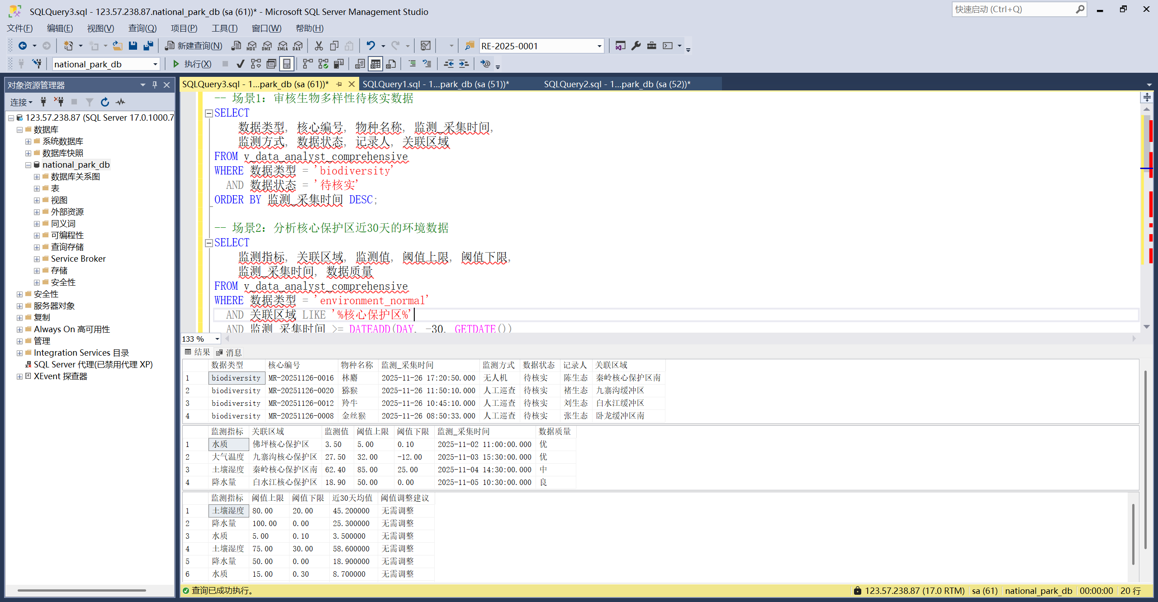
查询结果截图

科研人员视图创建代码
DROP VIEW IF EXISTS v_env_researcher; -- 视图5：科研人员专用
GO

USE national_park_db;
GO
-- ==============================================
-- 【视图5：生态环境监测业务线-科研人员专用】v_env_researcher
-- 角色：科研人员 | 核心需求：长期趋势、多指标关联、实验区域对比
-- ==============================================
CREATE VIEW v_env_researcher AS
SELECT
ai.area_name AS 实验区域,
ai.area_level AS 区域级别,
mi.index_name AS 监测指标,
-- 统计近6个月的指标均值（科研趋势分析）
AVG(ed.monitor_value) AS 近6月均值,
MAX(ed.monitor_value) AS 近6月最大值,
MIN(ed.monitor_value) AS 近6月最小值,
-- 关联实验设备信息
md.device_type AS 监测设备类型,
-- 标记是否为实验区域（科研重点）
CASE WHEN ai.area_name LIKE '%实验区%' THEN '是' ELSE '否' END AS 是否实验区域,
-- 数据采集周期（辅助实验设计）
DATEDIFF(DAY, MIN(ed.collect_time), MAX(ed.collect_time)) AS 数据采集周期_天
FROM tb_environment_data ed
JOIN tb_monitor_index mi ON ed.index_id = mi.index_id
JOIN tb_area_info ai ON ed.area_id = ai.area_id
JOIN tb_monitor_device md ON ed.device_id = md.device_id
-- 科研需求：近6个月数据（长期趋势）
WHERE ed.collect_time >= DATEADD(MONTH, -6, GETDATE())
-- 按区域+指标分组（科研多维度对比）
GROUP BY ai.area_name, ai.area_level, mi.index_name, md.device_type;
GO
科研人员视图查询代码
-- 视图5（科研人员）测试：实验区域多指标趋势对比
SELECT
实验区域,
监测指标,
近6月均值,
近6月最大值,
是否实验区域,
数据采集周期_天
FROM v_env_researcher
WHERE 是否实验区域 = '是' -- 科研重点关注实验区
ORDER BY 实验区域, 监测指标;
GO
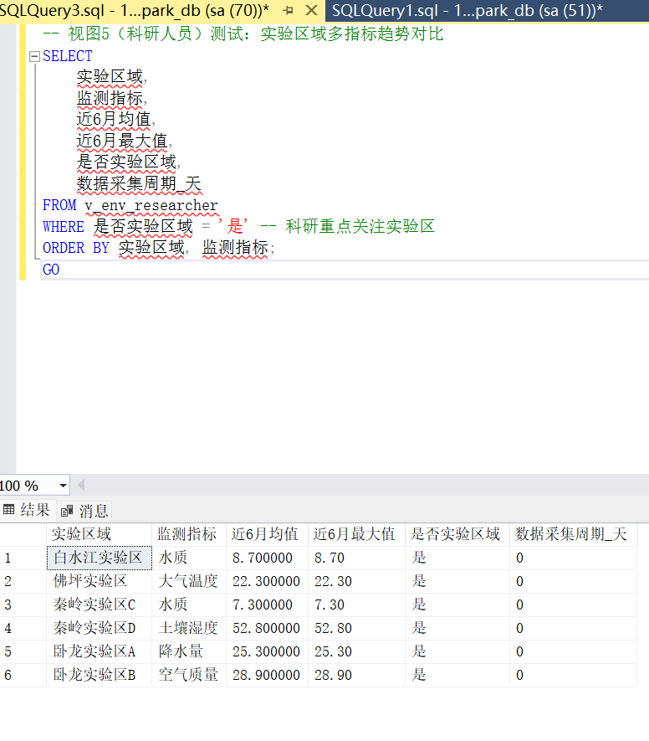
查询结果截图

