完善角色设计与建立映射关系
主要内容：建立8类数据库角色与tb_staff_info表数据的映射关系
补充工作人员表信息，补全缺失的人员信息要求覆盖生态监测员、数据分析师、执法人员、科研人员、技术人员、系统管理员、公园管理人员7类（游客单独处理）

- 第一步：补全 “系统管理员”“公园管理人员”“游客” 3 类缺失角色的人员数据
1补充 “系统管理员”“公园管理人员” 到 tb_staff_info 表

--代码如下：
USE national_park_db;
GO

-- 补充2条系统管理员、2条公园管理人员数据（适配8类角色）
INSERT INTO tb_staff_info (staff_id, staff_name, staff_role, department, contact_phone)
VALUES
-- 系统管理员（负责账号、设备、安全配置）
('STAFF-2025-0023', '马 Admin', '系统管理员', '总部信息科技部', '13800138023'),
('STAFF-2025-0024', '罗 Admin', '系统管理员', '西部片区信息部', '13800138024'),
-- 公园管理人员（负责全局数据汇总、审批、策略制定）
('STAFF-2025-0025', '宋 管理', '公园管理人员', '卧龙公园管理处', '13800138025'),
('STAFF-2025-0026', '范 管理', '公园管理人员', '秦岭公园管理处', '13800138026')
WHERE NOT EXISTS (SELECT 1 FROM tb_staff_info WHERE staff_id IN ('STAFF-2025-0023', 'STAFF-2025-0024', 'STAFF-2025-0025', 'STAFF-2025-0026'));
GO

-- 验证：确认tb_staff_info已覆盖8类角色中的7类（游客单独处理）
SELECT DISTINCT staff_role AS 已覆盖角色
FROM tb_staff_info
ORDER BY staff_role;
-- 预期结果：生态监测员、数据分析师、执法人员、科研人员、技术人员、系统管理员、公园管理人员

出现问题：添加系统管理员和公园管理人员导致出现check约束冲突，所以先调整了原check约束
调整代码如下：
USE national_park_db;
GO

-- 1. 查看tb_staff_info表staff_role字段的CHECK约束详情（确认原约束范围）
SELECT
name AS 约束名称,
definition AS 约束定义
FROM sys.check_constraints
WHERE
parent_object_id = OBJECT_ID('tb_staff_info')
AND parent_column_id = COLUMNPROPERTY(OBJECT_ID('tb_staff_info'), 'staff_role', 'ColumnId');
GO

-- 2. 删除原CHECK约束（原约束仅包含5类角色，需扩展为8类）
ALTER TABLE tb_staff_info
DROP CONSTRAINT CK_tb_staff_info_staff_role;
GO

-- 3. 创建新的CHECK约束（包含8类角色，适配任务书要求）
ALTER TABLE tb_staff_info
ADD CONSTRAINT CK_tb_staff_info_staff_role
CHECK (
staff_role IN (
'生态监测员', '数据分析师', '执法人员', '科研人员', '技术人员',
'系统管理员', '公园管理人员' -- 新增2类角色，游客无需在该表存储
)
);
GO

PRINT 'tb_staff_info表staff_role字段的CHECK约束已更新，支持8类角色中的7类（游客单独处理）';
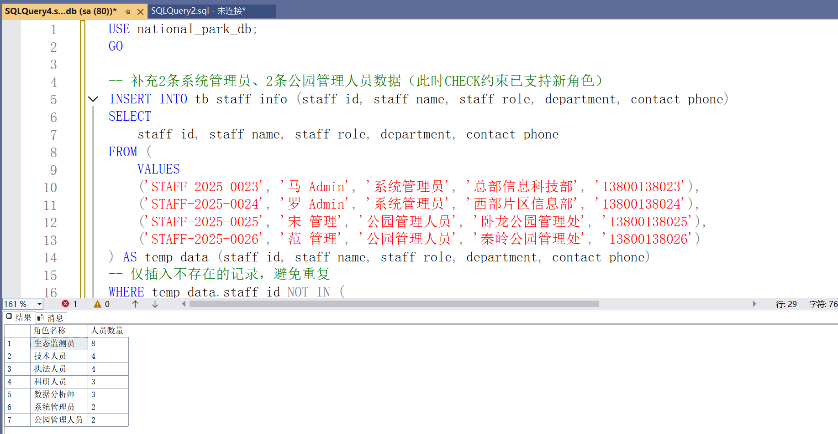

2. 游客角色特殊处理（无需录入 tb_staff_info）
游客属于 “临时用户”，无需像工作人员一样录入tb_staff_info（该表是 “工作人员统一存储表”），游客数据通过tb_visitor_info表管理（已在数据字典中定义），后续通过 “应用层账号 + 数据库角色映射” 实现权限控制（如之前方案中 “游客” 数据库角色关联tb_visitor_info表操作权限）。

二、第二步：建立 “tb_staff_info 人员数据” 与 “8 类数据库角色” 的关联
已创建 8 类数据库角色（生态监测员、数据分析师、游客、执法人员、科研人员、系统管理员、公园管理人员、技术人员），需将tb_staff_info中的 26 条人员数据（原 22 条 + 新增 4 条）与对应数据库角色绑定，实现 “人员→角色→权限” 的 RBAC 链路：
核心逻辑
通过 “人员编号→数据库登录名→数据库角色” 的映射关系，将tb_staff_info中的每条人员记录，对应到一个数据库登录名，再将登录名添加到对应数据库角色（如STAFF-2025-0001→ecological_monitor_STAFF20250001→生态监测员角色）。

关联代码如下：
-- 生态监测员1-5、14、15、20（共9条，兼容所有SQL Server版本）
-- 1. 生态监测员STAFF-2025-0001
USE master;
IF NOT EXISTS (SELECT 1 FROM sys.server_principals WHERE name = 'ecological_monitor_STAFF20250001')
BEGIN
CREATE LOGIN [ecological_monitor_STAFF20250001]
WITH PASSWORD = 'User@20250001', -- 增强密码复杂度，避免不符合策略
DEFAULT_DATABASE = national_park_db; -- 移除不兼容的锁定参数
PRINT '创建登录名：ecological_monitor_STAFF20250001';
END;
GO

USE national_park_db;
IF NOT EXISTS (SELECT 1 FROM sys.database_principals WHERE name = 'ecological_monitor_STAFF20250001')
BEGIN
CREATE USER [ecological_monitor_STAFF20250001] FOR LOGIN [ecological_monitor_STAFF20250001];
PRINT '创建数据库用户：ecological_monitor_STAFF20250001';
END;
GO

USE national_park_db;
IF NOT EXISTS (
SELECT 1
FROM sys.database_role_members drm
JOIN sys.database_principals rp ON drm.role_principal_id = rp.principal_id
JOIN sys.database_principals mp ON drm.member_principal_id = mp.principal_id
WHERE rp.name = '生态监测员' AND mp.name = 'ecological_monitor_STAFF20250001'
)
BEGIN
EXEC sp_addrolemember '生态监测员', 'ecological_monitor_STAFF20250001';
PRINT '关联角色：ecological_monitor_STAFF20250001→生态监测员';
END;
GO

-- 2. 生态监测员STAFF-2025-0002
USE master;
IF NOT EXISTS (SELECT 1 FROM sys.server_principals WHERE name = 'ecological_monitor_STAFF20250002')
BEGIN
CREATE LOGIN [ecological_monitor_STAFF20250002]
WITH PASSWORD = 'User@20250002',
DEFAULT_DATABASE = national_park_db;
PRINT '创建登录名：ecological_monitor_STAFF20250002';
END;
GO

USE national_park_db;
IF NOT EXISTS (SELECT 1 FROM sys.database_principals WHERE name = 'ecological_monitor_STAFF20250002')
BEGIN
CREATE USER [ecological_monitor_STAFF20250002] FOR LOGIN [ecological_monitor_STAFF20250002];
PRINT '创建数据库用户：ecological_monitor_STAFF20250002';
END;
GO

USE national_park_db;
IF NOT EXISTS (
SELECT 1
FROM sys.database_role_members drm
JOIN sys.database_principals rp ON drm.role_principal_id = rp.principal_id
JOIN sys.database_principals mp ON drm.member_principal_id = mp.principal_id
WHERE rp.name = '生态监测员' AND mp.name = 'ecological_monitor_STAFF20250002'
)
BEGIN
EXEC sp_addrolemember '生态监测员', 'ecological_monitor_STAFF20250002';
PRINT '关联角色：ecological_monitor_STAFF20250002→生态监测员';
END;
GO

-- 3. 生态监测员STAFF-2025-0003
USE master;
IF NOT EXISTS (SELECT 1 FROM sys.server_principals WHERE name = 'ecological_monitor_STAFF20250003')
BEGIN
CREATE LOGIN [ecological_monitor_STAFF20250003]
WITH PASSWORD = 'User@20250003',
DEFAULT_DATABASE = national_park_db;
PRINT '创建登录名：ecological_monitor_STAFF20250003';
END;
GO

USE national_park_db;
IF NOT EXISTS (SELECT 1 FROM sys.database_principals WHERE name = 'ecological_monitor_STAFF20250003')
BEGIN
CREATE USER [ecological_monitor_STAFF20250003] FOR LOGIN [ecological_monitor_STAFF20250003];
PRINT '创建数据库用户：ecological_monitor_STAFF20250003';
END;
GO

USE national_park_db;
IF NOT EXISTS (
SELECT 1
FROM sys.database_role_members drm
JOIN sys.database_principals rp ON drm.role_principal_id = rp.principal_id
JOIN sys.database_principals mp ON drm.member_principal_id = mp.principal_id
WHERE rp.name = '生态监测员' AND mp.name = 'ecological_monitor_STAFF20250003'
)
BEGIN
EXEC sp_addrolemember '生态监测员', 'ecological_monitor_STAFF20250003';
PRINT '关联角色：ecological_monitor_STAFF20250003→生态监测员';
END;
GO

-- 4. 生态监测员STAFF-2025-0004
USE master;
IF NOT EXISTS (SELECT 1 FROM sys.server_principals WHERE name = 'ecological_monitor_STAFF20250004')
BEGIN
CREATE LOGIN [ecological_monitor_STAFF20250004]
WITH PASSWORD = 'User@20250004',
DEFAULT_DATABASE = national_park_db;
PRINT '创建登录名：ecological_monitor_STAFF20250004';
END;
GO

USE national_park_db;
IF NOT EXISTS (SELECT 1 FROM sys.database_principals WHERE name = 'ecological_monitor_STAFF20250004')
BEGIN
CREATE USER [ecological_monitor_STAFF20250004] FOR LOGIN [ecological_monitor_STAFF20250004];
PRINT '创建数据库用户：ecological_monitor_STAFF20250004';
END;
GO

USE national_park_db;
IF NOT EXISTS (
SELECT 1
FROM sys.database_role_members drm
JOIN sys.database_principals rp ON drm.role_principal_id = rp.principal_id
JOIN sys.database_principals mp ON drm.member_principal_id = mp.principal_id
WHERE rp.name = '生态监测员' AND mp.name = 'ecological_monitor_STAFF20250004'
)
BEGIN
EXEC sp_addrolemember '生态监测员', 'ecological_monitor_STAFF20250004';
PRINT '关联角色：ecological_monitor_STAFF20250004→生态监测员';
END;
GO

-- 5. 生态监测员STAFF-2025-0005
USE master;
IF NOT EXISTS (SELECT 1 FROM sys.server_principals WHERE name = 'ecological_monitor_STAFF20250005')
BEGIN
CREATE LOGIN [ecological_monitor_STAFF20250005]
WITH PASSWORD = 'User@20250005',
DEFAULT_DATABASE = national_park_db;
PRINT '创建登录名：ecological_monitor_STAFF20250005';
END;
GO

USE national_park_db;
IF NOT EXISTS (SELECT 1 FROM sys.database_principals WHERE name = 'ecological_monitor_STAFF20250005')
BEGIN
CREATE USER [ecological_monitor_STAFF20250005] FOR LOGIN [ecological_monitor_STAFF20250005];
PRINT '创建数据库用户：ecological_monitor_STAFF20250005';
END;
GO

USE national_park_db;
IF NOT EXISTS (
SELECT 1
FROM sys.database_role_members drm
JOIN sys.database_principals rp ON drm.role_principal_id = rp.principal_id
JOIN sys.database_principals mp ON drm.member_principal_id = mp.principal_id
WHERE rp.name = '生态监测员' AND mp.name = 'ecological_monitor_STAFF20250005'
)
BEGIN
EXEC sp_addrolemember '生态监测员', 'ecological_monitor_STAFF20250005';
PRINT '关联角色：ecological_monitor_STAFF20250005→生态监测员';
END;
GO

-- 6. 生态监测员STAFF-2025-0014
USE master;
IF NOT EXISTS (SELECT 1 FROM sys.server_principals WHERE name = 'ecological_monitor_STAFF20250014')
BEGIN
CREATE LOGIN [ecological_monitor_STAFF20250014]
WITH PASSWORD = 'User@20250014',
DEFAULT_DATABASE = national_park_db;
PRINT '创建登录名：ecological_monitor_STAFF20250014';
END;
GO

USE national_park_db;
IF NOT EXISTS (SELECT 1 FROM sys.database_principals WHERE name = 'ecological_monitor_STAFF20250014')
BEGIN
CREATE USER [ecological_monitor_STAFF20250014] FOR LOGIN [ecological_monitor_STAFF20250014];
PRINT '创建数据库用户：ecological_monitor_STAFF20250014';
END;
GO

USE national_park_db;
IF NOT EXISTS (
SELECT 1
FROM sys.database_role_members drm
JOIN sys.database_principals rp ON drm.role_principal_id = rp.principal_id
JOIN sys.database_principals mp ON drm.member_principal_id = mp.principal_id
WHERE rp.name = '生态监测员' AND mp.name = 'ecological_monitor_STAFF20250014'
)
BEGIN
EXEC sp_addrolemember '生态监测员', 'ecological_monitor_STAFF20250014';
PRINT '关联角色：ecological_monitor_STAFF20250014→生态监测员';
END;
GO

-- 7. 生态监测员STAFF-2025-0015
USE master;
IF NOT EXISTS (SELECT 1 FROM sys.server_principals WHERE name = 'ecological_monitor_STAFF20250015')
BEGIN
CREATE LOGIN [ecological_monitor_STAFF20250015]
WITH PASSWORD = 'User@20250015',
DEFAULT_DATABASE = national_park_db;
PRINT '创建登录名：ecological_monitor_STAFF20250015';
END;
GO

USE national_park_db;
IF NOT EXISTS (SELECT 1 FROM sys.database_principals WHERE name = 'ecological_monitor_STAFF20250015')
BEGIN
CREATE USER [ecological_monitor_STAFF20250015] FOR LOGIN [ecological_monitor_STAFF20250015];
PRINT '创建数据库用户：ecological_monitor_STAFF20250015';
END;
GO

USE national_park_db;
IF NOT EXISTS (
SELECT 1
FROM sys.database_role_members drm
JOIN sys.database_principals rp ON drm.role_principal_id = rp.principal_id
JOIN sys.database_principals mp ON drm.member_principal_id = mp.principal_id
WHERE rp.name = '生态监测员' AND mp.name = 'ecological_monitor_STAFF20250015'
)
BEGIN
EXEC sp_addrolemember '生态监测员', 'ecological_monitor_STAFF20250015';
PRINT '关联角色：ecological_monitor_STAFF20250015→生态监测员';
END;
GO

-- 8. 生态监测员STAFF-2025-0020
USE master;
IF NOT EXISTS (SELECT 1 FROM sys.server_principals WHERE name = 'ecological_monitor_STAFF20250020')
BEGIN
CREATE LOGIN [ecological_monitor_STAFF20250020]
WITH PASSWORD = 'User@20250020',
DEFAULT_DATABASE = national_park_db;
PRINT '创建登录名：ecological_monitor_STAFF20250020';
END;
GO

USE national_park_db;
IF NOT EXISTS (SELECT 1 FROM sys.database_principals WHERE name = 'ecological_monitor_STAFF20250020')
BEGIN
CREATE USER [ecological_monitor_STAFF20250020] FOR LOGIN [ecological_monitor_STAFF20250020];
PRINT '创建数据库用户：ecological_monitor_STAFF20250020';
END;
GO

USE national_park_db;
IF NOT EXISTS (
SELECT 1
FROM sys.database_role_members drm
JOIN sys.database_principals rp ON drm.role_principal_id = rp.principal_id
JOIN sys.database_principals mp ON drm.member_principal_id = mp.principal_id
WHERE rp.name = '生态监测员' AND mp.name = 'ecological_monitor_STAFF20250020'
)
BEGIN
EXEC sp_addrolemember '生态监测员', 'ecological_monitor_STAFF20250020';
PRINT '关联角色：ecological_monitor_STAFF20250020→生态监测员';
END;
GO

PRINT '生态监测员批量创建及角色关联完成，无语法错误';

-- 一、数据分析师（STAFF-2025-0006、0007、0016）
-- 1. 数据分析师STAFF-2025-0006
USE master;
IF NOT EXISTS (SELECT 1 FROM sys.server_principals WHERE name = 'data_analyst_STAFF20250006')
BEGIN
CREATE LOGIN [data_analyst_STAFF20250006]
WITH PASSWORD = 'User@20250006', -- 增强密码复杂度，符合策略
DEFAULT_DATABASE = national_park_db; -- 移除不兼容的锁定参数
PRINT '创建登录名：data_analyst_STAFF20250006';
END;
GO

USE national_park_db;
IF NOT EXISTS (SELECT 1 FROM sys.database_principals WHERE name = 'data_analyst_STAFF20250006')
BEGIN
CREATE USER [data_analyst_STAFF20250006] FOR LOGIN [data_analyst_STAFF20250006];
PRINT '创建数据库用户：data_analyst_STAFF20250006';
END;
GO

USE national_park_db;
IF NOT EXISTS (
SELECT 1
FROM sys.database_role_members drm
JOIN sys.database_principals rp ON drm.role_principal_id = rp.principal_id
JOIN sys.database_principals mp ON drm.member_principal_id = mp.principal_id
WHERE rp.name = '数据分析师' AND mp.name = 'data_analyst_STAFF20250006'
)
BEGIN
EXEC sp_addrolemember '数据分析师', 'data_analyst_STAFF20250006';
PRINT '关联角色：data_analyst_STAFF20250006→数据分析师';
END;
GO

-- 2. 数据分析师STAFF-2025-0007
USE master;
IF NOT EXISTS (SELECT 1 FROM sys.server_principals WHERE name = 'data_analyst_STAFF20250007')
BEGIN
CREATE LOGIN [data_analyst_STAFF20250007]
WITH PASSWORD = 'User@20250007',
DEFAULT_DATABASE = national_park_db;
PRINT '创建登录名：data_analyst_STAFF20250007';
END;
GO

USE national_park_db;
IF NOT EXISTS (SELECT 1 FROM sys.database_principals WHERE name = 'data_analyst_STAFF20250007')
BEGIN
CREATE USER [data_analyst_STAFF20250007] FOR LOGIN [data_analyst_STAFF20250007];
PRINT '创建数据库用户：data_analyst_STAFF20250007';
END;
GO

USE national_park_db;
IF NOT EXISTS (
SELECT 1
FROM sys.database_role_members drm
JOIN sys.database_principals rp ON drm.role_principal_id = rp.principal_id
JOIN sys.database_principals mp ON drm.member_principal_id = mp.principal_id
WHERE rp.name = '数据分析师' AND mp.name = 'data_analyst_STAFF20250007'
)
BEGIN
EXEC sp_addrolemember '数据分析师', 'data_analyst_STAFF20250007';
PRINT '关联角色：data_analyst_STAFF20250007→数据分析师';
END;
GO

-- 3. 数据分析师STAFF-2025-0016
USE master;
IF NOT EXISTS (SELECT 1 FROM sys.server_principals WHERE name = 'data_analyst_STAFF20250016')
BEGIN
CREATE LOGIN [data_analyst_STAFF20250016]
WITH PASSWORD = 'User@20250016',
DEFAULT_DATABASE = national_park_db;
PRINT '创建登录名：data_analyst_STAFF20250016';
END;
GO

USE national_park_db;
IF NOT EXISTS (SELECT 1 FROM sys.database_principals WHERE name = 'data_analyst_STAFF20250016')
BEGIN
CREATE USER [data_analyst_STAFF20250016] FOR LOGIN [data_analyst_STAFF20250016];
PRINT '创建数据库用户：data_analyst_STAFF20250016';
END;
GO

USE national_park_db;
IF NOT EXISTS (
SELECT 1
FROM sys.database_role_members drm
JOIN sys.database_principals rp ON drm.role_principal_id = rp.principal_id
JOIN sys.database_principals mp ON drm.member_principal_id = mp.principal_id
WHERE rp.name = '数据分析师' AND mp.name = 'data_analyst_STAFF20250016'
)
BEGIN
EXEC sp_addrolemember '数据分析师', 'data_analyst_STAFF20250016';
PRINT '关联角色：data_analyst_STAFF20250016→数据分析师';
END;
GO

-- 二、执法人员（STAFF-2025-0008、0009、0017、0021）
-- 1. 执法人员STAFF-2025-0008
USE master;
IF NOT EXISTS (SELECT 1 FROM sys.server_principals WHERE name = 'law_enforcer_STAFF20250008')
BEGIN
CREATE LOGIN [law_enforcer_STAFF20250008]
WITH PASSWORD = 'User@20250008',
DEFAULT_DATABASE = national_park_db;
PRINT '创建登录名：law_enforcer_STAFF20250008';
END;
GO

USE national_park_db;
IF NOT EXISTS (SELECT 1 FROM sys.database_principals WHERE name = 'law_enforcer_STAFF20250008')
BEGIN
CREATE USER [law_enforcer_STAFF20250008] FOR LOGIN [law_enforcer_STAFF20250008];
PRINT '创建数据库用户：law_enforcer_STAFF20250008';
END;
GO

USE national_park_db;
IF NOT EXISTS (
SELECT 1
FROM sys.database_role_members drm
JOIN sys.database_principals rp ON drm.role_principal_id = rp.principal_id
JOIN sys.database_principals mp ON drm.member_principal_id = mp.principal_id
WHERE rp.name = '执法人员' AND mp.name = 'law_enforcer_STAFF20250008'
)
BEGIN
EXEC sp_addrolemember '执法人员', 'law_enforcer_STAFF20250008';
PRINT '关联角色：law_enforcer_STAFF20250008→执法人员';
END;
GO

-- 2. 执法人员STAFF-2025-0009
USE master;
IF NOT EXISTS (SELECT 1 FROM sys.server_principals WHERE name = 'law_enforcer_STAFF20250009')
BEGIN
CREATE LOGIN [law_enforcer_STAFF20250009]
WITH PASSWORD = 'User@20250009',
DEFAULT_DATABASE = national_park_db;
PRINT '创建登录名：law_enforcer_STAFF20250009';
END;
GO

USE national_park_db;
IF NOT EXISTS (SELECT 1 FROM sys.database_principals WHERE name = 'law_enforcer_STAFF20250009')
BEGIN
CREATE USER [law_enforcer_STAFF20250009] FOR LOGIN [law_enforcer_STAFF20250009];
PRINT '创建数据库用户：law_enforcer_STAFF20250009';
END;
GO

USE national_park_db;
IF NOT EXISTS (
SELECT 1
FROM sys.database_role_members drm
JOIN sys.database_principals rp ON drm.role_principal_id = rp.principal_id
JOIN sys.database_principals mp ON drm.member_principal_id = mp.principal_id
WHERE rp.name = '执法人员' AND mp.name = 'law_enforcer_STAFF20250009'
)
BEGIN
EXEC sp_addrolemember '执法人员', 'law_enforcer_STAFF20250009';
PRINT '关联角色：law_enforcer_STAFF20250009→执法人员';
END;
GO

-- 3. 执法人员STAFF-2025-0017
USE master;
IF NOT EXISTS (SELECT 1 FROM sys.server_principals WHERE name = 'law_enforcer_STAFF20250017')
BEGIN
CREATE LOGIN [law_enforcer_STAFF20250017]
WITH PASSWORD = 'User@20250017',
DEFAULT_DATABASE = national_park_db;
PRINT '创建登录名：law_enforcer_STAFF20250017';
END;
GO

USE national_park_db;
IF NOT EXISTS (SELECT 1 FROM sys.database_principals WHERE name = 'law_enforcer_STAFF20250017')
BEGIN
CREATE USER [law_enforcer_STAFF20250017] FOR LOGIN [law_enforcer_STAFF20250017];
PRINT '创建数据库用户：law_enforcer_STAFF20250017';
END;
GO

USE national_park_db;
IF NOT EXISTS (
SELECT 1
FROM sys.database_role_members drm
JOIN sys.database_principals rp ON drm.role_principal_id = rp.principal_id
JOIN sys.database_principals mp ON drm.member_principal_id = mp.principal_id
WHERE rp.name = '执法人员' AND mp.name = 'law_enforcer_STAFF20250017'
)
BEGIN
EXEC sp_addrolemember '执法人员', 'law_enforcer_STAFF20250017';
PRINT '关联角色：law_enforcer_STAFF20250017→执法人员';
END;
GO

-- 4. 执法人员STAFF-2025-0021
USE master;
IF NOT EXISTS (SELECT 1 FROM sys.server_principals WHERE name = 'law_enforcer_STAFF20250021')
BEGIN
CREATE LOGIN [law_enforcer_STAFF20250021]
WITH PASSWORD = 'User@20250021',
DEFAULT_DATABASE = national_park_db;
PRINT '创建登录名：law_enforcer_STAFF20250021';
END;
GO

USE national_park_db;
IF NOT EXISTS (SELECT 1 FROM sys.database_principals WHERE name = 'law_enforcer_STAFF20250021')
BEGIN
CREATE USER [law_enforcer_STAFF20250021] FOR LOGIN [law_enforcer_STAFF20250021];
PRINT '创建数据库用户：law_enforcer_STAFF20250021';
END;
GO

USE national_park_db;
IF NOT EXISTS (
SELECT 1
FROM sys.database_role_members drm
JOIN sys.database_principals rp ON drm.role_principal_id = rp.principal_id
JOIN sys.database_principals mp ON drm.member_principal_id = mp.principal_id
WHERE rp.name = '执法人员' AND mp.name = 'law_enforcer_STAFF20250021'
)
BEGIN
EXEC sp_addrolemember '执法人员', 'law_enforcer_STAFF20250021';
PRINT '关联角色：law_enforcer_STAFF20250021→执法人员';
END;
GO

-- 三、科研人员（STAFF-2025-0010、0011、0018）
-- 1. 科研人员STAFF-2025-0010
USE master;
IF NOT EXISTS (SELECT 1 FROM sys.server_principals WHERE name = 'researcher_STAFF20250010')
BEGIN
CREATE LOGIN [researcher_STAFF20250010]
WITH PASSWORD = 'User@20250010',
DEFAULT_DATABASE = national_park_db;
PRINT '创建登录名：researcher_STAFF20250010';
END;
GO

USE national_park_db;
IF NOT EXISTS (SELECT 1 FROM sys.database_principals WHERE name = 'researcher_STAFF20250010')
BEGIN
CREATE USER [researcher_STAFF20250010] FOR LOGIN [researcher_STAFF20250010];
PRINT '创建数据库用户：researcher_STAFF20250010';
END;
GO

USE national_park_db;
IF NOT EXISTS (
SELECT 1
FROM sys.database_role_members drm
JOIN sys.database_principals rp ON drm.role_principal_id = rp.principal_id
JOIN sys.database_principals mp ON drm.member_principal_id = mp.principal_id
WHERE rp.name = '科研人员' AND mp.name = 'researcher_STAFF20250010'
)
BEGIN
EXEC sp_addrolemember '科研人员', 'researcher_STAFF20250010';
PRINT '关联角色：researcher_STAFF20250010→科研人员';
END;
GO

-- 2. 科研人员STAFF-2025-0011
USE master;
IF NOT EXISTS (SELECT 1 FROM sys.server_principals WHERE name = 'researcher_STAFF20250011')
BEGIN
CREATE LOGIN [researcher_STAFF20250011]
WITH PASSWORD = 'User@20250011',
DEFAULT_DATABASE = national_park_db;
PRINT '创建登录名：researcher_STAFF20250011';
END;
GO

USE national_park_db;
IF NOT EXISTS (SELECT 1 FROM sys.database_principals WHERE name = 'researcher_STAFF20250011')
BEGIN
CREATE USER [researcher_STAFF20250011] FOR LOGIN [researcher_STAFF20250011];
PRINT '创建数据库用户：researcher_STAFF20250011';
END;
GO

USE national_park_db;
IF NOT EXISTS (
SELECT 1
FROM sys.database_role_members drm
JOIN sys.database_principals rp ON drm.role_principal_id = rp.principal_id
JOIN sys.database_principals mp ON drm.member_principal_id = mp.principal_id
WHERE rp.name = '科研人员' AND mp.name = 'researcher_STAFF20250011'
)
BEGIN
EXEC sp_addrolemember '科研人员', 'researcher_STAFF20250011';
PRINT '关联角色：researcher_STAFF20250011→科研人员';
END;
GO

-- 3. 科研人员STAFF-2025-0018
USE master;
IF NOT EXISTS (SELECT 1 FROM sys.server_principals WHERE name = 'researcher_STAFF20250018')
BEGIN
CREATE LOGIN [researcher_STAFF20250018]
WITH PASSWORD = 'User@20250018',
DEFAULT_DATABASE = national_park_db;
PRINT '创建登录名：researcher_STAFF20250018';
END;
GO

USE national_park_db;
IF NOT EXISTS (SELECT 1 FROM sys.database_principals WHERE name = 'researcher_STAFF20250018')
BEGIN
CREATE USER [researcher_STAFF20250018] FOR LOGIN [researcher_STAFF20250018];
PRINT '创建数据库用户：researcher_STAFF20250018';
END;
GO

USE national_park_db;
IF NOT EXISTS (
SELECT 1
FROM sys.database_role_members drm
JOIN sys.database_principals rp ON drm.role_principal_id = rp.principal_id
JOIN sys.database_principals mp ON drm.member_principal_id = mp.principal_id
WHERE rp.name = '科研人员' AND mp.name = 'researcher_STAFF20250018'
)
BEGIN
EXEC sp_addrolemember '科研人员', 'researcher_STAFF20250018';
PRINT '关联角色：researcher_STAFF20250018→科研人员';
END;
GO

PRINT '批次2：数据分析师、执法人员、科研人员创建及角色关联完成';

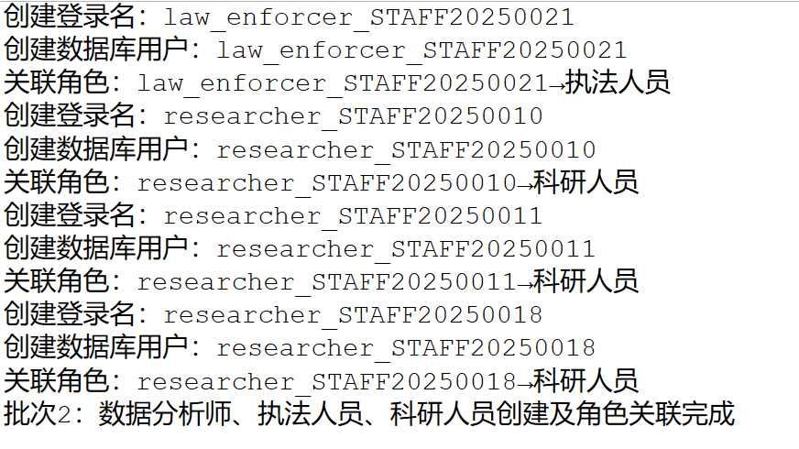

-- 一、技术人员（STAFF-2025-0012、0013、0019、0022）
-- 1. 技术人员STAFF-2025-0012
USE master;
IF NOT EXISTS (SELECT 1 FROM sys.server_principals WHERE name = 'technician_STAFF20250012')
BEGIN
CREATE LOGIN [technician_STAFF20250012]
WITH PASSWORD = 'User@20250012',
DEFAULT_DATABASE = national_park_db;
PRINT '创建登录名：technician_STAFF20250012';
END;
GO

USE national_park_db;
IF NOT EXISTS (SELECT 1 FROM sys.database_principals WHERE name = 'technician_STAFF20250012')
BEGIN
CREATE USER [technician_STAFF20250012] FOR LOGIN [technician_STAFF20250012];
PRINT '创建数据库用户：technician_STAFF20250012';
END;
GO

USE national_park_db;
IF NOT EXISTS (
SELECT 1
FROM sys.database_role_members drm
JOIN sys.database_principals rp ON drm.role_principal_id = rp.principal_id
JOIN sys.database_principals mp ON drm.member_principal_id = mp.principal_id
WHERE rp.name = '技术人员' AND mp.name = 'technician_STAFF20250012'
)
BEGIN
EXEC sp_addrolemember '技术人员', 'technician_STAFF20250012';
PRINT '关联角色：technician_STAFF20250012→技术人员';
END;
GO

-- 2. 技术人员STAFF-2025-0013
USE master;
IF NOT EXISTS (SELECT 1 FROM sys.server_principals WHERE name = 'technician_STAFF20250013')
BEGIN
CREATE LOGIN [technician_STAFF20250013]
WITH PASSWORD = 'User@20250013',
DEFAULT_DATABASE = national_park_db;
PRINT '创建登录名：technician_STAFF20250013';
END;
GO

USE national_park_db;
IF NOT EXISTS (SELECT 1 FROM sys.database_principals WHERE name = 'technician_STAFF20250013')
BEGIN
CREATE USER [technician_STAFF20250013] FOR LOGIN [technician_STAFF20250013];
PRINT '创建数据库用户：technician_STAFF20250013';
END;
GO

USE national_park_db;
IF NOT EXISTS (
SELECT 1
FROM sys.database_role_members drm
JOIN sys.database_principals rp ON drm.role_principal_id = rp.principal_id
JOIN sys.database_principals mp ON drm.member_principal_id = mp.principal_id
WHERE rp.name = '技术人员' AND mp.name = 'technician_STAFF20250013'
)
BEGIN
EXEC sp_addrolemember '技术人员', 'technician_STAFF20250013';
PRINT '关联角色：technician_STAFF20250013→技术人员';
END;
GO

-- 3. 技术人员STAFF-2025-0019
USE master;
IF NOT EXISTS (SELECT 1 FROM sys.server_principals WHERE name = 'technician_STAFF20250019')
BEGIN
CREATE LOGIN [technician_STAFF20250019]
WITH PASSWORD = 'User@20250019',
DEFAULT_DATABASE = national_park_db;
PRINT '创建登录名：technician_STAFF20250019';
END;
GO

USE national_park_db;
IF NOT EXISTS (SELECT 1 FROM sys.database_principals WHERE name = 'technician_STAFF20250019')
BEGIN
CREATE USER [technician_STAFF20250019] FOR LOGIN [technician_STAFF20250019];
PRINT '创建数据库用户：technician_STAFF20250019';
END;
GO

USE national_park_db;
IF NOT EXISTS (
SELECT 1
FROM sys.database_role_members drm
JOIN sys.database_principals rp ON drm.role_principal_id = rp.principal_id
JOIN sys.database_principals mp ON drm.member_principal_id = mp.principal_id
WHERE rp.name = '技术人员' AND mp.name = 'technician_STAFF20250019'
)
BEGIN
EXEC sp_addrolemember '技术人员', 'technician_STAFF20250019';
PRINT '关联角色：technician_STAFF20250019→技术人员';
END;
GO

-- 4. 技术人员STAFF-2025-0022
USE master;
IF NOT EXISTS (SELECT 1 FROM sys.server_principals WHERE name = 'technician_STAFF20250022')
BEGIN
CREATE LOGIN [technician_STAFF20250022]
WITH PASSWORD = 'User@20250022',
DEFAULT_DATABASE = national_park_db;
PRINT '创建登录名：technician_STAFF20250022';
END;
GO

USE national_park_db;
IF NOT EXISTS (SELECT 1 FROM sys.database_principals WHERE name = 'technician_STAFF20250022')
BEGIN
CREATE USER [technician_STAFF20250022] FOR LOGIN [technician_STAFF20250022];
PRINT '创建数据库用户：technician_STAFF20250022';
END;
GO

USE national_park_db;
IF NOT EXISTS (
SELECT 1
FROM sys.database_role_members drm
JOIN sys.database_principals rp ON drm.role_principal_id = rp.principal_id
JOIN sys.database_principals mp ON drm.member_principal_id = mp.principal_id
WHERE rp.name = '技术人员' AND mp.name = 'technician_STAFF20250022'
)
BEGIN
EXEC sp_addrolemember '技术人员', 'technician_STAFF20250022';
PRINT '关联角色：technician_STAFF20250022→技术人员';
END;
GO

-- 二、系统管理员（STAFF-2025-0023、0024）
-- 1. 系统管理员STAFF-2025-0023
USE master;
IF NOT EXISTS (SELECT 1 FROM sys.server_principals WHERE name = 'sys_admin_STAFF20250023')
BEGIN
CREATE LOGIN [sys_admin_STAFF20250023]
WITH PASSWORD = 'User@20250023',
DEFAULT_DATABASE = national_park_db;
PRINT '创建登录名：sys_admin_STAFF20250023';
END;
GO

USE national_park_db;
IF NOT EXISTS (SELECT 1 FROM sys.database_principals WHERE name = 'sys_admin_STAFF20250023')
BEGIN
CREATE USER [sys_admin_STAFF20250023] FOR LOGIN [sys_admin_STAFF20250023];
PRINT '创建数据库用户：sys_admin_STAFF20250023';
END;
GO

USE national_park_db;
IF NOT EXISTS (
SELECT 1
FROM sys.database_role_members drm
JOIN sys.database_principals rp ON drm.role_principal_id = rp.principal_id
JOIN sys.database_principals mp ON drm.member_principal_id = mp.principal_id
WHERE rp.name = '系统管理员' AND mp.name = 'sys_admin_STAFF20250023'
)
BEGIN
EXEC sp_addrolemember '系统管理员', 'sys_admin_STAFF20250023';
PRINT '关联角色：sys_admin_STAFF20250023→系统管理员';
END;
GO

-- 2. 系统管理员STAFF-2025-0024
USE master;
IF NOT EXISTS (SELECT 1 FROM sys.server_principals WHERE name = 'sys_admin_STAFF20250024')
BEGIN
CREATE LOGIN [sys_admin_STAFF20250024]
WITH PASSWORD = 'User@20250024',
DEFAULT_DATABASE = national_park_db;
PRINT '创建登录名：sys_admin_STAFF20250024';
END;
GO

USE national_park_db;
IF NOT EXISTS (SELECT 1 FROM sys.database_principals WHERE name = 'sys_admin_STAFF20250024')
BEGIN
CREATE USER [sys_admin_STAFF20250024] FOR LOGIN [sys_admin_STAFF20250024];
PRINT '创建数据库用户：sys_admin_STAFF20250024';
END;
GO

USE national_park_db;
IF NOT EXISTS (
SELECT 1
FROM sys.database_role_members drm
JOIN sys.database_principals rp ON drm.role_principal_id = rp.principal_id
JOIN sys.database_principals mp ON drm.member_principal_id = mp.principal_id
WHERE rp.name = '系统管理员' AND mp.name = 'sys_admin_STAFF20250024'
)
BEGIN
EXEC sp_addrolemember '系统管理员', 'sys_admin_STAFF20250024';
PRINT '关联角色：sys_admin_STAFF20250024→系统管理员';
END;
GO

-- 三、公园管理人员（STAFF-2025-0025、0026）
-- 1. 公园管理人员STAFF-2025-0025
USE master;
IF NOT EXISTS (SELECT 1 FROM sys.server_principals WHERE name = 'park_manager_STAFF20250025')
BEGIN
CREATE LOGIN [park_manager_STAFF20250025]
WITH PASSWORD = 'User@20250025',
DEFAULT_DATABASE = national_park_db;
PRINT '创建登录名：park_manager_STAFF20250025';
END;
GO

USE national_park_db;
IF NOT EXISTS (SELECT 1 FROM sys.database_principals WHERE name = 'park_manager_STAFF20250025')
BEGIN
CREATE USER [park_manager_STAFF20250025] FOR LOGIN [park_manager_STAFF20250025];
PRINT '创建数据库用户：park_manager_STAFF20250025';
END;
GO

USE national_park_db;
IF NOT EXISTS (
SELECT 1
FROM sys.database_role_members drm
JOIN sys.database_principals rp ON drm.role_principal_id = rp.principal_id
JOIN sys.database_principals mp ON drm.member_principal_id = mp.principal_id
WHERE rp.name = '公园管理人员' AND mp.name = 'park_manager_STAFF20250025'
)
BEGIN
EXEC sp_addrolemember '公园管理人员', 'park_manager_STAFF20250025';
PRINT '关联角色：park_manager_STAFF20250025→公园管理人员';
END;
GO

-- 2. 公园管理人员STAFF-2025-0026
USE master;
IF NOT EXISTS (SELECT 1 FROM sys.server_principals WHERE name = 'park_manager_STAFF20250026')
BEGIN
CREATE LOGIN [park_manager_STAFF20250026]
WITH PASSWORD = 'User@20250026',
DEFAULT_DATABASE = national_park_db;
PRINT '创建登录名：park_manager_STAFF20250026';
END;
GO

USE national_park_db;
IF NOT EXISTS (SELECT 1 FROM sys.database_principals WHERE name = 'park_manager_STAFF20250026')
BEGIN
CREATE USER [park_manager_STAFF20250026] FOR LOGIN [park_manager_STAFF20250026];
PRINT '创建数据库用户：park_manager_STAFF20250026';
END;
GO

USE national_park_db;
IF NOT EXISTS (
SELECT 1
FROM sys.database_role_members drm
JOIN sys.database_principals rp ON drm.role_principal_id = rp.principal_id
JOIN sys.database_principals mp ON drm.member_principal_id = mp.principal_id
WHERE rp.name = '公园管理人员' AND mp.name = 'park_manager_STAFF20250026'
)
BEGIN
EXEC sp_addrolemember '公园管理人员', 'park_manager_STAFF20250026';
PRINT '关联角色：park_manager_STAFF20250026→公园管理人员';
END;
GO

PRINT '批次3：技术人员、系统管理员、公园管理人员创建及角色关联完成';

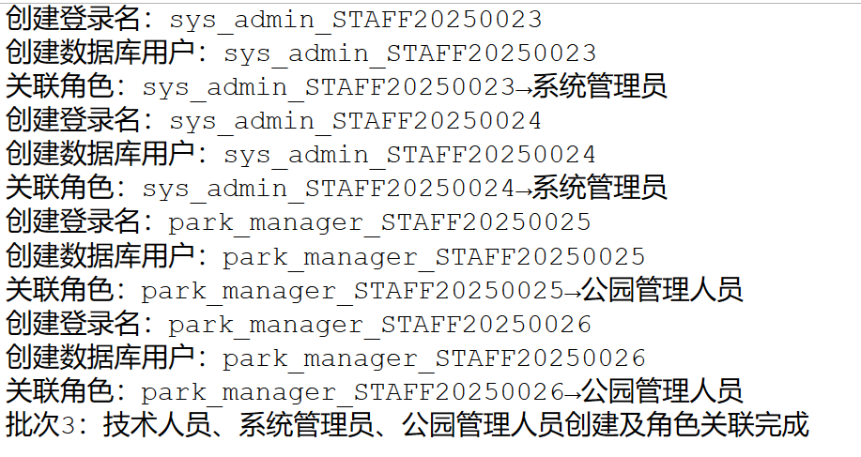

验证是否关联完整代码：
USE national_park_db;
GO

-- 1.1 验证服务器登录名（共26个，对应26个工作人员）
USE master;
GO
SELECT
name AS 登录名,
type_desc AS 类型,
create_date AS 创建时间,
is_disabled AS 是否禁用
FROM sys.server_principals
WHERE
name LIKE 'ecological_monitor_%'
OR name LIKE 'data_analyst_%'
OR name LIKE 'law_enforcer_%'
OR name LIKE 'researcher_%'
OR name LIKE 'technician_%'
OR name LIKE 'sys_admin_%'
OR name LIKE 'park_manager_%'
ORDER BY create_date DESC;
-- 预期结果：26条记录，无禁用（is_disabled=0）
GO

-- 1.2 验证数据库用户与角色关联（修正子查询关联逻辑，解决GROUP BY报错）
USE national_park_db;
GO
SELECT
rp.name AS 角色名称,
COUNT(DISTINCT mp.name) AS 关联用户数,
-- 修正：子查询先关联drm2和rp2，再匹配外部rp的principal_id，确保语法兼容
STUFF((
SELECT ', ' + mp2.name
FROM sys.database_role_members drm2
JOIN sys.database_principals rp2 ON drm2.role_principal_id = rp2.principal_id -- 先关联角色
JOIN sys.database_principals mp2 ON drm2.member_principal_id = mp2.principal_id -- 再关联用户
WHERE rp2.principal_id = rp.principal_id -- 显式匹配外部角色的ID
FOR XML PATH(''), TYPE
).value('.', 'NVARCHAR(MAX)'), 1, 2, '') AS 关联用户示例
FROM sys.database_principals rp
LEFT JOIN sys.database_role_members drm ON rp.principal_id = drm.role_principal_id
LEFT JOIN sys.database_principals mp ON drm.member_principal_id = mp.principal_id
WHERE rp.name IN (
'生态监测员', '数据分析师', '执法人员', '科研人员',
'技术人员', '系统管理员', '公园管理人员'
) AND rp.type = 'R' -- 仅筛选数据库角色
GROUP BY rp.name, rp.principal_id; -- 显式包含rp.principal_id（部分版本需GROUP BY所有非聚合列）
-- 预期结果：生态监测员(7人)、执法人员(4人)、技术人员(4人)、科研人员(3人)、数据分析师(3人)、系统管理员(2人)、公园管理人员(2人)
GO

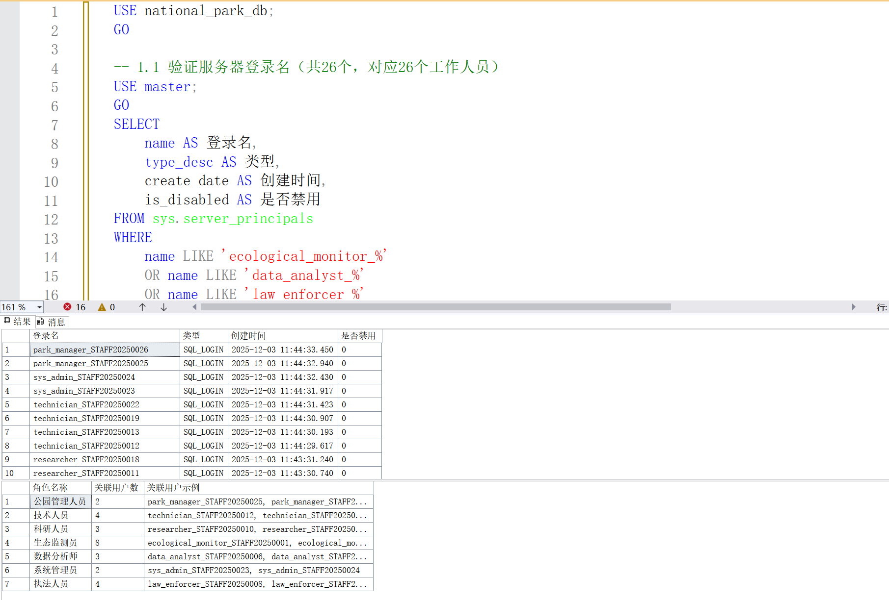
验证截图

