小组课设角色创建任务
--角色创建与视图关联代码如下：
USE national_park_db;
GO

-- 一、创建8个核心业务角色
-- 1. 生态监测员角色（生物多样性监测业务线）
IF NOT EXISTS (SELECT * FROM sys.database_principals WHERE name = '生态监测员' AND type = 'R')
BEGIN
CREATE ROLE [生态监测员] AUTHORIZATION dbo;
PRINT '生态监测员角色创建完成';
END
GO

-- 2. 数据分析师角色（跨业务线：生物多样性+生态环境监测+科研数据支撑）
IF NOT EXISTS (SELECT * FROM sys.database_principals WHERE name = '数据分析师' AND type = 'R')
BEGIN
CREATE ROLE [数据分析师] AUTHORIZATION dbo;
PRINT '数据分析师角色创建完成';
END
GO

-- 3. 游客角色（游客智能管理业务线）
IF NOT EXISTS (SELECT * FROM sys.database_principals WHERE name = '游客' AND type = 'R')
BEGIN
CREATE ROLE [游客] AUTHORIZATION dbo;
PRINT '游客角色创建完成';
END
GO

-- 4. 执法人员角色（执法监管业务线）
IF NOT EXISTS (SELECT * FROM sys.database_principals WHERE name = '执法人员' AND type = 'R')
BEGIN
CREATE ROLE [执法人员] AUTHORIZATION dbo;
PRINT '执法人员角色创建完成';
END
GO

-- 5. 科研人员角色（科研数据支撑业务线）
IF NOT EXISTS (SELECT * FROM sys.database_principals WHERE name = '科研人员' AND type = 'R')
BEGIN
CREATE ROLE [科研人员] AUTHORIZATION dbo;
PRINT '科研人员角色创建完成';
END
GO

-- 6. 系统管理员角色（全局管理）
IF NOT EXISTS (SELECT * FROM sys.database_principals WHERE name = '系统管理员' AND type = 'R')
BEGIN
CREATE ROLE [系统管理员] AUTHORIZATION dbo;
PRINT '系统管理员角色创建完成';
END
GO

-- 7. 公园管理人员角色（全局统筹）
IF NOT EXISTS (SELECT * FROM sys.database_principals WHERE name = '公园管理人员' AND type = 'R')
BEGIN
CREATE ROLE [公园管理人员] AUTHORIZATION dbo;
PRINT '公园管理人员角色创建完成';
END
GO

-- 8. 技术人员角色（跨业务线：生态环境监测+科研数据支撑+执法监管）
IF NOT EXISTS (SELECT * FROM sys.database_principals WHERE name = '技术人员' AND type = 'R')
BEGIN
CREATE ROLE [技术人员] AUTHORIZATION dbo;
PRINT '技术人员角色创建完成';
END
GO

-- 二、角色与视图访问权限关联（按业务线匹配）
-- 1. 生态监测员角色 - 关联生物多样性监测业务线视图
GRANT SELECT ON v_ecological_monitor TO [生态监测员];
GRANT SELECT ON v_ecological_species_distribution TO [生态监测员];
-- 监测员工作绩效视图仅管理人员查看，生态监测员暂不授予
PRINT '生态监测员角色与视图关联完成';
GO

-- 2. 数据分析师角色 - 关联跨业务线分析类视图
GRANT SELECT ON v_data_analyst_comprehensive TO [数据分析师]; -- 科研数据支撑业务线
GRANT SELECT ON v_env_abnormal_alert TO [数据分析师]; -- 生态环境监测业务线
GRANT SELECT ON v_ecological_species_distribution TO [数据分析师]; -- 生物多样性监测业务线
PRINT '数据分析师角色与视图关联完成';
GO

-- 3. 游客角色 - 关联游客智能管理业务线视图
GRANT SELECT ON v_visitor_reservation TO [游客];
GRANT SELECT ON v_visitor_guide TO [游客];
-- 游客轨迹预警视图为管理端使用，游客暂不授予
PRINT '游客角色与视图关联完成';
GO

-- 4. 执法人员角色 - 关联执法监管业务线视图
GRANT SELECT ON v_enforcement_surveillance TO [执法人员];
GRANT SELECT ON v_law_enforcer TO [执法人员];
PRINT '执法人员角色与视图关联完成';
GO

-- 5. 科研人员角色 - 关联科研数据支撑+生态环境监测业务线视图
GRANT SELECT ON v_env_researcher TO [科研人员]; -- 科研数据支撑业务线
GRANT SELECT ON v_researcher_env_data TO [科研人员]; -- 生态环境监测业务线
PRINT '科研人员角色与视图关联完成';
GO

-- 6. 系统管理员角色 - 关联所有视图（全局管理权限）
GRANT SELECT ON v_ecological_monitor TO [系统管理员];
GRANT SELECT ON v_ecological_species_distribution TO [系统管理员];
GRANT SELECT ON v_ecological_monitor_performance TO [系统管理员];
GRANT SELECT ON v_technician_comprehensive TO [系统管理员];
GRANT SELECT ON v_data_analyst_comprehensive TO [系统管理员];
GRANT SELECT ON v_env_researcher TO [系统管理员];
GRANT SELECT ON v_visitor_reservation TO [系统管理员];
GRANT SELECT ON v_visitor_guide TO [系统管理员];
GRANT SELECT ON v_visitor_out_of_area_warning TO [系统管理员];
GRANT SELECT ON v_env_abnormal_alert TO [系统管理员];
GRANT SELECT ON v_env_device_operation TO [系统管理员];
GRANT SELECT ON v_researcher_env_data TO [系统管理员];
GRANT SELECT ON v_enforcement_surveillance TO [系统管理员];
GRANT SELECT ON v_law_enforcer TO [系统管理员];
GRANT SELECT ON v_park_manager TO [系统管理员];
GRANT SELECT ON v_admin_account TO [系统管理员];
GRANT SELECT ON v_admin_device TO [系统管理员];
GRANT SELECT ON v_admin_security TO [系统管理员];
PRINT '系统管理员角色与所有视图关联完成';
GO

-- 7. 公园管理人员角色 - 关联全局统筹类视图
GRANT SELECT ON v_ecological_monitor_performance TO [公园管理人员]; -- 生物多样性监测业务线
GRANT SELECT ON v_park_manager TO [公园管理人员]; -- 执法监管业务线
GRANT SELECT ON v_visitor_out_of_area_warning TO [公园管理人员]; -- 游客智能管理业务线
PRINT '公园管理人员角色与视图关联完成';
GO

-- 8. 技术人员角色 - 关联设备运维类视图
GRANT SELECT ON v_technician_comprehensive TO [技术人员]; -- 科研数据支撑业务线
GRANT SELECT ON v_env_device_operation TO [技术人员]; -- 生态环境监测业务线
PRINT '技术人员角色与视图关联完成';
GO

PRINT '所有角色创建及视图权限关联全部完成';
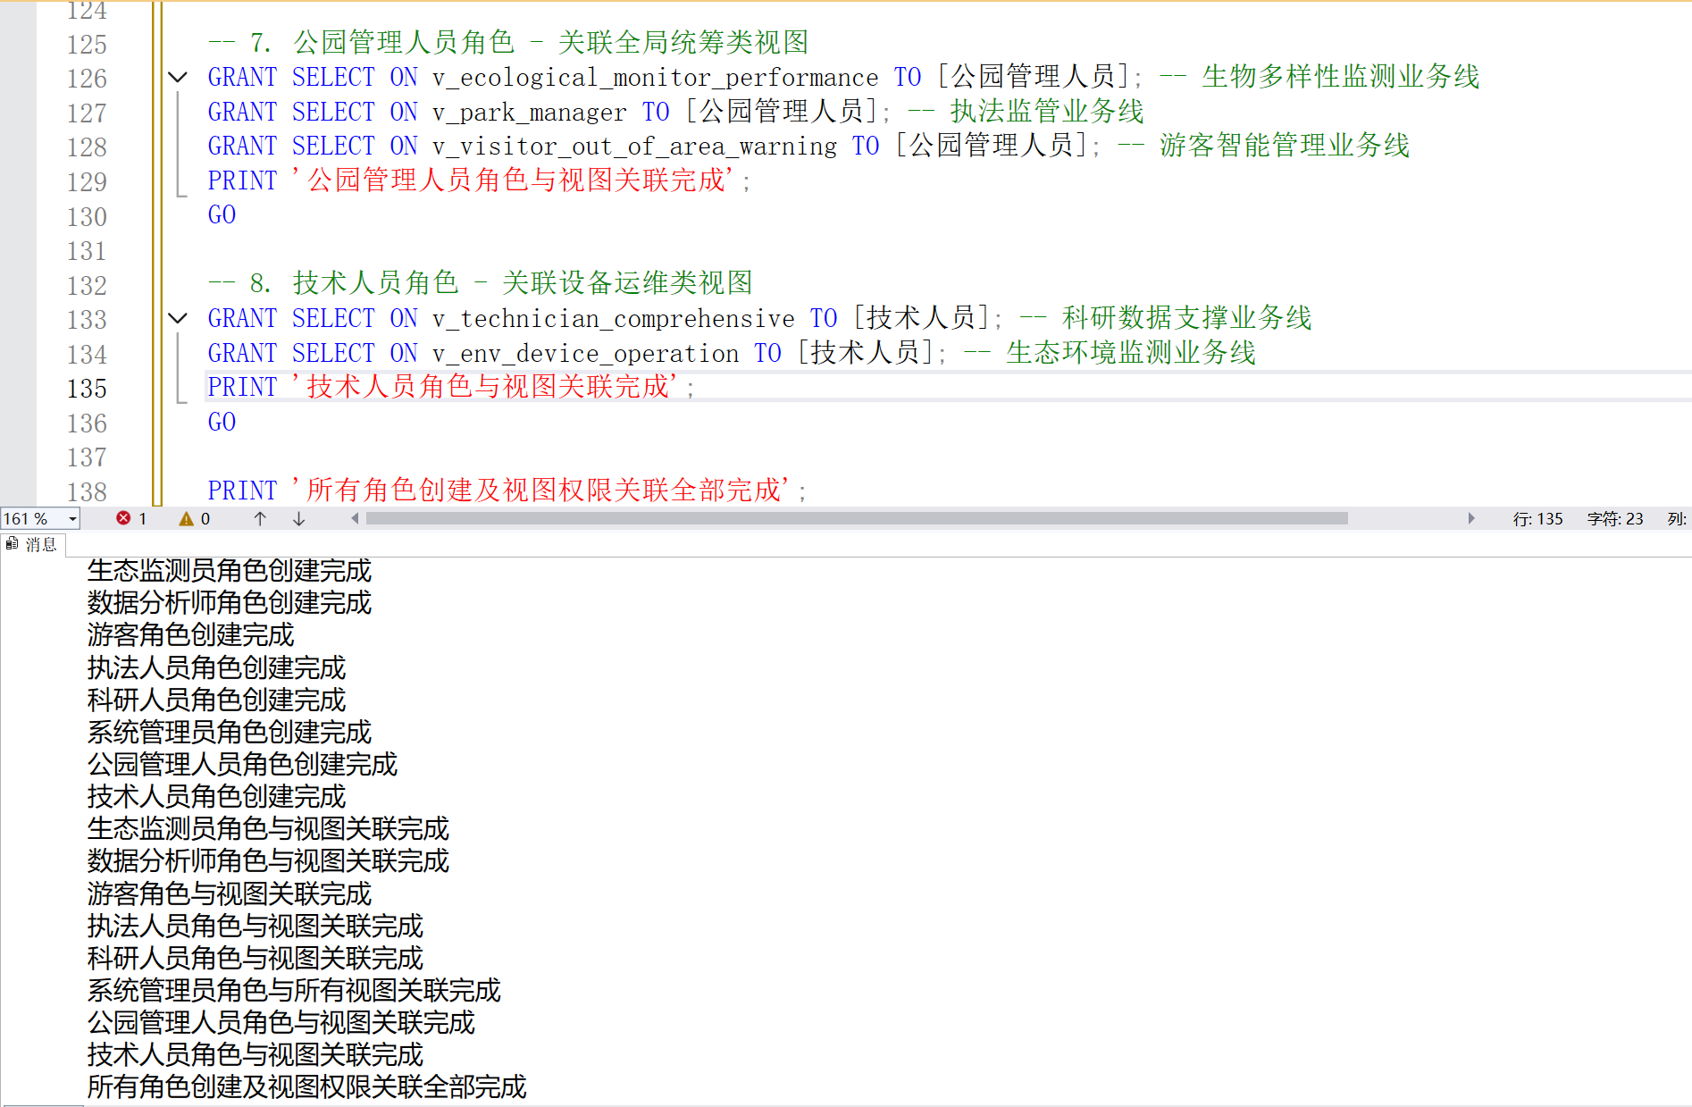
角色权限授予代码：
USE national_park_db;
GO

-- 一、生态监测员权限授予
GRANT INSERT, UPDATE ON tb_monitor_record TO [生态监测员];
GRANT SELECT, INSERT ON tb_habitat_info TO [生态监测员];
GRANT SELECT ON tb_species_info TO [生态监测员];
GRANT SELECT ON tb_monitor_device TO [生态监测员];
GRANT SELECT ON tb_area_info TO [生态监测员];

DENY UPDATE ON tb_monitor_record (record_id, species_id, device_id, monitor_time, recorder_id) TO [生态监测员];
DENY UPDATE ON tb_habitat_info (habitat_id, main_species_id) TO [生态监测员];

DENY DELETE ON tb_monitor_record TO [生态监测员];
DENY DELETE ON tb_habitat_info TO [生态监测员];

GRANT SELECT ON v_ecological_monitor TO [生态监测员];
GRANT SELECT ON v_ecological_species_distribution TO [生态监测员];
PRINT '生态监测员权限授予完成';
GO

-- 二、数据分析师权限授予
GRANT UPDATE, SELECT ON tb_monitor_record TO [数据分析师];
GRANT SELECT, UPDATE ON tb_environment_data TO [数据分析师];
GRANT UPDATE, SELECT ON tb_monitor_index TO [数据分析师];
GRANT SELECT ON tb_area_info TO [数据分析师];

DENY UPDATE ON tb_monitor_record (record_id, species_id, device_id, monitor_time, monitor_lng, monitor_lat, recorder_id) TO [数据分析师];
DENY UPDATE ON tb_environment_data (data_id, index_id, device_id, collect_time, monitor_value, area_id) TO [数据分析师];
DENY UPDATE ON tb_monitor_index (index_id, index_name, unit, monitor_frequency) TO [数据分析师];

DENY DELETE ON tb_monitor_record TO [数据分析师];
DENY DELETE ON tb_environment_data TO [数据分析师];
DENY DELETE ON tb_monitor_index TO [数据分析师];

GRANT SELECT ON v_data_analyst_comprehensive TO [数据分析师];
GRANT SELECT ON v_env_abnormal_alert TO [数据分析师];
GRANT SELECT ON v_ecological_species_distribution TO [数据分析师];
PRINT '数据分析师权限授予完成';
GO

-- 三、游客权限授予
GRANT INSERT, SELECT ON tb_visitor_info TO [游客];
GRANT INSERT, SELECT ON tb_reservation_record TO [游客];
GRANT SELECT ON tb_flow_control TO [游客];

DENY UPDATE ON tb_visitor_info (visitor_id, id_card) TO [游客];
DENY UPDATE ON tb_reservation_record (reservation_id, visitor_id, ticket_amount, payment_status) TO [游客];

DENY SELECT, INSERT, UPDATE, DELETE ON tb_visitor_track TO [游客];
DENY SELECT ON tb_visitor_info TO [游客];

GRANT SELECT ON v_visitor_reservation TO [游客];
GRANT SELECT ON v_visitor_guide TO [游客];
PRINT '游客权限授予完成';
GO

-- 四、执法人员权限授予
GRANT UPDATE, SELECT ON tb_illegal_behavior TO [执法人员];
GRANT SELECT, UPDATE ON tb_enforcement_dispatch TO [执法人员];
GRANT SELECT, UPDATE ON tb_law_enforce_device TO [执法人员];
GRANT SELECT ON tb_area_info TO [执法人员];

DENY UPDATE ON tb_illegal_behavior (behavior_id, behavior_type, occur_time, occur_area_id, evidence_path, penalty_basis) TO [执法人员];
DENY UPDATE ON tb_enforcement_dispatch (dispatch_id, behavior_id, enforcer_id, dispatch_time) TO [执法人员];
DENY UPDATE ON tb_law_enforce_device (device_id, device_type, last_check_time) TO [执法人员];

DENY DELETE ON tb_illegal_behavior TO [执法人员];
DENY DELETE ON tb_enforcement_dispatch TO [执法人员];

GRANT SELECT ON v_enforcement_surveillance TO [执法人员];
GRANT SELECT ON v_law_enforcer TO [执法人员];
PRINT '执法人员权限授予完成';
GO

-- 五、科研人员权限授予
GRANT INSERT, UPDATE, SELECT ON tb_research_project TO [科研人员];
GRANT INSERT, SELECT ON tb_research_data_collect TO [科研人员];
GRANT INSERT, UPDATE, SELECT ON tb_research_achievement TO [科研人员];
GRANT SELECT ON tb_environment_data TO [科研人员];
GRANT SELECT ON tb_area_info TO [科研人员];

DENY UPDATE ON tb_research_project (project_id, leader_id, application_unit, project_start_date, research_field) TO [科研人员];
DENY UPDATE ON tb_research_data_collect (collect_id, project_id, collector_id, collect_time, collect_area_id, data_source) TO [科研人员];
DENY UPDATE ON tb_research_achievement (achievement_id, project_id, achievement_type, achievement_name, publish_submit_time, file_path) TO [科研人员];

DENY DELETE ON tb_research_project TO [科研人员];
DENY DELETE ON tb_research_data_collect TO [科研人员];
DENY DELETE ON tb_research_achievement TO [科研人员];

GRANT SELECT ON v_env_researcher TO [科研人员];
GRANT SELECT ON v_researcher_env_data TO [科研人员];
PRINT '科研人员权限授予完成';
GO

-- 六、系统管理员权限授予
-- 账号管理表
GRANT INSERT, UPDATE, DELETE, SELECT ON tb_staff_info TO [系统管理员];
GRANT INSERT, UPDATE, DELETE, SELECT ON tb_researcher_info TO [系统管理员];
GRANT INSERT, UPDATE, DELETE, SELECT ON tb_law_enforcer TO [系统管理员];

-- 设备管理表
GRANT UPDATE, SELECT ON tb_monitor_device TO [系统管理员];
GRANT UPDATE, SELECT ON tb_law_enforce_device TO [系统管理员];
GRANT UPDATE, SELECT ON tb_video_monitor TO [系统管理员];

-- 核心业务表（手动指定全表SELECT，避免批量存储过程）
GRANT SELECT ON tb_monitor_record TO [系统管理员];
GRANT SELECT ON tb_habitat_info TO [系统管理员];
GRANT SELECT ON tb_species_info TO [系统管理员];
GRANT SELECT ON tb_environment_data TO [系统管理员];
GRANT SELECT ON tb_monitor_index TO [系统管理员];
GRANT SELECT ON tb_visitor_info TO [系统管理员];
GRANT SELECT ON tb_reservation_record TO [系统管理员];
GRANT SELECT ON tb_flow_control TO [系统管理员];
GRANT SELECT ON tb_illegal_behavior TO [系统管理员];
GRANT SELECT ON tb_enforcement_dispatch TO [系统管理员];
GRANT SELECT ON tb_research_project TO [系统管理员];
GRANT SELECT ON tb_research_data_collect TO [系统管理员];
GRANT SELECT ON tb_research_achievement TO [系统管理员];
GRANT SELECT ON tb_area_info TO [系统管理员];

-- 禁止核心表删除
DENY DELETE ON tb_monitor_record TO [系统管理员];
DENY DELETE ON tb_illegal_behavior TO [系统管理员];
DENY DELETE ON tb_research_project TO [系统管理员];

-- 视图权限（手动指定所有视图）
GRANT SELECT, ALTER ON v_ecological_monitor TO [系统管理员];
GRANT SELECT, ALTER ON v_ecological_species_distribution TO [系统管理员];
GRANT SELECT, ALTER ON v_ecological_monitor_performance TO [系统管理员];
GRANT SELECT, ALTER ON v_technician_comprehensive TO [系统管理员];
GRANT SELECT, ALTER ON v_data_analyst_comprehensive TO [系统管理员];
GRANT SELECT, ALTER ON v_env_researcher TO [系统管理员];
GRANT SELECT, ALTER ON v_visitor_reservation TO [系统管理员];
GRANT SELECT, ALTER ON v_visitor_guide TO [系统管理员];
GRANT SELECT, ALTER ON v_visitor_out_of_area_warning TO [系统管理员];
GRANT SELECT, ALTER ON v_env_abnormal_alert TO [系统管理员];
GRANT SELECT, ALTER ON v_env_device_operation TO [系统管理员];
GRANT SELECT, ALTER ON v_researcher_env_data TO [系统管理员];
GRANT SELECT, ALTER ON v_enforcement_surveillance TO [系统管理员];
GRANT SELECT, ALTER ON v_law_enforcer TO [系统管理员];
GRANT SELECT, ALTER ON v_park_manager TO [系统管理员];
GRANT SELECT, ALTER ON v_admin_account TO [系统管理员];
GRANT SELECT, ALTER ON v_admin_device TO [系统管理员];
GRANT SELECT, ALTER ON v_admin_security TO [系统管理员];
PRINT '系统管理员权限授予完成';
GO

-- 七、公园管理人员权限授予
-- 审批/配置表
GRANT UPDATE, SELECT ON tb_research_project TO [公园管理人员];
GRANT UPDATE, SELECT ON tb_flow_control TO [公园管理人员];
GRANT UPDATE, SELECT ON tb_enforcement_dispatch TO [公园管理人员];

-- 字段级控制
DENY UPDATE ON tb_research_project (project_id, project_name, leader_id, application_unit, project_start_date, project_end_date, research_field) TO [公园管理人员];
DENY UPDATE ON tb_flow_control (area_id) TO [公园管理人员];
DENY UPDATE ON tb_enforcement_dispatch (dispatch_id, behavior_id, dispatch_time, response_time, handle_complete_time) TO [公园管理人员];

-- 全表查看权限（手动指定）
GRANT SELECT ON tb_monitor_record TO [公园管理人员];
GRANT SELECT ON tb_habitat_info TO [公园管理人员];
GRANT SELECT ON tb_species_info TO [公园管理人员];
GRANT SELECT ON tb_environment_data TO [公园管理人员];
GRANT SELECT ON tb_monitor_index TO [公园管理人员];
GRANT SELECT ON tb_visitor_info TO [公园管理人员];
GRANT SELECT ON tb_reservation_record TO [公园管理人员];
GRANT SELECT ON tb_flow_control TO [公园管理人员];
GRANT SELECT ON tb_illegal_behavior TO [公园管理人员];
GRANT SELECT ON tb_enforcement_dispatch TO [公园管理人员];
GRANT SELECT ON tb_research_project TO [公园管理人员];
GRANT SELECT ON tb_research_data_collect TO [公园管理人员];
GRANT SELECT ON tb_research_achievement TO [公园管理人员];
GRANT SELECT ON tb_area_info TO [公园管理人员];

-- 禁止插入/删除
DENY INSERT, DELETE ON tb_research_project TO [公园管理人员];
DENY INSERT, DELETE ON tb_flow_control TO [公园管理人员];
DENY INSERT, DELETE ON tb_enforcement_dispatch TO [公园管理人员];
DENY INSERT, DELETE ON tb_monitor_record TO [公园管理人员];
DENY INSERT, DELETE ON tb_illegal_behavior TO [公园管理人员];

-- 视图权限
GRANT SELECT ON v_ecological_monitor_performance TO [公园管理人员];
GRANT SELECT ON v_park_manager TO [公园管理人员];
GRANT SELECT ON v_visitor_out_of_area_warning TO [公园管理人员];
PRINT '公园管理人员权限授予完成';
GO

-- 八、技术人员权限授予
GRANT UPDATE, SELECT ON tb_monitor_device TO [技术人员];
GRANT UPDATE, SELECT ON tb_law_enforce_device TO [技术人员];
GRANT UPDATE, SELECT ON tb_video_monitor TO [技术人员];

DENY UPDATE ON tb_monitor_device (device_id, device_type, deploy_area_id, install_time, communication_protocol) TO [技术人员];
DENY UPDATE ON tb_law_enforce_device (device_id, device_type) TO [技术人员];
DENY UPDATE ON tb_video_monitor (monitor_point_id, deploy_area_id, install_lng, install_lat, monitor_range) TO [技术人员];

DENY SELECT, INSERT, UPDATE, DELETE ON tb_monitor_record TO [技术人员];
DENY SELECT, INSERT, UPDATE, DELETE ON tb_illegal_behavior TO [技术人员];

GRANT SELECT ON v_technician_comprehensive TO [技术人员];
GRANT SELECT ON v_env_device_operation TO [技术人员];
PRINT '技术人员权限授予完成';
GO

PRINT '所有角色权限（无批量存储过程）全部授予完成';

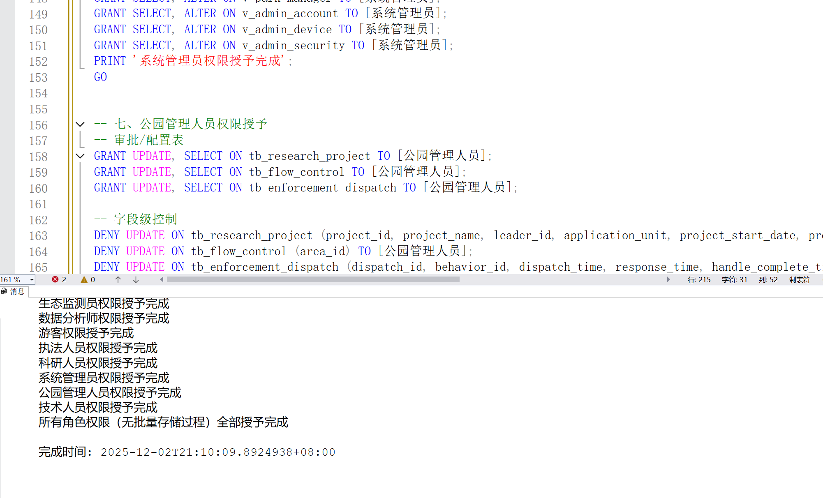
角色权限授予截图

--角色权限与视图验证代码：
USE national_park_db;
GO

-- 定义待验证的角色列表
DECLARE @roles TABLE (role_name VARCHAR(50));
INSERT INTO @roles VALUES
('生态监测员'), ('数据分析师'), ('游客'), ('执法人员'),
('科研人员'), ('系统管理员'), ('公园管理人员'), ('技术人员');

-- 遍历所有角色，输出每个角色的表权限、视图权限
DECLARE @current_role VARCHAR(50);
DECLARE role_cursor CURSOR FOR SELECT role_name FROM @roles;
OPEN role_cursor;
FETCH NEXT FROM role_cursor INTO @current_role;

WHILE @@FETCH_STATUS = 0
BEGIN
PRINT '=================================================================';
PRINT '【角色：' + @current_role + '】可访问的表及权限：';
PRINT '-----------------------------------------------------------------';

-- 1. 输出该角色的表权限
SELECT
OBJECT_NAME(major_id) AS 表名称,
permission_name AS 权限类型,
state_desc AS 权限状态
FROM sys.database_permissions
WHERE
class = 1 -- 表级权限
AND USER_NAME(grantee_principal_id) = @current_role
AND OBJECT_NAME(major_id) NOT LIKE 'sys%' -- 排除系统表
ORDER BY 表名称, 权限类型;

PRINT CHAR(10) + '【角色：' + @current_role + '】可访问的视图及权限：';
PRINT '-----------------------------------------------------------------';

-- 2. 输出该角色的视图权限
SELECT
OBJECT_NAME(major_id) AS 视图名称,
permission_name AS 权限类型,
state_desc AS 权限状态
FROM sys.database_permissions
WHERE
class = 1 -- 视图级权限（视图属于对象级）
AND USER_NAME(grantee_principal_id) = @current_role
AND OBJECT_NAME(major_id) LIKE 'v_%' -- 仅筛选自定义视图
ORDER BY 视图名称, 权限类型;

PRINT '=================================================================' + CHAR(10);
FETCH NEXT FROM role_cursor INTO @current_role;
END

CLOSE role_cursor;
DEALLOCATE role_cursor;
GO
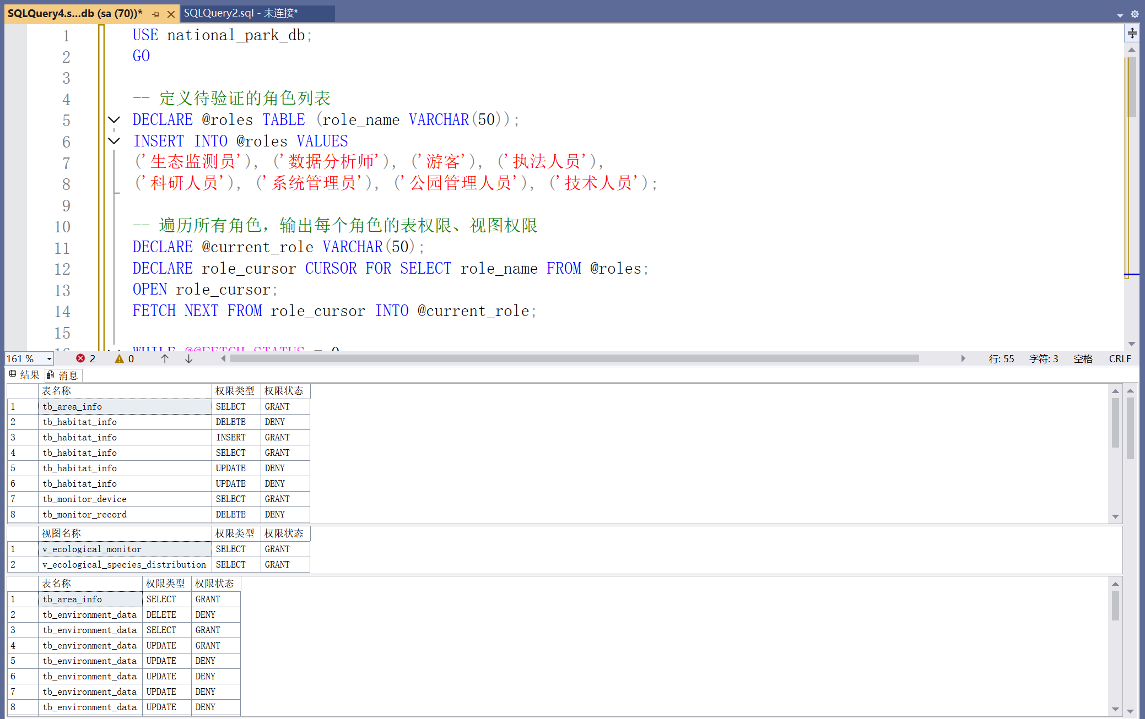
可以看见所有角色的表权限以及视图权限

