科研数据支撑业务线触发器

触发器名称 | 触发对象 | 触发时机 |  | 核心功能 | 关键条件 | 业务价值
trg_check_research_project_status（项目状态检测） | tb_research_data_collect |  | 插入 / 更新前拦截 | 插入采集记录前校验关联科研项目的状态 | 项目状态为“已结题” | 避免已终止的科研项目产生无效采集数据，保障科研数据与项目进度的逻辑一致性

触发器创建代码（项目状态检测）
-- ========== 1. 创建项目状态校验函数 ==========
CREATE FUNCTION dbo.fn_check_project_status(@project_id VARCHAR(20))
RETURNS BIT
AS
BEGIN
DECLARE @project_status VARCHAR(10);
DECLARE @result BIT = 0; -- 0=允许插入，1=禁止插入

-- 查询项目状态
SELECT @project_status = project_status
FROM tb_research_project
WHERE project_id = @project_id;

-- 若项目已结题，返回1（禁止）
IF @project_status = '已结题'
SET @result = 1;

RETURN @result;
END;
GO

-- ========== 3. 创建采集记录插入校验触发器 ==========
CREATE TRIGGER trg_check_research_project_status
ON tb_research_data_collect
INSTEAD OF INSERT
AS
BEGIN
SET NOCOUNT ON;

-- 检查插入的记录是否关联已结题项目
IF EXISTS (
SELECT 1
FROM inserted i
WHERE dbo.fn_check_project_status(i.project_id) = 1
)
BEGIN
-- 抛出自定义异常
THROW 50001, '该科研项目已结题，禁止新增数据采集记录', 1;
END
ELSE
BEGIN
-- 正常插入合法记录
INSERT INTO tb_research_data_collect (
collect_id, project_id, collector_id, collect_time,
collect_area_id, collect_content, data_source
)
SELECT
collect_id, project_id, collector_id, collect_time,
collect_area_id, collect_content, data_source
FROM inserted;
END
END;
GO

触发器功能验证代码
-- ========== 异常测试：插入已结题项目（RP-2025-0005）的采集记录 ==========
-- 预期：触发50001错误，提示“该科研项目已结题，禁止新增数据采集记录”
INSERT INTO tb_research_data_collect (
collect_id, project_id, collector_id, collect_time,
collect_area_id, collect_content, data_source
)
VALUES (
'RC-20251202-0005', -- 采集记录ID
'RP-2025-0005', -- 已结题项目ID
'RE-2025-0005', -- 负责人ID（与项目leader_id对应）
'2025-12-02 16:00:00', -- 采集时间
'AREA-2025-0005', -- 采集区域ID
'金丝猴栖息地植被样本-001', -- 采集内容
'实地采集' -- 数据来源
);
GO

-- ========== 验证结果：确认该项目无采集记录 ==========
-- 预期：查询结果为空
SELECT * FROM tb_research_data_collect WHERE project_id = 'RP-2025-0005';
GO

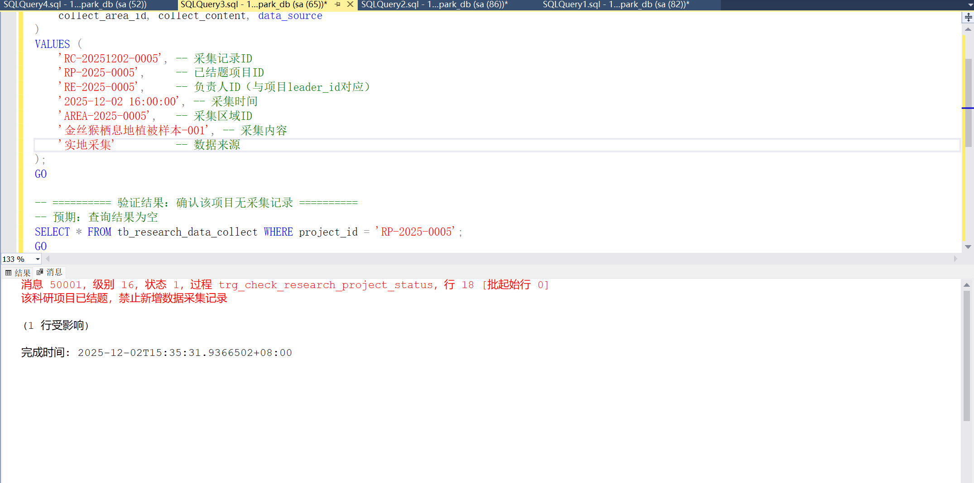
功能验证截图

