|  |
| --- |
|  |
| The Documentation |
| [Type the document subtitle] |
|  |
| **[Your Name]** |
| **[Pick the date]** |

[Type the abstract of the document here. The abstract is typically a short summary of the contents of the document. Type the abstract of the document here. The abstract is typically a short summary of the contents of the document.]

Table of Contents

[To update the table of contents, right click the message below and select Update Field (F9 on PC, ⌥⌘U on Mac).]

**No table of contents entries found.**

1. Pages
   1. Page Tree

前端-病人  
 Home  
 Login Page  
 Homepage  
 餐后  
 餐前  
 补录  
 具体日期血糖  
 Page 3  
前端-医生  
后端-数据库  
后端-护士

* 1. Home
     1. User Interface

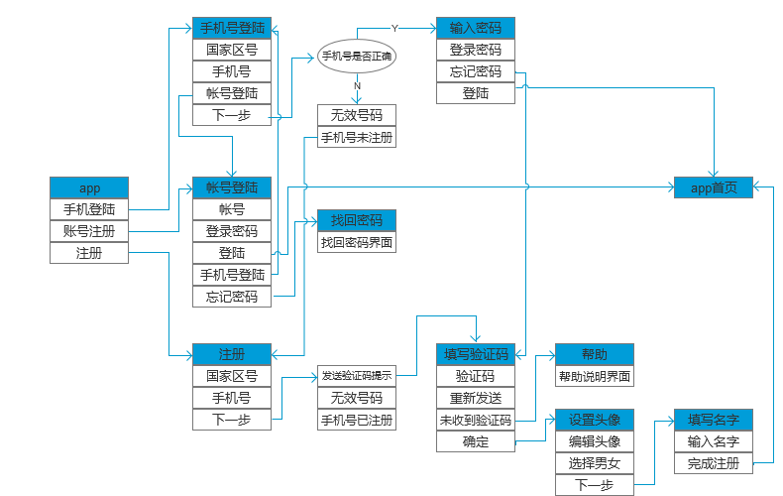

* 1. Login Page
     1. User Interface

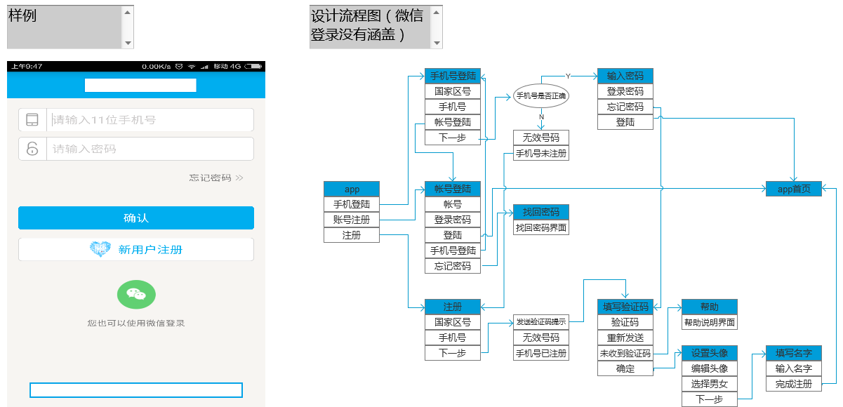

* 1. Homepage
     1. User Interface

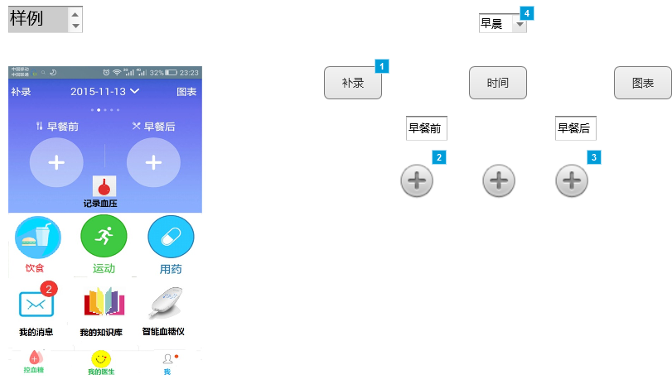

* + 1. Widget Table

|  |  |  |  |
| --- | --- | --- | --- |
| Footnote | Name | Interactions | Note |
| 1 | 补录按键 | OnClick:  Case 1:  Open 补录 in Current Window |  |
| 2 | 添加餐前血糖值 | OnClick:  Case 1:  Open 餐前 in Current Window |  |
| 3 | 添加餐后血糖值 | OnClick:  Case 1:  Open 餐后 in Current Window |  |
| 4 | 条件输入 | OnSelectionChange:  Case 1  (If selected option of This equals "早晨"):  Set 时间段前 to State1, 时间段后 to State1  Case 2  (Else If selected option of This equals "中午"):  Set 时间段前 to State2, 时间段后 to State2  Case 3  (Else If selected option of This equals "晚上"):  Set 时间段前 to State3, 时间段后 to State3 | 根据系统时间来判断 |

* + 1. 时间段前
       1. State1
       2. User Interface



* + - 1. State2
      2. User Interface



* + - 1. State3
      2. User Interface



* + 1. 时间段后
       1. State1
       2. User Interface



* + - 1. State2
      2. User Interface



* + - 1. State3
      2. User Interface



* 1. 餐后
     1. User Interface

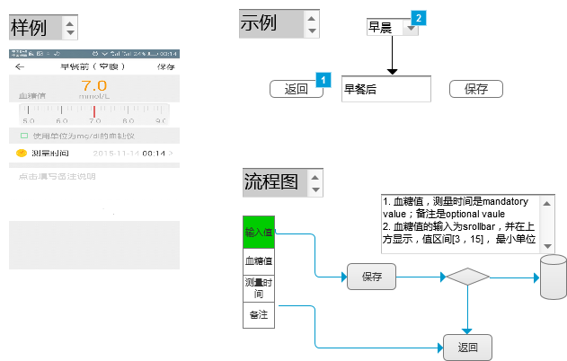

* + 1. Widget Table

|  |  |  |  |
| --- | --- | --- | --- |
| Footnote | Name | Interactions | Note |
| 1 | 返回 | OnClick:  Case 1:  Open Link in Parent Window |  |
| 2 | 条件输入 | OnSelectionChange:  Case 1  (If selected option of This equals "早晨"):  Set 餐后时间段 to State1  Case 2  (Else If selected option of This equals "中午"):  Set 餐后时间段 to State2  Case 3  (Else If selected option of This equals "晚上"):  Set 餐后时间段 to State3 | 根据系统时间来判断 |

* + 1. 餐后时间段
       1. State1
       2. User Interface



* + - 1. State2
      2. User Interface



* + - 1. State3
      2. User Interface



* 1. 餐前
     1. User Interface

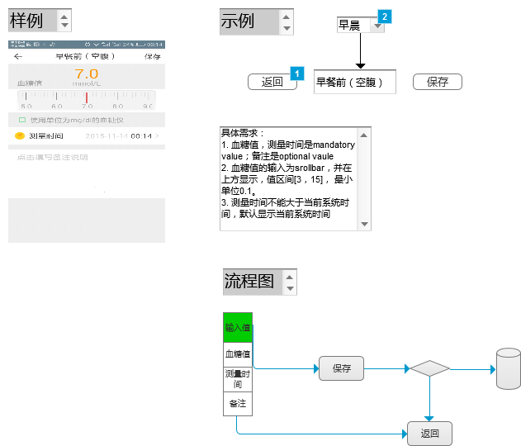

* + 1. Widget Table

|  |  |  |  |
| --- | --- | --- | --- |
| Footnote | Name | Interactions | Note |
| 1 | 返回 | OnClick:  Case 1:  Open Link in Parent Window |  |
| 2 | 条件输入 | OnSelectionChange:  Case 1  (If selected option of This equals "早晨"):  Set 餐前时间段 to State1  Case 2  (Else If selected option of This equals "中午"):  Set 餐前时间段 to State2  Case 3  (Else If selected option of This equals "晚上"):  Set 餐前时间段 to State3 | 根据系统时间来判断 |

* + 1. 餐前时间段
       1. State1
       2. User Interface



* + - 1. State2
      2. User Interface



* + - 1. State3
      2. User Interface



* 1. 补录
     1. User Interface

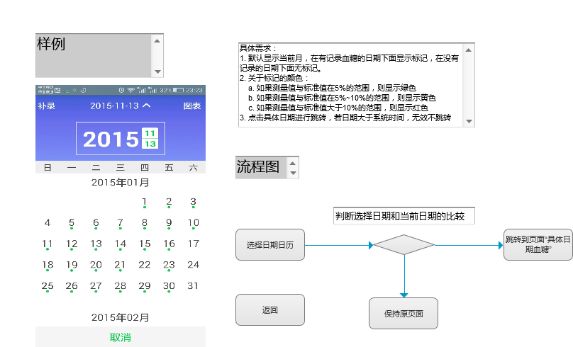

* 1. 具体日期血糖
     1. User Interface

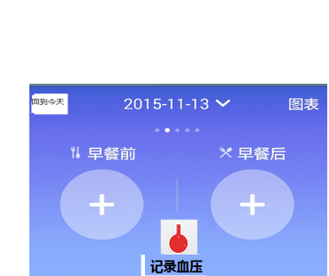

* 1. Page 3