Lab-04.R
qiman
2026-04-14
# Click the Play button to run this code
5 + 3
## [1] 8
# complete code below so answer is 10
5 + 3 + 2
## [1] 10
# make assignment and inspect the object
x <- 3 * 4
x
## [1] 12
x <- 1:50
plot(x)
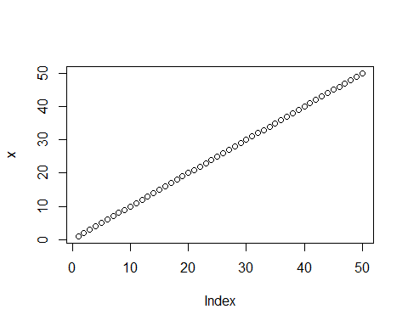
plot(x, sin(x), type = "l", col = "red", lwd = 4)
