High-Alpha Temporal Top-Z Rate Reorganization Mediates Dose–Motor Coupling Following NeuroEPO Treatment

Abstract
Objective: Motor dysfunction in Parkinson’s disease is increasingly conceptualized as a disturbance of large-scale network organization rather than a purely focal deficit. Oscillatory brain activity provides a frequency-resolved framework for large-scale neural communication, yet it remains unclear whether frequency-specific network reorganization links treatment exposure to selective motor modulation.
Methods: In a randomized placebo-controlled study, we examined frequency-resolved feature-space network organization from resting-state EEG using graph-theoretical analysis in a channel–frequency feature space. Sparse networks were estimated using EBICglasso, and Top‑Z rate changes were evaluated using binomial generalized linear mixed models (GLMMs) across canonical frequency bands and scalp regions. Bootstrap-based mediation analyses tested whether Top‑Z rate reorganization statistically linked treatment exposure (dose) to domain-specific motor outcomes.
Results: GLMMs revealed distributed band- and region-specific Top‑Z rate reorganization, with the strongest categorical Group×Time shifts in posterior Low-Alpha Top-Z rates. Mediation analyses showed that dose-related High-Alpha Top-Z rate reorganization over the temporal scalp region most consistently mediated the association between exposure and domain-resolved motor outcomes, with additional band- and region-specific pathways for select outcomes.
Conclusions: These findings identify a frequency-resolved feature-space conditional-dependence network signature (EBICglasso-regularized partial correlations among channel–frequency spectral features) in which High-Alpha temporal Top-Z rate reorganization mediates the relationship between NeuroEPO exposure and domain-selective motor outcomes. The results support a large-scale network mechanism through which NeuroEPO may influence motor function, detectable even when global clinical measures show limited between-group separation.
Keywords: NeuroEPO; Parkinson’s disease; EEG; Top-Z rate; High-Alpha; Mediation analysis, Graph theory

1. Introduction
Motor dysfunction in neurological disorders is increasingly conceptualized as a disturbance of large-scale network organization rather than solely a consequence of focal structural damage.Converging evidence from electrophysiological and neuroimaging studies indicates that motor impairments are associated with disrupted cortical connectivity, altered hub architecture, and impaired coordination across distributed frontal–parietal systems (Baggio et al., 2014; Olde Dubbelink et al., 2014; Vervoort et al., 2016; Rubinov and Sporns, 2010). Understanding how therapeutic interventions reshape these network dynamics remains a central challenge in translational neuroscience.
Oscillatory activity provides a fundamental organizing principle for large-scale communication (Fries, 2015). Distinct frequency bands are thought to subserve different spatial and temporal scales of integration (Buzsáki and Watson, 2012; Siegel et al., 2012), with slow-frequency oscillations supporting long-range coordination and hierarchical information exchange (He and Raichle, 2009). In motor disorders, alterations in low-frequency dynamics—including Delta-band activity—have been linked to impaired cortical integration and abnormal motor control (Geraedts et al., 2018), and coherent delta-band interactions between cortical areas have been related to long-range coordination during decision processes (Nácher et al., 2013). In Parkinson’s disease, oscillatory systems-level accounts further implicate distributed rhythm-based mechanisms that extend beyond the basal ganglia to cortico–basal ganglia–thalamo–cortical loops and large-scale cortical communication (Brittain and Brown, 2014).
Erythropoietin (EPO) and EPO-derived formulations have been proposed as neuroprotective and neuromodulatory agents with pleiotropic actions that extend beyond erythropoiesis, including anti-inflammatory and anti-oxidative effects, modulation of apoptosis-related signaling, and support of cellular resilience under stress (Maiese et al., 2005; Rey et al., 2019). In Parkinson’s disease-relevant contexts, EPO has been linked to mechanisms involving mitochondrial metabolism and pathways relevant to dopaminergic vulnerability, suggesting a plausible route by which exposure could influence systems-level brain function (Rey et al., 2021). At the molecular level, EPO-related transcriptional responses in the brain have been shown to engage synaptic plasticity-associated gene programs, supporting the interpretation that treatment exposure could be accompanied by functional reorganization rather than solely symptomatic modulation (Mengozzi et al., 2012). Clinically and translationally, intranasal NeuroEPO has been evaluated for short-term tolerance in Parkinson’s disease, providing practical context for the formulation and administration route used in patient studies (García-Llano et al., 2021). Moreover, prior work has reported that NeuroEPO-related cognitive effects in Parkinson’s disease patients can be statistically mediated by EEG source activity, providing precedent for an exposure → EEG mediator → outcome framework in this setting (Bringas Vega et al., 2022).
In the present study, we combined graph-theoretical analysis of frequency-resolved feature-space network organization with dose-based mediation modeling to examine whether frequency-specific network reconfiguration statistically links NeuroEPO exposure to domain-resolved motor outcomes. We hypothesized that (1) NeuroEPO exposure would be associated with frequency- and region-specific reorganization of frequency-resolved Top‑Z rate organization, and (2) a subset of band- and region-specific Top‑Z rate pathways would statistically mediate the association between cumulative dose and domain-resolved motor outcomes.
2. Methods
2.1. Participants and study design
Participants were enrolled in a randomized, placebo-controlled study. NeuroEPO exposure was administered according to the intervention protocol, [add protocol here] while placebo participants received identical procedures without active compound. Cumulative treatment exposure was quantified as total NeuroEPO dose; placebo participants were coded as dose = 0. Clinical and EEG assessments were conducted at baseline (pre-intervention) and after 9 months of completion of the intervention period (post-intervention).
Baseline demographic and clinical characteristics were summarized for the NeuroEPO and placebo groups. Baseline variables included age (years), education (years), and study-coded measures of disease duration/progression and motor severity available in the source dataset (Table 1). The motor performance was assessed by two certified neurologist using the Unified Parkinson Disease Rating Scale MDS-UPDRS-III item scores collecteds at pre- and post-intervention visits (Goetz et al., 2008), where the severity variable was recorded as an ordinal 0–4 grade, with lower values indicating better motor status, and was used for baseline description only.
2.1.1. Baseline statistical summary
All baseline variables were computed in R. Continuous variables are reported as mean ± SD and compared between groups using two-sample t-tests; effect sizes are reported as Cohen’s $d$. The ordinal motor severity grade is reported as median [IQR] and compared using the Wilcoxon rank-sum test; the effect size for this ordinal variable is reported as rank-biserial correlation (RBC). Baseline p values are provided for descriptive purposes.
2.2. EEG Acquisition and Preprocessing
Resting-state EEG recordings were acquired and preprocessed at the study site using standard procedures. Network modeling was performed in sensor space using EEG-derived spectral features organized in a channel–frequency feature space, such that each node corresponds to one EEG channel at a specific frequency value in Hz.
Artifact-cleaned EEG was processed on the Cbrain platform (Rev: 7.0.0-229; https://portal.cbrain.mcgill.ca/) using the HarMNqEEG tool. For all downstream analyses, we used the exported Harmonized_Z_scores_Log_Spectra output, i.e., z-scored log-transformed power spectra. Spectral features were available at 47 discrete frequency points spanning 1.17–19.14 Hz for 18 scalp channels following the standard 10–20 montage: Fp1, Fp2, F7, F3, Fz, F4, F8, T7, C3, Cz, C4, T8, P7, P3, P4, P8, O1, O2. Consequently, all frequency-resolved analyses were restricted to frequencies up to 19.14 Hz.
Canonical frequency bands were used for stratified summaries and visualization based on fixed cut points: Delta (0.5–4 Hz), Theta (4–8 Hz), Low-Alpha (8–10 Hz), High-Alpha (10–13 Hz), and Beta (13–30 Hz). Because the available discrete frequency points spanned 1.17–19.14 Hz, the Beta band in this dataset reflects the 13–19.14 Hz sub-range (partial beta coverage).
2.2.1. Channel × frequency node definition
EEG spectral features were represented in a sensor–frequency feature space. For each participant and session, the HarMNqEEG output can be viewed as a spectrum matrix organized as channels (rows) × frequency bins (columns). Each network node corresponds to one channel at one specific frequency point (a channel–frequency feature; total possible nodes $47×18=846$per session prior to PCA filtering), and node values were the z-scored log-spectral amplitudes provided by HarMNqEEG.
For statistical modeling, per-session spectrum matrices were reshaped into a tabular format by vectorizing all channel–frequency entries. To support consistent parsing across analysis steps, feature names were encoded as X{frequency}Hz_{channel}_{session} (e.g., X18.75Hz_Fp1_pre). The leading X was added solely to satisfy software constraints on valid variable names (avoiding names beginning with a numeric character) and carries no analytical meaning.
2.2.2. Interpretation
Nodes therefore represent spectral-feature variables (sensor × frequency), not anatomical brain regions. Edges represent EBICglasso-regularized partial correlations in a Gaussian graphical model, i.e., conditional dependence among channel–frequency spectral features rather than phase-based functional connectivity measures (e.g., coherence or phase-locking value).
2.2.3. EEG recording and preprocessing
Resting-state eyes-closed EEG was recorded at baseline (pre-intervention) and 9 months after intervention follow-up visit in both groups. EEG was acquired at the CIREN Neurophysiology Laboratory using a Medicid IV system with Track Walker TM v5.0 software. Signals were recorded using the International IFCN 10–20 system referenced to linked earlobes (A1–A2), band-pass filtered at acquisition (0.5–30 Hz), amplified (10,600×), and digitized at 200 Hz (12-bit A/D). Electrode impedance was maintained below 5 kΩ. Participants were recorded in their clinically defined “ON” medication state.
Artifact handling followed a two-stage procedure. First, an experienced neurophysiologist visually inspected each recording and selected a minimum of 24 artifact-free epochs (2.56 s each) per participant. Second, semi-automatic artifact-rejection tools (EEGLAB plugins under MATLAB) were used to remove residual artifacts (e.g., muscle activity and eye movements). Quantitative EEG processing was conducted on the CBRAIN portal (HarMNqEEG pipeline). Time-domain signals were re-referenced to the average reference montage and corrected using the Global Scale Factor to reduce inter-individual non-neurophysiological variability. Spectral features were then derived and exported as harmonized z-scored log spectra (Harmonized_Z_scores_Log_Spectra). The exported spectra comprised 47 discrete frequency points spanning 1.17–19.14 Hz. Because the exported sensor-space tables did not include Pz, all downstream analyses were conducted on the available 18 channels (Fp1, Fp2, F7, F3, Fz, F4, F8, T7, C3, Cz, C4, T8, P7, P3, P4, P8, O1, O2).
2.3. Feature Selection and Network Estimation (EBICglasso)
Networks were estimated in a channel–frequency feature space using Gaussian graphical modeling (Epskamp et al., 2018). For each Group × Time condition (Placebo_pre, Placebo_post, NeuroEPO_pre, NeuroEPO_post), we selected wide-table columns containing “Hz” and the corresponding session label (“pre” or “post”). The resulting feature matrix (participants × channel–frequency features) was converted to numeric format, observations with missing values were removed, and log-spectral values were standardized across participants within that condition (column-wise z-scoring) prior to multivariate modeling. This condition-level preprocessing standardization is distinct from the within-participant standardization ($Value_{z}$) used for individual-level summaries (Section 2.4).
Dimensionality reduction was performed using principal component analysis (PCA). The number of retained components was determined using a scree “elbow” criterion (maximum-distance method), and channel–frequency variables were retained if their absolute loading exceeded 0.05 on any retained component. This PCA-filtered feature set defined the node set for network estimation within each Group × Time condition. Here, “network” refers to a conditional dependence structure among channel–frequency features (regularized partial correlations), rather than phase-based functional connectivity (Epskamp et al., 2018).
For each condition, we computed a Pearson correlation matrix over the PCA-filtered variables and applied smoothing/positive-definiteness corrections when needed (cor.smooth; nearPD). Sparse weighted networks were then estimated using EBICglasso (qgraph implementation; $γ=0.5$), yielding undirected weighted adjacency matrices in which edges represent regularized partial correlations between channel–frequency nodes (Epskamp and Fried, 2018). Community structure was identified using the spinglass algorithm; when networks were not fully connected, community detection was performed on the largest connected component (Fortunato, 2010; Reichardt and Bornholdt, 2006).
Because PCA-based feature retention was performed separately within each Group × Time condition under a fixed criterion, the number (and identity) of retained channel–frequency nodes could differ across conditions. In this framework, variation in the retained node set is treated as an informative property of the data, reflecting differences in the number of channel–frequency features showing stable multivariate structure under the same selection criterion, rather than being forced to match across conditions.
2.4. Individual-Level Node Standardization and Region Mapping
To derive individual-level metrics while retaining condition-specific network topology, we mapped each participant’s wide-table channel–frequency variables to the node set of the corresponding Group × Time condition using channel–frequency name parsing (Channel_Hz) and retained only matched nodes. For each participant and session, node values were standardized within participant ($Value_{z}$) to reduce between-person scaling differences.
This within-participant standardization ($Value_{z}$) was used only for individual-level summaries (including Top-Z selection) and is distinct from the column-wise standardization applied during condition-level network estimation.
Channels were mapped to coarse scalp regions (Frontal, Central, Parietal, Occipital, Temporal) based on standard channel naming convention (Supplementary Methods). Frequency values were assigned to canonical bands using the cut points defined in Section 2.2.
2.5. Top-Z Identification and Top-Z Rate Aggregation
We quantified frequency-resolved reorganization using the Top-Z rate [citation] and summarized results as band- and region-resolved Top-Z rates. For each participant $i$, time point $t∈\{\text{pre},\text{post}\}$, frequency band $b$, and scalp region $r$, Top-Z rates were computed as:
$${\text{Top-Z_rate}}_{itbr}=\frac{k_{itbr}}{n_{itbr}},$$
where $k_{itbr}$is the number of Top-Z-labeled nodes and $n_{itbr}$is the total number of available nodes in that band × region cell (after mapping the participant’s channel–frequency variables to the condition-specific node set). Cells with fewer than 5 available nodes were treated as missing.
2.5.1. Top-Z nodes
For each participant and session, nodes were ranked by absolute standardized value $∣Value_{\left(z\right)}∣$. Top-Z nodes were defined in a frequency-resolved manner: within each frequency band, the top 10% of nodes (by $∣Value_{\left(z\right)}∣$) were labeled as Top-Z (minimum 5 nodes per band). Top-Z selection was performed within band (pooling across regions); Top-Z rates were then summarized for each band × region cell as the proportion of Top-Z nodes among all available nodes in that cell. This Top-Z definition serves as a distributional concentration index based on feature magnitude and is not a centrality-based hub definition. For channel-level topography (Figure 2), Top-Z labels were recomputed within Low-Alpha for each participant × session using the available channel–frequency nodes in the node-level table, and then aggregated to channel-wise proportions.
2.6. Statistical Analysis of Top-Z Rate Reorganization
To evaluate group differences in pre–post Top-Z rate change, we fitted binomial generalized linear mixed models (GLMMs) separately for each frequency band and scalp region. For each band × region cell, the response was modeled as the number of Top-Z nodes $k_{itbr}$out of $n_{itbr}$total available nodes:
$$k_{itbr}∼\text{Binomial}(n_{itbr},p_{itbr}),$$
$$\text{logit}(p_{itbr})=β_{0}+β_{1}Group_{\left(i\right)}+β_{2}Time_{\left(t\right)}+β_{3}(Group_{\left(i\right)}×Time_{\left(t\right)})+u_{\left(i\right)},$$
where $Group_{\left(i\right)}∈\{\text{Placebo},\text{NeuroEPO}\}$, $Time_{\left(t\right)}∈\{\text{pre},\text{post}\}$, and $u_{\left(i\right)}$is a participant-specific random intercept. The primary effect of interest was the Group × Time interaction term $β_{3}$, testing whether pre–post changes differed between groups.
False discovery rate control was applied using the Benjamini–Hochberg procedure across the 25 band × region interaction tests (Benjamini and Hochberg, 1995). This binomial formulation naturally accommodates condition-specific variation in the number of available nodes per band × region cell ($n_{itbr}$) while modeling Top-Z counts relative to the cell-specific denominator.
2.7. Clinical Outcomes
Motor outcomes were assessed using MDS-UPDRS-III item scores collected at pre- and post-intervention visits (Goetz et al., 2008). To summarize domain-level motor performance, we constructed four composites by averaging relevant MDS-UPDRS-III subitems within each domain at each time point (items listed in Figure 4). The baseline ordinal “motor severity grade” reported in Table 1 is a study-coded 0–4 variable in the source dataset and is distinct from the item-level MDS-UPDRS-III outcomes analyzed here.
For each domain, we computed a change score as post − pre; negative change values indicate clinical improvement. Group-level summaries are shown as mean change with 95% confidence intervals. For clarity, the “Agility” composite variable primarily reflects gait/posture/freezing-related MDS-UPDRS-III items, whereas the “leg agility” sub-items are included within the “Fine motor” composite variable.
In addition, Stroop word-reading time was analyzed as a secondary non-motor outcome. The Stroop test is a widely used measure of processing speed and executive control; its inclusion allows exploratory comparison of dose-dependent network reorganization effects on motor versus cognitive performance.
2.8. Mediation Analysis
We tested whether dose-related Top-Z rate reorganization statistically linked NeuroEPO exposure to post-intervention outcomes using bootstrap mediation analysis. Cumulative NeuroEPO dose was used as a continuous exposure variable (placebo coded as dose = 0). Candidate mediators were the post-intervention Top-Z rates within each frequency band × scalp region cell, with baseline (pre-intervention) Top-Z rates included as covariates (pre-adjusted post mediator). Outcomes comprised post-intervention MDS-UPDRS-III subitems and domain-resolved composites (primary), with Stroop word-reading time treated as exploratory.
For each outcome $Y$and mediator $M$, we fit two linear models: (i) a mediator model,
$$M_{post}=α_{0}+a⋅dose+α_{1}M_{pre}+α_{2}age+α_{3}education+ε_{M},$$
and (ii) an outcome model,
$$Y_{post}=β_{0}+c^{'}⋅dose+b⋅M_{post}+β_{1}M_{pre}+β_{2}Y_{pre}+β_{3}age+β_{4}education+ε_{Y}.$$
The indirect effect was estimated as $a×b$, and the direct effect as $c^{'}$. Uncertainty for indirect and direct effects was quantified using nonparametric bootstrap resampling (2000 resamples) and percentile 95% confidence intervals. To reduce dependence on scale and facilitate comparison across outcomes, we also computed standardized coefficients by z-scoring model variables within the analysis sample.
Because mediator and outcome variables had different missingness patterns, mediator and outcome models were allowed to use different participant subsets under complete-case selection for the variables required by each model. Given the large number of mediator–outcome pairs screened, mediation results were summarized using a stringent “both” criterion: the bootstrap 95% confidence interval for the indirect effect excluded zero and both the a- and b-path coefficients were significant (p < 0.05). Effects displayed in figures were oriented in the direction of clinical improvement for visualization (i.e., outcomes where lower scores indicate improvement were sign-flipped for display only).

3. Results
3.1. Participants / Baseline characteristics
Baseline characteristics were broadly comparable between groups (|Cohen’s $d$| ≤ 0.24 for continuous variables; |RBC| = 0.18 for the ordinal motor severity grade).
Table 1
Baseline characteristics of the study sample
Characteristic | NeuroEPO (n = 36) | Placebo (n = 19) | Effect size | p value
Age, years | 59.83 ± 7.92 | 57.84 ± 9.17 | 0.24 | 0.428
Education, years | 4.03 ± 0.84 | 3.95 ± 0.71 | 0.10 | 0.710
Disease duration/progression (study-coded variable) | 12.19 ± 6.35 | 11.37 ± 3.86 | 0.15 | 0.552
Motor severity (study-coded ordinal 0–4 grade; lower is better) | 2.00 [2.00, 2.00] | 2.00 [2.00, 3.00] | −0.18 | 0.125
Values are mean ± SD for continuous variables and median [IQR] for the study-coded ordinal motor severity grade (0–4 scale; lower is better). Effect sizes are reported as Cohen’s $d$for continuous variables and rank-biserial correlation (RBC) for the ordinal motor severity grade. P values are from two-sample t-tests (continuous variables) and the Wilcoxon rank-sum test (ordinal variable), and are provided for descriptive purposes.

3.2. Frequency-Specific Top-Z Rate Reorganization
Graph-theoretical analyses revealed frequency- and region-specific changes in Top-Z organization across scalp regions (Figure 1). In the Top-Z rate, significant Group × Time interaction effects were distributed across multiple frequency bands rather than being restricted to Delta. Interaction directions are reported on the log-odds scale and quantify relative pre–post shifts in Top-Z rate between groups (not clinical improvement per se). Specifically, positive interaction effects were observed in the Theta band within frontal and temporal regions and in the Low-Alpha band within parietal and occipital regions, whereas negative interaction effects were evident in Delta within the parietal region, across High-Alpha in multiple regions, and within Beta in the temporal region (BH–FDR $p_{adj}<0.05$). Because the number of available nodes varied across band × region cells under condition-specific feature retention, interaction effects reflect changes in Top-Z counts relative to the cell-specific denominators modeled in the binomial GLMM.
Importantly, the bands/regions showing the largest categorical Group × Time shifts did not necessarily coincide with those showing the strongest dose-dependent network–behavior coupling in mediation models.

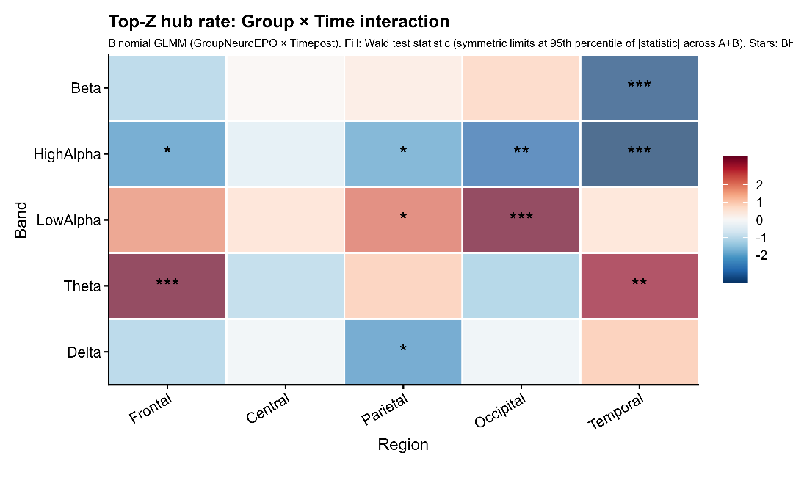
Fig. 1. Frequency-specific Top-Z rate reorganization (Group × Time interaction). Top-Z rate, where Top-Z nodes were defined, within each participant and session, as the top 10% of nodes ranked by $∣Value_{z}∣$within each frequency band (minimum 5 nodes per band). Top-Z selection was performed within band (pooling across regions), and Top-Z rates were then summarized within each band × region cell (minimum cell size = 5 nodes). For each frequency band × scalp region cell, Group × Time interaction effects (${\text{Group}}_{NeuroEPO}×{\text{Time}}_{post}$) were estimated using binomial GLMMs on Top-Z counts $k$out of total available nodes $n$(model: cbind(k, n−k) ∼ Group * Time + (1|ID)). Colors indicate Wald $z$-statistics (symmetric scaling). Asterisks denote BH–FDR-adjusted significance for the interaction ($p_{adj}<0.05$) across the 25 band × region tests. Nodes correspond to channel–frequency spectral features (Channel_Hz; z-scored log spectra), and edges represent EBICglasso-regularized partial correlations (feature-space conditional dependence), not phase-based connectivity.

To characterize the most robust Top-Z spatial pattern, Figure 2 focuses on the Low-Alpha band, where the Group × Time interaction was strongest in the occipital region and remained significant in the parietal region. Channel-level mapping further illustrates the scalp distribution of Low-Alpha Top-Z rate change (post − pre) contrasted between groups, supporting a posterior (parieto–occipital) pattern of treatment-associated redistribution.
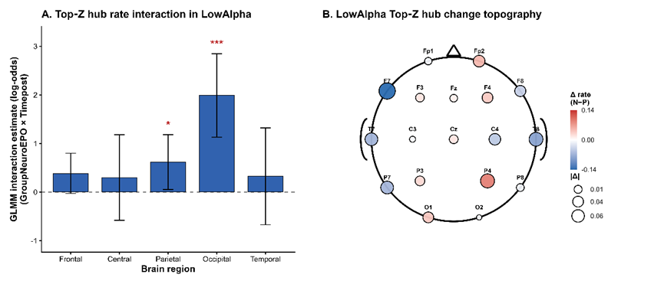
Fig. 2. Spatial localization of Low-Alpha Top-Z rate reorganization. (A) Region-level interaction effects. Bar plot showing Group × Time interaction estimates (log-odds; ${\text{Group}}_{NeuroEPO}×{\text{Time}}_{post}$) from binomial GLMMs for the Low-Alpha Top-Z rate. Error bars denote 95% confidence intervals computed as estimate ± 1.96 × SE. Asterisks indicate BH–FDR-adjusted significance ($p_{adj}<0.05$) across the five regional tests within Low-Alpha. (B) Channel-level topography. Scalp map showing the between-group difference in within-subject change in channel-level Top-Z rate (post − pre) for Low-Alpha, computed as $Δ_{NeuroEPO}−Δ_{Placebo}$. For each participant and session, Top-Z nodes were re-identified within Low-Alpha as the top 10% of available nodes ranked by $∣Value_{z}∣$. Channel-level Top-Z rate was defined as the proportion of that channel’s Low-Alpha frequency-point nodes labeled Top-Z; marker color encodes directional differences and marker size encodes effect magnitude.

3.3 Dose–Outcome Mediation: High-Alpha Temporal Top-Z Rate Reorganization and Clinical Change
To test whether dose-related network reorganization statistically linked exposure to clinical change, we performed bootstrap mediation analyses (2000 resamples) using cumulative NeuroEPO dose as the exposure and pre-adjusted post-intervention outcomes. Motor outcomes (MDS-UPDRS-III subitems and domain-resolved composites) were treated as the primary clinical focus. We screened Top-Z rate mediators and applied a stringent “both” criterion requiring (i) a non-zero bootstrap 95% CI for the indirect effect and (ii) significant a- and b-path coefficients (p < 0.05).
Across motor outcomes, the most consistent dose-dependent network–behavior coupling was expressed in High-Alpha temporal Top-Z rate pathways. These mediation effects linked dose to multiple MDS-UPDRS-III subitems spanning pronation–supination (left), rigidity (left upper and lower limb), and toe tapping (left), suggesting a frequency- and region-specific temporal High-Alpha pathway through which exposure relates to selective motor change. Consistent with the broader pattern of dissociation observed in this study, the band–region cells showing the strongest categorical Group × Time reorganization were not necessarily the same cells that most consistently captured continuous dose–motor coupling in mediation models.
In addition to motor findings, we observed exploratory evidence for non-motor dose–mediator–outcome coupling, including a Beta temporal pathway linking dose to Stroop word-reading time. Because the primary clinical focus of this manuscript is motor function and non-motor outcomes are not summarized in Section 3.3, these secondary findings are reported for completeness and should be interpreted cautiously pending replication.
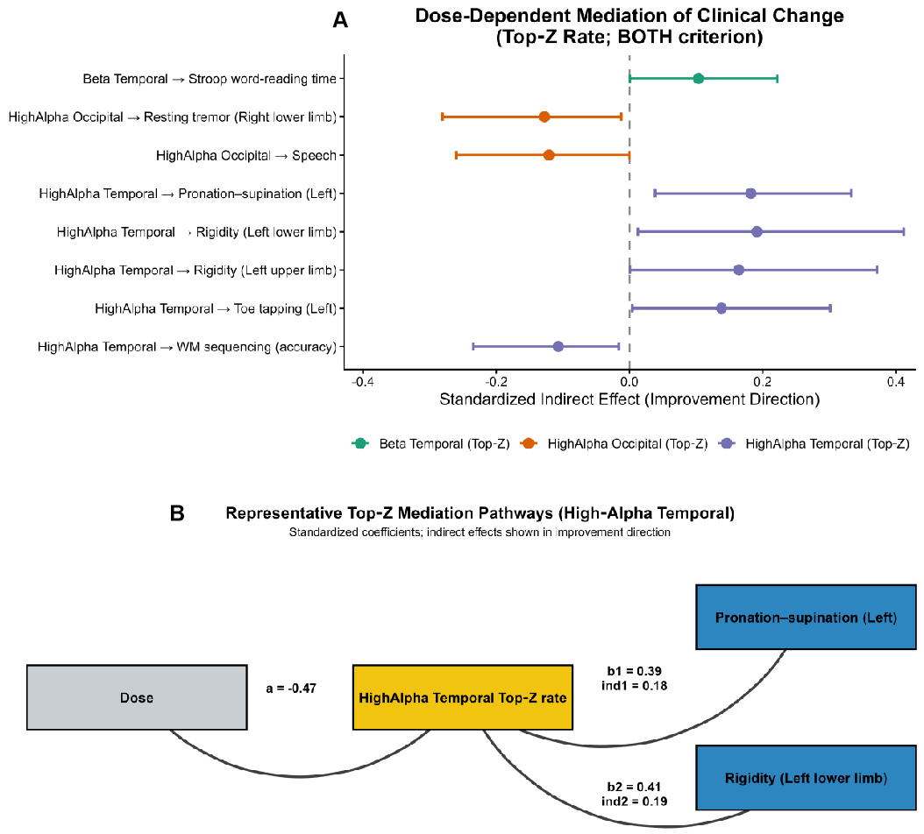
Fig. 3. Dose-dependent Top-Z mediation pathways. (A) Bootstrap-estimated standardized indirect effects (95% CIs) for dose → Top-Z rate mediator → outcome pathways that met the stringent "both" criterion. Analyses were restricted to Top-Z rate mediators; eight pathways met the criterion and are shown. For display, effects are oriented in the direction of clinical improvement (MDS-UPDRS-III items and Stroop times were sign-flipped because lower scores indicate improvement). The "both" criterion required that the 95% bootstrap confidence interval for the indirect effect excluded zero and that both the a- and b-path coefficients were significant (p < 0.05). (B) Representative standardized mediation diagram illustrating dose → post-intervention High-Alpha temporal Top-Z rate (controlling for baseline) → clinical outcome, annotated with standardized a, b, and indirect effects (shown in the improvement direction).

3.4. Clinical Outcomes
At follow-up, global motor severity did not show a clear between-group separation at the descriptive level. This section summarizes motor outcomes (MDS-UPDRS-III); non-motor outcomes are not presented here. At the domain-composite level, pre–post change scores (post − pre) indicated mean improvements (negative values) in Fine motor and Agility in both groups, whereas Rigidity and Tremor composites showed mean changes closer to zero with wider uncertainty (Figure 4). Overall, the pattern suggests that pre–post motor gains were more prominent for fine motor and agility than for rigidity or tremor at the domain level.
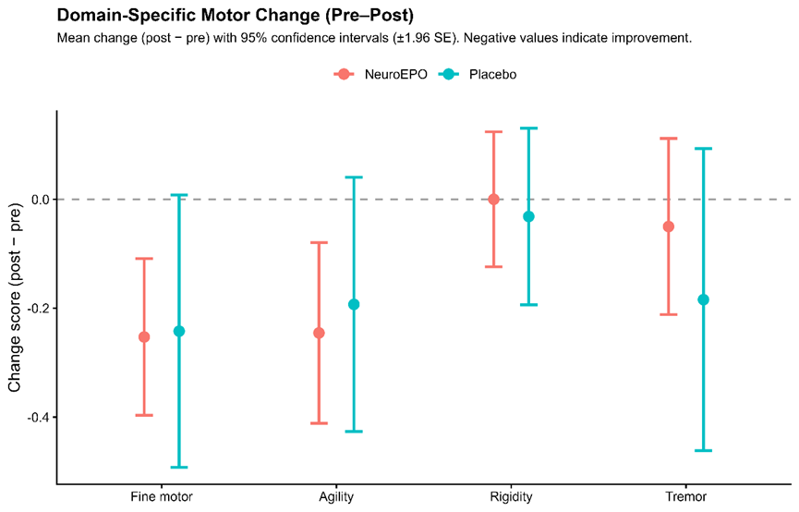
Fig. 4. Domain-specific motor change from pre to post. Mean change scores (post − pre) with 95% confidence intervals are shown for four motor domains (Fine motor, Agility, Rigidity, Tremor) computed as the mean of the corresponding MDS-UPDRS-III subitems. Negative values indicate clinical improvement. The Agility composite corresponds to gait/posture/freezing-related MDS-UPDRS-III items.
4. Discussion
This study links frequency-resolved EEG network reorganization to clinical change following NeuroEPO exposure by integrating Top-Z rate GLMMs with dose-based bootstrap mediation models. While categorical Group×Time interaction effects in Top-Z rates were distributed across multiple bands and regions—most prominently in posterior Low-Alpha Top-Z rates—dose-dependent network–behavior coupling was most consistently expressed through High-Alpha temporal Top-Z pathways. These mediation effects linked dose to several domain-resolved motor subitems (e.g., pronation–supination, rigidity, toe tapping), suggesting a frequency- and region-specific route by which exposure relates to selective motor change, even when global severity measures show limited between-group separation. A key finding is the distinction between (i) where treatment-related Top-Z rate reorganization is statistically detectable in Group × Time interaction models and (ii) where Top-Z rate changes most consistently relate to motor outcomes in dose-based mediation analyses. Under the Top-Z definition—based on participant-level standardized node values ($∣Value_{\left(z\right)}∣$), with Top-Z nodes defined within each frequency band and summarized as band × region rates—interaction effects were distributed across multiple bands and scalp regions, with the strongest categorical Group × Time shift expressed as a robust posterior Low-Alpha pattern (particularly occipital, with parietal also significant). By contrast, mediation analyses most consistently implicated High-Alpha temporal Top-Z rate pathways as statistical intermediates linking cumulative dose to improvement-direction motor outcomes. This dissociation indicates that the bands showing the clearest categorical Group × Time reorganization are not necessarily the same bands that best capture individual-difference network–behavior coupling along a continuous exposure dimension (Imai et al., 2010; Mišić and Sporns, 2016).
The predominance of High-Alpha temporal pathways in mediation models is consistent with the role of alpha-range dynamics in regulating cortical excitability and functional gating. In the present sensor-level feature-space framework, Top‑​Z rates quantify the concentration of high-magnitude standardized spectral-feature values within each band rather than graph-centrality-defined hubs. Dose-related redistribution of High-Alpha Top-Z rates over temporal scalp sensors may therefore index a frequency-specific shift in the prominence of high-alpha spectral features that covaries with selective motor change. Notably, “temporal” here denotes temporal scalp sensors, and inferences about anatomical sources are outside the scope of the present sensor-space network model.
Finally, the present findings should be interpreted in light of the Top‑Z definition: Top‑Z rates capture the concentration of high-magnitude within-participant standardized spectral-feature values within each band, rather than a topology-derived hub construct based on graph centrality. Within this feature-space framework, High-Alpha temporal Top-Z pathways most consistently mediated dose–motor coupling, supporting a frequency-resolved mechanism for selective motor modulation. Future work should test whether the High-Alpha temporal Top-Z mediation pattern generalizes across cohorts and whether convergent network markers (e.g., source-level or centrality-based measures under harmonized node definitions) yield similar dose–outcome coupling.
5. Limitations
Several limitations should be considered when interpreting these findings. First, the sample size, while sufficient to detect frequency-specific Top‑Z rate effects, may limit the generalizability of the observed mediation patterns and reduce sensitivity to smaller effects in other frequency bands. Replication in larger cohorts will be necessary to confirm the stability and robustness of the High-Alpha temporal Top-Z mediation pattern.
Second, Resting-state eyes-closed EEG is sensitive to fluctuations in vigilance/arousal, and low-frequency power (particularly in the Delta range) can be disproportionately affected by residual non-neural artifacts (e.g., slow drifts, eye-related activity) despite careful epoch selection and semi-automatic artifact rejection. Therefore, frequency-specific Top-Z rate findings—especially at the lowest frequencies—should be interpreted cautiously as reflecting spectral-feature redistribution in the available cleaned data rather than a definitive marker of neurophysiological change independent of state effects.
Third, networks were estimated in a channel–frequency feature space with condition-specific PCA-based feature retention prior to EBICglasso. As a result, the available node set (and therefore the denominator in Top‑Z rate estimates) could vary across conditions and across band × region cells. Although the binomial GLMM formulation explicitly models Top-Z counts relative to the cell-specific denominator and minimum-node rules were applied, variation in feature retention complicates interpretation: fewer retained nodes should be interpreted as fewer channel–frequency features exhibiting sufficiently stable multivariate structure under the fixed selection criterion, rather than as a direct measure of weakened coupling.
Fourth, the Top‑Z rate metric captures a distributional concentration of high-magnitude within-participant standardized spectral-feature values within each frequency band, rather than a topology-derived hub construct based on graph centrality. Accordingly, Top-Z rates should be interpreted as an index of frequency-resolved spectral-feature redistribution, and future work should evaluate convergent validity with alternative network measures (e.g., centrality- or source-level metrics) under harmonized node definitions.
Fifth although mediation analyses provide statistical evidence linking treatment exposure, network reorganization, and motor outcomes, causal inference remains constrained by the study design and the temporal resolution of measurements. While group-by-time interactions support treatment-associated change, the precise neurobiological pathways underlying the observed frequency- and region-specific Top-Z rate reorganization cannot be directly established.
Sixth, the study timeframe may not have been sufficient to capture potential global motor improvements that could emerge with longer-term follow-up. Network-level plasticity may precede broader clinical shifts, and extended observation periods may clarify the longitudinal relationship between Top‑Z rate reorganization and aggregate motor severity.
Finally, although we use the term “mediation” consistent with the statistical framework, the results should be interpreted as evidence of an indirect-effect pattern rather than definitive proof of a causal mechanism, given the measurement schedule and potential unmeasured confounding.

6. Conclusion
In summary, this study provides evidence that NeuroEPO exposure is associated with frequency- and region-specific redistribution of EEG Top‑Z rate organization and that dose–outcome coupling is most consistently expressed through High-Alpha temporal Top-Z rate pathways. Dose-based mediation analyses further indicate that High-Alpha temporal Top-Z rate reorganization statistically links exposure to selective motor outcomes, consistent with targeted domain-level modulation. Together, these findings suggest that treatment-related effects may be better captured by frequency-resolved network markers and domain-resolved motor phenotyping than by global severity measures alone, particularly when overall between-group separation is limited.
These results further suggest that EEG-based network markers may provide a sensitive systems-level readout of treatment-related neuroplasticity in Parkinson’s disease, complementing conventional clinical outcome measures.

References
Baggio, H.C., Sala-Llonch, R., Segura, B., Marti, M.J., Valldeoriola, F., Compta, Y., Tolosa, E., Junqué, C., 2014. Functional brain networks and cognitive deficits in Parkinson’s disease. Hum. Brain Mapp. 35, 4620–4634. https://doi.org/10.1002/hbm.22499
Benjamini, Y., Hochberg, Y., 1995. Controlling the false discovery rate: a practical and powerful approach to multiple testing. J. R. Stat. Soc. Series B Stat. Methodol. 57, 289–300.
Bringas Vega, M.L., Pedroso Ibáñez, I., Razzaq, F.A., Zhang, M., Morales Chacón, L., Ren, P., Galan Garcia, L., Gan, P., Virues Alba, T., Lopez Naranjo, C., Jahanshahi, M., Bosch-Bayard, J., Valdes-Sosa, P.A., 2022. The effect of NeuroEPO on cognition in Parkinson’s disease patients is mediated by electroencephalogram source activity. Front. Neurosci. 16, 841428. https://doi.org/10.3389/fnins.2022.841428
Brittain, J.S., Brown, P., 2014. Oscillations and the basal ganglia: motor control and beyond. Neuroimage 85, 637–647. https://doi.org/10.1016/j.neuroimage.2013.05.084
Buzsáki, G., Watson, B.O., 2012. Brain rhythms and neural syntax: implications for efficient coding of cognitive content and neuropsychiatric disease. Dialogues Clin. Neurosci. 14, 345–367. https://doi.org/10.31887/DCNS.2012.14.4/gbuzsaki
Epskamp, S., Borsboom, D., Fried, E.I., 2018. Estimating psychological networks and their accuracy: a tutorial paper. Behav. Res. Methods 50, 195–212. https://doi.org/10.3758/s13428-017-0862-1
Epskamp, S., Fried, E.I., 2018. A tutorial on regularized partial correlation networks. Psychol. Methods 23, 617–634. https://doi.org/10.1037/met0000167
Fortunato, S., 2010. Community detection in graphs. Phys. Rep. 486, 75–174. https://doi.org/10.1016/j.physrep.2009.11.002
Fries, P., 2015. Rhythms for cognition: communication through coherence. Neuron 88, 220–235. https://doi.org/10.1016/j.neuron.2015.09.034
García-Llano, M., Pedroso-Ibáñez, I., Morales-Chacón, L., Rodríguez-Obaya, T., Pérez-Ruiz, L., Sosa-Testé, I., Amaro-González, D., Bringas-Vega, M.L., 2021. Short-term tolerance of nasally-administered NeuroEPO in patients with Parkinson disease. MEDICC Rev. 23, 49–54. https://doi.org/10.37757/MR2021.V23.N1.10
Geraedts, V.J., Boon, L.I., Marinus, J., Gouw, A.A., van Hilten, J.J., Stam, C.J., Tannemaat, M.R., Contarino, M.F., 2018. Clinical correlates of quantitative EEG in Parkinson disease: a systematic review. Neurology 91, 871–883. https://doi.org/10.1212/WNL.0000000000006473
Goetz, C.G., Tilley, B.C., Shaftman, S.R., Stebbins, G.T., Fahn, S., Martinez-Martin, P., Poewe, W., Sampaio, C., Stern, M.B., Dodel, R., Dubois, B., Holloway, R., Jankovic, J., Kulisevsky, J., Lang, A.E., Lees, A., Leurgans, S., LeWitt, P.A., Nyenhuis, D., Olanow, C.W., Rascol, O., Schrag, A., Teresi, J.A., van Hilten, J.J., LaPelle, N., 2008. Movement Disorder Society-sponsored revision of the Unified Parkinson’s Disease Rating Scale (MDS-UPDRS): scale presentation and clinimetric testing results. Mov. Disord. 23, 2129–2170. https://doi.org/10.1002/mds.22340
He, B.J., Raichle, M.E., 2009. The fMRI signal, slow cortical potential and consciousness. Trends Cogn. Sci. 13, 302–309. https://doi.org/10.1016/j.tics.2009.04.004
Imai, K., Keele, L., Tingley, D., 2010. A general approach to causal mediation analysis. Psychol. Methods 15, 309–334. https://doi.org/10.1037/a0020761
Maiese, K., Li, F., Chong, Z.Z., 2005. New avenues of exploration for erythropoietin. JAMA 293, 90–95. https://doi.org/10.1001/jama.293.1.90
Mengozzi, M., Cervellini, I., Villa, P., Erbayraktar, Z., Gökmen, N., Yilmaz, O., Erbayraktar, S., Manohasandra, M., Van Hummelen, P., Vandenabeele, P., Chernajovsky, Y., Annenkov, A., Ghezzi, P., 2012. Erythropoietin-induced changes in brain gene expression reveal induction of synaptic plasticity genes in experimental stroke. Proc. Natl. Acad. Sci. U. S. A. 109, 9617–9622. https://doi.org/10.1073/pnas.1200554109
Mišić, B., Sporns, O., 2016. From regions to connections and networks: new bridges between brain and behavior. Curr. Opin. Neurobiol. 40, 1–7. https://doi.org/10.1016/j.conb.2016.05.003
Nácher, V., Ledberg, A., Deco, G., Romo, R., 2013. Coherent delta-band oscillations between cortical areas correlate with decision making. Proc. Natl. Acad. Sci. U. S. A. 110, 15085–15090. https://doi.org/10.1073/pnas.1314681110
Olde Dubbelink, K.T.E., Hillebrand, A., Stoffers, D., Deijen, J.B., Twisk, J.W.R., Stam, C.J., Berendse, H.W., 2014. Disrupted brain network topology in Parkinson’s disease: a longitudinal magnetoencephalography study. Brain 137, 197–207. https://doi.org/10.1093/brain/awt316
Reichardt, J., Bornholdt, S., 2006. Statistical mechanics of community detection. Phys. Rev. E 74, 016110. https://doi.org/10.1103/PhysRevE.74.016110
Rey, F., Balsari, A., Giallongo, T., Ottolenghi, S., Di Giulio, A.M., Samaja, M., Carelli, S., 2019. Erythropoietin as a neuroprotective molecule: an overview of its therapeutic potential in neurodegenerative diseases. ASN Neuro 11, 1759091419871420. https://doi.org/10.1177/1759091419871420
Rey, F., Ottolenghi, S., Giallongo, T., Balsari, A., Martinelli, C., Rey, R., Allevi, R., Di Giulio, A.M., Zuccotti, G.V., Mazzucchelli, S., Foresti, R., Samaja, M., Carelli, S., 2021. Mitochondrial metabolism as target of the neuroprotective role of erythropoietin in Parkinson’s disease. Antioxidants (Basel) 10, 121. https://doi.org/10.3390/antiox10010121
Rubinov, M., Sporns, O., 2010. Complex network measures of brain connectivity: uses and interpretations. Neuroimage 52, 1059–1069. https://doi.org/10.1016/j.neuroimage.2009.10.003
Siegel, M., Donner, T.H., Engel, A.K., 2012. Spectral fingerprints of large-scale neuronal interactions. Nat. Rev. Neurosci. 13, 121–134. https://doi.org/10.1038/nrn3137
Vervoort, G., Alaerts, K., Bengevoord, A., Nackaerts, E., Heremans, E., Vandenberghe, W., Nieuwboer, A., 2016. Functional connectivity alterations in the motor and fronto-parietal network relate to behavioral heterogeneity in Parkinson’s disease. Parkinsonism Relat. Disord. 24, 48–55. https://doi.org/10.1016/j.parkreldis.2016.01.016

