1. Git

ssh-keygen.exe -t rsa

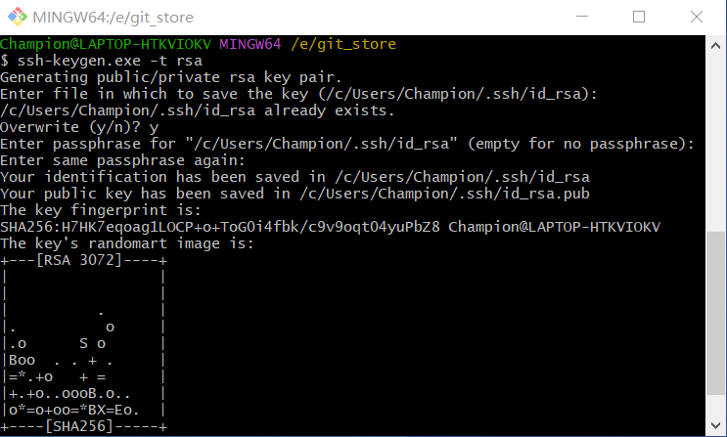

cat ~/.ssh/id_rsa.pub

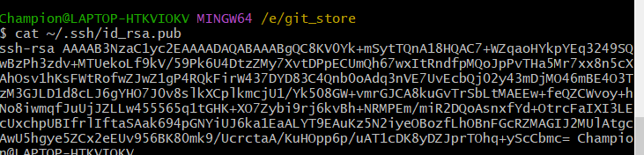

把公钥绑定到GitHub上

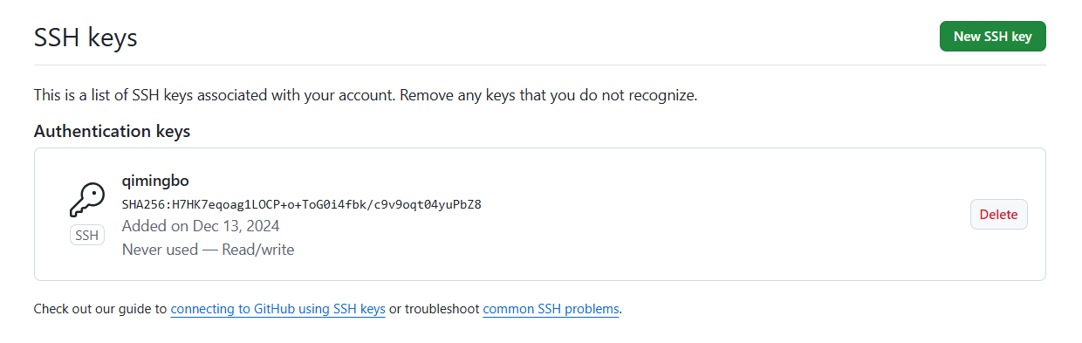

2安装TortoiseGit