Results
Search results

Basic features of the included articles
The analysis encompasses 16 articles,which collectively examines 17 studies.The total sample size has 2193 participants, with 1105 individuals assigned to the experimental group and 1088 individuals assigned to the control group.There are 1211 male participants and 982 female ones.The age of the samples ranges from 4.9 to 15.63 years. The intervention duration covers from 15 to 90 minutes, with frequencies from 1 to 5 times each week. The intervention cycles span from 2 to 12 weeks.The interventions are concentrated on sports and games programs. The assessed outcome indicators include enjoyment and satisfaction, intervention instruments and major findings. See Table 2 for detailed information.
Quality assessment(后面做）
Tests for bias
This research includes outcome indicators for analysis,and the funnel plot demonstrates a distribution that is symmetrical, indicating the absence of publication bias,as seen in the Fig. 3.
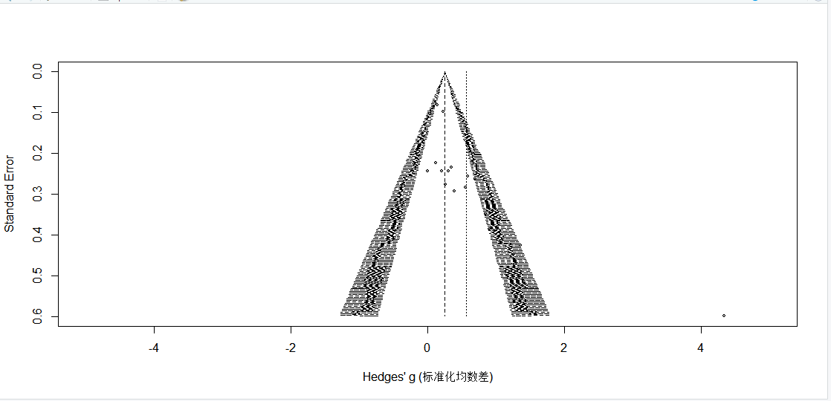
Fig. 3 Bias funnel plot

Efficacy tests
The relationship between teaching games in physical education and enjoyment of children and adolescents
Heterogeneity tests were performed on the articles that were included in the analysis. Out of the total, 17research indicated an altered association between the enjoyment experienced by children and adolescents in the context of teaching physicaleducation games . The researchers apply a random effects model to collect the findings about the articles’ outcome indicators. This study includes 17 studies and 2193 participants in total, with 1088 in the control group and 1105 in the experimental group. The present research provides evidence supporting the favorable impact of a physical education intervention using games on the positive emotions of children and adolescents in the experimental group (SMD = 0.56, 95% CI: [0.22, 0.90],P < 0.05), as depicted in Fig. 4

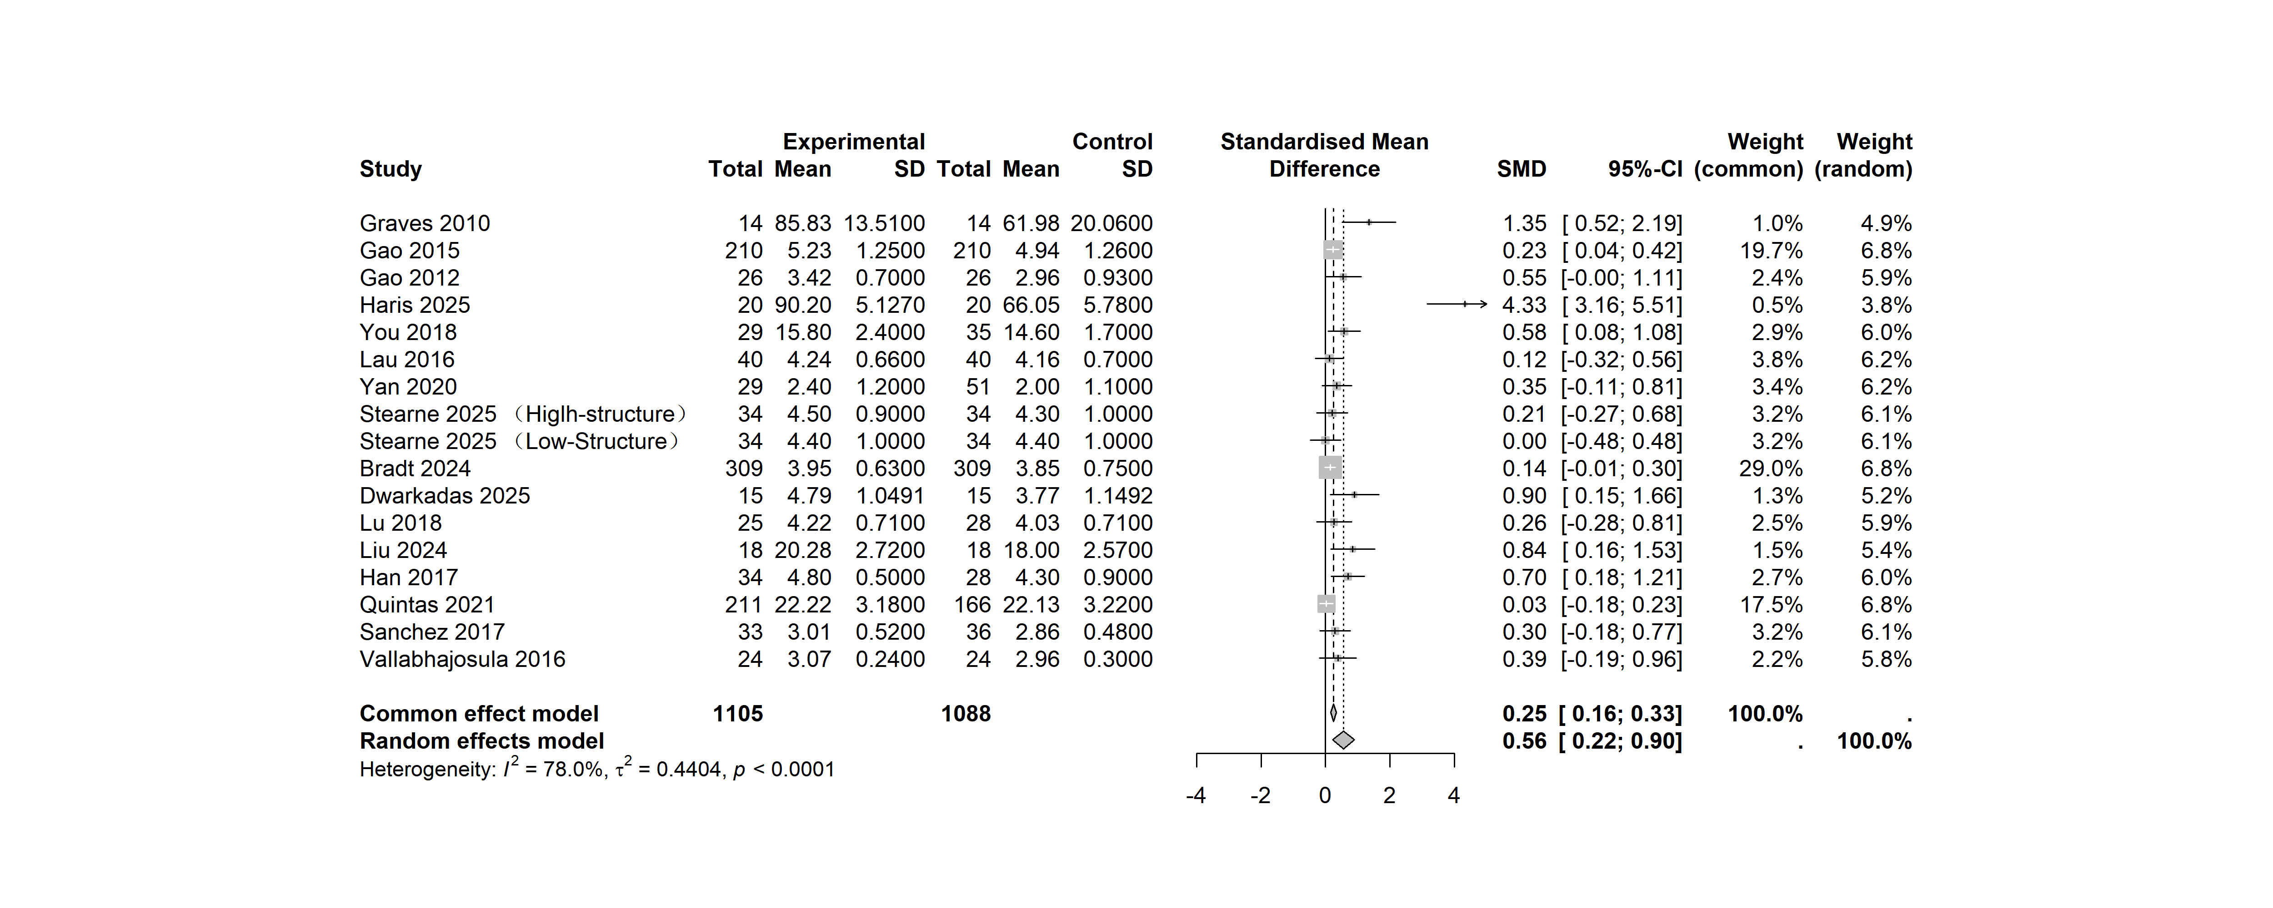
Fig. 4 Forest plot depicting the relation between physical game teaching and enjoyment in children and adolescents

Subgroup analyses
The combined impact size data for effectiveness of gamification on children and adolescents show a significant degree of variation. It is achieved by analyzing subgroups based on gender, age, duration, frequency, bmi ,location and exercise Intensity as potential influencing factors.
The results of subgroup analyses examining the influence of gender, age, duration, frequency,bmi ,location and exercise Intensity. On the effects of gamification indicate that when boys accounted for less than 50% of the total participants, gamification failed to produce a statistically significant overall effect$( SMD=0.13,95\%CI:[−0.15,2.20],P>0.05)$;in contrast, when boys made up more than 50% of the sample, these games exerted a significant positive overall effect ($SMD=0.23,95\%CI:[0.13,2.20],P<0.05$).Furthermore, it is observed that childhood experienced an increasing enjoyment$(SMD=0.33,95\%CI:[0.20,0.46],P<0.05)$, whereas adolescents aged 12 and above do not show a similar increase (P > 0.05). The duration of gamification ranging from less 40 minutes $(SMD=0.39,95\%CI:[0.24,0.52],P<0.05$can provide a favorable impact on enjoyment experienced by children and adolescents. Moreover, extending the duration of gamification beyond 40 minutes$(SMD=0.18,95\%CI:[0.04,0.34],P<0.05)$ may also improve their enjoyment. It is more feasible to provide gamification within a frequency range of less 3 sessions perweek $(SMD=0.27,95\%CI:[0.12,0.43],P<0.05$ to elicit enjoyment among children and adolescents. Constantly, it is suitable to give gamification, exceeding the threshold of 3 sessions per week $(SMD=0.25,95\%CI:[0.10,0.42],P<0.05)$. The optimal duration for physical game teaching to elicit enjoyable outcomes in children and adolescents is more than 8 weeks $(SMD=0.46,95\%CI:[0.17,0.77],P<0.05$, but durations less 8 weeks are also considered acceptable$(SMD=0.20,95\%CI:[0.08,0.32],P<0.05)$.Meanwhile,it is clear that children and adolescents with normal body weight experienced pleasure $(SMD=0.39,95\%CI:[0.14,0.65],P<0.05)$, while those with a larger body size reported greater pleasure$(SMD=0.92,95\%CI:[0.56,1.28],P<0.05)$.Furthermore, this study demonstrates that gamification significantly enhance engagement and enjoyment among children and adolescents in North America$(SMD=0.49,95\%CI:[0.23,0.74],P<0.05)$, while showing no significant effect in Asia and Europe$(P>0.05)$.The limited research (9 articles) demonstrates that moderate-to-high-intensity gamification significantly enhance children's engagement and enjoyment$(SMD=0.35,95\%CI:[0.11,0.60],P<0.05)$
However, when reduced to moderate intensity, the enjoyment of participation among children became insignificant$(SMD=0.54,95\%CI:[−0.13,1.22],P<0.05)$. Hence, such factors as gender, age, duration, frequency, cycling ,bmi ,location and exercise Intensity contribute significantly to the observed variation in satisfaction, as seen in Figs. 5, 6, 7, 8, 9.

