Yum install ibus-libpinyin

Applications --> system tools --> setting --> Region & Language

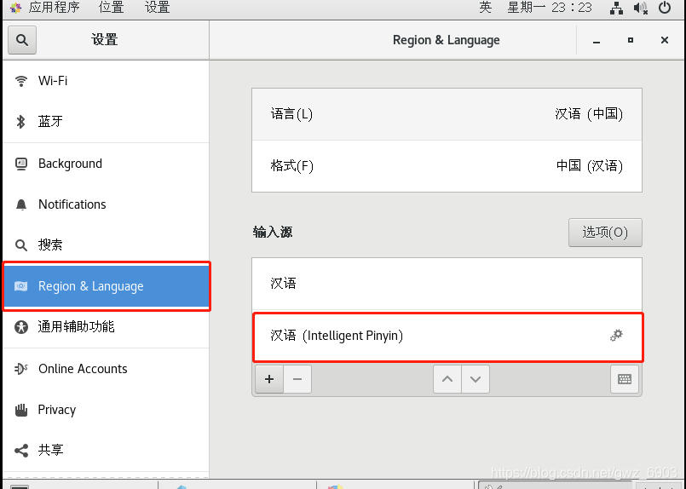

输入源（Input sources）

增加 Chinese (intelligent Pinyin)

按shift进行切换

<https://blog.csdn.net/gwz_6903/article/details/100679186>