Assignment 4 – Active Cloud Site

Group 3.

Qing Qi

Wenwen Zhang

1.We exploited 52-Week Price Range Strategy in the article

<https://www.aaii.com/journal/article/quantitative-strategies-for-selecting-stocks>

to recommend top stocks based on the threshold of 0.82. If the price score computed by this

formula below is larger than 0.82, we suggest that this is a shock that we could buy:

price score = (current price-low price of 52 week)/ (high price of 52 week – low price of 52 week).

2. The Link to GitHub repository: <https://github.com/qing2qi/2018_Fall_Assignment4_ActiveCloudSite>

We create a method recommend in HomeController class to implement stock recommendation function. We add one column in the Company table to store the price Score value. Firstly, we get all companies in the database. Secondly, we find the equities by companies’ symbols from extend web link. Thirdly we compute the price score base the formula above and return those stock larger than 0.82 to the page. Meanwhile, we send those data to front page to display the price scores of all stocks using chart.js. The page screenshot shows below:

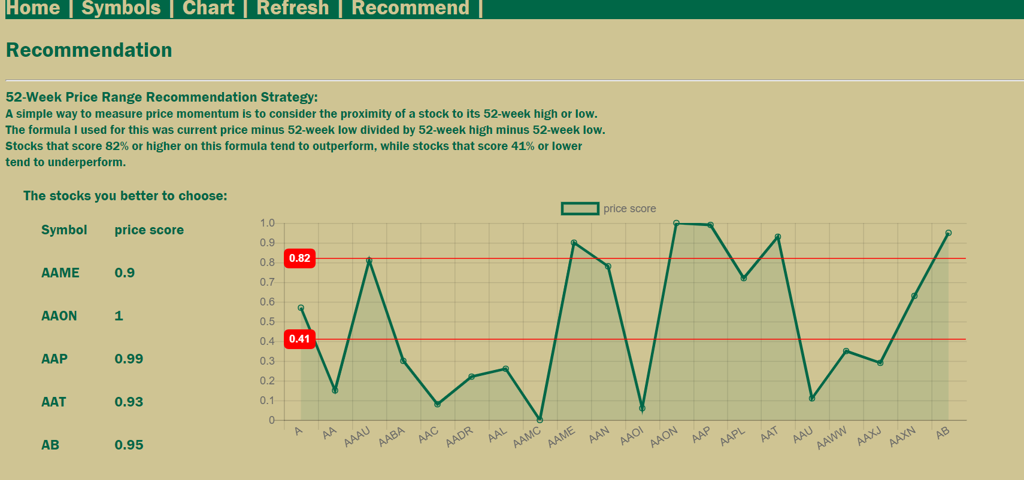

3. We deployed the current project to the Azure cloud platform. It is useful for us to learn Azure. <http://qingapp.azurewebsites.net>

4. We spend more than 48 hours to learn IEX Trading API, the MVC applications, EF frame and Chart.js. Through delving into the original project provide on the Github below and accomplishing the stock recommendation function,

<https://github.com/ISM6225/2018_Fall_Assignment4_ActiveCloudSite>

we mastered how to exploit MVC frame to develop application and known that chart.js has lots of properties that could help us show the information easily. After we create new attributes in database, the EF Frame cannot update database. We do a lot research about the problem but cannot find good way to deal with this problem. We just delete original database firstly then create new one when we change the table.