**Analysis:**

**The long term trend** for quarterly total beer consumption in New Zealand is decreasing. Apart from a **slight increase** from 3.2 litres per quarter in **late 2007** to approximately **3.4million** litres per quarter in 2008 probably due to a good year of beer sales in that year possibly **due to the recession** that occurred nation-wide beer may have been used as a stress release. This represents a 0.2 million litre increase as quantifying the trend gives (3.1 -2.9)/51 = 1960 litres rounded to approximately 2000 litres per quarter. The long term trend does not seem to decrease a large amount but there does seem to be a notable decrease from approximately 3.1 million litres when the investigation first begun in 2000, to approximately 3.0 litres when the investigation finished in late 2012. In 2011 there was **another small increase** in the consumption of beer In New Zealand, this may have been **due to the Rugby World Cup** event which would have influenced the consumption rates as alcohol is closely linked to high tension sports such as rugby. The rugby world cup would also have meant that there was a temporary increase in the population (the adult population) thus it would also affect the beer consumption. **This information is taken from Maths NZ resources**.

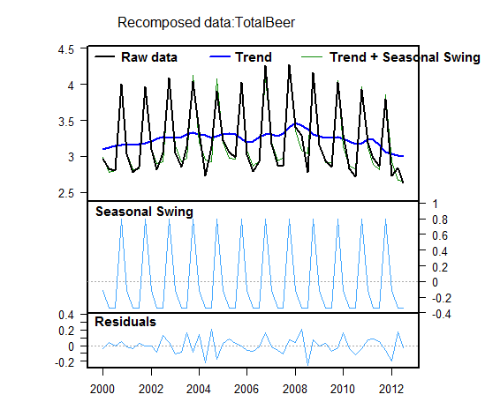

**Residuals:**

In the plot of the residuals above for the graph of Beer Consumption in New Zealand (Source: Statistics New Zealand), the observed values have a range of approximately 4.3 -2.7 million litres which results in a range of 1.6 million litres. The most significant residuals therefore must have a residual equal to or greater than 0.16 million litres.

The first largest positive residual occurred in the 4th quarter of 2004 and is about 0.2 million litres of beer consumed over the expected amount consumed for that year. This may be due to extreme weather that occurred in early 2004. The storm that affected New Zealand was reportedly the worst storm New Zealand has had for the past 10 years. Beer therefore, may have been used as a coping mechanism as people would have to spend long periods of time inside and beer is often used during cold weather as a bi -product of the breaking down of the alcohol in our system is heat, so beer could have been used as a heating mechanism during this stormy period.

The second significant positive residual occurred in the second quarter 2008 and is about 0.2 million litres of beer consumed over the expected amount consumed for this quarter. This may be due to the recession that hit New Zealand between ec 2007 - June 2008, because this high positive residual occurs quite early on in 2008 we can assume that beer was consumed as a stress relief in these troubled times and many people turned to alcohol as an escape method.

The first significant negative residual occurred in the second quarter 2004 and is approximately 0.22 million litres consumed less than the estimated or expected for this quarter. This may be due to the decrease in beer available for consumption in 2004. According to Statistics New Zealand, “The volume of beer available for consumption in the December 2004 year decreased by 0.2 percent compared with 2003.” This would have meant that there was less beer for New Zealanders to buy therefore they consumed less.

The second significant negative residual occurred in the third quarter of 2008 and is approximately 0.25 million litres consumed less than the expected beer consumption for this quarter. This may have been due to the fact that the recession hit New Zealand from Dec 2007 - June 2008 which would have surprised a lot of people and took a toll on people as the recession progressed meaning that by the third quarter of 2008, New Zealanders were forced to give up their beer purchases/consumption in order to be wise with their money.

Because these residuals are quite large, it makes me unconfident to make assumptions for the future statistics of beer consumption in New Zealand as an event could suddenly occur that might drastically affect beer consumption quantities.

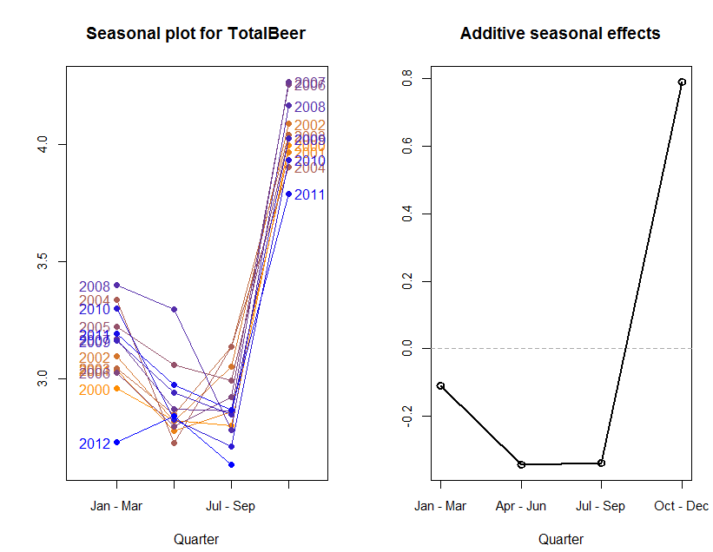

**Seasonal effects:**

The seasonal patterns for beer consumption in New Zealand between 2000 -2012 are on the whole quite similar. The maximum level of beer consumption occurred in October - December quarter where it is around 0.8 million litres above the trend, while in both April-June and the July-September quarter is around 0.5 million litres below the trend. The seasonal plots for 2008 and 2012 seem inconsistent with those of other years. In the second quarter (April-June) of 2008 the level of beer consumed appears higher than for the same times in other years. This is the same result for 2012 as well. In 2012 the amount of beer consumed in the second quarter is higher than in the first quarter. This is different because for all of the other years, the first quarter is higher than the second. As a result of these differences, If I were to forecast, it may be unreliable because the Holt- Winters model places more of an emphasis on the later data values when calculating the forecast, therefore it tends not to focus on the earlier data values.

The maximum average seasonal effect occurred as stated in October - December quarter for all years (2000-2012) this may be because these are the month(s) leading up to christmas and holiday seasons which tends to see an increase in all alcohol and beer consumption as people do not have work to worry about the next day and it is traditional to have alcoholic beverages at holiday celebrations. Beer is usually part of the Christmas celebrations and is consumed with friends and family. The minimum average seasonal effect occurs in April-June of all years between 2000-2012, this may be due to many different factors to which I can not find statistical reasoning or evidence, but perhaps because this is in the middle of the working year and University semester. There are not usually any large events during these months that would make beer consumption in New Zealand increase.

There is not much difference between the seasonal effect trough of the months April-June and July-September quarters. What is surprising is that there is quite a significant seasonal effect value for the January-March quarter, it also seems to be quite consistent apart from the 2012 value. This could be caused by New Year's celebrations (from all cultural groups) in New Zealand. However from the seasonal effects graph we can see that Christmas seems to be more of a time to celebrate with beer than New Years as people may like to treat themselves to a higher alcohol percentage beverage such as wine for New Year’s whereas beer is a more go to Christmas alcohol. This makes me more confident in forecasting for the future especially for the October-December quarter. Beer is also a more refreshing beverage and because Christmas in New Zealand comes in the warmer months, beer is a popuular cooling beverage (Source: <http://www.stuff.co.nz/marlborough-express/your-marlborough/beer/9534362/Beer-for-the-Christmas-season>)

**Variability in a time series:**

The range of values for each of the following components can be read off of the graphs included in this report. All percents are to three significant figures.

|  |  |  |  |
| --- | --- | --- | --- |
|  | Spread (Millions of Litres) | Range (Millions of Litres) | Percentage of raw range |
| Raw | 3.0 to 4.3 | 1.3 |  |
| Trend | 3.1 to 3.0 | 0.1 | 7.69% |
| Seasonal | -0.3 to 0.8 | 1.1 | 84.6% |
| Residual | -0.1 to 0.2 | 0.3 | 23.1% |

The main source of variation in the total amount of beer consumed in New Zealand (in millions of litres) between 2000-2012 appears to be accounted for by the trend with approximately 84.6% of the overall variation explained by the trend. Compared with the effects of the long term trend of a slow decrease in total beer consumption and the residuals, the contribution of seasonal effects is large.

**Forecasts:**

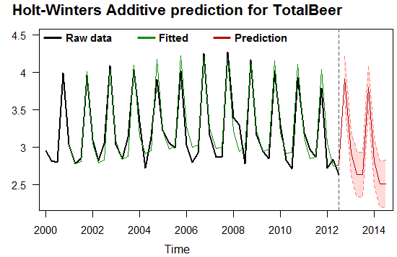

‘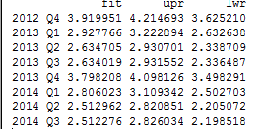

The model forecasts that in the fourth quarter of 2012 total beer consumption in New Zealand will be approximately 3.9 million litres (the actual value is very likely to lie between 3.6 million litres and 4.2 million litres).

A visual inspection of the model from 2000 -2012 indicates a reasonably good fit which means I can have confidence in the predictions. The Holt-Winters model does, however, put greater emphasis on the most recent data and this is where the greatest variation from the model is observed, particularly in 2006 onwards. So there is potential for the forecast to be inaccurate.

By removing the data set the three quarters from 2014 and making ‘forecasts’ for these quarters using the Holt-Winters model, the following values are produced 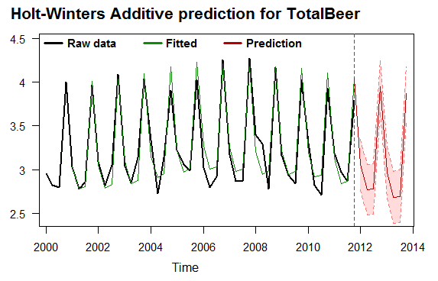

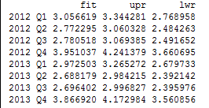  
  
  
  
  
  
  
  
https://lh3.googleusercontent.com/nUrFevMggFtjxul6cjbr0XeGXeWykwRKQroXJFMaGfacYwynh7q0IVEjvY9tjY2j3MeRVvh-d-ufkf-KwllQH_fkRsfx4j63JU5i76vixtlwla5rBxem9_OFukNMEwh34VxvsOea

It can be seen that two of the actual value of total beer consumption lies within the limits of the ‘forecast’ values which partially confirms the reliability of forecasts using the model. However the first predicted value differs with the actual reading on the original graph in that the predicted value deviates 0.328 million litres and does not lie within the limits, therefore this decreases the reliability of the prediction. The further away from the historical data we get, the less confident I get in determining forecast reliability.

Therefore because the first quarter of 2012 prediction does not lie within the limits, but in contrast the second and third quarter do I have different levels of confidence in the predictions for each quarter due to the differing range sizes. 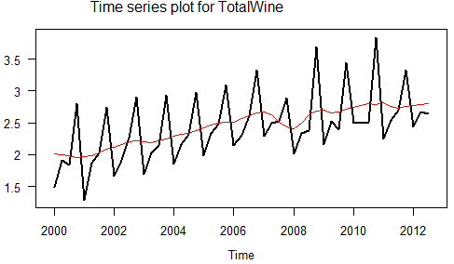

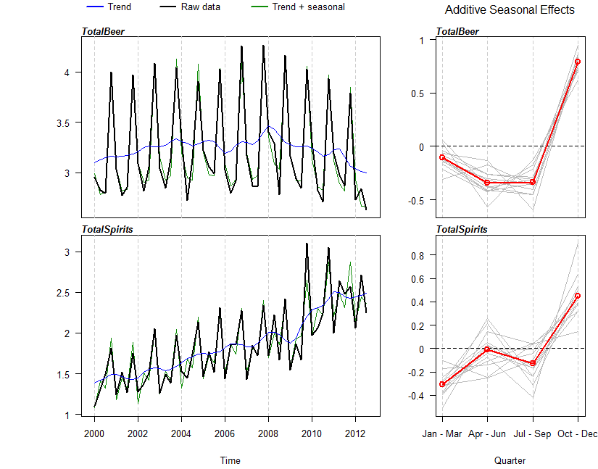  
  
  
  
  
  
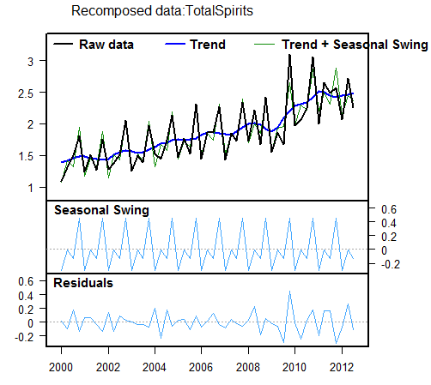

**Comparing variables:**

Comparing the overall trend and seasonal effect between total beer consumed and total spirits consumed we can see that the overall trend of beer consumption is decreasing (as stated in report) whereas to the overall trend of total spirits consumed in New Zealand appears to be increasing at a higher rate. Both graphs are not symmetrical/ linear and have high peaks and low troughs. Total beer consumed in New Zealand is increasing at a rate of 0.0375 million litres between the years 2000 to 2008 however after this point there is a change in trend and the total beer consumed in New Zealand decreases at a rate of 0.2 million litres from 2008 to 2012. Comparing this to the total spirits consumed in New Zealand, there is a 0.0917 million litre increase for the duration of the investigation (2000 to 2012) in a more linear fashion than the total beer consumption.

The total spirit consumption does appear to have a large trough in 2008 where it drops from 2 million litres to 1.7 million litres of spirits consumed in a very short period of time. This may be due, like the fall in beer consumption at this time, to the global recession ( Source: <https://www.drugfoundation.org.nz/mythbusters/drinking-during-hard-times>) as there would have been a realisation that wasting money on spirits or alcohol was not smart at this time when money was not coming in. To save money many New Zealanders made a choice to reduce their spirit and alcohol intake and this can be seen in the total spirit consumption graph. The global recession began in december of 2007 and ended in June 2009, so this covered the time period that the trough is observed in (Source: <https://en.wikipedia.org/wiki/Great_Recession>).

After June 2009 when the recession ended, the trend returns back to its steady increase in total spirit consumption in New Zealand, whereas to the trend in the total beer consumption in New Zealand after 2008 decreases. The increase after the recession of total spirits consumed seems to be at a faster rate, as the increase is now at an average of 0.2 million litres consumed between the years 2009 to 2012. Looking at research from wikipedia on the increased popularity of alcopops I am assuming that this faster rate of increase is due to the larger amount of teenagers drinking spirits such as alcopops which became a lot more popular as they taste more like a fruity soda drink and so can be consumed easily by this generation ( Source:<https://en.wikipedia.org/wiki/Alcopop> ).  At the time (2009 to 2012) alcopops were new on the market as well so would have been purchased and consumed a lot more as they were aimed/ advertised at young adults.

The total spirit consumption in New Zealand has a significant peak in 2011, just as the total beer consumption also had a peak at this time. As justified for this peak in total beer consumption, it can be assumed, and also researched that the peak was a result of the increase in sport events as alcohol is a large part of that culture. Alcohol and spirits sold not only in off-licensed stores but also in restaurants would have increased as tourists chose to dine out instead (Source: <http://www.stats.govt.nz/browse_for_stats/economic_indicators/NationalAccounts/impact-of-rugby-world-cup.aspx>).

Looking at the average seasonal of both graphs, the appear to be quite similar. Both seasonal effects graph for total beer and total spirit consumption has a reasonably small peak in the January to March quarter which I have explained earlier in the report that it may have been due to New Year’s celebrations and also because the hot summer weather brings events and  encourages people to have a cool drink of beer or spirits etc. Again in both seasonal effects graphs, there is a large peak in the October to December quarter. This can be reasoned for both to be because of the Christmas celebrations. However unlike the total beer consumption seasonal effects grah, the total spirits consumed has a peak in the April to June quarter, however, there seems to be some inconsistency with this peak as the un averaged lines are very varied. This could be caused by teenagers being experimental with the different flavours of alcopops around this time. Similarly the total beer consumption season effects graph also has a fair amount of inconsistencies around the April to June quarter as well.

I have considered the multiplicative data and have concluded that it less of a better fit between the raw data and the model, so I have analysed the additive data only as this seems to show that it is a better fit to the model.

**Conclusion:**

Relating this analysis and forecasting back to the purpose, The amount of beer consumed in total in New Zealand has an overall decreasing trend. It is significantly affected by events such as the global recession and the rugby world cup as well as seasonal impacts such as Christmas, New Year’s and the summer season. These events have also caused an increase in the total spirit consumption. So the overall consumption of beer in New Zealand has not decreased by much compared to the rate of increase in spirit consumption but from making and analysing a forecast I can predict that this decreasing beer consumption trend will continue in the years after 2012.

So the beer culture in New Zealand does seem to be slowing but looking at the increase in spirit consumption tells us that new Zealand’s alcohol consumption as a whole is not slowing, in fact because the total amount of spirits consumed is happening at quite fast rates it seems that alcohol culture is on the rise (can also look at included total wine raw trend graph as it is increasing as well).

Talk about the forecasting

Who would find these results useful, conclusion is summarising the report. Marker wants to be able to see what the main points are.

Home brewing might also have been a reason that beer consumption increased because it would have encouraged people to make their own

**Excellence is showing insight**, **proofread and make sure the sentence make sense, and why are you interested in this investigation - what does it have to do with the world and with you?**

**Think about the economic situation and large events.**

**Research is very important because it shows insight.**

**Does not have to be perfect.**

**NZ Herald and Stuff are excellent website for evidence.**

**The whole procedure is to make a forecast, that’s what you say in the purpose.**

**Read through the high excellence example in work book.**

**Holt winters = more on later values - might not be in line with the model, talk about the distance between raw data and holt winters model.**

**Look for fluctuations for confidence.**

**Show that you understand what the data means and know about the topic.  PROOF READ!**

**Focus on the basic structure of PPDAC.**

**Always justify!**