Criterion B: Design

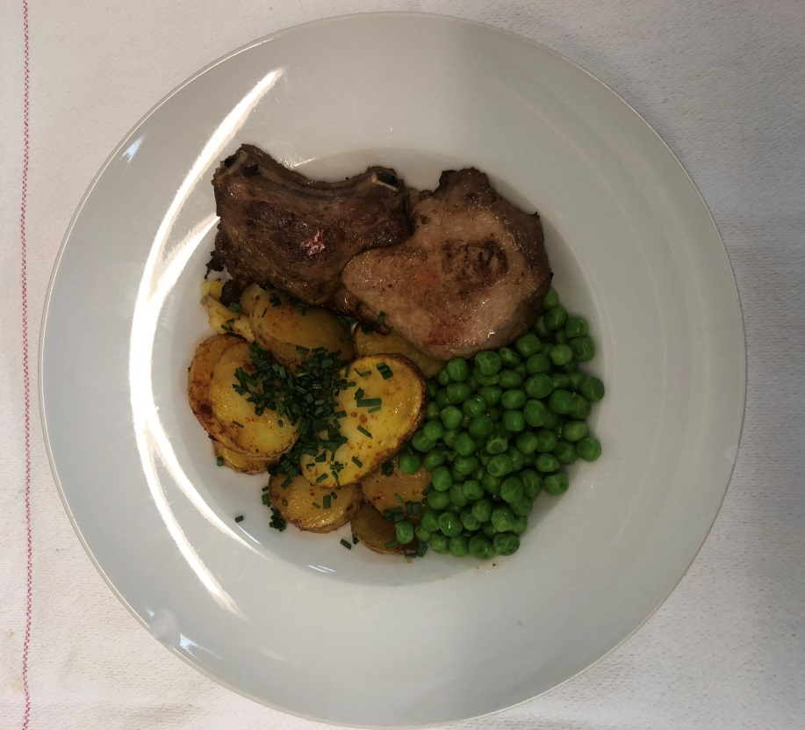

Menu 1

Task number | Planned action | Planned outcome | Time estimate | Target completion date | Criterion
1 | Brainstorming | Ideas for project | 30 minutes |  | A
2 | Initial discussion with advisor –  Comp Sci Teacher | Ideas approved by advisor: Mr Harlington | 10 minutes |  | A
3 | Interview with cooks | Researching more about
4
5
6
7

