**MyShake: Building a global smartphone earthquake early warning system**

*Qingkai Kong, Asaf Inbal, Richard Allen and Jennifer Strauss, Berkeley Seismology Lab, UC Berkeley*

**Summary:**

MyShake is a project aims to build a global smartphone seismic network to enable earthquake early warning capability by using the power of crowdsourcing. It utilizes the sensors inside everyone’s smartphones to monitor the earthquakes. The motivation of this study is to build a seismic network that can be easily scaled it up to a dense network globally to provide useful earthquake early warning to the public, especially places where they cannot afford traditional seismic stations. After MyShake released to the public in Feb 2016, we have more than 300,000 people downloaded and the network have already been covered the whole global within very short time. In this study, we will discuss the aspects of issuing earthquake early warning through this smartphone network.

**Introduction:**

The Earthquake Early Warning System (EEWS) can be used to reduce the earthquake hazards by issuing warning to people before the largest shaking arrives. It is has been already implemented in a few countries where they all share earthquake hazards (*Kanamori* 2005; *Allen et al.* 2009). It uses the principle that P wave travels faster than the S wave, but S wave carries more energy that usually causes the damages. If we have sensors could detect the P wave and send out an electronic signal that travels at the speed of light, and people at further places from the epicenter could get a warning even before the large shaking arrives at their locations, since the seismic waves travel at the speed of sound. This is similar to the fact that during the thunderstorm, we could see the flash first and then hear the sound a few seconds later due to the different travel speed of light and sound. The earthquake early warning has already been proved to be useful to reduce the earthquake hazards in the past earthquake, i.e. Japan, Mexico, and California etc. But building and running an earthquake early warning system is not easy, not only you need the expertise, but also the high cost associate with it. Therefore, it is not available to all places where they expose the earthquake hazards. We need to have an approach that a low-cost seismic network could be build to make the earthquake early warning available to all the people who are close to the earthquakes. There are various efforts alone this line, for example, the Quake Catcher network (*Cochran et al.* 2009*)*, Community Seismic Network (*Clayton et al.* 2011) and the P-Alert (Hsieh et al. 2014; Wu 2015) all explored using the low-cost dedicated sensors to do earthquake early warnings. But these networks also share the same deployment and operation complexity that are not easy to scale it up to a global network. MyShake is exploring a different approach that using the power of crowdsourcing. With a simple click to download the MyShake application, it could turn your smartphone into a seismometer and start to monitor the earthquakes. We don’t need to send out the engineer teams and the hardware to deploy this network, at the same time, the maintenance of the phones are made easy by the user themselves.

But of course, there are many more new challenges involve with this smartphone seismic network that we need to address. For instance, how the sensors inside the phones could be used to detect earthquakes in a noisy environment that all kinds of human activities are making the problem difficult, how could we take into account of many smartphones to confirm the earthquakes detected by this network, how to deal with the fact the configuration of the network is constantly changing, etc.

**MyShake Methodology and Observations:**

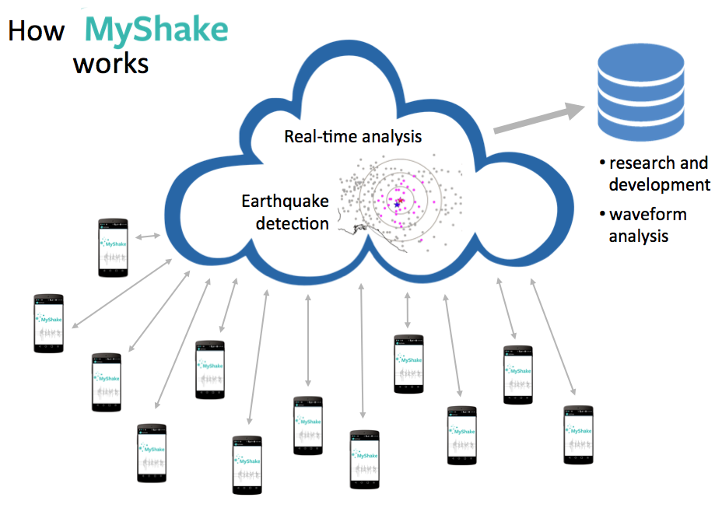

Figure 1: How MyShake works. This is the structure of the MyShake system. It consists of end users (MyShake users), a cloud to aggregate information from multiple sensors inside the smartphones to detect the earthquake and issue earthquake early warning, and databases to collect the waveform data from the sensors.

****MyShake is a smartphone application that can turn the daily used smartphones into portable seismometers. It monitors the accelerometers inside the phones and distinguishes the earthquake movement experienced by the phone from the daily human activities. *Kong et al.* (2015) and *Kong et al.* (2016b) discussed the implementation of the whole network including the Artificial Neural Network (ANN) running on the single phone to separate the earthquake movements from the daily human activities and the network detection algorithm to detect the earthquakes based on the information from multiple smartphones in a region. These core algorithms make the building of this smartphone earthquake early warning system feasible. The whole infrastructure was implemented in a way that data from smartphones can be handled at central cloud server and issue earthquake early warning to the public. Figure 1 shows the structure of the system: the users download MyShake to their phones, which will turn their phones into portable seismometers.

The ANN algorithm runs on the phone will responsible for the detection of the motion, and make a decision whether it is earthquake-like motion or not. It uses a sliding window approach to extract useful features from the waveforms that can best characterize the earthquake and human motions, features extracted are similar to the ones described in *Kong and Zhao* (2012). These features are fed into the ANN algorithm to let it distinguish earthquakes from the normal human activities. If it thinks the motion that the phone experiencing is like earthquakes, it sends a real-time message including the time of the detection, the location of the phone, and the amplitude of the movement back to the cloud server. On the server, a network algorithm is monitoring the incoming messages from multiple phones in a region, essentially conducting a clustering analysis in real-time to find spatial and temporal clusters to confirm earthquakes. Once an earthquake is confirmed from multiple smartphones, the location of the earthquake, origin time, and the magnitude of the earthquake will be estimated based on the data we collected.

Not only we collect data in real-time, but also 3-component acceleration waveform data will be collected as well when the phones are connected to power and WIFI. As shown in Figure 1, the waveform data will be stored in the database for further research analysis and fine-tuning of the system. *Kong et al.* (2016a) reported the initial observations from the waveform data recorded by MyShake users. The example from the 2016 Borrego Springs M5.2 earthquake shows clear that most of the phones could trigger on the P wave arrivals and the S wave arrivals. The waveforms from the MyShake compare with the nearby seismic stations are matching well, which illustrate that we could extract the key parameters from the waveform to estimate the earthquakes. Besides, the PGA values from MyShake show the same attenuation as that from traditional seismic network.

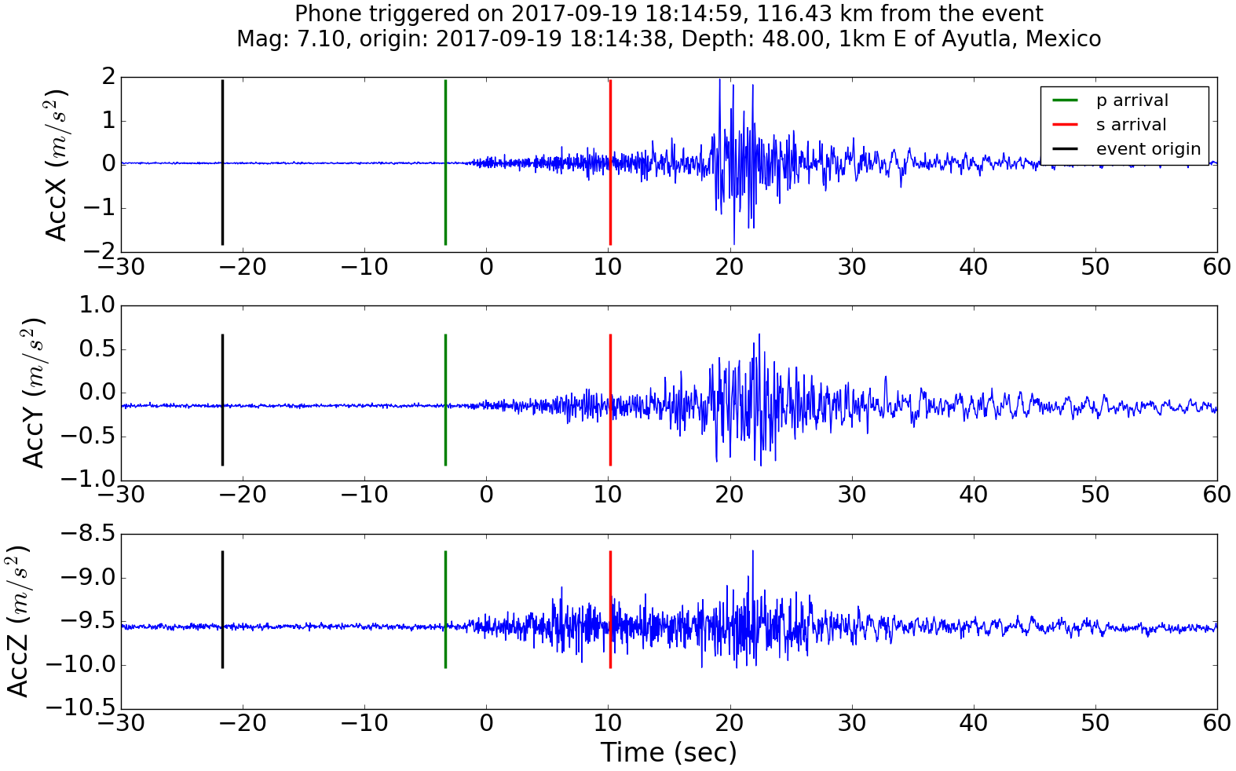

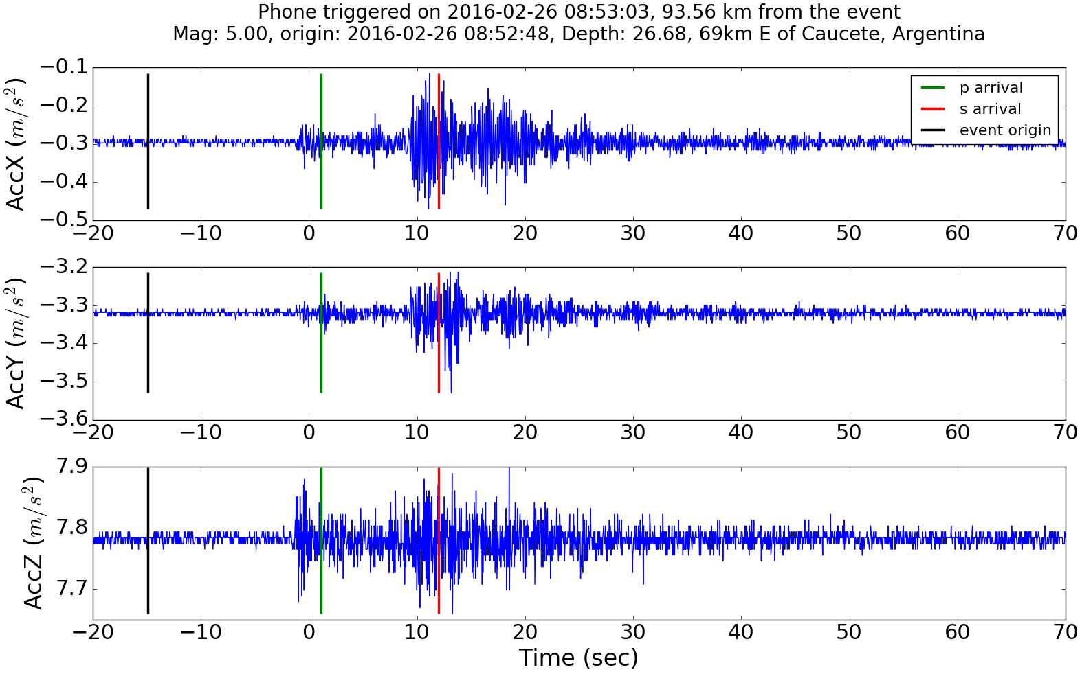

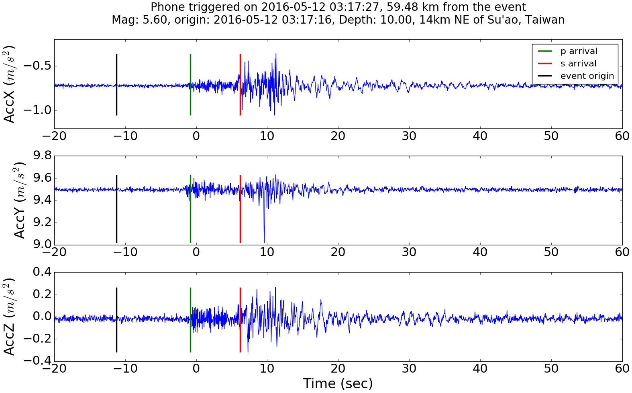

Figure 2: ANN Detections on the P wave. Time zero is the ANN detected the event. The top 3 waveforms are recorded by a MyShake user at Mexico at 116 km, middle 3 waveforms are from Argentina at 94 km, bottom 3 waveforms are from Taiwan at 59 km.

In addition, lots of the detections from MyShake show the ANN algorithm trigger on the P wave, especially for large earthquakes as shown in Figure 2 for 3 examples. Time zeros in the figures are the detection time of the ANN, and the green and red lines are the estimated P and S wave arrival times from a 1-D velocity model AK135 from *Kennett et al.* (1995). The black line is the origin time of the earthquake. The waveforms are the accelerations, X and Y are the two orthogonal directions within the plane of the phone screen, and the Z component is the direction perpendicular to the phone screen. We can see the ANN algorithm in all these cases are triggered after the P wave arrivals, which will gain the warning time than that triggered on the S wave. This is also illustrating that for larger earthquakes, and we could even trigger the phones on the P wave arrival at the close users’ locations.



**Earthquake Early Warning using MyShake:**

The ANN algorithm running on the phone is the first step to detect earthquakes. But the key part to issue earthquake early warning is from the network detection algorithms, which is finding clusters from multiple smartphones within a region. Currently the network detection algorithm used in MyShake is modified from the detection algorithm discussed in Kuyuk et al. (2014). It searches for a temporal and spatial cluster of triggers, and requires greater than 60% of operating active phones to have triggered within a 10 km radius region for an event to be declared, see Kong et al. (2016b) for details. Once an event is created, the algorithm will continue to update the origin time, location, and magnitude of the earthquake based on the continual flow of trigger information. Currently, the origin time is set to the earliest trigger time, and the centroid of the all the triggered phones within 10 km of the phone trigger is used as the epicenter. This first generation magnitude estimation is based on expected ground shaking amplitude as a function of distance. Using this network detection algorithm, the earthquake occurred near the MyShake users could be detected. If we overlay the earthquakes with the populations of the world, we could see that for many places where they don’t have seismic stations, MyShake network will take an important role to issue earthquake early warnings.

This current algorithm runs on the backend server of MyShake monitors the occurring of the global earthquakes. It not only collects the triggers from the ANN algorithm on the phone, but it also has a more sensitive STA/LTA (Short-Term Average / Long-Term Average) algorithm (Allen 1978) on the phone before the ANN triggers. This information could be also used in the early detections. In figure 4, the STA/LTA triggers from the Borrego Springs earthquake is shown as the blue dots. Each blue dot is the time when the STA/LTA detects some movements (either human being of the earthquakes) on a different phone. We could see the P and S wave passing by trigger most of these phones. Comparing that with the ANN triggers from the same earthquake showing in figure 2b in *Kong et al.* (2016a), the STA/LTA triggers are faster (due to our implementation, which the STA/LTA first triggers, then we activate the ANN algorithm) but nosier. Therefore, combining different type of information will help us to have faster and more accurate detections.

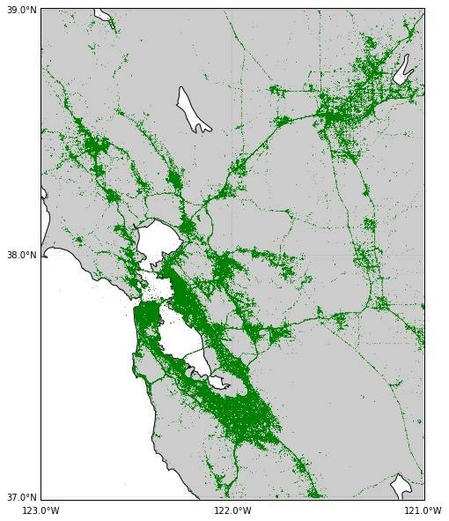

Figure 3: The MyShake users’ footprint within a month in Bay Area. The green dots are where the phones sent a heartbeat message back to the server.

**Discussion/Conclusions:**

Currently, MyShake team is working on the earthquake early warning capability of this network, since this network is so different from the traditional seismic network. The sensors in MyShake network are dynamically moving both in time and space. For example during the day, a lot of these sensors will move around which will affect the detection capabilities of the network since the best data come from the phones are still. Besides, a natural limitation of this network is that people are clustered into the cities, and we will have many phones inside the cities, but not everywhere outside the cities as shown in Figure 3. Therefore, this network is unevenly distributed. In addition, the hardware of the sensors are heterogeneity, poor to good quality sensors are all contributing data to the system. All these are adding complexity into the system to detect earthquakes. Also, for the current algorithm is good for a few thousands of phones, but what if we have millions of phones streaming data to the cloud server, how do we detect the earthquakes efficiently?

****MyShake team is currently working with the data science community to solve all these challenges to build this earthquake early warning system using everyone’s smartphones.

**Acknowledgements:**

The authors would like to thank the Deutsche Telekom Silicon Valley Innovation Center who collaborates with Berkeley Seismology Lab on MyShake project. We also thank Gordon and Betty Moore Foundation who provide funding for MyShake study. Of course we also thank all the MyShake team members and the awesome MyShake users.

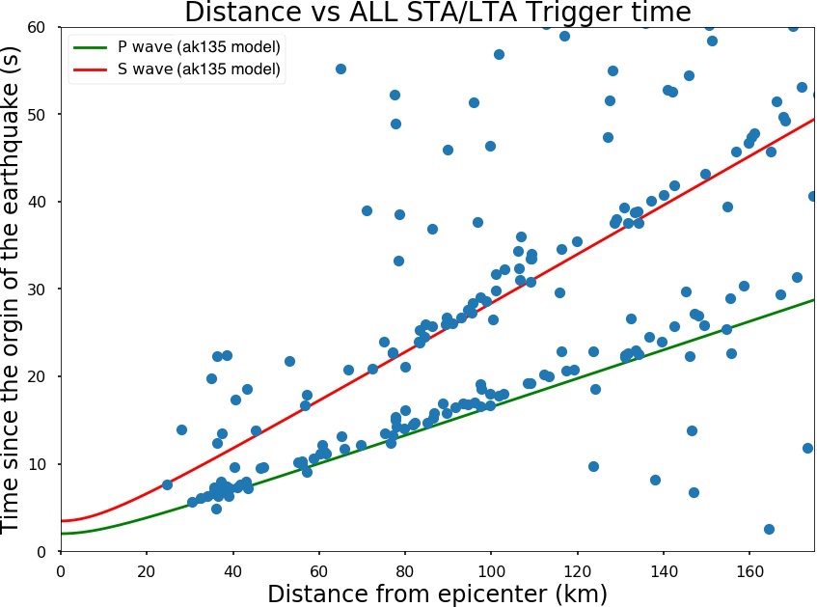

Figure 4: STA/LTA triggers from the Borrego Springs M5.2 earthquake on 2016-06-10. The blue dots are the phone triggers by the STA/LTA algorithm. The green and red lines are the estimated P and S wave using the ak135.

Allen RM, Gasparini P, Kamigaichi O, Bose M (2009) The Status of Earthquake Early Warning around the World: An Introductory Overview. Seismol Res Lett 80:682–693. doi: 10.1785/gssrl.80.5.682

Allen R V. (1978) Automatic earthquake recognition and timing from single traces. Bull Seismol Soc Am 68:1521–1532

Clayton RW, Heaton T, Chandy M, et al (2011) Community seismic network. Ann Geophys 54:738–747. doi: 10.4401/ag-5269

Cochran E, Lawrence J, Christensen C, RS (2009) The Quake-Catcher Network: Citizen Science Expanding Seismic Horizons. Seismol Res Lett 80:26–30. doi: 10.1785/gssrl.80.1.26

Hsieh C-Y, Wu Y, Chin T-L, et al (2014) Low Cost Seismic Network Practical Applications for Producing Quick Shaking Maps in Taiwan. Terr Atmos Ocean Sci 25:617. doi: 10.3319/TAO.2014.03.27.01(T)

Kanamori H (2005) Real-Time Seismology and Earthquake Damage Mitigation. Annu Rev Earth Planet Sci 33:195–214. doi: 10.1146/annurev.earth.33.092203.122626

Kennett BLN, Engdahl ER, Buland R (1995) Constraints on seismic velocities in the Earth from traveltimes. Geophys J Int 122:108–124. doi: 10.1111/j.1365-246X.1995.tb03540.x

Kong Q, Allen RM, Schreier L (2016a) MyShake: Initial observations from a global smartphone seismic network. Geophys Res Lett 43:9588–9594. doi: 10.1002/2016GL070955

Kong Q, Allen RM, Schreier L, Kwon Y-W (2016b) MyShake: A smartphone seismic network for earthquake early warning and beyond. Sci Adv 2:e1501055–e1501055. doi: 10.1126/sciadv.1501055

Kong Q, Kwony Y-W, Schreierz L, et al (2015) Smartphone-based networks for earthquake detection. In: 2015 15th International Conference on Innovations for Community Services (I4CS). IEEE, pp 1–8

Kong Q, Zhao M (2012) Evaluation of earthquake signal characteristics for early warning. Earthq Eng Eng Vib 11:435–443. doi: 10.1007/s11803-012-0133-1

Kuyuk HS, Allen RM, Brown H, et al (2014) Designing a network-based earthquake early warning algorithm for California: ElarmS-2. Bull Seismol Soc Am 104:162–173. doi: 10.1785/0120130146

Wu Y-M (2015) Progress on Development of an Earthquake Early Warning System Using Low-Cost Sensors. Pure Appl Geophys 172:2343–2351. doi: 10.1007/s00024-014-0933-5