In 2001, a paper found a silent slip event on the deeper Cascadia Subduction Interface [*Dragert et al.*, 2001]. This discovery comes from the observation of the GPS stations that reversed their direction of motion (see the following figure). This paper conducted a slip inversion to model the observation. And they found that the sudden displacements are best explained by ~2 centimeters of aseismic slip over a 50-kilo-meter-by-300-kilometer area on the subduction interface downdip from the seismogenic zone, a rupture equivalent to an earthquake of moment magnitude 6.7. This paper provides evidence that slip of the hotter, plastic part of the subduction interface, and hence stress loading of the megathrust earthquake zone, can occur in discrete pulses.

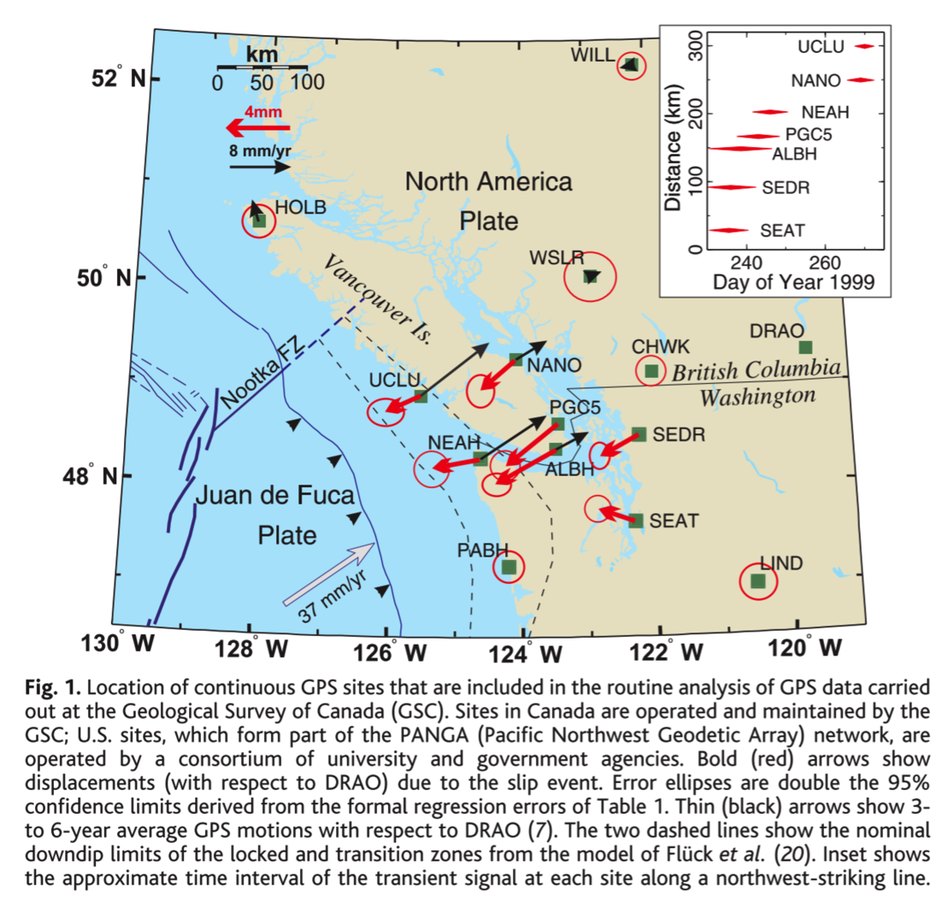

In 2002, anther paper in science found the periodicity of slow earthquakes in Cascadia [*Miller*, 2002]. They found the slow earthquakes occur on average every 14.5±1 months over 10 years. The conclusion from this paper is: the regular and cyclical nature of the transient events indicates that they are a fundamental mode of strain release in subduction zones.

The tremor first found and proposed in non-volcanic setting using seismic network [*Obara*, 2002]. The tremor was found southwest Japan. The predominant frequency of the tremors ranged from 1 to 10 Hz, and was lower than that of ordinary earthquakes of similar size. The tremors are around depth of 30 km. The following figure shows the location of the tremor, but we can see two gaps where there’s no tremors.

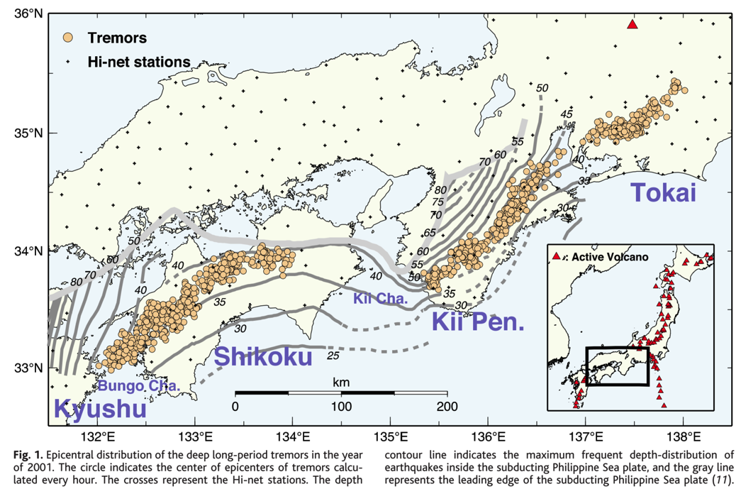

The possible cause of the tremor this paper gave is: considering the long duration and mobility of the tremor activity, the generation of tremors may be related to the movement of fluid in the subduction zone. At high temperature and pressure, aqueous fluid mixed with silicate melts exists as a supercritical fluid. The presence of supercritical fluid may reduce the friction and change the fracture criterion of the rock by increasing the pore pressure and/or create new cracks through hydraulic fracturing. Therefore, tremor activity with a long duration time might be caused by a chain reaction of small fractures caused by the supercritical fluid.

After the Japanese paper about Tremor, [*Rogers and Dragert*, 2003] combine the seismic data and GPS data to prove the tremor on the seismic data is correlate with the slip seen on the GPS at Cascadia. The tremor at Cascadia is different from that in Japan in that: the signals observed in Cascadia correlate temporally and spatially with six deep slip events that have occurred over the past 7 years. Also, in this paper, they first refer to this associated tremor and slip phenomenon as episodic tremor and slip (ETS). They have one paragraph with a definition what is ETS.

[*Nedimović et al.*, 2003] from the reflection profile showed that there is a change in the reflection character on seismic images from a thin sharp reflection where the subduction thrust is inferred to be locked, to a broad reflection band at greater depth where aseismic slip is thought to be occurring. This suggests that these slip events occur where faults deform ductily in zones that are several kilometers thick and that contain substantial fluid-filled porosity. This change in reflection character may provide a new technique to map the landward extent of rupture in great earthquakes and improve the characterization of seismic hazards in subduction zones.

[*Nadeau and Dolenc*, 2005] found tremor exists at a transform plate boundary zone along the San Andreas Fault (SAF). The SAF tremors are less frequency (fewer than 5 events detected in any 24-hour period), have shorter durations (less than 20 min), have smaller peak amplitudes (< M0.5 earthquake), and release less energy (energy equivalents < M1.5). There’s a correlation between tremor and local earthquake rates at Cholame.

Same year in 2005, a paper published in Nature show the tremors in northern Cascadia are distributed over a depth range exceeding 40 km within a limited horizontal band [*Kao et al.*, 2005]. They are using a newly developed method ‘source scanning algorithm’ (SSA) to identify the tremors. They found the tremors are distributed over a wide depth range than thought before only at the slab interface. They gave the difference of tremors and earthquakes in this paper: (1) difference in the distribution, tremors tend to occur in places where local earthquakes are sparse; (2) tremors are more in the 1 – 5 Hz frequency band. The possible explanations of tremor are: (1) fluid released from the dehydration of subducted materials facilitating the occurrence of ETS tremors. (2) Alternatively, if the tremors are interpreted as the de facto seismic part of the episodic slip, then the slip may have occurred in a zone much more diffuse than previous studies have suggested.

**References:**

Dragert, G., K. Wang, and T. S. James (2001), A silent slip event on the deeper Cascadia subduction interface., *Science*, *292*(5521), 1525–8, doi:10.1126/science.1060152.

Kao, H., S.-J. Shan, H. Dragert, G. Rogers, J. F. Cassidy, and K. Ramachandran (2005), A wide depth distribution of seismic tremors along the northern Cascadia margin, *Nature*, *436*(7052), 841–844, doi:10.1038/nature03903.

Miller, M. M. (2002), Periodic Slow Earthquakes from the Cascadia Subduction Zone, *Science (80-. ).*, *295*(5564), 2423–2423, doi:10.1126/science.1071193.

Nadeau, R. M., and D. Dolenc (2005), Nonvolcanic tremors deep beneath the San Andreas fault, *Science (80-. ).*, *307*(January), 389, doi:10.1126/science.1107142.

Nedimović, M. R., R. D. Hyndman, K. Ramachandran, and G. D. Spence (2003), Reflection signature of seismic and aseismic slip on the northern Cascadia subduction interface, *Nature*, *424*(6947), 416–420, doi:10.1038/nature01840.

Obara, K. (2002), Nonvolcanic Deep Tremor Associated with Subduction in Southwest Japan, *Science (80-. ).*, *296*(5573), 1679–1681, doi:10.1126/science.1070378.

Rogers, G., and H. Dragert (2003), Episodic tremor and slip on the Cascadia subduction zone: the chatter of silent slip., *Science*, *300*(5627), 1942–1943, doi:10.1126/science.1084783.