Features:

1. **GENDER**: F, M
2. **ADMISSION LOCATION**: EMERGENCY ROOM ADMIT, CLINIC REFERRAL/PREMATURE , TRANSFER FROM HOSP/EXTRAM, PHYS REFERRAL/NORMAL DELI , TRANSFER FROM OTHER HEALT , TRANSFER FROM SKILLED NUR
3. **LANGUAGE**: ENGL, RUSS, SPAN, PTUN, PORT, CANT, HAIT, CAPE , MAND, VIET, GREE, ITAL, PERS, HIND, FREN, *URD, ALBA, *AMH, *LIT, LAOT, *TEL , *ROM
4. **RELIGION**: CATHOLIC, NOT SPECIFIED, PROTESTANT QUAKER, UNOBTAINABLE, JEWISH, OTHER, BUDDHIST, EPISCOPALIAN, CHRISTIAN SCIENTIST, GREEK ORTHODOX, ROMANIAN EAST. ORTH, UNITARIAN-UNIVERSALIST, MUSLIM, JEHOVAH'S WITNESS, HINDU, BAPTIST
5. **MARITAL STATUS**: MARRIED, SINGLE, WIDOWED, DIVORCED, SEPARATED, UNKNOWN (DEFAULT)
6. **ETHNICITY**: WHITE, BLACK/AFRICAN AMERICAN, UNKNOWN/NOT SPECIFIED, HISPANIC OR LATINO, OTHER, UNABLE TO OBTAIN, ASIAN, HISPANIC/LATINO - PUERTO RICAN, WHITE – RUSSIAN, HISPANIC/LATINO – DOMINICAN, BLACK/CAPE VERDEAN, PATIENT DECLINED TO ANSWER, ASIAN – CHINESE, WHITE – BRAZILIAN, PORTUGUESE, ASIAN – VIETNAMESE, BLACK/HAITIAN, MULTI RACE ETHNICITY, ASIAN – FILIPINO, HISPANIC/LATINO – GUATEMALAN, WHITE - OTHER EUROPEAN, AMERICAN INDIAN/ALASKA NATIVE, HISPANIC/LATINO – SALVADORAN, BLACK/AFRICAN, ASIAN – KOREAN, HISPANIC/LATINO – CUBAN, ASIAN - ASIAN INDIAN, MIDDLE EASTERN
7. **DEAD WITHIN 24 HOURS AFTER ADMISSION**: YES, NO
8. **AGE**
9. **NUM OF PERSCRIPTION**: 1, 2, 3, 4, 5, 6, 7, 8, 9, 10, 12, 14, 15, 16, 18, 21, 24, 27
10. **ADMIT TIME**
11. **LAB_TEST** (can be multiple choices)

* *LOINC CODE*: 26454-9, 26465-5, 2160-0, 2823-3, 3094-0, 2345-7, 33914-3, 5902-2, 742-7, 711-2, 6768-6, 8122-4, 2039-6, 1751-7, 4544-3, 2085-9, 2951-2, 2093-3, 2500-7, 2498-4, 2075-0
* *LAB TEST TIME*
* *LAB TEST RESUL*

Possible design idea for lab tests:

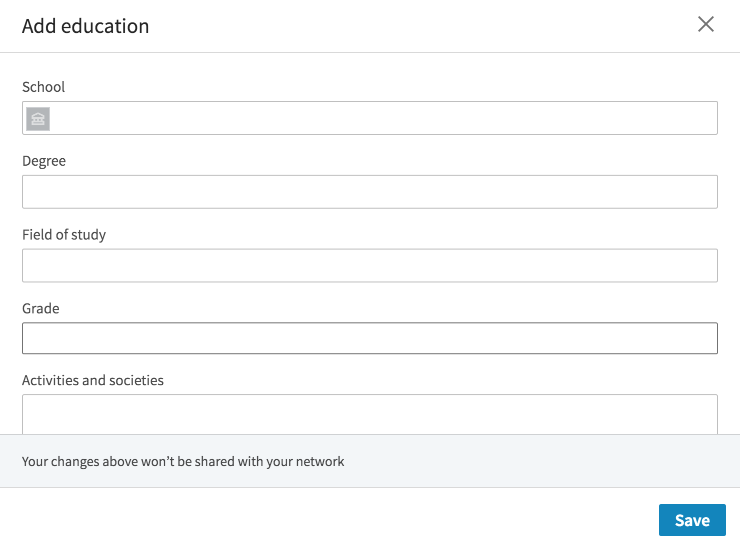

DEAD/EXPIRED 0

HOME 1

HOME HEALTH CARE 2

LONG TERM CARE HOSPITAL 3

REHAB/DISTINCT PART HOSP 4

SNF 5

26454-9, time, res

711, time, res

Code:

Time:

Res:

Add