1,If else 语句

**public** **class** test2 {

**public** **static** **void** main(String[]args){

**int** month=13;

**if**(month>0&&month<=3){

System.*out*.println("第一季度");

}**else** **if**((month>3&&month<=6)){

System.*out*.println("第二季度");

}**else** **if**((month>6&&month<=9)){

System.*out*.println("第三季度");

}**else** **if**((month>9&&month<=12)){

System.*out*.println("第四季度");

}**else** {

System.*out*.println("您的输入有误");

}

}

}

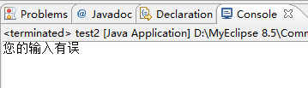

2,switch 语句

**public** **class** test {

**public** **static** **void** main (String [] args){

**int** month=4;

**switch**(month){

**case** 1:

**case** 2:

**case** 3:

System.*out*.println("第一季度");

**break**;

**case** 4:

**case** 5:

**case** 6:

System.*out*.println("第二季度");

**break**;

**case** 7:

**case** 8:

**case** 9:

System.*out*.println("第三季度");

**break**;

**case** 10:

**case** 11:

**case** 12:

System.*out*.println("第四季度");

**break**;

**default**:

System.*out*.println("您输入的数字有误");

**break**;

}

}

}