Group 10

Author: 叶菁菁

Software Requirements

Pocker Game

Table of Contents

System Objective 2

Domain Analysis 2

System Architecture 4

Use Cases 5

Software Requirements 6

R1: playerUI 6

R2: master 6

R3: database 10

## System Objective

In this project, we are developing a software that can improve a pocker game to three players. You know just for fun. Enjoy the fun of playing cards!

## Domain Analysis

There players need to play the game with each other and the game should follow the basic rule and have some UI embellishment.

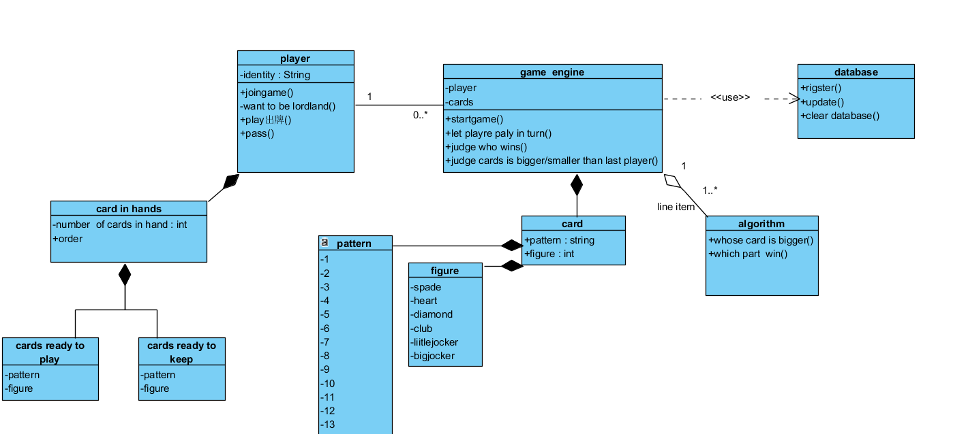

Here is the sequence of events for a player to play my pocker game

1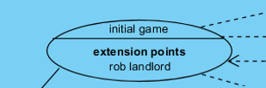when develop I find totally can’t identify

Who is your before player and next player

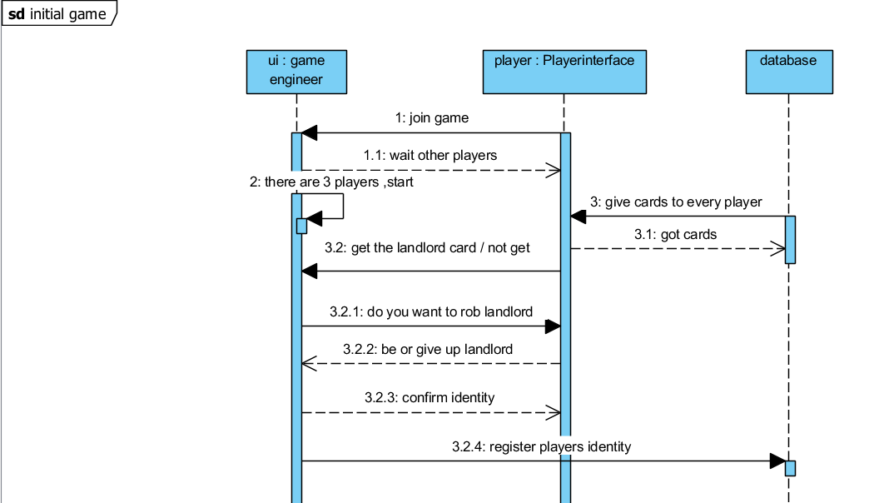

2

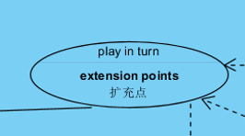

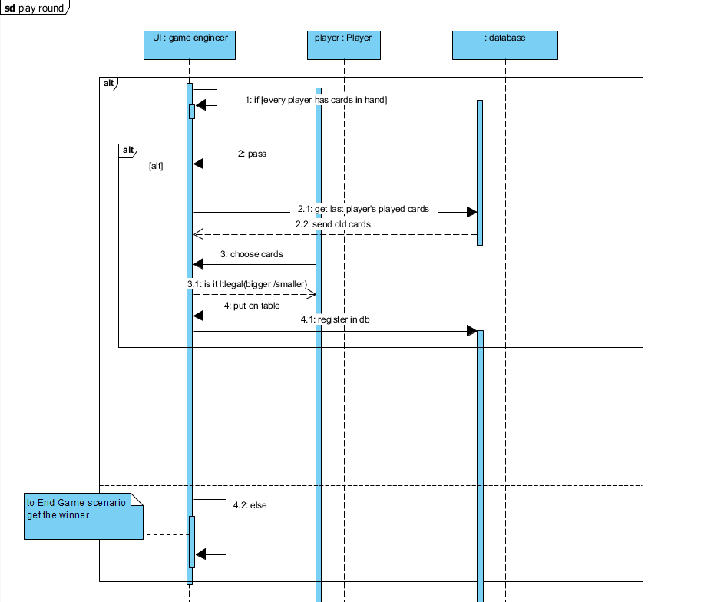

3 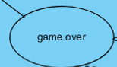

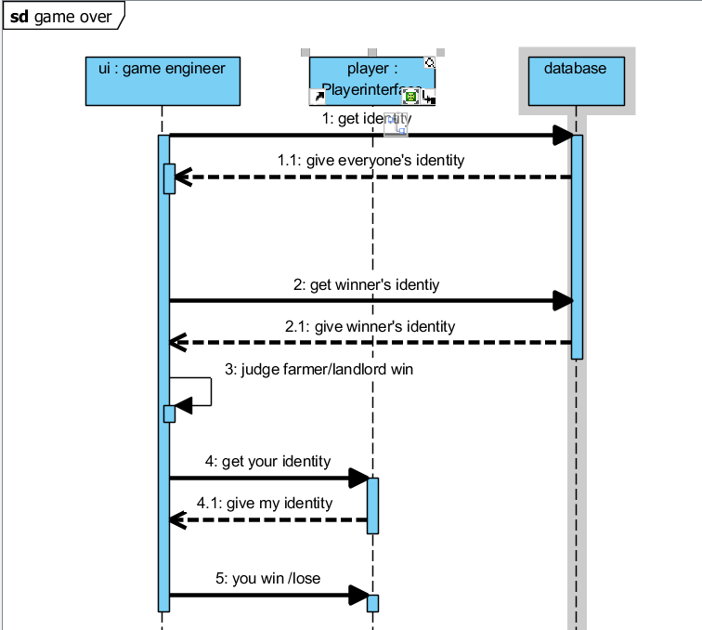

## System Architecture

From the information above, we will design a software system that allows three players to play game together. The information of their cards, their name will be stored in database witch is include in the master. Master decide the order of players to play the game and the start and kill the game at right time. The system architecture is shown below:

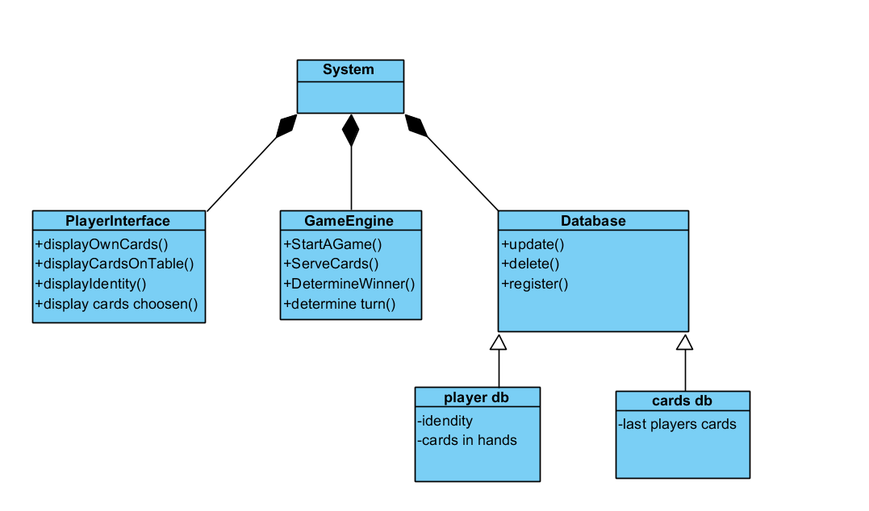

## Use Cases

The system can achieve the following use cases from the game player

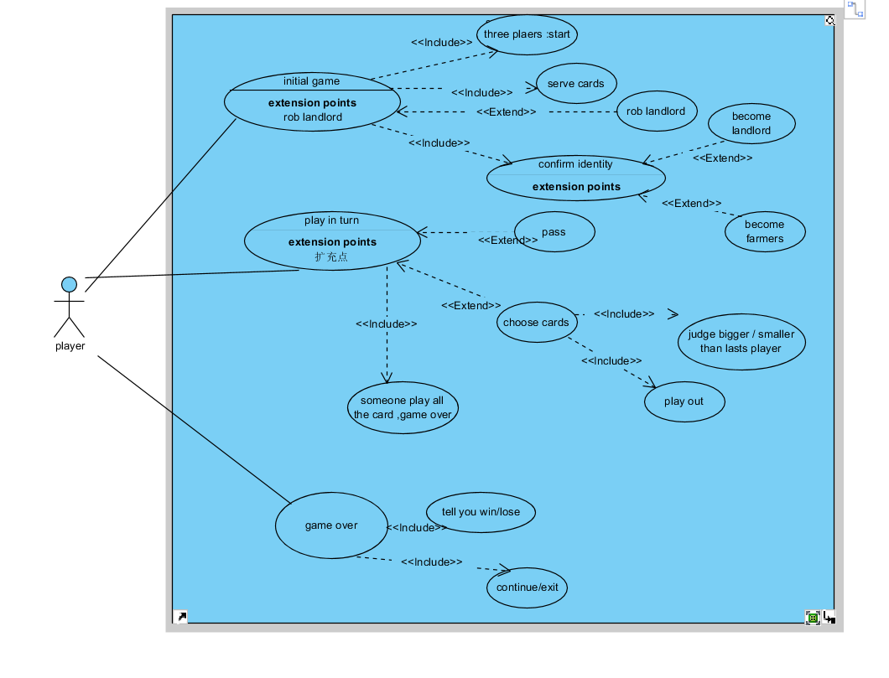

## Software Requirements

### R1: playerUI

* R1.1: can rob lord
* R1.2: has countdown when choose cards
* R1.3: can see the number of cards of other two players
* R1.4: have UI effect of win/lose boom,wangzha,airplane
* R1.5: show head and name for players
* R1.6: have tips for wrong cards
* R1.7: have tips if other players’ cards is less than 3

### R2: master

R2.1: start the game when everyone is ready

R2.2: let players play one by one

R2.3: if someone don’t play any cards until 25 seconds is used out, pass it turn

R2.4 decide who is win, when someone play all the cards

* Must obey the basic game rule

Colored Joker > Black & White Joker > 2 > Ace (A) > King (K) > Queen (Q) > Jack (J) > 10 > 9 > 8 > 7 > 6 > 5 > 4 > 3.

[Suits](https://en.wikipedia.org/wiki/Suit_(cards)) are irrelevant. Players can play the game with all the suits erased from the cards.

wangzha and the Bomb

The Rocket and the Bomb are groups of cards that work differently in terms of game play.

|  |  |  |  |
| --- | --- | --- | --- |
| Special Category | Description | Example | Special Note |
| *Wangzha王炸* | Colored Joker and black-and-white Joker | Colored Joker + black-and-white Joker | It can beat everything in the game. |
| *Bomb* | 4 cards of the same rank | 3-3-3-3 (the lowest ranking Bomb) 2-2-2-2 (the highest ranking Bomb) | It can beat any other category and individual card except *Rocket* or another Bomb with a higher or equal rank. |

Category of hands

The game uses the concept of hands, similar to the [hands](https://en.wikipedia.org/wiki/List_of_poker_hands) in [poker](https://en.wikipedia.org/wiki/Poker), except there are more variations and not necessarily consisted of only five cards.

Compare only the same Category. A player can only beat the prior hand using of the same Category but not the others. Note that this means that the ordering of the rows in the following table is not relevant to gameplay.

Compare only the Chains with the same length. Beat the prior hand using the same number of cards is a basic doctrine which only the Rocket and the Bomb may violate. For example, although both 9-10-J-Q-K and 3-4-5-6-7-8-9 are *Single Chains*, 9-10-J-Q-K cannot beat 3-4-5-6-7-8-9, nor vice versa.

Compare the rank in the Primal cards only. The Kicker's rank is irrelevant to the comparison unless a variation with 2+ decks is being played.

Jokers and 2 are non-consecutive cards. Colored Joker, black-and-white Joker, and 2 cannot be used in any of the Primal cards of the Chains since they are not traditionally considered as the consecutive cards sequentially next to the Ace. Examples of illegal *Chain*: 2-3-4-5-6, 2-2-2-3-3-3 w/ A-A-7-7, K-A-2 + B&W Joker + Colored Joker

|  |  |  |  |  |  |
| --- | --- | --- | --- | --- | --- |
| Category | | | Description | Example | |
| *Primal* | with (+) kicker | Chain | Lowest rank and/or shortest chain | Highest rank and/or longest chain possible |
| *Solo* | — | — | Any single card | 3 | Colored joker |
| *solo* | — | Shunzi 顺子 | ≥ Five consecutive individual cards | 3-4-5-6-7 | 3-4-5-6-7-8-9-10-J-Q-K-A |
| *Pair* | — | — | Two matching cards of equal rank | 3-3 | 2-2 |
| *Pair* | — | Sisters | ≥ Three consecutive pairs | 3-3-4-4-5-5 | 5-5-6-6-7-7-8-8-9-9-10-10-J-J-Q-Q-K-K-A-A |
| *Trio* | — | — | Three-of-a-kind: Three individual cards of the same rank | 3-3-3 | 2-2-2 |
| *Airplane* | — | Chain | ≥ Two consecutive trios | 3-3-3-4-4-4 | 9-9-9-10-10-10-J-J-J-Q-Q-Q-K-K-K-A-A-A |
| *Trio* | Solo | — | Three cards of the same rank with a solo as the kicker | 3-3-3 + 4 | 2-2-2 + colored joker |
| *Trio* | Solo | Airplane | ≥ Two consecutive trios with each carries a distinct individual card as the kicker | 3-3-3-4-4-4 + 5-6 | 10-10-10-J-J-J-Q-Q-Q-K-K-K-A-A-A + 7-8-9-2-colored joker |
| *Trio* | Pair | — | Full house: Three cards of the same rank with a pair as the kicker. | 3-3-3 + 4-4 | 2-2-2 + A-A |
| *Trio* | Pair | Chain | ≥ Two consecutive trios with each carrying a pair as the kicker | 3-3-3-4-4-4 + 5-5-6-6 | J-J-J-Q-Q-Q-K-K-K-A-A-A + 8-8-9-9-10-10-2-2 |
| Bomb | | | Four-of-a-kind, with a kicker. Four cards of the same rank without the kicker is called a bomb, which defies category rules, even beats four *with*a kicker. | 3-3-3-3 | 2-2-2-2 |
| *Four* | Dual solo | — | Four-of-a-kind with two distinct individual cards as the kicker | 3-3-3-3 + 4 + 5 | 2-2-2-2 + A + colored joker |
| *Four* | Dual pair | — | Four-of-a-kind with two sets of pair as the kicker |  |  |
| The longest chain possible column is only applicable to a hand with twenty cards, which the landlord possesses after seizing the three leftover wild cards. | | | | | |

### R3: database

R3.1: store the name and head of players

R3.2: store the cards of everyone and the number of cards