Group 10

Author:叶菁菁

Traceability Report

Pocker Game

Table of Contents

System Architecture 2

Software Traceability 2

## System Architecture

The system architecture is shown below:

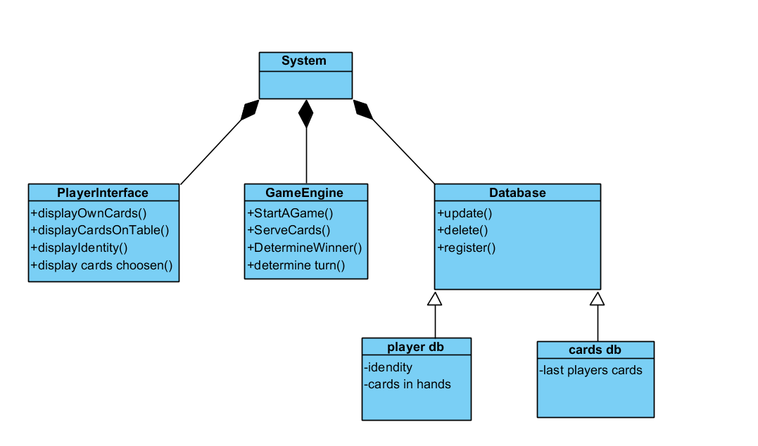

## Software Traceability

|  |  |  |
| --- | --- | --- |
|  | Is implemented by | Is validated by |
| R2.1: start the game when everyone is ready | S1.1 | T1.1 |
| R2.2: let players play one by one | S1.3 S1.4 | T1 |
| R2.3 25 seconds is used out, pass it turn | S1.3.1 | T1.4 |
| R2.4 decide who is win, | S1.5 | T1.6 |
| R3.1 | S1.1.2 |  |
| R3,2 | S1.3 |  |
| R1,1 | S1.2 | T1.2 |
| R1.2 | S1.3.1 |  |
| R1.3 | S1.3 |  |
| R1.4 | S1.6 S1.4.2 |  |
| R1.5 | S1.1.2 |  |
| R1.6 | S1.4.1 | T1.7 |
| R1.7 | S1.5 |  |