The Price of Stale State: When Does Network Awareness Pay in LLM Inference Serving?
Weiguo Hao
Henan University, Kaifeng, Henan, China. E-mail: 2410250817@henu.edu.cn

Abstract
Network-aware LLM routing, using both compute backlog and link state, cuts tail latency by amounts from negligible to over 70%, and one system retains its gains under telemetry delayed by 60 s. We ask when it pays and when trusting it hurts. A discrete-event simulator (ten realizations per cell across synthetic, Azure and BurstGPT sources), a single-node k3s cluster and a two-cloud deployment supply the evidence. Four findings result. (1) The benefit is set by configuration, not link speed: −3.3% when compute and link rankings agree versus −68.2% when they conflict (Cliff’s δ = 1.00, p = 1.8 × 10⁻⁴), from 4 to 16 workers. (2) Queue state loses 56–85% of its value within 5 s while link state retains 65–89% at 60 s, explaining the reported 60 s result from the slow-expiring channel. (3) A per-channel discounting rule retains 90–99% of the benefit under 60 s-old link state where uniform discounting retains none, in one identifiable regime. (4) On real containers a state read costs 56–876 ms against a 12 µs in-cluster round trip and affects the tail in a threshold-like pattern. Bidirectional cross-cloud KV transfer completes with zero failures, its dominant added cost landing at first token.
Keywords: LLM inference serving, network-aware scheduling, state staleness, telemetry, tail latency, measurement study

1. Introduction
Large language model (LLM) serving has moved from single-GPU engines to disaggregated deployments in which prefill and decode run on different workers, KV cache travels between them, and each incoming request must be routed to some worker [1, 2, 3, 4]. Routing is no longer a detail: the worker whose compute queue is emptiest is frequently not the worker whose link can deliver the request’s context (or its KV cache) fastest, and the two criteria can point in opposite directions. A growing line of work therefore makes the router network-aware, scoring candidates with both a compute-backlog term and a link term [5, 6, 7, 8, 9, 10].
The literature then reports strikingly different value for the same idea. Gains range from negligible to more than 70%, usually as a single number under a single configuration, and at least one published system reports that its gains “hold under workload shifts and telemetry delays up to 60 seconds” [9]. Taken at face value, that property would make much of the engineering effort around monitoring latency beside the point; yet that paper, and the closest concurrent work [8], sweep only one of the two quantities a router observes. The disagreement is hard to interpret because nobody holds the configuration fixed and asks which regime each number came from.
This paper asks that prior question: when does network awareness actually pay in LLM inference serving, and when does trusting observed state hurt? We treat the scheduler’s benefit as an outcome to be characterized—where it appears, where it vanishes, where it reverses sign, and how the driving factors interact—rather than a result to be demonstrated. Three design decisions make that characterization possible.
Ten independent workload realizations, not one. A single run of a congested queueing system is not an experiment. In preliminary single-seed screens, changing the routing decisions of the first ∼2.5% of requests alone moved the 95th-percentile sojourn time by up to 17% in a 4000-request run, which means single-seed comparisons are dominated by trajectory noise.
We accordingly treat the seed—one independent realization of the arrival process—as the unit of observation: every comparison aggregates ten seeds, uses per-request paired tests within a seed, and quotes intervals across seeds. At least one apparent “network awareness becomes harmful under stale state” result from a single-seed screen traces to one extreme seed, and §7 shows the concrete case.
One mechanism variable, measured directly. Rather than reporting that network awareness “helps”, we identify the configuration variable that decides whether the link term carries information beyond the compute term: the rank correlation between per-worker compute capacity and per-worker bandwidth. When the fastest-computing worker also has the widest link, both criteria select the same worker and the link term is redundant; when they disagree, the link term is what stands between the user and a 68% worse tail. We call this property alignment, and it is absent as an explanatory variable in the work we surveyed while accounting for much of the spread in published gains.
Staleness treated as two channels with different expiry times. The router observes two physically different quantities: the compute queue at each worker, which moves on sub-second to second timescales, and the link state, whose bandwidth component is a physical property and whose congestion component changes over tens of seconds. Sweeping the two jointly shows their value expires at rates separated by roughly an order of magnitude, which is exactly what makes the published “60 s does not matter” claim true for one channel and misleading as a general statement. We further separate latency, where the router sees an old but true value, from averaging, where it sees a time-smoothed value in which current spikes have disappeared, because the two defects distort decisions differently.
The contributions follow the same structure. We introduce compute–bandwidth rank alignment as the variable governing whether network information adds anything, and validate it across three nodes × ten seeds (the regimes separate completely: Cliff’s δ = 1.00, p = 1.8 × 10⁻⁴), across 4/8/16 workers, and against a direct probe that rules out the luck-based alternative explanation. We build a two-channel model of staleness with measured expiry times, a 2-D queue-age × link-age sweep, and a separate treatment of averaging windows. From the measured expiry curves we read off a per-channel conditional discounting rule (rather than tuning one), state the single regime in which it is worth using, and show why the intuitive term-level design fails. On real containers we measure the observation feedback loop that simulation abstracts away—state fetch costing 56 ms to 876 ms against 12 µs for an in-cluster round trip, increasing with load, with a threshold-like tail effect. The whole study runs behind four verification gates with append-only artifacts, a per-run manifest, and a script that re-derives every quoted number from raw outputs; the design choices that do not survive our own experiments are kept in the results sections they belong to.
Scope and evidence. The paper makes a boundary claim, not a performance claim: it does not introduce a scheduler that beats the state of the art, and the discounting rule is in several regimes indistinguishable from simply trusting fresh network state. The evidence is organized in three tiers, each with a defined job. The simulator carries the controlled boundary analysis across three workload sources; a single-node k3s deployment with application-level link shaping validates directional effects and measures the observation costs the simulator omits, with repeat-to-repeat dispersion reported so its resolution is explicit; and a tightly scoped two-cloud LLM deployment anchors the feasibility and first-token cost of cross-cloud KV movement. One mechanism question—what load property determines when discounting pays—survives two pre-registered hypotheses and is left open in §7.5 with the experiment that could settle it.

2. Background and Related Work

2.1. Disaggregated LLM serving and KV movement
Prefill/decode disaggregation has become a standard abstraction: compute-intensive prefill and memory-bound decode are placed on separate workers, and KV cache is moved between them over the cluster network [1, 2, 3]. Production systems extend the pattern with cache-centric global schedulers [3], dynamic rescheduling and migration [4], phase-aware placement [2], chunked prefill to smooth the throughput–latency tradeoff [11], and locality-aware loading [12].
Because KV cache is large and its transfer sits on the critical path, the network side of this architecture has become its own research area, spanning KV compression and streaming [13], routing-collision avoidance, and network-aware placement of the two phases [7, 14]. Recent position papers frame the scarce resource as having shifted from raw FLOPs toward managed state, placement, network movement, and decision quality [15, 16]. Taking that shift as given, this paper studies the decision-quality component: what the router must know, how fresh that knowledge has to be, and when acting on it is worse than ignoring it.

2.2. Network-aware scheduling
Network-aware scheduling has a published history, mostly outside LLM serving. CASSINI places training jobs using periodically refreshed communication-pattern measurements [5]; VClos isolates tenants to avoid ECMP hash collisions in multi-tenant GPU clusters [6]; TopoOpt co-optimizes topology and parallelization [17]. Within LLM serving, Helix solves a max-flow placement problem over heterogeneous GPUs and links [7], and GenSched jointly selects servers and allocates resources for prefill/decode stages in heterogeneous edge networks [10]. The closest concurrent work is NetKV, which selects decode instances through a network-cost oracle over a modeled dynamic congestion field [8], and Aegis, which places work on an accelerator cluster using per-second switch queue and ECN telemetry [9]. Two gaps run through this body of work. Every system evaluates one mechanism in one configuration, so the boundary at which a network term stops carrying information is never characterized, and none treats the correlation between the compute ranking and the bandwidth ranking as an experimental variable; Helix, for example, solves a placement directly rather than asking how much the answer depends on the two rankings agreeing.

2.3. Stale and delayed state information
That stale state degrades load balancing is established knowledge: stale load data produces wrong server selections [18], delayed-information load balancing was formally listed as an open problem [19], and stale link state drives routing oscillation [20]. ParSync turned admissible staleness into a design variable, relaxing freshness for scalability [21]. The Age-of-Information literature cautions against treating age itself as the objective, since no universal staleness threshold exists and the mapping from age to harm is application-specific [22, 23]. Telemetry-side work optimizes freshness directly [24], while recent systems find freshness-based guards can be far too conservative, blocking 92–95% of harmless cases in a different domain [25].
For LLM serving, NetKV derives a bound under which a stale estimate leaves the ranking unchanged and reports a refresh-interval sweep concluding that the benefit is insensitive [8]; Aegis reports gains holding under telemetry delays up to 60 s [9]. Our measurements are consistent with both and explain them: each sweep varies the link-side observable, the channel we find to expire slowly (§6). We add the three missing pieces—the queue-side observable that expires roughly an order of magnitude faster, a joint rather than one-at-a-time sweep, and the separation of latency from time-averaging as distinct distortions.

2.4. Positioning
The measurements sit inside a concrete serving and fabric context. The engines under disaggregated systems—PagedAttention/vLLM [26], SGLang [27], Orca [28]—and the multiplexing strategies layered above them [29] define what “a worker’s queue” means; industrial frameworks such as Dynamo [30] and llm-d [31] expose exactly the placement decisions we study; current systems continue to push on KV locality and imprecise request metadata [32], stale-state handling in packet-level load balancing [33], cross-region balancing [34], and freshness of RAG-side data [35]. The fabric is the standard Clos topology [36] with mature congestion control [37, 38, 39], and published inference throughput ceilings [40] set the scale at which queueing matters.
None of these components is modified; the question is when a scheduler should include a network term at all.
Table 1 summarizes the gap. Relative to prior work we (a) introduce a configuration variable that predicts the magnitude of the benefit, (b) characterize staleness as two channels with different expiry plus an averaging dimension, (c) evaluate conditional use of network information against both of its extremes and report where it loses, and (d) measure the cost of obtaining state on real containers, which simulation omits. Boundary studies with openly reported negative findings have precedent in adjacent areas, including self-described negative results in KV caching [41], design-space studies of when each disaggregation level pays off [42], and equilibria that switch regime at saturation [43]; that is the template we follow.
Table 1. Positioning against the closest prior work. “Channels” = how many observed quantities are swept for freshness; “Boundary” = whether the paper characterizes where the benefit disappears or reverses; “Align.” = whether compute–bandwidth rank agreement is an experimental variable.

Work | Venue | Serving | Chan. | Bound. | Align.
CASSINI [5] | NSDI’24 | no | 1 | no | no
VClos [6] | ComNet’25 | no | 1 | no | no
Helix [7] | ASPLOS’25 | yes | 1 | no | no
GenSched [10] | INFOCOM’26 | yes | 1 | no | no
NetKV [8] | preprint | yes | 1 | partial | no
Aegis [9] | SIGCOMM’26 | no | 1 | no | no
this paper | — | yes | 2+win. | yes | yes

3. System Model and Method
Figure 1 summarizes the system: public LLM inference traces enter a router that maintains two channels of observed state and dispatches each request to one worker in a heterogeneous pool whose members differ in both compute rate and link quality; the metrics are collected at the pool boundary.
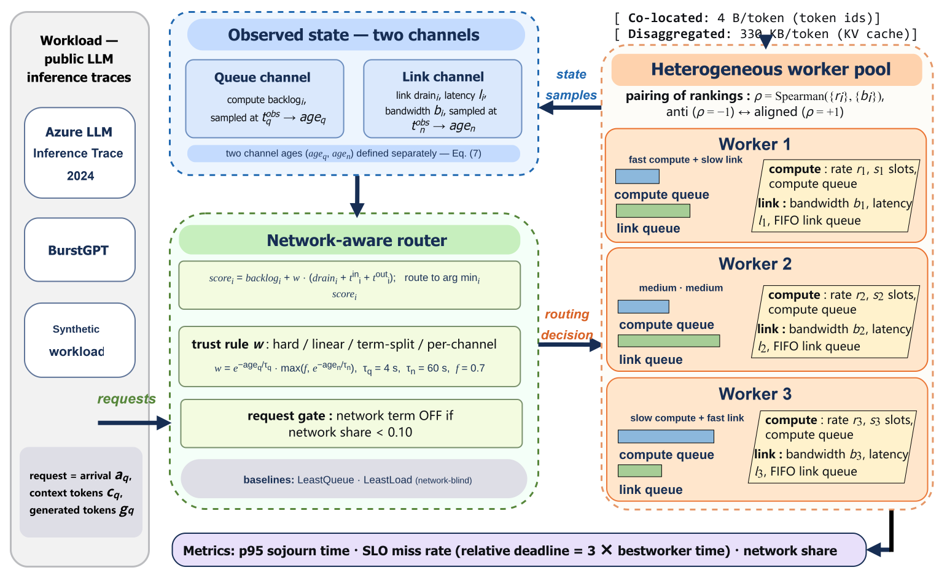
Figure 1. System architecture. Three workload sources feed a network-aware router that observes queue and link state through separate sampling channels, applies the scoring and trust rules of §3.4–§3.6, and dispatches to a heterogeneous worker pool; p95 sojourn time, SLO miss rate and network share are measured end to end.

3.1. Workers, requests, and two queues
We model a heterogeneous pool of N workers. Worker i has compute rate $r_{i}$ (work units per second), $s_{i}$ service slots, one-way link latency $ℓ_{i}$, and link bandwidth $b_{i}$. A request q is characterized by its arrival time $a_{q}$, context length $c_{q}$, and generated length $g_{q}$. Its compute work is
$$w_{q}=αc_{q}+βg_{q},$$
with α = 1 and β = 4 (prefill and decode cost per token differ; these coefficients are engineering estimates, see §9). Its network payload is
$${in}_{q}=κ_{c}c_{q}, {out}_{q}=κ_{g}g_{q},$$
where $κ_{c}$ is the decisive modeling choice of this paper. We evaluate two regimes: co-located ($κ_{c}$ = $κ_{g}$ = 4 bytes/token: only token ids move) and disaggregated ($κ_{c}$ = 330 kB/token: KV cache moves, a 70B-class model). Everything else is held fixed, so the two regimes isolate the effect of network payload.
Serving a request on worker i consumes one of its $s_{i}$ slots for $w_{q}/r_{i}$ seconds, and requires two one-way transfers:
$$t_{q,i}^{in}=ℓ_{i}+\frac{{in}_{q}}{b_{i}}, t_{q,i}^{out}=ℓ_{i}+\frac{{out}_{q}}{b_{i}}.$$
Two queues therefore delay a request: the compute queue, whose drain time we estimate as
backlogi=q∈unfinishedi​wqrisi,
where ${\tilde{w}}_{q}$ is a request’s full work (an upper-bound estimate, as in-flight requests are charged their entire work), and the link queue, whose drain time is
draini=q∈in-flight on i​bytesqbi.
Equations (4) and (5) are deliberately symmetric: one is the drain time of a compute queue, the other of a link queue. A network-aware router uses both; a network-blind router uses only the first.

3.2. Two channels of observable state, and three distortions
The scheduler never sees the true state. Its policy receives an observation
$$O\left(t\right)={\left\{v_{i}\left(t\right), t_{q}^{obs}, t_{n}^{obs}\right\}}_{i=1..N},$$
where $v_{i}$ is the view of worker i (pending work, link bytes, latency, bandwidth), $t_{q}^{obs}$ is when the queue fields were sampled and $t_{n}^{obs}$ when the link fields were sampled. We call
$${age}_{q}=t−t_{q}^{obs}, {age}_{n}=t−t_{n}^{obs}$$
the queue age and link age. Keeping them separate is not cosmetic: §6 shows the two expire at different rates, and a policy gating on a single age necessarily misjudges one of them.
The three distortions that act on this observation have distinct mechanisms and consequences. Latency (age > 0 with a value that was true at sampling time) makes the router react late. Averaging, where the router is shown the time-average of the last W seconds rather than an instantaneous value, preserves slow variation but smooths away spikes, so the router under-reacts to a burst it is currently inside; it sees the wrong thing rather than merely an old thing. Sampling cost—the act of reading state takes time, and longer when the system is busy—forms a feedback loop that simulation normally omits and that we measure on real containers in §8.
Averaging is implemented as $v_{i}$ computed by time-weighted integration over [t − W, t] for the queue channel and by uniformly sampling the link trajectory on [t − W, t] for the link channel.

3.3. Objectives
Our primary metric is the 95th percentile of end-to-end sojourn time (arrival to completion), the metric operators of a tail-sensitive service care about. We additionally report network share, the fraction of a request’s end-to-end time spent moving bytes, which gives the natural scale of the benefit, and an SLO miss rate with a relative deadline
$$d_{q}=m⋅\min_{i}\left(t_{q,i}^{in}+w_{q}/r_{i}+t_{q,i}^{out}\right), m=3,$$
i.e. a request misses its SLO if it is more than m times slower than it would have been on its best possible worker with an empty queue. A fixed absolute deadline saturates (miss rate → 0 or 1) across our operating range and carries no information; the relative form does not.

3.4. Routing policies
All policies score candidate workers and pick the minimum, breaking ties by worker id, so they differ only in the score:
$$LeastQueue: {score}_{i}={pending}_{i},$$
$$LeastLoad: {score}_{i}={backlog}_{i},$$
$$NetworkAware: {score}_{i}={backlog}_{i}+\left(t_{i}^{in}+t_{i}^{out}\right),$$
$$NetworkAware2: {score}_{i}={backlog}_{i}+\left({drain}_{i}+t_{i}^{in}+t_{i}^{out}\right).$$
LeastLoad is the network-blind reference; NetworkAware2 is full-trust network awareness. Both (11) and (12) consume observed link values and are therefore exposed to stale state. We enforce one crucial property: setting the network weight to zero makes (11)–(12) bit-identical to (10), verified per request as gate 2 in §4, so every measured difference is attributable to the network term alone.

3.5. Alignment: the configuration variable
Whether the link term carries information depends on how the two worker rankings—by compute capacity and by bandwidth—relate. We quantify the relation with
$$ρ=Spearman\left(\{r_{i}\},\{b_{i}\}\right)∈\left[−1,1\right],$$
computed on the node configuration alone (no workload, no policy). At ρ = +1 the fastest-computing worker also has the widest link, so “pick the idlest” and “pick the fattest pipe” select the same worker and the network term is redundant; at ρ = −1 the rankings conflict maximally, which is precisely where a network term has something to add. Configurations are constructed by permuting the attachment of links to workers while holding the multisets of links and compute rates fixed, so only the pairing changes: anti (ρ = −1), rot1 (intermediate), aligned (ρ = +1).
Beyond N = 4 the compute-rate ladder (period 4, powers of two) cannot be permuted into extreme correlations against an N-step bandwidth ramp, and the attainable range narrows (|ρ| from 1.00 at N = 3, 4 to 0.49 at N = 8 and 0.24 at N = 16). Every measured effect is therefore reported next to the achieved ρ rather than the configuration label.

3.6. Conditional use of network state
The discounting policies decide how much trust to place in observed network state. Every variant keeps the compute term (4) intact—an early design that also weakened the queue term sent every request to a “fat link, slow compute” worker and inflated p95 by 9×—and scales only the network term. They differ in what they discount:
$$hard: w=1\left[{age}_{q}≤τ_{q}\right]⋅1\left[{age}_{n}≤τ_{n}\right],$$
$$linear: w=clamp\left(1−\frac{{age}_{q}}{τ_{q}}\right) clamp\left(1−\frac{{age}_{n}}{τ_{n}}\right),$$
$$term\text{-}split: {score}_{i}={backlog}_{i}+w_{q}w_{dyn} {drain}_{i}+∑t,$$
$$per\text{-}channel: w=exp\left(−\frac{{age}_{q}}{τ_{q}}\right)max\left(f, exp\left(−\frac{{age}_{n}}{τ_{n}}\right)\right),$$
each multiplied into the whole network term of (12). Equation (17) is the final rule, with $τ_{q}$ = 4 s, $τ_{n}$ = 60 s and floor f = 0.7; (16) is the term-level alternative that §7 rejects on evidence, and (14)–(15) are the obvious baselines. None of the three parameters is tuned: they are read off the measured expiry curves of §6, and §7 establishes insensitivity to moving each one by a factor of two.
All variants coincide at zero age and reduce to (10) when the discount factor reaches zero, preserving gate 2.
A second, orthogonal gate. Every discounted score also carries a multiplicative indicator on the request’s own network share: if ${share}_{q}=\left(t_{q}^{in}+t_{q}^{out}\right)/\left(t_{q}^{in}+t_{q}^{out}+w_{q}/\overset{‾}{r}\right)<0.10$, the network term is switched off entirely.
The gate is a property of the request rather than the state, and it is what keeps the policy correct in the co-located regime where network awareness has nothing to contribute (§5). Because the threshold is hard, policies record the fraction of decisions it zeroes ($w_{gated,frac}$), so a reader can confirm the network term was actually used rather than merely available.

4. Experimental Setup

4.1. Simulator
The discrete-event simulator is built on SimPy. Each worker has $s_{i}=4$ independent slots advancing at $r_{i}$ work units/s without mutual contention (§9), plus one link pipe that serializes transfers. A simulated request passes through input transfer on the link pipe, compute on a slot, and output transfer back on the link pipe. Transfer times use the true link state at the instant each transfer starts, while routing decisions use the observed state. Per request, the simulator records the full time decomposition—dispatch, transfer-in end, compute end, finish—which feeds both the white-box checks of §4.5 and the real-cluster comparison of §8.
Unless stated otherwise, N = 3 workers run at compute rates 16000, 8000, 4000 work units/s (four slots each; total capacity 112 000 work units/s) with the link set {400 Gbps/1 µs, 100 Gbps/1.5 µs, 25 Gbps/2 µs}. The deployed configuration attaches the slowest link to the fastest worker (ρ = −1, “anti”), the configuration in which the two rankings conflict; §5 varies the pairing deliberately. Two network conditions run throughout: degraded, meaning static heterogeneous links, and unstable, where bandwidth follows a mean-reverting process in log space (θ = 0.5, $σ_{b}$ = 0.8, $σ_{ℓ}$ = 0.4, sampled at 0.2 s). Static conditions stay in the design because link staleness is then exactly ineffective, a degenerate cell that belongs in the evidence rather than out of sight.

4.2. Workload sources
Three sources are deliberate: a boundary claim that survives only one generator is not a boundary claim.
Synthetic. A non-homogeneous Poisson process whose rate is sinusoidally modulated with burstiness = 1.5, so the rate ranges over roughly 0.37×–2.72× its base over a period of n/8 requests; context and generated lengths are log-normal. The generator is stationarity-free in the sense of carrying smooth, persistent rate modulation without heavy tails or diurnal structure.
Table 2. Load characterization per source (mean over segments). “CV(1s)” is the coefficient of variation of per-second arrival counts; “AC(1s)” the lag-1 autocorrelation of that series; “rate chg.” the mean relative change of the 5-second windowed arrival rate across a 5-second shift; “Fano” the variance-to-mean ratio of per-second counts. A stationary Poisson process would show CV ≈ 0, AC ≈ 0 and Fano ≈ 1.
Source | Workload | CV(1s) | AC(1s) | Rate chg. | Fano
Synthetic | mixed | 0.60 | 0.85 | 0.30 | 7.0
Synthetic | data-heavy | 0.65 | 0.73 | 0.27 | 3.7
Azure | mixed | 0.23 | 0.17 | 0.14 | 1.4
Azure | data-heavy | 0.30 | 0.28 | 0.17 | 1.6
BurstGPT | mixed | 1.30 | 0.73 | 0.43 | 302
BurstGPT | data-heavy | 2.11 | 0.55 | 0.99 | 939
Azure LLM inference trace. The public Azure LLM inference trace [44] (code subset, one week, 16.8M requests) is binned into workload classes by context and generated token quantiles, so a class is a slice of real traffic rather than a trace-provided label. Each seed draws a different segment of the week and therefore a different real traffic regime.
BurstGPT. The ChatGPT/GPT-4 conversational trace [45] exhibits much stronger burstiness than Azure (Table 2) and is likewise split into one segment per seed.

4.3. Load calibration
Policy comparisons across workload classes are meaningful only at matched load intensity, since per-request work differs across classes by an order of magnitude. The offered rate per cell is calibrated to a target intensity ρ = 0.6 through the multi-resource feasible region: for each worker we take the smaller of its compute-limited and bandwidth-limited capacity, sum across workers, and set arrival rate to ρ times that sum. Calibrating on aggregate capacity is unsafe because, with heterogeneous workers, the aggregate figure can exceed the sustainable rate by more than 2× and produce runs whose p95 only measures queue drainage. Gate 1 (§4.5) rejects any cell whose realized load ratio exceeds 0.9; every cell in all three batches passes.

4.4. Statistics
The unit of observation is the seed, one independent workload realization (one time segment for traces). Within a seed, all policies see a bit-identical request stream, so per-request comparisons are paired by request id and tested with the Wilcoxon signed-rank test, effect sizes are reported as Cliff’s δ, and multiplicity is controlled with Holm–Bonferroni within each family. Across seeds we report means with 95% confidence intervals from the t-distribution on k − 1 degrees of freedom rather than from the request count: with ∼11 000 requests per seed, request-level tests declare 0.04% differences significant, which is why inference runs at the seed level.
Because per-seed percentile estimates in the trace batches can differ by a factor of 5–8, every effect table reports the median alongside the mean and flags cells where the two disagree in sign.

4.5. Verification gates
No large matrix starts before four gates pass, and each gate is an artifact rather than a prose assertion. The first holds load intensity in [0.3, 0.9] with load ratio ≤ 0.9 per cell. The second enforces the ablation as a strict subset: with the network weight at zero, the policy’s per-request (node_id, finish) sequence is bit-identical to LeastLoad, compared by array equality and never by a p-value. The third checks seed reproducibility, requiring the same seed to reproduce the per-request sequence exactly. The fourth establishes assumption provenance, tagging every parameter as public-trace fact, published measurement, engineering estimate, or synthetic setting, with the engineering estimates enumerated in §9. Across all three batches the gates expand to eleven concrete assertions and pass 11/11, including white-box checks that a single request’s finish time equals arrival + transfer + service + transfer to within 10⁻⁹ s and a black-box check that p95 is monotonically non-decreasing in offered load. Artifacts are append-only: a superseded run is annotated rather than deleted, and analysis always reads the latest run id.

4.6. Real-cluster testbed
The real deployment is a single-node k3s cluster inside WSL2 with three worker pods under CPU limits (compute capacity ratio 4:2:1) and application-level link shaping (100, 500, 1000 Mbit s⁻¹) that reproduces the simulator’s “fast compute/slow link” tension. A client outside the cluster calls pod IPs directly—the DNS add-on is disabled because images cannot be pulled in this environment—so every request traverses the real kernel network stack. Per request, the client records end-to-end latency, the chosen worker, the age of the state snapshot, the injected state lag, and the transfer/service decomposition. The testbed is designed for direction validation and for the observation costs the simulator cannot produce; §8 reports its repeat-to-repeat dispersion explicitly, which defines the resolution at which its numbers should be read.

4.7. Reproducibility
Each run writes a manifest containing the UTC timestamp, code version, full configuration and its hash, seeds, platform versions, workload statistics, and wall-clock cost. One script (export_paper_numbers.py) re-derives every number quoted in this paper directly from the raw per-run outputs, making the claim-to-data link mechanical rather than manual.

5. RQ1: Where Does Network Awareness Pay?

5.1. The link term must model the link queue, not just its width
“Network-aware” is not one policy. Table 3 compares two network-aware scores against the network-blind LeastLoad reference on identical cells: v1 adds only the transfer time $t^{in}+t^{out}$ (Eq. 11), while v2 also adds the link-queue drain time (Eq. 12). On the heterogeneous static network the contrast is qualitative—for data-heavy traffic v1 is harmful (+12.4%, worse in 5/5 seeds) while v2 is strongly beneficial (−66.7%, better in 5/5). The mechanism is mechanical: the widest link sits on the slowest-computing worker, so a score knowing only “this link is wide” keeps sending traffic to a worker already falling behind, while a score that also knows “and currently drained by others” does not. Throughout the paper “network awareness” means v2 unless stated otherwise; the v1 row stays in the tables as the convenient-but-wrong formulation a practitioner is most likely to reach for.
Three boundary conditions follow. On the heterogeneous static network (degraded), network awareness earns its keep: −67 to −74% across workloads and sources (Azure: −77.1%/−77.0% for data-heavy/mixed; BurstGPT: −66.9%/−57.6%). On the volatile network the benefit shrinks by roughly a factor of three (synthetic −17 to −26%, Azure −37 to −40%) and can vanish or invert on the burstiest source (BurstGPT data-heavy/unstable: +6.2% mean, +9.0% median, better in only 2/5 seeds).
The uniform-link control then confirms the mechanism: with identical links everywhere there is nothing for the network term to exploit, and the effect is 0.0% for v1 in 12/12 cells.
Table 3. Benefit boundary on the synthetic source (5 seeds, 20 000 requests/cell, ρ = 0.6). Values are Δp95 relative to LeastLoad (%, negative is better); “stale” is queue age 2 s / link age 30 s. v1 = transfer-time-only score, v2 = transfer time + link-queue drain. “normal” is a uniform-link control: a network term can carry no information there, and it indeed delivers ≈ 0.
Workload | Network | v1 fresh | v2 fresh | v1 stale | v2 stale
compute-heavy | normal | 0.0 | 0.1 | 0.0 | −0.5
compute-heavy | degraded | −55.1 | −74.2 | −4.6 | −41.9
compute-heavy | unstable | −9.8 | −11.1 | +3.1 | +5.1
data-heavy | normal | 0.0 | −0.3 | 0.0 | −0.8
data-heavy | degraded | +12.4 | −66.7 | +0.2 | −70.9
data-heavy | unstable | +2.9 | −25.5 | +0.4 | −17.3
low-latency | normal | 0.0 | +0.4 | 0.0 | −0.3
low-latency | degraded | −6.3 | −70.1 | −1.3 | −14.4
low-latency | unstable | +16.5 | −11.5 | +30.1 | +23.5
mixed | normal | 0.0 | −0.5 | 0.0 | +0.7
mixed | degraded | −11.4 | −71.5 | −9.5 | −66.8
mixed | unstable | −3.1 | −26.2 | −4.3 | −8.9

5.2. Network share is an on/off gate, not a dial
The sharpest boundary is how much traffic crosses the network at all. Figure 2 covers all four link-scale profiles. Holding everything else fixed and switching the payload model from KV-cache transfer (330 kB/token) to token-id-only (4 B/token) moves measured network share from 0.72–0.90 to 0.00–0.02 and the benefit from −54.2%/−10.5%/−5.4% (compute-heavy/mixed/low-latency, heterogeneous static network) to −1.1%/−0.6%/−0.0%. Averaged over the four link-scale profiles, the token-id-only regime gives Δp95 of −0.6 to +0.7% for every workload, indistinguishable from zero. This is not a tautology of the §3.6 share gate: the gate zeroes only some decisions ($w_{gated,frac}$ = 0.09–0.19 in the KV regime), and the residual decisions still have to be scored correctly, which is why the KV regime retains a 10–54% effect.
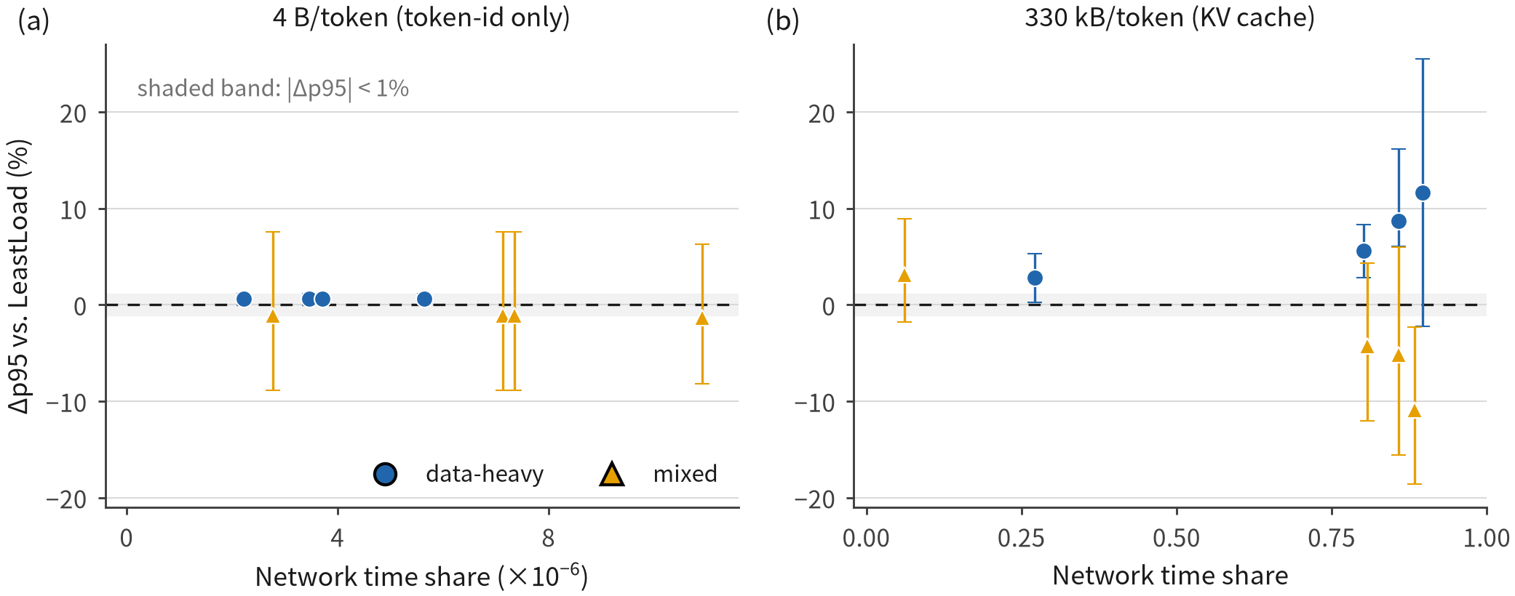
Figure 2. Benefit of the network-aware score against the network-blind baseline as a function of the fraction of end-to-end time spent moving bytes. Each point is one configuration (link-scale profile × workload class) at ten seeds; the two payload regimes are separated by the vertical gap. Below a network share of a few percent the effect is indistinguishable from zero.

5.3. Alignment: the variable that explains the magnitude
Varying only the pairing of compute capacity and link bandwidth, with both multisets fixed and ten seeds per cell, produces the paper’s most robust mechanism result (Table 4). When the rankings agree (ρ = +1), network awareness yields −3.3%—statistically distinguishable from zero but operationally negligible; at maximal conflict (ρ = −1) it yields −68.2%. Group tests over seeds separate the regimes completely (Cliff’s δ = 1.00, Mann–Whitney p = 1.8 × 10⁻⁴ for data-heavy/degraded; δ ≥ 0.94 and p ≤ 4.4 × 10⁻⁴ in all four workload×network combinations), and the pooled trend over the continuous variable is $ρ_{s}$ = +0.72 (p = 2.6 × 10⁻²⁰, n = 120): the better aligned the configuration, the smaller the benefit. Figure 3 places the three alignment configurations side by side.
Table 4. Alignment sweep (synthetic, 10 seeds, 12 000 requests/cell; NetworkAware2 vs LeastLoad). ρ is the Spearman rank correlation between per-worker compute rate and bandwidth (Eq. 13), measured on the configuration itself. “aligned” is a control: the network term should add nothing, and does not.
Workload | Network | ρ | Δp95 (%) | 95% CI | n
data-heavy | degraded | −1.00 | −68.2 | ±1.1 | 10
data-heavy | degraded | +0.50 | −30.0 | ±1.3 | 10
data-heavy | degraded | +1.00 | −3.3 | ±2.4 | 10
data-heavy | unstable | −1.00 | −27.0 | ±3.9 | 10
data-heavy | unstable | +0.50 | −26.1 | ±7.3 | 10
data-heavy | unstable | +1.00 | −9.5 | ±2.6 | 10
mixed | degraded | −1.00 | −70.3 | ±1.2 | 10
mixed | degraded | +0.50 | −35.4 | ±3.0 | 10
mixed | degraded | +1.00 | −22.0 | ±2.8 | 10
mixed | unstable | −1.00 | −26.3 | ±5.2 | 10
mixed | unstable | +0.50 | −29.7 | ±7.6 | 10
mixed | unstable | +1.00 | −11.7 | ±3.1 | 10
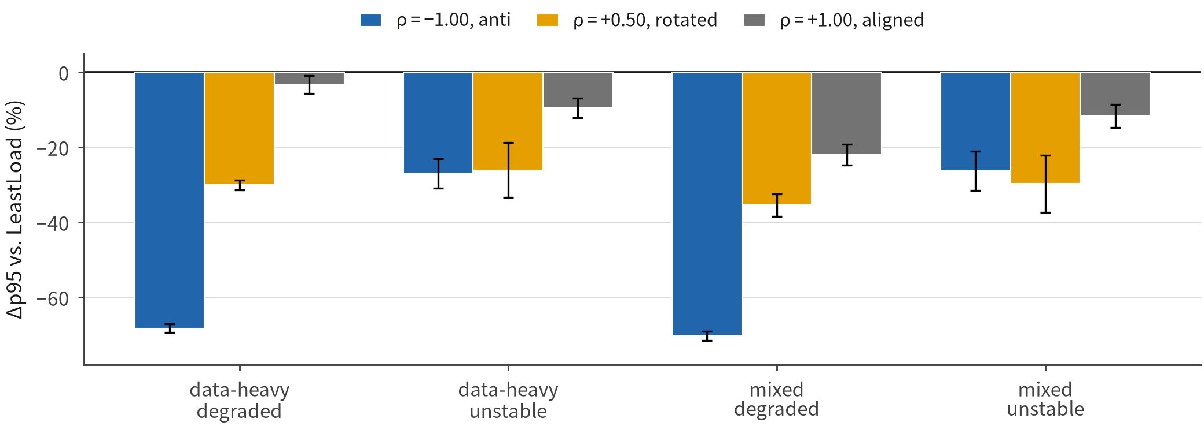
Figure 3. Benefit against the network-blind baseline for the three alignment configurations, four workload×network combinations, ten seeds each. Error bars are 95% confidence intervals over seeds. The aligned control sits at the origin; the anti-aligned configuration carries the effect.

5.4. Comparison against standard and mechanism-level baselines
Four comparison arms, each answering a distinct question, run in the same cells with per-request pairing (Table 5), so the network-aware family cannot be charged with beating only weak baselines.
Against power-of-two-choices (P2C), the standard strong baseline of load-balancing literature, P2C beats LeastLoad in only 4/8, 5/8 and 3/8 cells on synthetic, Azure and BurstGPT respectively, and trails LeastLoad by up to +17.2% on Azure. The reason is structural: with three workers in an anti-aligned configuration, the lower-backlog member of two random samples is frequently the worker with the slowest link.
Every network-aware arm beats P2C in at least 6/8 cells; the positive reading is that a network-blind two-choice rule is simply a poor fit for heterogeneous links.
P2CNet applies the NetworkAware2 score to two randomly sampled workers instead of all N. Across the 24 cells it wins 13 and loses 11, a coin flip, with occasional large advantages on trace batches (Azure, mixed/degraded/stale: −63.3% versus −40.5% for full NetworkAware2). The network term carries the effect; global visibility does not, and a practical router therefore needs two probes per request rather than N.
CongestionOnly, the Aegis-style score reduced to backlog plus link drain without the transfer-time term, matches NetworkAware2 on synthetic data (even winning 4/8 cells there, e.g. data-heavy/degraded/fresh: −74.4% versus −68.2%) but is materially worse on both traces, especially under stale state (Azure, mixed/degraded/stale: −27.9% versus −40.5%; data-heavy/degraded/stale: −31.5% versus −41.1%). The static bandwidth term is redundant only when link widths are already known to the router.
Bottleneck replaces the sum of compute and network time with their maximum, the resource-bottleneck view a max-flow placement takes. The sum wins 8/8 synthetic cells while the two tie 4/8 on each trace; at three workers under anti-alignment the resources are substitutable enough that summing is at least as good and simpler.
Table 5. Baselines vs. the network-blind reference (10 seeds, Δp95 vs. LeastLoad, %, negative is better). “P2C” = power-of-two-choices on backlog; “P2CNet” = two-choice on the network-aware score; “Cong. only” = congestion term alone (Aegis-style); “Bottleneck” = max(compute, network) (Helix-style). “NA2” = NetworkAware2.
Source | Cell | P2C | P2CNet | Cong. only | Bottleneck | NA2
Synthetic | d-heavy/degr./fresh | +5.6 | −69.8 | −74.4 | −66.4 | −68.2
Synthetic | mixed/unst./stale | −14.4 | −24.2 | −11.5 | −6.9 | −8.0
Azure | d-heavy/degr./fresh | +17.2 | −76.2 | −76.4 | −77.8 | −76.7
Azure | mixed/degr./stale | −6.5 | −63.3 | −27.9 | −43.5 | −40.5
Azure | d-heavy/unst./stale | −25.8 | −27.9 | −0.3 | +0.8 | −2.0
BurstGPT | mixed/degr./stale | −15.9 | −50.1 | −30.2 | −34.2 | −40.8
BurstGPT | mixed/unst./stale | −23.3 | −20.1 | +2.1 | +1.2 | +7.2
cells beating LeastLoad (max. 8) | — | 3–5 | 7–8 | 6–8 | 6–8 | 6–8

5.5. Does the effect survive scale, and is it real?
The first objection is that the alignment effect could be a three-worker artifact. Re-running at 4, 8 and 16 workers, the anti-aligned penalty stays essentially flat with size: −63.1%, −60.7%, −57.0% (all p ≤ 1.7 × 10⁻³, Cliff δ ≥ 0.84). What shrinks is the attainable contrast, because the period-four compute ladder against an N-step bandwidth ramp cannot reach extreme correlations (|ρ|: 1.00 at N = 3, 4; 0.49 at N = 8; 0.24 at N = 16), while the within-size trend remains monotone and significant ($ρ_{s}$ = +0.94, +0.82, +0.78). The deployed anti-aligned benefit is scale-robust; the narrowing is an experimental-control limit, not a mechanism, and Figure 4 presents it that way.
The second objection is that LeastLoad might simply get lucky at larger sizes. For every routed request we record the bandwidth rank of the chosen worker (rank 1 = widest link). Under anti-alignment, LeastLoad lands at ranks 2.08, 2.88, 4.57, 7.93 for N = 3, 4, 8, 16 against random-choice values of 2.0, 2.5, 4.5, 8.5—at or worse than random across the whole range (mean deviation 0.28 ranks), never luckier.
Under alignment it does reach good links (1.44, 1.61, 3.37, 6.59), increasingly so with size, which is exactly why the control benefit grows there. The two configurations differ in what a network-blind router can achieve, not in luck.
The third objection—evaluator-induced artifacts from the SLO definition, the two data-volume regimes, and the four engineering coefficients—is taken up in §9. On load intensity itself we offer a bounded statement rather than a curve: the intensity sweep used the weaker v1 score, and across target intensities 0.30–0.90 its p95 effect spans −15.6% to +30.8% (per-level means −3.0, +6.3, +0.3, −1.9, −2.7%, with no stable sign). All v2 results are measured at ρ = 0.6; extending the corrected rule along the intensity axis is the leading item of §10’s future work.
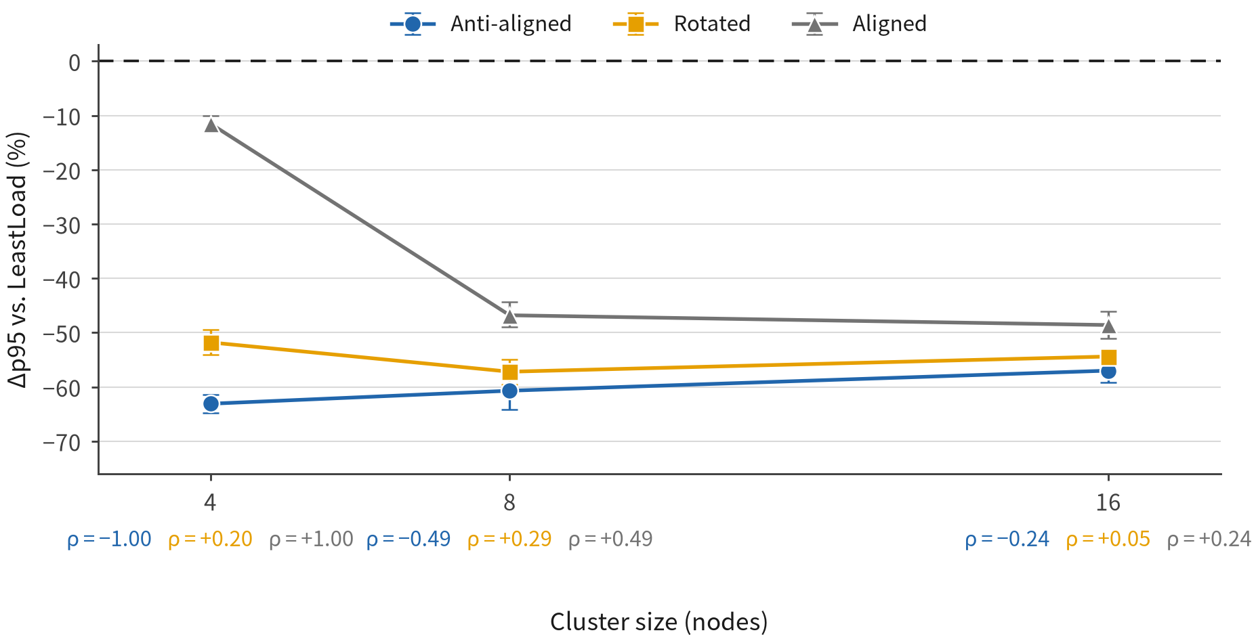
Figure 4. The anti-aligned penalty as a function of cluster size, with the rank correlation ρ annotated at each point. The penalty is flat; what shrinks with size is the attainable contrast (the ρ values themselves).

6. RQ2: How Fast Does Observed State Expire?

6.1. Two channels, one grid
Queue age and link age are swept jointly on the grid {0, 1, 5} s × {0, 1, 15, 60} s with ten seeds per cell on the volatile network, where link age is not trivially ineffective. Table 6 and Figure 5 report the grid, and two readings organize it.
Link state barely expires. With the queue held fresh, moving the link snapshot from 0 s to 60 s retains 89% of the benefit for data-heavy traffic (−27% → −24%) and 65% for mixed (−26% → −17%), on the volatile network rather than the static control.
Queue state expires fast, and the two impairments compose. With the link held fresh, 5 s of queue age costs 56% of the benefit for both mixed (−26% → −4%) and data-heavy (−27% → −12%). When both channels are old (5 s/60 s), the benefit falls to −4% (data-heavy) and −1% (mixed), smaller than either single impairment predicts. Equal-age comparison is meaningless in the other direction too: five seconds of queue age destroy 56–85% of the benefit while sixty seconds of link age destroy only 11–35%. Two points per channel cannot support fitted exponentials, but the ordering is unambiguous and large—the queue channel’s effective time constant sits roughly an order of magnitude or more below the link channel’s.
The reason lies in what the two observables are made of. Link bandwidth is a slowly varying physical property, so an old snapshot still ranks workers almost correctly on its structural component, with only the congestion part perishing. A compute queue has no structural component at all; it is a statement about “right now” and goes wrong at the rate the load changes.
This is also the resolution of the published “telemetry delayed by 60 s does not matter” finding [9]: it is reproducible because the slow-expiring channel was the one swept, and incomplete because the fast-expiring one was not measured.
Table 6. Joint staleness grid (synthetic, 10 seeds, NetworkAware2 vs LeastLoad, Δp95 in %). Rows: queue age; columns: link age. Reading down a column isolates link age; reading across a row isolates queue age.
queue age | link age 0s | 1s | 15 s | 60 s
data-heavy 0s | −27 | −25 | −23 | −24
data-heavy 1s | −24 | −22 | −17 | −19
data-heavy 5s | −12 | −9 | −5 | −4
mixed 0s | −26 | −22 | −15 | −17
mixed 1s | −15 | −16 | −11 | −8
mixed 5s | −4 | −7 | 0 | −1
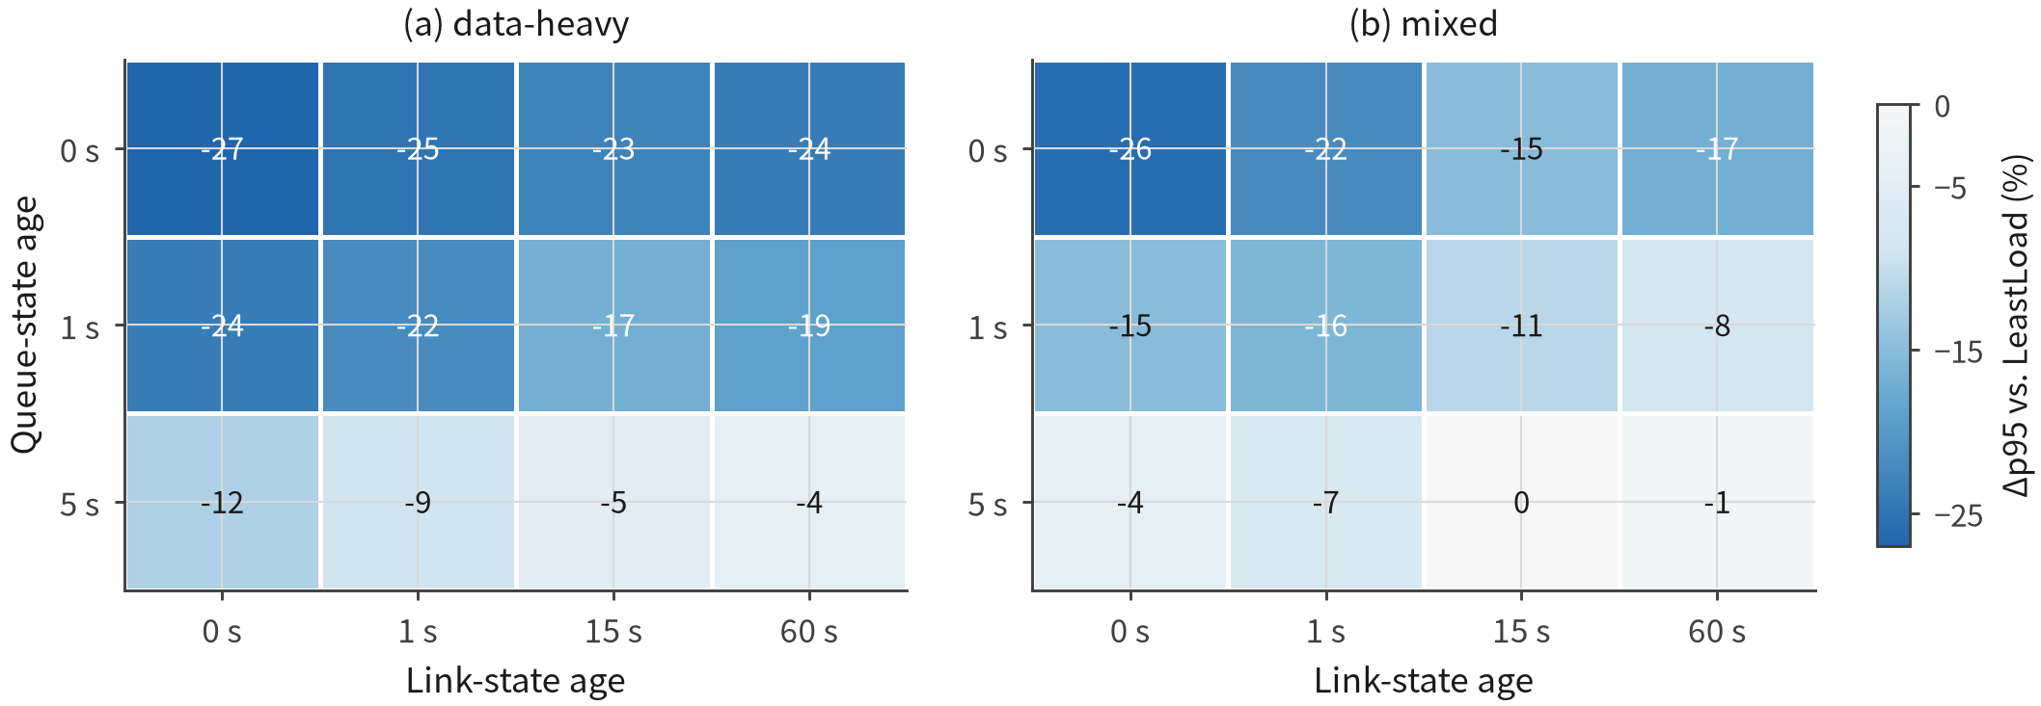
Figure 5. Joint staleness grid: benefit of the network-aware score relative to the network-blind baseline as a function of link-state age (columns) and queue-state age (rows), on the volatile network. Moving right costs little; moving down is expensive.

6.2. Latency and averaging are different distortions
A real monitoring stack typically reports a time average (avg_over_time across the scrape interval), and a smoothing window is a different defect from a lag: lag delays the reaction, while averaging erases the spike the router is currently inside. The window is swept independently of lag (lag = 0) for each channel.
Averaging raises absolute latency substantially and almost equally for both policies—a 30 s queue window moves p95 from 46.2 s to 65.2 s for the network-aware policy and from 139.6 s to 211.1 s for the network-blind baseline (+41% and +51%; mixed/degraded: +44% and +52%; mixed/unstable: +46% and +35%). The relative advantage moves far less: essentially unchanged on the static network (−67.0% → −69.1% for data-heavy, −71.7% → −69.1% for mixed) and only moderately eroded on the volatile network (−20.4% → −14.4% for mixed). The same amount of pure queue lag, by contrast, collapses the benefit to −4% at 5 s. A smoothed average is therefore markedly less damaging than a stale value for this system, inverting the intuition that every loss of freshness is equivalent. Which distortion dominates in practice is set by what the monitoring stack actually reports—window length, scrape interval, and export delay.

7. Conditional Use of Network State
The expiry results motivate discounting the network term as its inputs age. Four rules (Eqs. 14–17) are evaluated in the same cells as the two extremes—full trust as NetworkAware2, no trust as LeastLoad—with ten seeds and 12 000 requests per cell across all three sources, using per-request pairing so the comparison isolates the rules rather than the configurations.

7.1. Why the first design failed
The first design discounted within the link term. Its hypothesis was that a stale link snapshot keeps its structural content (“which link is wide”) while losing its dynamic content (“who is congesting it now”), so the transfer term would stay at full weight and only the congestion term would decay. The hypothesis is mechanistically attractive but the cells reject it. Under a 60 s-old link snapshot (Table 7), term-split retains only −40.2% of the −76.7% available on the Azure trace, where one factor across the whole network term retains −76.2%; on synthetic data it overshoots into harm (+5.5%, the benefit gone entirely). The mechanism mirrors the earlier queue-term failure in reverse: muting the congestion penalty makes “fat link, slow compute” workers attractive again, and traffic piles onto precisely the worker the link term exists to avoid. The operational lesson is that discounting belongs at the granularity of the information source—the channel—not at the level of an individual score term.
Table 7. Four discounting rules against the two extremes, under a 60 s-old link snapshot with a fresh queue (all values are Δp95 vs. LeastLoad, %; negative is better). “per-channel” is Eq. 17, “term-split” is the falsified design Eq. 16; “uniform” and “hard” are Eqs. 15 and 14. Values in parentheses are medians, given only where the trace batches’ per-seed spread is large.
Source | Cell | full trust | per-channel | term-split | uniform | hard
Synthetic | d-heavy / degraded | −68.2 | −61.2 | +5.5 | 0.0 | 0.0
Synthetic | mixed / degraded | −70.3 | −66.2 | −16.6 | 0.0 | 0.0
Azure | d-heavy / degraded | −76.7 | −76.2 | −40.2 | +0.1 | +0.1
Azure | mixed / degraded | −76.8 | −74.4 | −31.1 | +0.7 | +0.5
BurstGPT | mixed / degraded | −60.1 | −58.8 | −28.7 | −20.7 | −10.6
BurstGPT | mixed / unstable, 5/60 s | +32.5 (+23.4) | +3.0 (−0.1) | +1.7 | −3.3 | +2.5
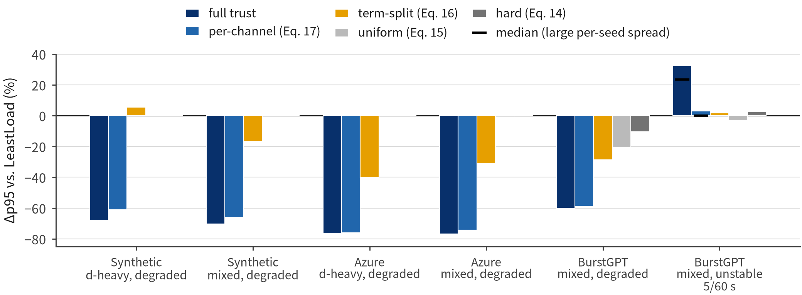
Figure 6. The four discounting rules against both extremes, on the three workload sources (mixed workload, heterogeneous static network). Per-channel discounting tracks full trust where the link snapshot is old, while uniform and threshold discounting collapse to the network-blind baseline.

7.2. What the corrected rule buys, and where it does not pay
The per-channel rule keeps 90–99% of the available benefit under a 60 s-old link snapshot on all three sources (Azure: −76.7% → −76.2%; synthetic: −68.2% → −61.2%; BurstGPT: −60.1% → −58.8%), where uniform and hard discounting retain none (Figure 6). Section 6 predicts exactly this: because the link channel barely decays, discounting it can mostly subtract value.
The rule is insurance rather than a general upgrade, and Table 8 maps its price. It is a net loss in most Azure conditions and never dominates both extremes; what it buys is the removal of one specific failure mode. In the final row of Table 7, on the burstiest source with both channels stale, full trust is harmful in the majority of seeds (median +23.4%) and the per-channel rule restores parity (median −0.1%).
The median is what exposed the regime in the first place: at that cell mean (+32.5%) and median (+23.4%) agree in sign, but at the neighbouring data-heavy/unstable, 5/0 cell the mean is +27.8% while the median is −0.5—a single-seed artifact that a mean-only table would have promoted into a finding.
Table 8. Verdict counts over 24 conditions per source (6 staleness configurations × 2 workloads × 2 network conditions). “Better than both” counts conditions where the rule beats both full trust and no trust. No rule dominates.
Source | Rule | beats both | loses both | beats full | loses full
Synthetic | per-channel | 5 | 1 | 5 | 18
Synthetic | term-split | 4 | 3 | 4 | 19
Synthetic | uniform | 5 | 5 | 5 | 18
Synthetic | hard | 5 | 1 | 5 | 17
Azure | per-channel | 1 | 4 | 1 | 22
Azure | term-split | 1 | 5 | 1 | 22
Azure | uniform | 2 | 4 | 4 | 19
Azure | hard | 4 | 8 | 7 | 15
BurstGPT | per-channel | 8 | 2 | 10 | 13
BurstGPT | term-split | 6 | 2 | 8 | 15
BurstGPT | uniform | 10 | 4 | 10 | 13
BurstGPT | hard | 7 | 3 | 8 | 14

7.3. The regime where discounting is needed
Asking “in how many independent seeds does full trust lose to the network-blind baseline” is more robust than asking how large the mean effect is, and Table 9 localizes the answer sharply. With a fresh queue, full trust wins 9–10 of 10 seeds even at a 60 s-old link snapshot, so discounting there is pure loss. On the volatile network with a 5 s-old queue, it loses in 4–6 of 10 seeds on every source. Discounting has a job to do in that one cell—the cell the two-channel expiry model of §6 points to—and nowhere else.
Table 9. Seeds (of 10) in which full trust beats the network-blind baseline. The only regime where full trust is unreliable is a stale queue on a volatile network.
Queue / link age | Source | mixed / deg. | mixed / unst. | d-heavy / unst.
0/60 s | Synthetic | 10 | 10 | 10
0/60 s | Azure | 10 | 9 | 10
0/60 s | BurstGPT | 10 | 9 | 6
5/0 s | Synthetic | 10 | 6 | 10
5/0 s | Azure | 10 | 4 | 4
5/0 s | BurstGPT | 8 | 7 | 5
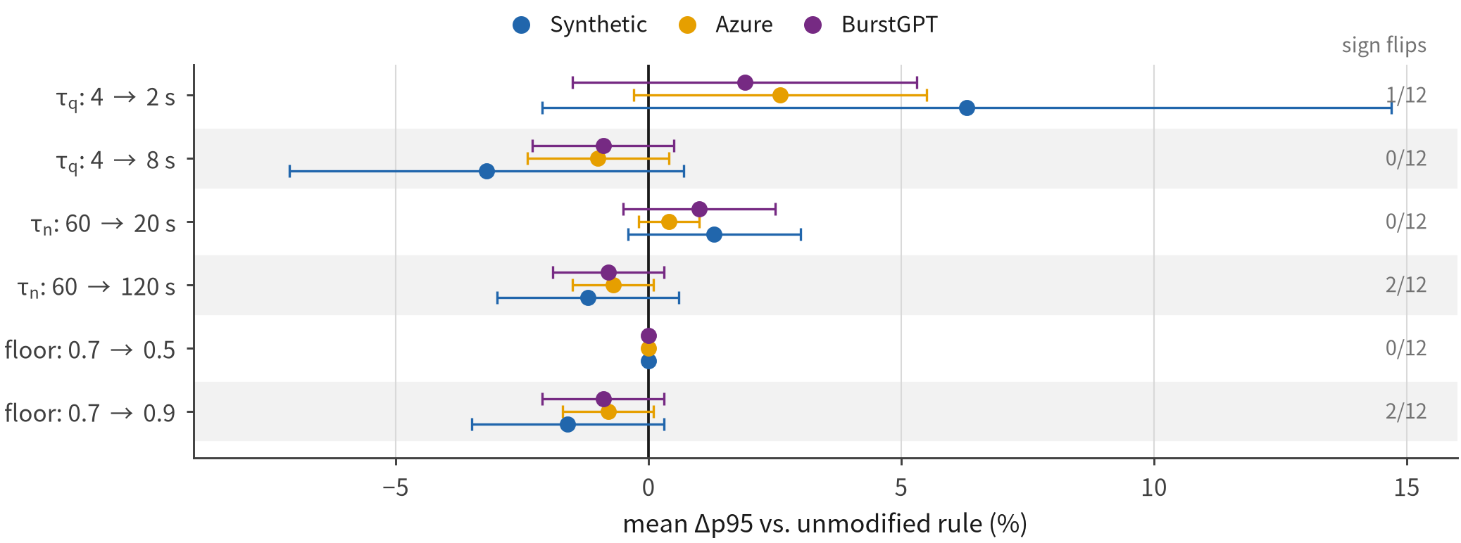
Figure 7. One-factor-at-a-time ablation of the per-channel rule on all three sources. Bars show the mean change in p95 relative to the unmodified rule with 95% confidence intervals; the annotation on each bar counts conditions where the sign of the conclusion changes.

7.4. Parameter sensitivity
Eq. 17 contains exactly three numbers, each read from the §6 expiry curves rather than tuned, and each is ablated by a factor of two one at a time (Table 10). The link-side time constant at 20–120 s moves p95 by −1.2 to +1.3%; the weight floor at 0.5–0.9 moves it by −1.6 to 0.0%; the queue-side constant at 2–8 s moves it by −3.2 to +6.3%, with confidence intervals spanning zero. The conclusion’s sign flips in at most 2 of 12 conditions on any source and in 0 of 12 on Azure (Figure 7). Constants read off data should behave this way: no single parameter is load-bearing.
Table 10. One-factor-at-a-time ablation of the per-channel rule (mean Δp95 vs. the unmodified rule, with 95% CI over 12 conditions; “flips” counts conditions where the sign of “rule vs. full trust” changes).
Variant | Synthetic | Azure | BurstGPT | flips (max)
$τ_{q}$: 4 → 2 s | +6.3 ± 8.4 | +2.6 ± 2.9 | +1.9 ± 3.4 | 1/12
$τ_{q}$: 4 → 8 s | −3.2 ± 3.9 | −1.0 ± 1.4 | −0.9 ± 1.4 | 1/12
$τ_{n}$: 60 → 20 s | +1.3 ± 1.7 | +0.4 ± 0.6 | +1.0 ± 1.5 | 0/12
$τ_{n}$: 60 → 120 s | −1.2 ± 1.8 | −0.7 ± 0.8 | −0.8 ± 1.1 | 2/12
floor: 0.7 → 0.5 | 0.0 ± 0.0 | 0.0 ± 0.0 | 0.0 ± 0.0 | 0/12
floor: 0.7 → 0.9 | −1.6 ± 1.9 | −0.8 ± 0.9 | −0.9 ± 1.2 | 2/12

7.5. An open mechanism question
The remaining question is which load property determines whether discounting pays. Two pre-registered hypotheses were tested and neither holds. The first tied harm to arrival burstiness: ordering sources by per-second arrival-count variability gives Azure (0.23–0.30) < synthetic (0.60–0.65) < BurstGPT (1.30–2.11), yet the fraction of benefit destroyed by 5 s of queue age is largest on Azure, breaking monotonicity. The second tied it to rate persistence—lag-1 autocorrelation of per-second counts and the mean relative change of windowed rates—on the rationale that transient spikes average out while sustained shifts do not; synthetic has the highest autocorrelation (0.73–0.85) and the lowest harm, rejecting that version too. The measured boundary stands without a fitted story: a stale queue on a volatile network, on all three sources. A scale-matching account, in which staleness matters when the observation window approaches the queue’s own drain time, is consistent with the data but untested; the controller-timescale mismatch result in [46] points to the concrete experiment that would test it.

8. Real-Cluster Measurements
The simulator supplies control by assuming that knowing is free. The container deployment runs the same routing logic on real software (§4.6)—a single-node k3s cluster with three worker pods, application-level link shaping, and a client outside the cluster—to measure the three quantities the simulator cannot represent, and then to quantify how repeatable those measurements are.

8.1. Pilot grid: where the mechanism appears on real networking
An exploratory single-run grid first located the effects worth repeating. At an offered load of $ρ_{cpu}$ = 0.50 with a 38.9 MB payload (measured network share 0.65), the network-aware policy beats the network-blind one in all four cells, by 21–45% on p95; at a 0.6 MB payload (network share 0.05) the same comparison reads −1.6%, +68.7%, +23.1%, −16.3%, no effect or harm. The on/off behavior of §5 therefore reproduces on the real kernel network path. Injecting a 3 s state lag moves the benefit from −45.2% to −21.4% at moderate load and from −37.5% to −27.9% at the higher load, matching the direction measured in simulation. Because each pilot cell ran once, its deltas are treated as targeting information for the repeat study rather than as magnitudes; §8.3 reports the dispersion that justifies that choice.

8.2. The cost of reading state, and the feedback loop it creates
Where the simulator assumes an instantaneous observation, the cluster prices it: fetching a worker’s state costs 56 ms to 876 ms against 12 µs for an in-cluster round trip, a factor of 50 to 900. The cost also moves with the system rather than staying constant, because the state endpoint contends for the same CPU quota as the work it describes. The busier the system, the staler the observation—exactly when freshness matters most—a feedback loop absent from simulation by construction.
Polling adds a second bound. With a 15 s polling period, the age of the state actually acted on averaged 6.4 s and reached 14.8 s worst-case, roughly half a period to a full period on top of export delay. No scheduler can be fresher than its polling loop, so “zero lag” is unavailable even with no network delay at all.
Two operational failure modes appear in the traces. The latency effect of stale state is threshold-like rather than proportional: pulls of 64 ms to 755 ms leave p95 essentially unchanged, while pulls of 3.6 s to 6.4 s make p95 2 to 3.6× worse, with the knee between 1 s and 5 s in this setting. When a state pull times out (>2 s), the client substitutes a conservative “everything is busy” value and the scheduler becomes effectively blind; the event occurred twice in a long run and is worth handling explicitly in any production design.
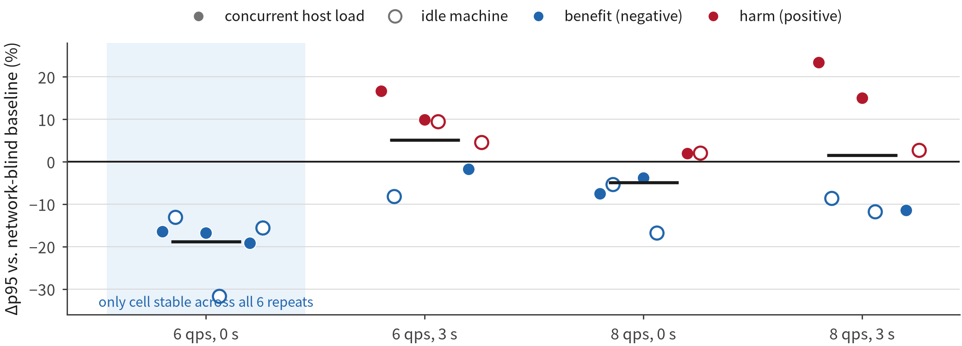
Figure 8. Real cluster, six independent repeats per cell. Bars are the network-aware policy’s p95 under three runs with a concurrent job on the host and three on an idle machine; short horizontal marks are the network-blind baseline for the same run. Only the fresh, moderate-load cell has a stable direction across all six.

8.3. Repeat study: what a single-node cluster can resolve
A focused grid—two offered loads × two staleness levels × the payload with 0.65 network share—was repeated six times, three while a simulation ran concurrently on the host and three on an otherwise idle machine. The repeats deliver three conclusions.
The fresh, moderate-load cell is stable across all six repeats: the network-aware policy is better six times out of six, by 13–32%, which establishes the direction of the simulation mechanism on the real network stack. At the higher load and in every stale cell the sign does not stabilize, and the correct reading is that this testbed cannot resolve those cells rather than that either policy is preferred. The repeats also adjudicate a candidate observation from the pilot: the three concurrent runs had suggested the network-aware policy became far more variable across repeats than the baseline (±17% vs. ±2.4% at qps 8 with 3 s staleness), but the idle-machine runs do not reproduce it (baseline 10.8% vs. policy 18.0%, with the ordering reversing at qps 6), so the observation is not retained.
The decisive statistic is the spread, not any individual delta: repeat-to-repeat dispersion is 10% to 30% even on an idle machine, which defines the resolving power of the testbed and the error bar on every cluster delta in this paper, including the larger pilot numbers in §8.1.
Table 11. Real cluster, six independent repeats of each cell (Δp95 of the network-aware policy vs. the network-blind one; negative is better). Only the fresh, moderate-load cell has a stable direction.
Load (qps) | State lag | with job 1 | with job 2 | with job 3 | idle 1 | idle 2 | idle 3
6 | 0s | −16.5 | −16.8 | −19.2 | −13.1 | −31.7 | −15.6
6 | 3s | +16.6 | +9.9 | −1.8 | −8.2 | +9.4 | +4.6
8 | 0s | −7.5 | −3.8 | +1.9 | −5.4 | −16.8 | +2.0
8 | 3s | +23.4 | +15.0 | −11.4 | −8.6 | −11.8 | +2.7

8.4. Cloud disaggregation: same-cloud baseline and cross-cloud feasibility
The container deployment validates direction but contains neither a real LLM service nor a cross-cloud KV path, so a separate, tightly scoped measurement ran Qwen2.5-1.5B-Instruct on A10 instances. Its role is a feasibility and deployment anchor: B2 comprises four paired service rounds and C two cloud directions, with requests nested inside rounds or directions as repeated observations rather than independent experiments.
Table 12 reports the anchor. In the same-cloud baseline, splitting prefill and decode raises median TTFT by 207.3% in serial execution and 97.1% at concurrency four, while the average token interval moves only +1.3% and −1.5% and total median latency rises 16.0% and 9.8%. The KV ledger closes independently: each split round moves 100 KV objects and about 4.294 GB with zero transfer failures and zero local prompt recomputation.
Table 12. Real-LLM deployment anchor. Values are medians unless a range is shown. B2 is a descriptive baseline over four paired rounds; C is a descriptive feasibility measurement over two directions. The C values are not inferential estimates.
Shape | Load | TTFT p50 | TTFT p95 | Token gap | Total p50 | Evidence unit
Base | serial | 0.068 | 0.122 | 0.0141 | 0.953 | B2, 4 rounds
Same-cloud split | serial | 0.211 | 0.321 | 0.0142 | 1.111 | B2, 4 rounds
Alibaba → Tencent | serial | 4.16 | 7.10 | 0.0177 | 5.26 | C, D1
Tencent → Alibaba | serial | 3.84 | 6.39 | 0.0144 | 4.78 | C, D2
Base | concurrency 4 | 0.144 | 0.309 | 0.0164 | 1.204 | B2, 4 rounds
Same-cloud split | concurrency 4 | 0.280 | 0.648 | 0.0162 | 1.301 | B2, 4 rounds
Alibaba → Tencent | concurrency 4 | 15.09 | 18.46 | 0.0191 | 16.25 | C, D1
Tencent → Alibaba | concurrency 4 | 14.87 | 21.30 | 0.0171 | 15.95 | C, D2
KV ledger: 28,798.9 bytes/token; 100 transfers/round; failures = 0; local recomputation = 0.
The cross-cloud run completes both directions and all 200 formal requests with zero failures and exactly 64 generated tokens per request. Against the same-cloud split baseline, serial TTFT rises 1872% for Alibaba-to-Tencent and 1720% for Tencent-to-Alibaba, with descriptive changes of 5289% and 5211% at concurrency four. The dominant extra cost lands before the first generated token while the decode stream stays comparatively stable; the two directions differ in client location, path asymmetry, tunnel conditions and GPU software, so the numbers characterize this deployment rather than a universal cloud penalty. Figure 9(a) puts the four deployment forms on one descriptive scale and Figure 9(b) presents the five C-stage prompt-length groups, with dashed 1/bandwidth engineering references drawn from measured bandwidth rather than fitted regressions.
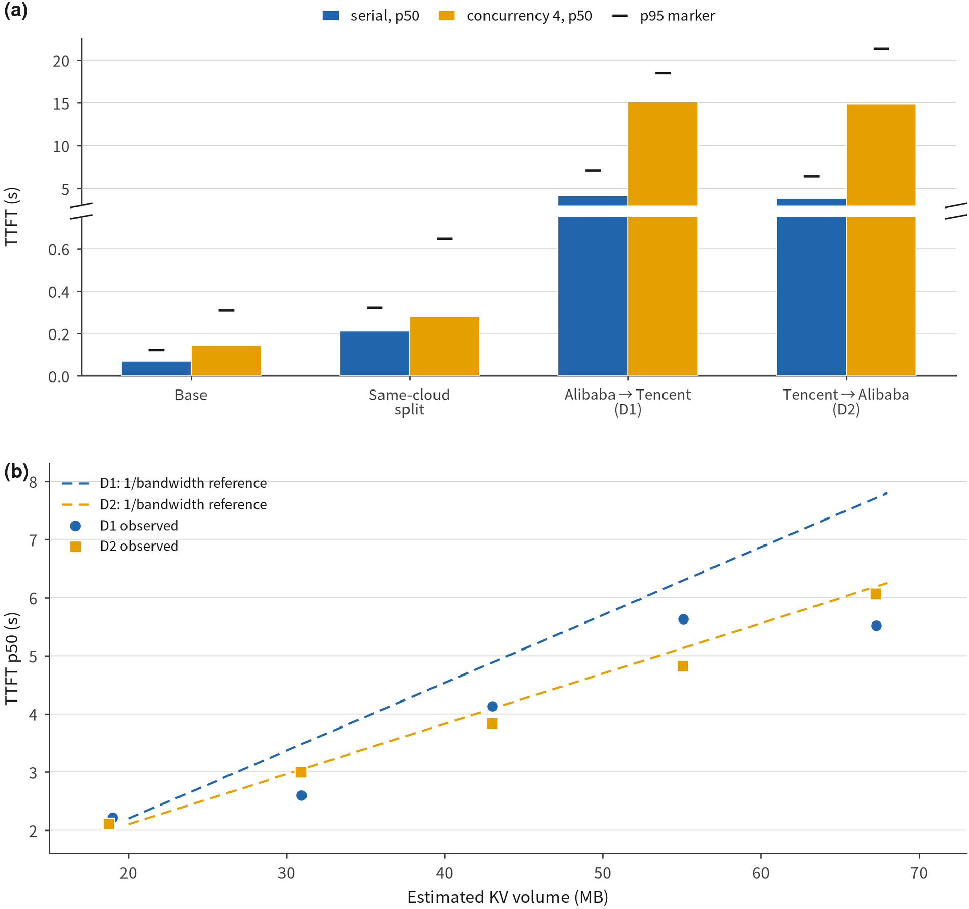
Figure 9. Real-cloud deployment anchor. (a) Median TTFT for same-cloud and cross-cloud configurations under serial and four-way concurrency. (b) C-stage TTFT against estimated KV volume for five fixed prompt groups. Dashed lines are anchored 1/bandwidth engineering references; this panel is a descriptive background, not a linearity test. D-mini was planned but not executed.

9. Threats to Validity
The limitations are organized around the three evidence tiers and the calibration behind them. Each caveat appears in this section once; the results sections state what was measured, and this section states how far each measurement reaches.
Simulator fidelity. Each worker’s slots advance independently at full speed, making total throughput the linear sum of per-slot rates. A real 4-way parallel serving process does not behave this way: per-request service time rose from 83 ms idle to 162 ms at sustained saturation (1.95×), so in the saturated region the simulator overestimates throughput by roughly a factor of two and inflates achievable throughput against a fixed SLO. Policy comparisons in p95 are less exposed because every policy shares the error, although that sharing remains an assumption rather than a measurement. On the network side, transfers serialize on a per-worker pipe without rate degradation under sharing, concurrent transfers are FIFO rather than processor-shared, and inter-worker links are independent with no shared uplink, incast, fabric-level queueing or congestion control; this understates network cost at high load and therefore makes the reported benefits conservative. The cluster testbed keeps the kernel path real—socket buffers and container-network loopback included—but applies bandwidth shaping in the application layer rather than with tc, so the shaping itself is not production network behavior.
Resolution of the real-system evidence. The container deployment is a single node with CPU-quotas, no GPUs, no RDMA and no multi-host fabric, which is why its job is direction validation and the measurement of observation costs rather than production magnitudes. Its resolving power is quantified: repeat-to-repeat dispersion on an idle machine runs 10% to 30%, and every real-cluster delta in the paper should be read with that error bar.
The cloud measurement uses one 1.5B model family on A10 instances with a fixed approximately 43 MB KV payload in B2/C, covering two cloud providers and one deployment path rather than a representative sample of models, GPU generations, regions or production networks; even with A10 accelerators on both sides, hosts, drivers, egress paths, tunnels and background conditions differ, so the data support feasibility and observed overhead under the stated configuration, not a provider ranking or a production cost model. B2’s four paired rounds and C’s two directions make those results descriptive rather than population-level estimates: the 800 B2 and 200 C requests are nested observations, not 1000 independent experiments, and because C places the client at different clouds with asymmetric measured bandwidth, cross-cloud differences cannot be attributed entirely to KV transfer. The planned D-mini input-length sweep did not execute, so data-volume variation is studied in simulation while the cloud runs remain mechanism and deployment anchors; no real-cloud scaling law is claimed, and Figure 9(b) is labeled accordingly.
Calibration and inputs. Four coefficients are declared engineering estimates rather than measurements: the work coefficients (α = 1, β = 4), the payload model $κ_{c}$ ∈ {4 B, 330 KB} per token, the injected staleness magnitudes, and the SLO multiplier (m = 3). The first two are mitigated by sweeping the payload model—the dominant choice—and by reporting network share, whose magnitude does not depend on α or β; the SLO multiplier enters only miss-rate secondary metrics and cannot move the p95 analysis that carries the claims. Absolute compute rates are not physically calibrated, which leaves relative policy comparisons meaningful and absolute second-level latencies not. For workloads, each trace represents one service class (Azure: the code subset with very short outputs; BurstGPT: ChatGPT/GPT-4 conversational traffic with strong bursts), and the workload classes are token-quantile slices rather than trace-provided labels; both traces were used in truncated downloads (the first 50 MB of the Azure week and a 50 MB BurstGPT sample), which shortens coverage without biasing arrival-rate calibration because rates are re-fitted per simulated prefix.
Coverage boundaries. Three known gaps bound the conclusions. First, the §7 discounting rule is evaluated only at load intensity ρ = 0.6; the available intensity sweep used the weaker v1 score, whose sign is unstable across intensities (−15.6% to +30.8%), and extending the corrected rule along that axis is the largest open item.
Second, beyond N = 4 strongly aligned configurations cannot be constructed, so the alignment effect is measured over a narrowing ρ range (down to 0.24 at N = 16); the anti-aligned benefit stays stable while the contrast narrows for experimental-control reasons. Third, observation error is modeled as a constant lag plus an optional averaging window, whereas the testbed shows actual age is a random variable and fetch cost is load-dependent, neither of which the simulator represents. Across all tiers, nothing here should be read as a claim about a specific production deployment: the contribution is the boundary itself—the configurations, payload regimes and freshness levels at which a network term is worth including, and those at which ignoring the network is the better choice.

10. Conclusion
Network-aware routing is usually presented as a benefit, and we asked the narrower question that the spread in published numbers implies: when does that benefit exist, and when does acting on network state make things worse? The answer is a boundary, not a speedup, and it has six parts.
A configuration variable explains the magnitude. With the fastest-computing worker on the widest link a network term adds essentially nothing (−3.3%); with the rankings in conflict it is worth −68.2%, the regimes separate completely across seeds, and the contrast persists from 3 to 16 workers. The value comes from disagreement, not from link speed.
The two observable channels expire roughly an order of magnitude apart—link state retains 65–89% of its value at 60 s while queue state loses 56–85% within 5 s—which makes the 60 s telemetry result reproducible and incomplete at once. Averaging and lateness are different defects: a 30 s smoothing window inflates absolute tail latency 35–52% on both policies but barely moves their relative advantage, where the same amount of pure lag destroys it. Discounting has to act at the level of the information source, because term-level splitting re-creates the “fat link, slow compute” pile-up, while per-channel discounting retains 90–99% of the benefit under a 60 s-old link snapshot where uniform and threshold rules retain none. Its useful regime is one cell wide—a stale queue on a volatile network; elsewhere full trust wins 9–10 of 10 seeds and discounting is a net loss, which is why we present the rule as insurance. Finally, reading state is not free: 56 ms to 876 ms per read against 12 µs for an in-cluster round trip, rising with load, with polling flooring achievable freshness at half to a full period and a staleness knee between 1 s and 5 s.
The evidence also includes the designs that did not survive, kept here because they map the boundary. The term-level discounting design was rejected by the cells, no discounting rule dominates the two extremes (the corrected rule is a net loss in most conditions on one of the three sources), and two pre-registered explanations for where discounting pays—arrival burstiness and rate persistence—were both refuted, leaving the mechanism open; on the cluster, a pilot variability observation failed to replicate on idle-machine runs and was dropped.
Four experiments follow directly from the gaps. The corrected rule should be swept along the load-intensity axis, the largest hole in coverage; the scale-matching hypothesis should be tested by tracking whether harm follows the ratio of the staleness window to the queue’s drain time, a concrete version of the controller-timescale mismatch in [46]; the testbed should move to multiple hosts with kernel-level shaping to convert direction-level evidence into magnitudes; and observation error should be modeled as sampled, load-dependent age with timeouts and fallbacks, since age variance and measurement cost are first-order effects a constant-lag simulator cannot represent.
The literature’s disagreement over the value of network-aware scheduling is not a contradiction waiting for a better scheduler. It is the predictable result of measuring one idea under different alignments, different payload regimes and different observable channels; quoting a benefit without the regime it was measured in is what makes the numbers incomparable, and naming that regime is the omission this paper set out to repair.
The two-cloud anchor closes the loop between simulation and a deployed serving path without changing that main claim. Same-cloud disaggregation raised median TTFT 207.3% in serial execution and 97.1% at concurrency four, with total median latency up 16.0% and 9.8%; the bidirectional cross-cloud run finished every formal request but placed median TTFT several times above the same-cloud split baseline. Read as descriptive anchors from four rounds and two directions, they show the KV path is feasible while its network cost can overwhelm decode-stage gains.

CRediT authorship contribution statement
Weiguo Hao: Conceptualization, Methodology, Software, Validation, Formal analysis, Investigation, Data curation, Writing – original draft, Writing – review & editing, Visualization, Project administration, Funding acquisition.

Declaration of competing interest
The author declares that there are no known competing financial interests or personal relationships that could have appeared to influence the work reported in this paper.

Declaration of generative AI and AI-assisted technologies in the writing process
During the preparation of this work, the author did not use any generative artificial intelligence or artificial-intelligence-assisted technologies.

Data availability
The simulator, workload processing scripts, per-run manifests and exported outputs used to derive every figure and table in this paper are openly available at https://github.com/qingtuanX/netkv-network-aware-scheduling. The Azure LLM inference trace and the BurstGPT trace are public datasets maintained by their original publishers.

Acknowledgements
This research did not receive any specific grant from funding agencies in the public, commercial, or not-for-profit sectors.

References
[1] Y. Zhong, S. Liu, J. Chen, J. Hu, Y. Zhu, X. Liu, X. Jin, H. Zhang, DistServe: Disaggregating prefill and decoding for goodput-optimized large language model serving, in: Proc. USENIX OSDI, USENIX Association, Santa Clara, CA, 2024, pp. 193–210.
[2] P. Patel, E. Choukse, C. Zhang, A. Shah, I. nigo Goiri, S. Maleki, R. Bianchini, Splitwise: Efficient generative LLM inference using phase splitting, in: Proc. ACM/IEEE ISCA, IEEE, 2024, pp. 118–132. doi:10.1109/ISCA59077.2024.00019.
[3] R. Qin, Z. Li, W. He, J. Cui, H. Tang, F. Ren, T. Ma, S. Cai, Y. Zhang, M. Zhang, Y. Wu, W. Zheng, X. Xu, Mooncake: A KVCache-centric disaggregated architecture for LLM serving, in: Proc. USENIX FAST, USENIX Association, Santa Clara, CA, 2025, pp. 155–170.
[4] B. Sun, Z. Huang, H. Zhao, W. Xiao, X. Zhang, Y. Li, W. Lin, Llumnix: Dynamic scheduling for large language model serving, in: Proc. USENIX OSDI, USENIX Association, Santa Clara, CA, 2024, pp. 173–191.
[5] S. Rajasekaran, M. Ghobadi, A. Akella, CASSINI: Network-aware job scheduling in machine learning clusters, in: Proc. USENIX NSDI, USENIX Association, Santa Clara, CA, 2024, pp. 1403–1420.
[6] X. Han, S. Zhao, Y. Lv, P. Cao, W. Jiang, Q. Yang, Y. Liu, S. Lin, B. Jiang, X. Liu, Y. Cui, C. Zhou, X. Wang, VClos: Network contention aware scheduling for distributed machine learning tasks in multi-tenant GPU clusters, Computer Networks 268 (2025) 111285. doi:10.1016/j.comnet.2025.111285.
[7] Y. Mei, Y. Zhuang, X. Miao, J. Yang, Z. Jia, R. Vinayak, Helix: Serving large language models over heterogeneous GPUs and network via max-flow, in: Proc. ACM ASPLOS, ACM, 2025, pp. 586–602. doi:10.1145/3669940.3707215.
[8] M. A. Ojewale, NetKV: Network-aware decode instance selection for disaggregated LLM inference, preprint; author list verified against local PDF (arXiv:2606.03910, p.1): single author, Cloud Competency Centre, National College of Ireland (2026). arXiv:2606.03910.
[9] R. Li, S. Cao, Aegis: Contract-bounded online adaptation for networked accelerator clusters, in: Proc. ACM SIGCOMM, ACM, 2026, pp. 1062–1074. doi:10.1145/3789240.3829167.
[10] H. Jin, S. Li, M. Gregory, GenSched: Phase-aware generative scheduling for LLM serving in heterogeneous edge networks, in: Proc. IEEE INFOCOM, IEEE, 2026, pp. 1–6. doi:10.1109/INFOCOM59046.2026.11571651.
[11] A. Agrawal, N. Kedia, A. Panwar, J. Mohan, N. Kwatra, B. S. Gulavani, R. Ramjee, Sarathi-Serve: Taming throughput–latency tradeoff in LLM inference with chunked prefill, in: Proc. USENIX OSDI, USENIX Association, Santa Clara, CA, 2024, pp. 117–134.
[12] Y. Fu, L. Xue, Y. Huang, A.-O. Brabete, D. Ustiugov, Y. Patel, L. Mai, ServerlessLLM: Locality-enhanced serverless inference for large language models, in: Proc. USENIX OSDI, USENIX Association, Santa Clara, CA, 2024, pp. 135–153.
[13] Y. Liu, H. Li, Y. Cheng, S. Ray, Y. Huang, Q. Zhang, K. Du, J. Yao, S. Lu, G. Ananthanarayanan, M. Maire, H. Hoffmann, A. Holtzman, J. Jiang, CacheGen: KV cache compression and streaming for fast large language model serving, in: Proc. ACM SIGCOMM, ACM, 2024, pp. 38–56. doi:10.1145/3651890.3672274.
[14] W. Li, G. Jiang, X. Ding, Z. Tao, C. Hao, C. Xu, Y. Zhang, H. Wang, FlowKV: A disaggregated inference framework with low-latency KV cache transfer and load-aware scheduling (2025). arXiv:2504.03775.
[15] M. Canini, T. A. Benson, R. Bianchini, I. nigo Goiri, D. Kostić, P. Pietzuch, S. Peter, Cloud abstractions for AI workloads, in: Proc. ACM SIGOPS APSys, ACM, 2025, pp. 98–105. doi:10.1145/3725783.3764395.
[16] T. Sisodia, From inference engine to inference control plane: Connecting vLLM, llm-d, and the evolution of efficient distributed LLM serving (2026). arXiv:2609.23130.
[17] W. Wang, M. Khazraee, Z. Zhong, M. Ghobadi, Z. Jia, C. Mudigere, Y. Zhang, A. Kewitsch, TopoOpt: Co-optimizing network topology and parallelization strategy for distributed training jobs, in: Proc. USENIX NSDI, USENIX Association, Boston, MA, 2023, pp. 739–767.
[18] M. Dahlin, Interpreting stale load information, in: Proc. IEEE ICDCS, IEEE, 1999, pp. 285–296. doi:10.1109/ICDCS.1999.776530.
[19] D. Lipshutz, Open problem: Load balancing with delayed information, Stochastic Systems 9 (2019) 305–306, formally lists delayed-information load balancing as an open problem. doi:10.1287/stsy.2019.0045.
[20] A. Shaikh, J. Rexford, K. G. Shin, Evaluating the impact of stale link state on QoS routing, IEEE/ACM Trans. Networking 9 (2001) 162–176, stale link state causes wrong routing decisions and oscillation. doi:10.1109/90.917073.
[21] Y. Feng, Z. Liu, Y. Zhao, T. Jin, Y. Wu, Y. Zhang, J. Cheng, C. Li, T. Guan, ParSync: Parallel synchronization for scheduling simplicity and scalability, in: Proc. USENIX ATC, USENIX Association, 2021, pp. 81–97, treats the admissible staleness as a design variable.
[22] R. D. Yates, Y. Sun, D. R. Brown, S. K. Kaul, E. Modiano, S. Ulukus, Age of information: An introduction and survey, IEEE J. Sel. Areas Commun. 39 (2021) 1183–1210, states that no universal staleness threshold exists; it must be measured per scenario and objective. doi:10.1109/JSAC.2021.3065072.
[23] M. Shisher, Y. Sun, I. Hou, Timely communications for remote inference, IEEE/ACM Trans. Networking 32 (2024) 3824–3839. doi:10.1109/TNET.2024.3408673.
[24] H. Kim, H. Kim, C. Bae, S. Pack, FreshINT: Freshness-aware early reporting in in-band network telemetry systems, in: Proc. IEEE INFOCOM, IEEE, 2026, pp. 1–6, directly optimizes telemetry freshness. doi:10.1109/INFOCOM59046.2026.11571376.
[25] Z. Zheng, J. Long, B. Li, J. Yao, Stale does not mean unsafe: Guard precision for tool-using LLM agents under infrastructure state races (2026). arXiv:2609.29522.
[26] W. Kwon, Z. Li, S. Zhuang, Y. Sheng, L. Zheng, C. H. Yu, J. E. Gonzalez, H. Zhang, I. Stoica, Efficient memory management for large language model serving with PagedAttention, in: Proc. ACM SOSP, ACM, 2023, pp. 611–626. doi:10.1145/3600006.3613165.
[27] L. Zheng, L. Yin, Z. Xie, C. Sun, J. Huang, C. H. Yu, S. Cao, C. Kozyrakis, I. Stoica, J. E. Gonzalez, C. Barrett, Y. Sheng, SGLang: Efficient execution of structured language model programs, in: Proc. NeurIPS, Neural Information Processing Systems Foundation, Inc. (NeurIPS), 2024, pp. 62557–62583. doi:10.52202/079017-2000.
[28] G.-I. Yu, J. S. Jeong, G.-W. Kim, S. Kim, B.-G. Chun, Orca: A distributed serving system for transformer-based generative models, in: Proc. USENIX OSDI, USENIX Association, Carlsbad, CA, 2022, pp. 521–538.
[29] Z. Li, L. Zheng, Y. Zhong, V. Liu, Y. Sheng, X. Jin, Y. Huang, Z. Chen, H. Zhang, J. E. Gonzalez, I. Stoica, AlpaServe: Statistical multiplexing with model parallelism for deep learning serving, in: Proc. USENIX OSDI, USENIX Association, Boston, MA, 2023, pp. 663–679.
[30] NVIDIA, Dynamo: A datacenter-scale distributed inference framework, Open-source project, https://github.com/ai-dynamo/dynamo (2025).
[31] llm-d project, llm-d: Kubernetes-native distributed inferencing, CNCF Sandbox, https://llm-d.ai (2025).
[32] W. Zhang, Z. Wu, Y. Mu, R. Ning, B. Liu, N. Sarda, M. Lee, F. Lai, JITServe: Slo-aware LLM serving with imprecise request information, proc. USENIX NSDI; author list, pages and publisher verified against the USENIX official BibTeX (2026).
[33] J. Liu, C. Zhang, H. Pan, Y. Li, PSP: Low-overhead packet-level load balancing for stale-state and bandwidth-asymmetric networks (2026). arXiv:2608.08425.
[34] A. R. Toniolo, R. Thorstenson, A. Dinesh, GORGO: Online tuning for cross-region network-aware LLM serving (2026). arXiv:2602.11688.
[35] V. K. Singh, P. Priyam, G. Bhowmick, ChurnBench: A drift-aware benchmark demonstrating that refresh scheduling, not cache age, governs staleness in agentic AI (2026). arXiv:2609.11515.
[36] M. Al-Fares, A. Loukissas, A. Vahdat, A scalable, commodity data center network architecture, in: Proc. ACM SIGCOMM, ACM, 2008, pp. 63–74. doi:10.1145/1402958.1402967.
[37] M. Alizadeh, A. Greenberg, D. A. Maltz, J. Padhye, P. Patel, B. Prabhakar, S. Sengupta, M. Sridharan, Data center TCP (DCTCP), in: Proc. ACM SIGCOMM, ACM, 2010, pp. 63–74. doi:10.1145/1851182.1851192.
[38] Y. Zhu, H. Eran, D. Firestone, C. Guo, M. Lipshteyn, Y. Liron, J. Padhye, S. Raindel, M. H. Yahia, M. Zhang, Congestion control for large-scale RDMA deployments, in: Proc. ACM SIGCOMM, ACM, 2015, pp. 523–536. doi:10.1145/2785956.2787484.
[39] Y. Li, R. Miao, H. H. Liu, Y. Zhuang, F. Feng, L. Tang, Z. Cao, M. Zhang, F. Kelly, M. Alizadeh, M. Yu, HPCC: High precision congestion control, in: Proc. ACM SIGCOMM, ACM, 2019, pp. 44–58. doi:10.1145/3341302.3342085.
[40] MLCommons, MLPerf inference: Datacenter v5.0 results, https://mlcommons.org/benchmarks/inference-datacenter/, llama-2-70B offline, e.g. Juniper Networks 32×H100 at 82,749 tokens/s (2025).
[41] S. Sivashanmugam, Elastic KV cache for LLM serving: A working reclamation mechanism, and why chunked prefill already closes the gap (2026). arXiv:2608.23658.
[42] H. Wu, A. R. Bambhaniya, S. Banerjee, T. Khare, How far can disaggregation go? a design-space exploration of attention-℠ disaggregation for efficient MoE LLM serving (2026). arXiv:2605.28302.
[43] A. Georgiou, The price of anarchy in disaggregated inference (2026). arXiv:2606.17081.
[44] Microsoft Azure, AzurePublicDataset: AzureLLMInferenceTrace, https://github.com/Azure/AzurePublicDataset, azure LLM inference trace, code subset, one week (2024).
[45] Y. Wang, Y. Chen, Z. Li, X. Kang, Y. Fang, Y. Zhou, Y. Zheng, Z. Tang, X. He, R. Guo, X. Wang, Q. Wang, A. C. Zhou, X. Chu, BurstGPT: A real-world workload dataset to optimize LLM serving systems, https://github.com/HPMLL/BurstGPT, chatGPT/GPT-4 conversational trace with strong burstiness (2024).
[46] G. Agarwal, A. Garg, I. Singhal, Decode-latency feedback prefill: A model-free controller and its generalization limits (2026). arXiv:2609.38386.

