中英文资料

DS18B20 Programmable

Resolution1-Wire Digital Thermometer

DESCRIPTION
The DS18B20 Digital Thermometer provides 9 to 12–bit centigrade temperature measurements and has an alarm function with nonvolatile user-programmable upper and lower trigger points. The DS18B20 communicates over a 1-wire bus that by definition requires only one data line (and ground) for communication with a central microprocessor. It has an operating temperature range of –55°C to +125°C and is accurate to 0.5°C over the range of –10°C to +85°C. In addition, the DS18B20 can derive power directly from the data line (“parasite power”), eliminating the need for an external power supply.

Each DS18B20 has a unique 64-bit serial code, which allows multiple DS18B20s to function on the same 1–wire bus; thus, it is simple to use one microprocessor to control many DS18B20s distributed over a large area. Applications that can benefit from this feature include HVAC environmental controls, temperature monitoring systems inside buildings, equipment or machinery, and process monitoring and control systems.

OVERVIEW
Figure 1 shows a block diagram of the DS18B20, and pin descriptions are given in Table 1. The 64-bit ROM stores the device’s unique serial code. The scratchpad memory contains the 2-byte temperature register that stores the digital output from the temperature sensor. In addition, the scratchpad provides access to the 1-byte upper and lower alarm trigger registers (TH and TL), and the 1-byte configuration register. The configuration register allows the user to set the resolution of the temperature-to-digital conversion to 9, 10, 11, or 12 bits. The TH, TL and configuration registers are nonvolatile (EEPROM), so they will retain data when the device is powered down.

The DS18B20 uses Dallas’ exclusive 1-wire bus protocol that implements bus communication using one control signal. The control line requires a weak pull up resistor since all devices are linked to the bus via a 3-state or open-drain port (the DQ pin in the case of the DS18B20).In this bus system, the microprocessor (the master device) identifies and addresses devices on the bus using each device’s unique
64-bit code. Because each device has a unique code, the number of devices that can be addressed on one bus is virtually unlimited. The 1-wire bus protocol, including detailed explanations of the commands and
“time slots,” is covered in the 1-WIRE BUS SYSTEM section of this datasheet.

Another feature of the DS18B20 is the ability to operate without an external power supply. Power is instead supplied through the 1-wire pull up resistor via the DQ pin when the bus is high. The high bus signal also charges an internal capacitor (CPP), which then supplies power to the device when the bus is low. This method of deriving power from the 1-wire bus is referred to as “parasite power.” As an alternative, the DS18B20 may also be powered by an external supply on VDD.

DS18B20 BLOCK DIAGRAM Figure 1
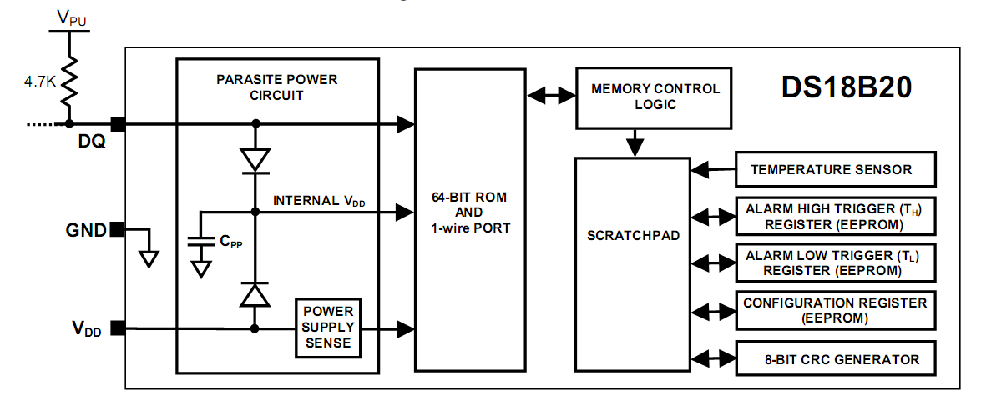
PIN ASSIGNMENT
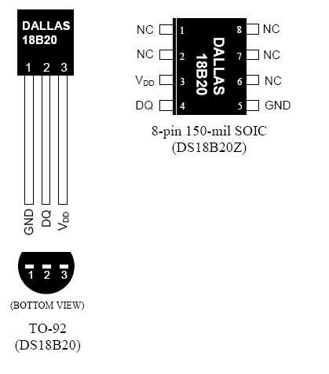
PIN DESCRIPTION
GND - Ground
DQ - Data In/Out Also provides power to the device when used in parasite power mode(see “Parasite Power” section.)
VDD - Power Supply Voltage
NC - No Connect

1-WIRE SIGNALING
The DS18B20 uses a strict 1-wire communication protocol to insure data integrity. Several signal types are defined by this protocol: reset pulse, presence pulse, write 0, write 1, read 0, and read 1. All of these signals, with the exception of the presence pulse, are initiated by the bus master.

INITIALIZATION PROCEDURE: RESET AND PRESENCE PULSES
All communication with the DS18B20 begins with an initialization sequence that consists of a reset pulse from the master followed by a presence pulse from the DS18B20. This is illustrated in Figure 13. When the DS18B20 sends the presence pulse in response to the reset, it is indicating to the master that it is on the bus and ready to operate. During the initialization sequence the bus master transmits (TX) the reset pulse by pulling the 1-wire bus low for a minimum of 480 µs. The bus master then releases the bus and goes into receive mode (RX). When the bus is released, the 5k pull up resistor pulls the 1-wire bus high. When the DS18B20 detects this rising edge, it waits 15–60 µs and then transmits a presence pulse by pulling the 1-wire bus low for 60–240 µs.

INITIALIZATION TIMING Figure 13
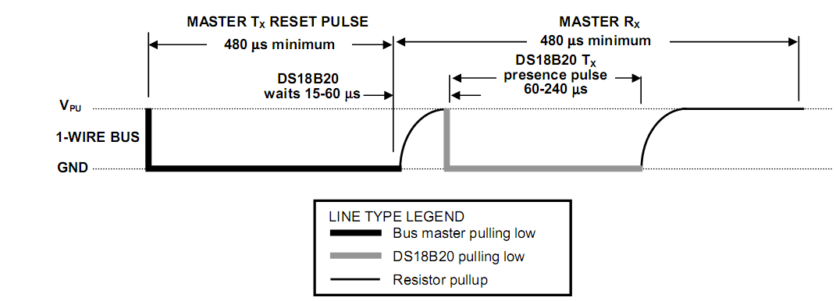
READ/WRITE TIME SLOTS
The bus master writes data to the DS18B20 during write time slots and reads data from the DS18B20 during read time slots. One bit of data is transmitted over the 1-wire bus per time slot.

WRITE TIME SLOTS
There are two types of write time slots: “Write 1” time slots and “Write 0” time slots. The bus master uses a Write 1 time slot to write a logic 1 to the DS18B20 and a Write 0 time slot to write a logic 0 to the DS18B20. All write time slots must be a minimum of 60 µs in duration with a minimum of a 1 µs recovery time between individual write slots. Both types of write time slots are initiated by the master pulling the 1-wire bus low (see Figure 14).
To generate a Write 1 time slot, after pulling the 1-wire bus low, the bus master must release the 1-wire bus within 15 µs. When the bus is released, the 5k pull up resistor will pull the bus high. To generate a Write 0 time slot, after pulling the 1-wire bus low, the bus master must continue to hold the bus low for the duration of the time slot (at least 60 µs). The DS18B20 samples the 1-wire bus during a window that lasts from 15 µs to 60 µs after the master initiates the write time slot. If the bus is high during the sampling window, a 1 is written to the DS18B20. If the line is low, a 0 is written to the DS18B20.

READ/WRITE TIME SLOT TIMING DIAGRAM Figure 14

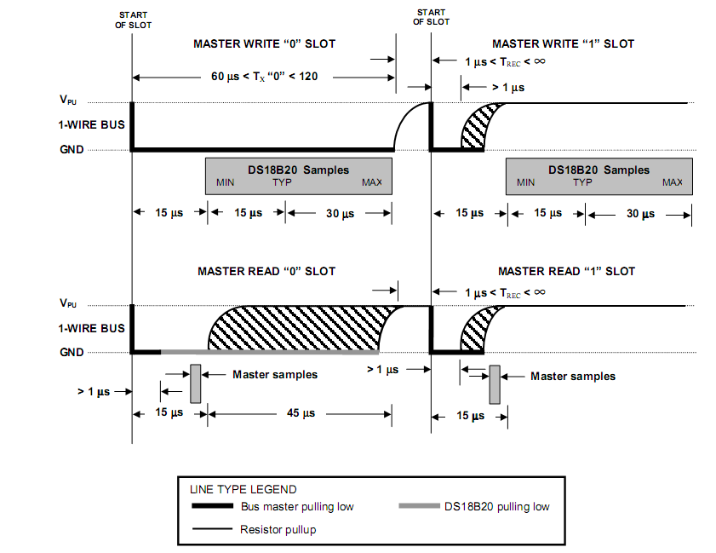

READ TIME SLOTS
The DS18B20 can only transmit data to the master when the master issues read time slots. Therefore, the master must generate read time slots immediately after issuing a Read Scratchpad [BEh] or Read Power Supply [B4h] command, so that the DS18B20 can provide the requested data. In addition, the master can generate read time slots after issuing Convert T [44h] or Recall E2[B8h] commands to find out the status of the operation as explained in the DS18B20 FUNCTION COMMAND section. All read time slots must be a minimum of 60 µs in duration with a minimum of a 1 µs recovery time between slots. A read time slot is initiated by the master device pulling the 1-wire bus low for a minimum of 1 µs and then releasing the bus (see Figure 14). After the master initiates the read time slot, the DS18B20 will begin transmitting a 1 or 0 on bus. The DS18B20 transmits a 1 by leaving the bus high and transmits a 0 by pulling the bus low. When transmitting a 0, the DS18B20 will release the bus by the end of the time slot, and the bus will be pulled back to its high idle state by the pull up resister. Output data from the DS18B20 is valid for 15 µs after the falling edge that initiated the read time slot. Therefore, the master must release the bus and then sample the bus state within 15 µs from the start of the slot. Figure 15 illustrates that the sum of TINIT, TRC, and TSAMPLE must be less than 15 µs for a read time slot. Figure 16 shows that system timing margin is maximized by keeping TINIT and TRC as short as possible and by locating the master sample time during read time slots towards the end of the 15 µs period.

DETAILED MASTER READ 1 TIMING Figure 15
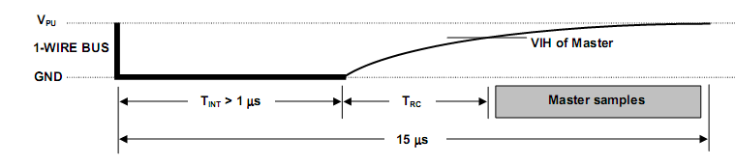
RECOMMENDED MASTER READ 1 TIMING Figure 16
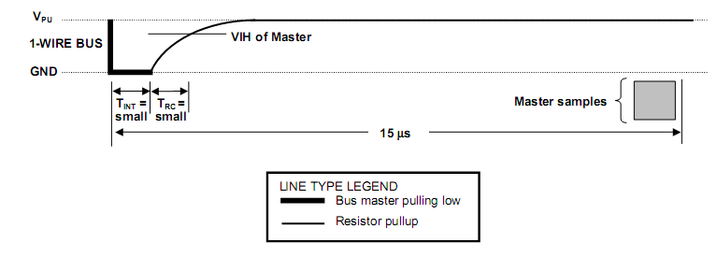

DS18B20可编程分辨率的单总线数字温度计

说明

DS18B20 数字温度计提供 9-12位摄氏温度测量而且有一个由高低电平触发的可 编程的不因电源消失而改变的报警功能。DS18B20 通过一个单线接口发送或接受信息，因此在中央处理器和 DS18B20 之间仅需一条连接线（加上地线）。它的测 温范围为-55～＋125℃，并且在-10～＋85℃精度为±5℃。除此之外，DS18B20 能直接从单线通讯线上汲取能量，除去了对外部电源的需求。
每个DS18B20都有一个独特的64位序列号，从而允许多只 DS18B20 同时连在 一根单线总线上；因此，很简单就可以用一个微控制器去控制很多覆盖在一大片 区域的 DS18B20。这一特性在 HVAC 环境控制、探测建筑物、仪器或机器的温度以及过程监测和控制等方面非常有用。
概览

图 1 是表示 DS18B20 的方框图，表 1 已经给出了引脚说明。64 位只读存储器储 存器件的唯一片序列号。高速暂存器含有两个字节的温度寄存器，这两个寄存器 用来存储温度传感器输出的数据。除此之外，高速暂存器提供一个直接的温度报 警值寄存器（TH 和 TL），和一个字节的的配置寄存器。配置寄存器允许用户将温 度的精度设定为 9，10，11 或 12 位。TH,TL 和配置寄存器是非易失性的可擦除 程序寄存器（EEPROM），所以存储的数据在器件掉电时不会消失。

DS18B20通过达拉斯公司独有的单总线协议依靠一个单线端口通讯。当全部器件 经由一个3态端口或者漏极开路端口（DQ引脚在DS18B20上的情况下)与总线连接 的时候，控制线需要连接一个弱上拉电阻。在这个总线系统中，微控制器（主器 件）依靠每个器件独有的64位片序列号辨认总线上的器件和记录总线上的器件地 址。 由于每个装置有一个独特的片序列码,总线可以连接的器件数目事实上是无 限的。单总线协议，包括指令的详细解释和“时序”单总线系统。

DS18B20的另一个功能是可以在没有外部电源供电的情况下工作。当总线处于高 电平状态，DQ与上拉电阻连接通过单总线对器件供电。同时处于高电平状态的总 线信号对内部电容（Cpp）充电，在总线处于低电平状态时，该电容提供能量给 器件。这种提供能量的形式被称为“寄生电源”。作为替代选择，DS18B20同样可以通过VDD引脚连接外部电源供电。

DS18B20方框图 图1
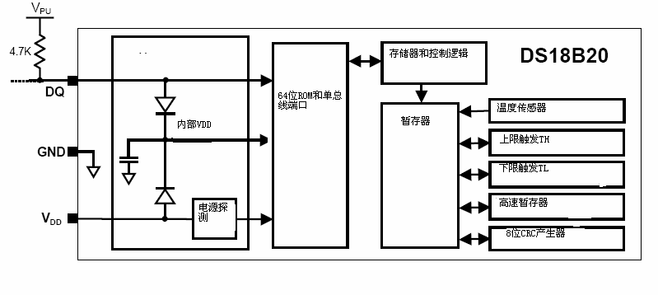

引脚排列

引脚说明

GND －地
DQ －数据 I/O 对于单线操作： 漏极开路。当工作在寄生电源模式时
用来提供电源（建“寄生电源”节）。
VDD －可选电源电压
NC －无连接
单总线信号

DS18B20 需要严格的单总线协议以确保数据的完整性。协议包括集中单总线信号 类型：复位脉冲、存在脉冲、写 0、写 1、读 0 和读 1。所有这些信号，除存在 脉冲外，都是由总线控制器发出的。

复位序列：复位和存在脉冲
和 DS18B20 间的任何通讯都需要以初始化序列开始，初始化序列见图 13。一个
复位脉冲跟着一个存在脉冲表明 DS18B20 已经准备好发送和接收数据。

在初始化序列期间，总线控制器拉低总线并保持 480us 以发出（TX）一个复位脉 冲，然后释放总线，进入接收状态（RX）。单总线由 5K 上拉电阻拉到高电平。当 DS18B20 探测到 I/O 引脚上的上升沿后，等待 15-60us,然后发出一个由 60-240us 低电平信号构成的存在脉冲。

初始化时序 图 13
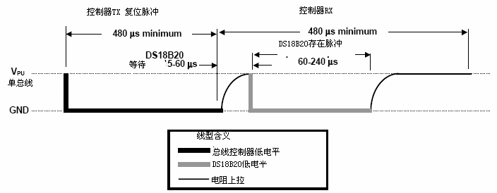

读/写时序
DS18B20 的数据读写是通过时序处理位来确认信息交换的。

写时序
由两种写时序：写 1 时序和写 0 时序。总线控制器通过写 1 时序写逻辑 1 到 DS18B20，写 0 时序写逻辑 0 到 DS18B20。所有写时序必须最少持续 60us，包括 两个写周期之间至少 1us 的恢复时间。当总线控制器把数据线从逻辑高电平拉到 低电平的时候，写时序开始（见图14）。总线控制器要生产一个写时序，必须把数据线拉到低电平然后释放，在写时序开 始后的 15us 释放总线。当总线被释放的时候，5K 的上拉电阻将拉高总线。总控 制器要生成一个写 0 时序，必须把数据线拉到低电平并持续保持（至少 60us）。

总线控制器初始化写时序后，DS18B20 在一个 15us 到 60us 的窗口内对 I/O 线采
样。如果线上是高电平，就是写 1。如果线上是低电平，就是写 0。

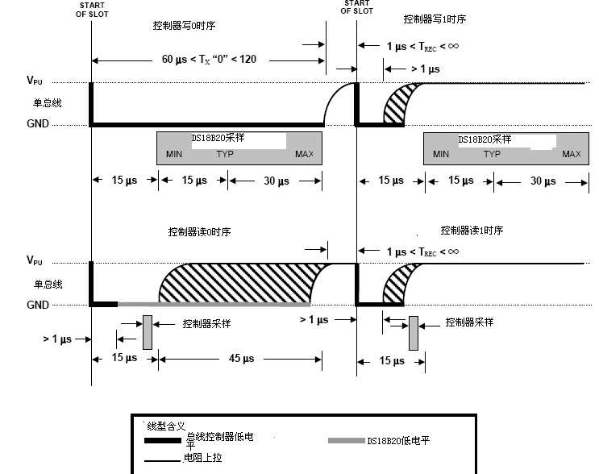

读时序
总线控制器发起读时序时，DS18B20 仅被用来传输数据给控制器。因此，总线控 制器在发出读暂存器指令[BEh]或读电源模式指令[B4H]后必须立刻开始读时序， DS18B20 可以提供请求信息。除此之外，总线控制器在发出发送温度转换指令[44h] 或召回 EEPROM 指令[B8h]之后读时序，详见 DS18B20 功能指令节。

所有读时序必须最少 60us,包括两个读周期间至少 1us 的恢复时间。当总线控制 器把数据线从高电平拉到低电平时，读时序开始，数据线必须至少保持 1us,然 后总线被释放（见图 14）。在总线控制器发出读时序后，DS18B20 通过拉高或拉 低总线上来传输 1 或 0。当传输逻辑 0 结束后，总线将被释放，通过上拉电阻回 到上升沿状态。从 DS18B20 输出的数据在读时序的下降沿出现后 15us 内有效。 因此，总线控制器在读时序开始后必须停止把 I/O 脚驱动为低电平 15us,以读取 I/O 脚状态。

图 15 标识 TINIT,TRC 和 TSAMPLE 之和必须小于 15us。图 16 指出，系统时间可 以用下面办法达到最大：TINIT 和 TRC 保持时间尽可能校；把控制器采样时间放控制器读 1 的详细时序 图 15
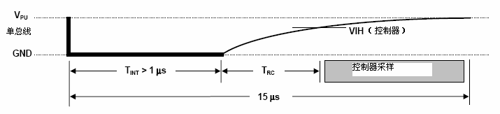

推荐控制器读 1 时序 图 16
