Qingyuan Zhang

Courtney Brown

POLS 301W 4:00 TTH

Assignment 1

September 9, 2015

With the presidential competition, the congressional mobilization always varies significantly between on-year and off-year. The abundant fund investment on presidential election year incense masses’ passion of participate in political activity, and thus increase the overall congressional mobilization. As shown in figure 1, there is a clear pattern fluctuate back and forth, which on-year mobilization is always higher than off-year mobilization from 1950 to 1970. The congressional mobilization from 1972 to 1988, as seen in figure 2, also satisfied the same pattern. However, under same the circumstance of the fluctuate, we can see a gap of the mobilization between figure 1 and figure 2, which reflects a descend of mobilization from 1970. According to figure 1 and figure 2, Both on-year and off-year congressional mobilization declines about 10%.

(Insert figure 1 and 2 here.)

To be more clear about the difference of congressional mobilization from 1970, we calculated the mean of on-year and off-year mobilizations from 1950 to 1970 and mean of mobilization from 1972 to 1988 and show them in table 1. The average on-year congressional mobilization decrease 9.28% and off-year congressional mobilization decrease 7.77%. This variance allows us to break the year up at 1970 to 1972 and think about the reason behind this decline.

(Insert table 1 here.)

In the history of United State in 1970s, we believe the Twenty-sixth Amendment, which lowered the voting age from 21 to 18 in March 1971, caused the difference of the congressional mobilization between 1970 and 1972. The Twenty-sixth Amendment, lowered the age of franchise and therefore, increased the number of population that eligible for voting. The new eligible, at age from 18 to 21, were able to participate in voting after 1970. However, they might not posses the full characteristic of an eligible voter. Most of the new eligible were students at school. They might just follow their parent decisions and let their parents to vote for them but not participate in election by themselves. As a result, the voting rate for youth remained is much lower than the rate of older voter. Based on the definition of congressional mobilization, when the number of eligible increase but the number of people to vote only increase slightly, the overall mobilization eventually goes down.

Table 1: Mean of on-year and off-year congressional mobilization of 1950-1970 and 1972-1988

|  |  |  |
| --- | --- | --- |
|  | On-year | Off-year |
| 1950-1970 | 0.5714173 | 0.433351 |
| 1972-1988 | 0.4785511 | 0.3556935 |

Figure 1: Plot of U.S. Congressional Mobilization, 1950-70

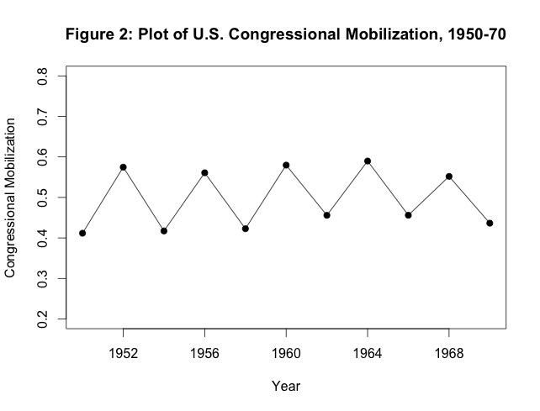

Figure 2: Plot of U.S. Congressional Mobilization, 1972-88

