Qingyuan Zhang

Courtney Brown

POLS 301W 4:00 TTH

Assignment 1

September 9, 2015

The decline of on-year and off-year congressional mobilization in 1970

With the presidential competition, the congressional mobilization always varies significantly between on-year and off-year. The investment on presidential election year incense masses’ passion of participate in political activity, and thus increase the overall congressional mobilization. As shown in figure 1, there is a clear pattern that fluctuates back and forth, such that on-year mobilization is always higher than off-year mobilization from 1950 to 1970. The congressional mobilization from 1972 to 1988, as seen in figure 2, also satisfied the same pattern. However, under same the circumstance of the fluctuate, we can see a gap of the mobilization between figure 1 and figure 2, which reflects a descend of mobilization from 1970. According to figure 1 and figure 2, Both on-year and off-year congressional mobilization declines about 10%.

(Insert figure 1 and 2 here.)

To be more clear about the difference of congressional mobilization from 1970, we calculated the mean of on-year and off-year mobilizations from 1950 to 1970 and mean of mobilization from 1972 to 1988 and show them in table 1. The average on-year congressional mobilization decrease 9.28% and off-year congressional mobilization decrease 7.77%. This variance allows us to break the year up at 1970 to 1972 and think about the reason behind this decline.

(Insert table 1 here.)

In the history of United State in 1970s, the Twenty-sixth Amendment, which lowered the voting age from 21 to 18 in March 1971, caused the difference of the congressional mobilization between 1970 and 1972. The Twenty-sixth Amendment, lowered the age of franchise and therefore, increased the number of population that eligible for voting. The new eligible, at age from 18 to 21, were able to participate in voting after 1970. However, they might not posses the full characteristic of an eligible voter. Most of the new eligible were students at school. They might just follow their parent decisions and let their parents to vote for them but not participate in election by themselves. As a result, the voting rate for youth remained is much lower than the rate of older voter. Based on the definition of congressional mobilization, when the number of eligible increase but the number of people to vote only increase slightly, the overall mobilization eventually goes down.

To prove the idea that the congressional mobilization goes down from 1970, we did a t-test for the both on-year and off-year difference between means of congressional mobilization from 1932 to 1970 and from 1972 to 1988. Before the implement of t-test, we conduct an f-test to see whether the variances of our two datasets are equal. As is seen in table 2, the f-test returns are fairly large p-value, which equals to 0.2875 and therefore we calculate our t-test using different variances. According to table 3, the t-test for difference between means of on-year congressional mobilization has a p-value equals to 0.0009525, which is far smaller than the 5% significant level. Based on our statistical analysis, we reject the null hypothesis and are 95% confident to declare that there is true difference between on-year congressional mobilization since 1970. In addition, the t-test for off-year congressional mobilization difference, as shown in table 3, generated p-value equal to 0.003493, which is small, if we take 5% as our threshold value. For the off-year congressional mobilization, we are still 95% confident that there is true difference between congressional mobilization since 1970. Since the sample size for both on-year data and off-year data are the same, we compare on-year p-value with off-year p-value. The p-value of on-year congressional mobilization difference is smaller than off-year the p-value. As a result, we are more confident about on-year than off-year that congressional mobilization has a difference since 1970.

(Insert table 2 and table 3 here.)

From above t-test analysis, there is a difference between means of congressional mobilization from 1932 to 1970 and 1972 to 1988. In order to quantify the difference between means, we use the 95% confidence interval to visualize the difference. From the table 3, the 95% confidence interval for the on-year difference is from 0.03201175 to 0.09753251. The difference, in the mean of on-year congressional mobilization since 1970, has 95% chance in the approximate range from 3.2% to 9.8%. The sign of the interval, which is all positive, affirms the t-test result that there is a true difference. As for the difference in means of off-year congressional mobilization, the 95% confidence interval is from 0.02396182 to 0.9391319. For the same reason, the positive interval reveals that off-year congressional mobilization also has a gap from 1970.

Deeply looking into the insight behind the total congressional mobilization, we analyze the Republican and Democratic mobilization separately. According to table 4, both on-year and off-year t-tests for mean of Republican mobilization has a same pattern as the total congressional mobilization. The Republican on-year difference t-test has p-value of 0.02042 and off-year with 0.0000816. Both p-value suggest that it is 95% possible that there is a true difference between Republican mean congressional mobilization since 1970. Interestingly, the Democratic congressional mobilization behaves differently. The p-value, as is seen in table 5, for difference in on-year Democratic congressional mobilization is 0.008372, which reveal the difference for on-year mobilization, while off-year has a p-value equals to 0.2458. The large p-value suggests that there might be no difference for off-year Democratic congressional mobilization at the year of 1972. This interesting statistic require us delve deeply to understand why the Twenty-sixth Amendment did not affect the off-year Democratic congressional mobilization.

(Insert table 4 and table 5 here.)

In the t-test for difference between mean of congressional mobilization, we choose 1932 as our starting point, because the Twentieth Amendment might affect our analysis about congressional mobilization. The Twentieth Amendment, proposed by the Congress in 1932, changed the beginning and ending of presidency and member of Congress term from March to January. The alternation of presidency term directly affects the election date, which can cause a serious difference for our t-score. In analysis for congressional mobilization, we focus on the percentage turnout as time goes on. In order to reduce the effect of other variables, we try to keep all of them constant. The change of election date is a change of confounding variable, which may affect our analysis about congressional mobilization.

Additionally, early 1930s is a period with several tremendous political change, such as the New Deal and the Great Depression. In 1932 election, the Republican terminate their 20 years control over white house. All those significant political changes might lead to tremendous gap in our t-test. If we include the data before 1932, then there will outlier when we calculate the mean of congressional mobilization before 1970 and result in an inaccurate outcome for the t-test. If the congressional mobilization before 1932 is higher than the mobilization after that, it will cause the mean of the pre-1970 mobilization goes up and increase the probability of the type one error. While, on the other hand, if the turnout rate is low then type two error may occur.

Table 1: Mean of on-year and off-year congressional mobilization of 1950-1970 and 1972-1988

|  |  |  |
| --- | --- | --- |
|  | On-year | Off-year |
| 1950-1970 | 0.5714173 | 0.433351 |
| 1972-1988 | 0.4785511 | 0.3556935 |

Table 2: F test to compare two variances between mean of on-year and off-year congressional mobilization of 1932-1970 and 1972-1988

|  |  |
| --- | --- |
| F score | 3.1036 |
| Numerator degree of freedom | 9 |
| Denominator degree of freedom | 4 |
| P-value | 0.2875 |
| 95% confidence interval | (0.3485313, 14.6428420) |

Table 3: Two sample t-test difference in mean of congressional mobilization of 1932-1970 and 1972-1988

|  |  |  |
| --- | --- | --- |
|  | On-year | Off-year |
| T-score | 4.2859 | 3.6752 |
| Degree of Freedom | 12.581 | 11.314 |
| P-value | 0.0009525 | 0.003493 |
| 95% confidence interval | (0.03201175, 0.09753251) | (0.02396182, 0.09491419) |

Table 4: Two sample t-test difference in mean of Republican congressional mobilization

|  |  |  |
| --- | --- | --- |
|  | On-year | Off-year |
| T-score | 2.6428 | 5.9502 |
| Degree of Freedom | 12.88 | 11.229 |
| P-value | 0.02042 | 0.0000816 |
| 95% confidence interval | (0.005023467,0.050248501) | (0.02653367,0.05756461) |

Table 5: Two sample t-test difference in mean of Democratic congressional mobilization

|  |  |  |
| --- | --- | --- |
|  | On-year | Off-year |
| T-score | 3.1219 | 1.2221 |
| Degree of Freedom | 12.599 | 11.684 |
| P-value | 0.008372 | 0.2458 |
| 95% confidence interval | (0.01029640, 0.05705532) | (-0.01157298, 0.04093691) |

Figure 1: Plot of U.S. Congressional Mobilization, 1950-70

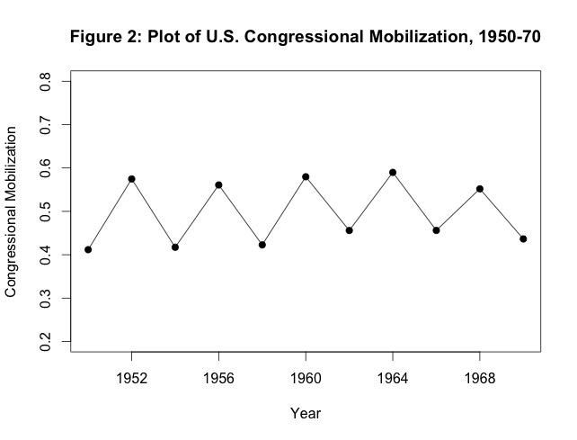

Figure 2: Plot of U.S. Congressional Mobilization, 1972-88

