Quiz 8
Qingyuan Zhang

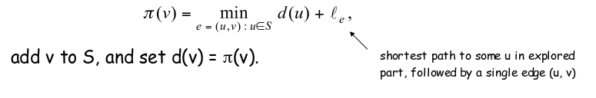

First we define the π(v) function as the figure above.

we set v as next node added to S, and t – v be the next edge that we are chosen.

The shortest u-t path plus (t,v) is an u-v path of length π(v).

Any u-v path will not shorter than π(v).

Let x-y be the first edge in P that leaves S, and let P' be the sub-path to x.

P is already longer as soon as it leaves S.

