1. **[chenchengwei@localhost FPGA]$ cd pulp-sdk/**
2. **[chenchengwei@localhost pulp-sdk]$ ls**
3. **[chenchengwei@localhost pulp-sdk]$ source ../setup_env_sim.sh**



图1

1. **[chenchengwei@localhost pulp-sdk]$ make clean**

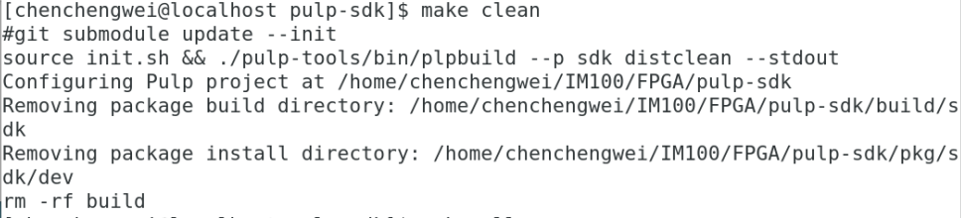

图2

1. **[chenchengwei@localhost pulp-sdk]$ make all**

编译SDK并等待编译完成

1. 进入到以下目录：

/home/chenchengwei/IM100/Design/pulp/DV/vcs_sim

7. source一下setup.sh文件，如下图3所示。

**[chenchengwei@localhost vcs_sim]$ source ../script/setup.sh**

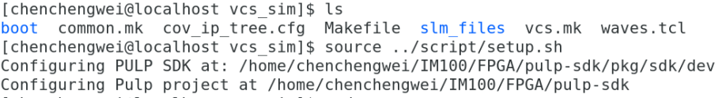

图3

8. **[chenchengwei@localhost vcs_sim]$ make regress**

然后等待这些例子跑完。