**Project 1**

Qiang Qin UFID:99696682

* Build two baseline network models for the GAN and the VAE. Describe the specifics of the networks, such has how many nodes, how many layers, composition of each layer, connectivity, etc.

My GAN network has two parts: Generate and Discriminate.

The generate network has 6 layers, including an input layer, 4 hidden layers and an output layer. For the input layer, the number of its nodes is the same as the number of input data. For hidden layers, they have 128, 256, 512, 1024 nodes separately. For output layer, it has 28*28 nodes (the size of an image).

The discriminate layer has 4 layers, including an input layer, two hidden layers and an output layer. For the input layer, it has 28*28 nodes. For hidden layers, they have 512 and 256 nodes separately. As for the output layer, there is only one node.

These two networks are all full connected. I use Relu function as my active function for every hidden layer and use sigmoid function for the output layer of discriminate network.

My VAE network also has two parts: encoder and decoder.

Encoder network has 4 layers, including an input layer, 2 hidden layers and an output layer. For input layer, it has 28*28 nodes. For hidden layers, they have 512 and 256 nodes separately. As for output layer, it has two nodes, which are the mean value and standard deviation.

Decoder network also has four layers, including an input layer, 2 hidden layers and an output layer. It’s looks symmetric about the encoder. It has 2 nodes in input layer, which are the mean value and standard deviation. For the hidden layers, they have 256 and 512 nodes separately. As for the output layer, it has 28*28 nodes.

Between encoder and decoder there is another node z, which is the hidden variable connects generated by the mean value and standard deviation calculated by encoder and then used for decoder to generate new image.

* Attempt to train both models on some small dataset. (Choose an appropriate subset of the MNIST dataset).
* Report your results of either some success or total failure. (You are not competing for accuracy yet. You are trying to see the kind of results that are produced and are thinking about how you can improve them. If your model doesn’t work, it is ﬁne for now, report it.)

I made some progress on both networks.

Here are the numbers generated by GAN:

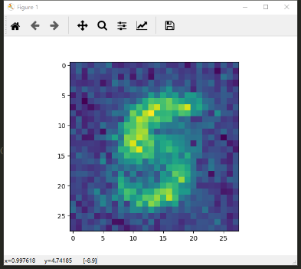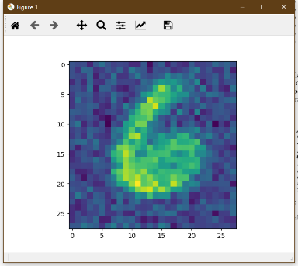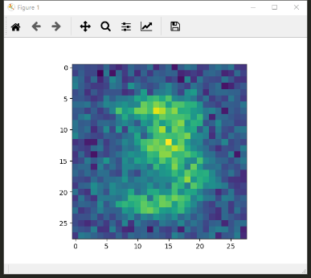

Here are the numbers generated by VAE:



* If your models-either or both-don’t work, analysis where the problem is and report your findings.

For GAN network, maybe convolution helps more, or if I adjust the batch size and learning rate, it’ll help.

For VAE network I’ll also try convolution layers and see if it helps me to generate new images.