7. Below is the iterations-accuracy figure:

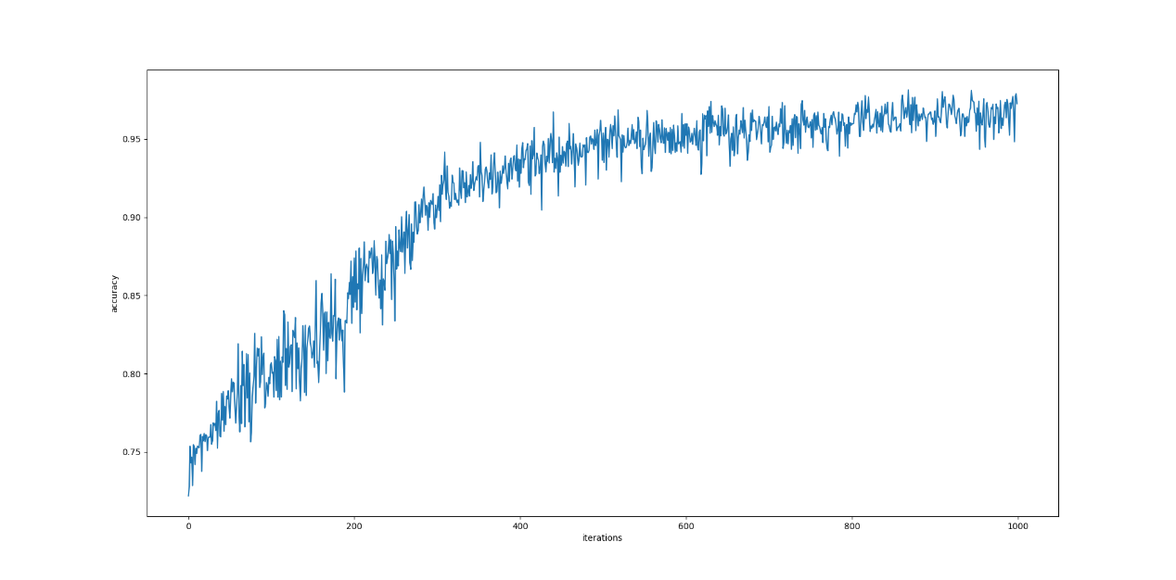

Below is the figure of hyperplane(green ‘+’s):

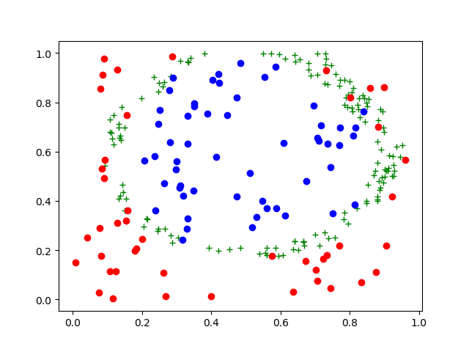

Below is the figure of weights and bias of the hyperplane:

