商务智能第一次作业

2016302580308 邓慧颖

武汉大学计算机学院2018-2019第一学期
商务智能-课后作业1

（卓越工程师班同学鼓励英文做答，将有一定加分）

1.请思考数据挖掘可能会遇到哪些法律问题，可能会和哪些法律有关，请举出具体例子并讨论
From the user's mouse movement track in the browser, he can estimate his attention to the webpage. From the user's click on the webpage link, he can guess his information demand. From the user's closing action on the window, he can infer his interest transfer. .
In 2006, AOL, in order to promote research, released a search query data set, including more than 20 million queries submitted by AOL search in 6 months for 650,000 users. In order to protect user privacy, AOL deletes the user's personal information and assigns an ID to each user. A reporter from the New York Times observed and analyzed AOL data and used the telephone directory to quickly identify the user with ID 4417749 as a 60-year-old single woman living in Georgia, Thelma Arnold [3]. Specifically, the user submitted a query for "landscapers in Lilburn, Ga", from which it can be inferred that this person probably lives in Lilburn, Georgia. The user has submitted a number of queries containing Arnold's name, which can be used to guess the person's surname is Arnold. The user searched for "60 single men", and can guess that this person may be a woman of about 60 years old, and so on.
2. Skewness是什么，请计算对称正态分布，正偏移和负偏移时候的Skewness的指（请自行拟定数据分布具体数值）
Skewness measures the asymmetry of the probability distribution of real random variables.
If it is positively distributed, the skewness is the third-order center distance and the value is 0.
Skewness=0 distribution pattern is the same as normal distribution skewness
Skewness>0 The positive deviation value is large, which is positive or negative. The long tail is dragged to the right.
Skewness<0 Negative deviation value is large, negative or left. The long tail is dragged to the left.
Graphs are as follows:
The Skewness=0 of the normal distribution. If Skewness>0 means the waveform has a long tail on the right side, if Skewness<0 means the waveform has a long tail on the left side.

3. 请对下图进行分析
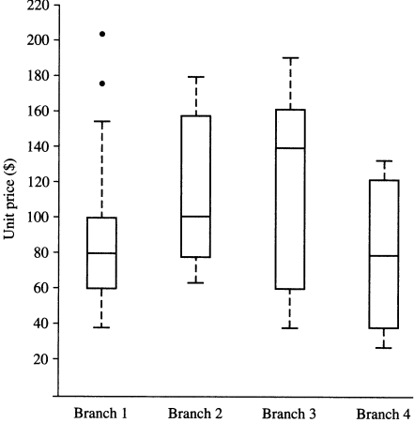
Solution: A boxplot incorporates the five number summary.
■ 1.The ends of the box are at the quartiles so the box length is the interquartile range (IQR).
■ 2.The median is marked by a line within the box.
■ 3.Two lines (called whiskers) outside the box extend to the smallest(Minimum) and largest(Maximum) observations.
■ 4.Boxplot can be compute in O(nlogn) time.
Thus, in Branch 1:
Minimum=38
Lower quartile =60
Median=80
Upper quartile =100
Maximum=158
Average value=80
Interquartile range=20
extreme outlier = 158
extreme outlier = 102

In Branch 2:
Minimum=62
Lower quartile =80
Median=100
Upper quartile =158
Maximum=178
Average value=119
Interquartile range=78

In Branch 3:
Minimum=38
Lower quartile =58
Median=140
Upper quartile =160
Maximum=190
Average value=109
Interquartile range=102

In Branch 4:
Minimum=24
Lower quartile =36
Median=78
Upper quartile =118
Maximum=128
Average value=77
Interquartile range=82

4. Q-Q plot 中如果两个数据集的数目不相同该如何处理？
First, the quantile of the assumed distribution is found on the Q-Q map to find a straight line instead, and then the quantile of the sample distribution is consistent with the quantile of the assumed distribution (that is, on a straight line).
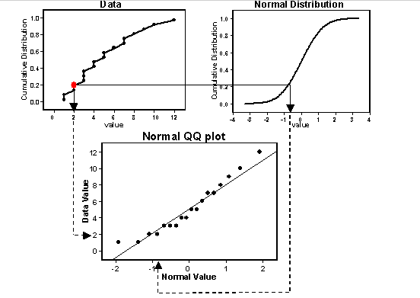
5.请自拟数据集计算混合类型相似度矩阵，数据应报告所有不同的类型，且属性总数目不低于10个
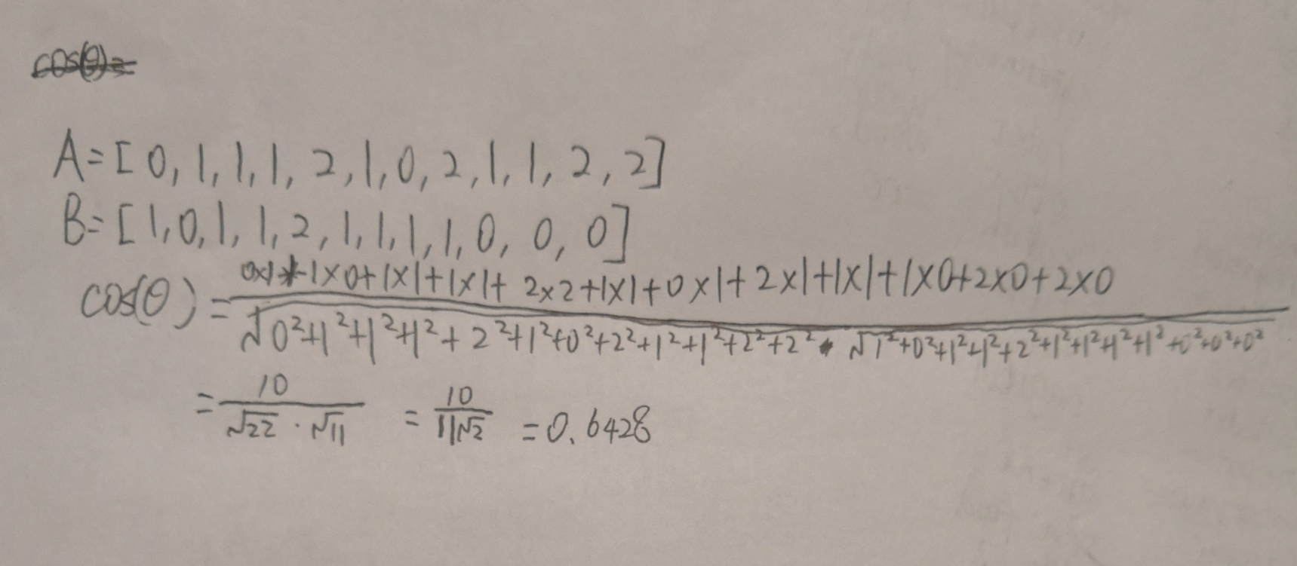
6.请编写程序实现Apriori算法和FP-Growth算法，算法可以根据给定的支持度和置信度获取所有的频繁项集和关联规则。请自拟数据集进行测试（数据集应按某种方式产生，请描述产生机制，数据集不少于1万条，商品数目不小于100种）并汇报以下结果并撰写报告汇报结果，
1）给定置信度为80%，关联规则数目随支持度变化的曲线图
2）给定支持度为30%，关联规则数目随置信度变化的曲线图
3）给定置信度为80%，请确定某个支持度s使得获取的关联规则数目正好大于20，请输出s和所获取的关联规则数目
文件夹Apriori和FR-Growth中

7. 请完成AI Studio中房价预测例子，并采集一定数目的真实数据，修改代码，汇报得到的结果
1. Complete the following code to achieve normalization of the floor space.
Output the normalized maximum price of the house to determine whether the operation is correct.
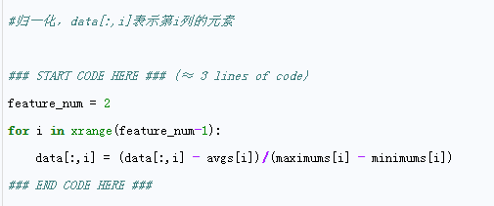
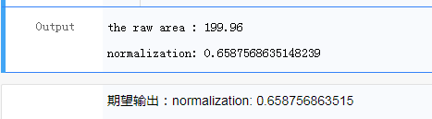
2 Completing the following code to complete the split between the training set and the test set. Output data size to verify that the split is correct.
prompt:
1. A[:x] means taking the first x elements in A
2. A[x:] means that the last element is taken from the (x+1)-th element.
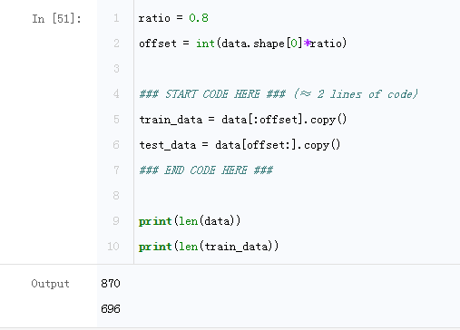

3. Define reader
Construct the read_data() function to read the training dataset train_set or the test dataset test_set. Its concrete implementation is to construct a reader() inside the read_data() function, and use the yield keyword to make the reader() become a generator. Note that the role of the yield keyword is similar to the return keyword. The reason is that the yield keyword can construct a generator. List, which saves memory usage.
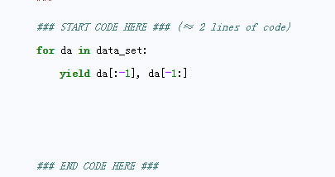

4.
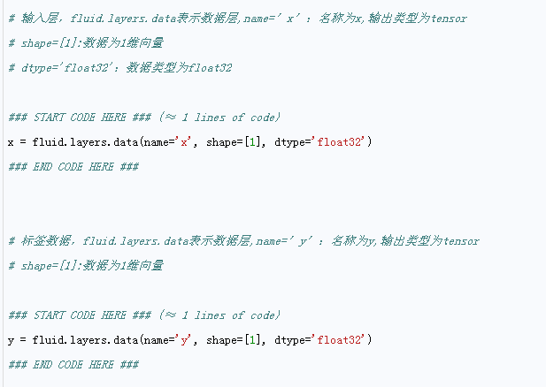
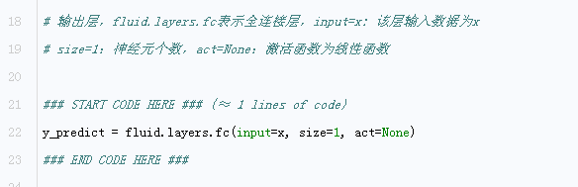

5. Defining loss function
This time, the mean square error loss function is used. You can call fluid.layers.square_error_cost(input= ,label= ) to calculate the variance, and average the difference by fluid.layers.mean(loss). The input is defined as the price forecast value, the label is defined as the label data, and the loss value is calculated.
Practice complete the code below
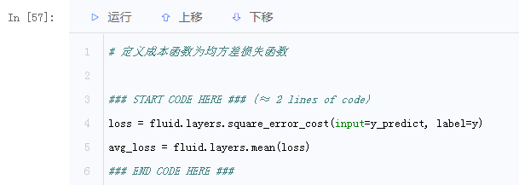

6. Package training parameters
Write the completed network parameters to the train_program() function, which is convenient for calling during training.
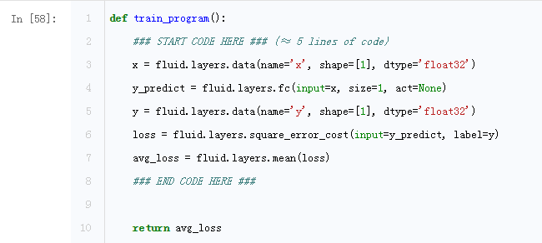

7. Please set the value of the learning rate yourself and observe the change of the cost function.
The learning rate parameter is: learning_rate
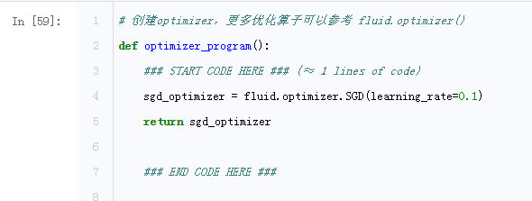

8. Start training
We can now start training by calling trainer.train(), and see if the model is perfect by observing the loss function image!
Try adjusting num_epochs to observe changes in the loss function (you can try 100 first)
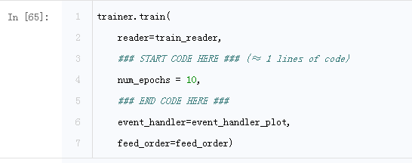
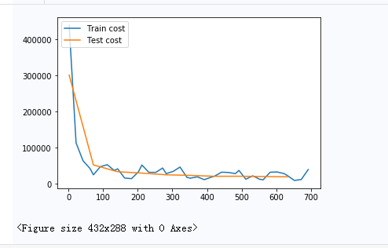

9.
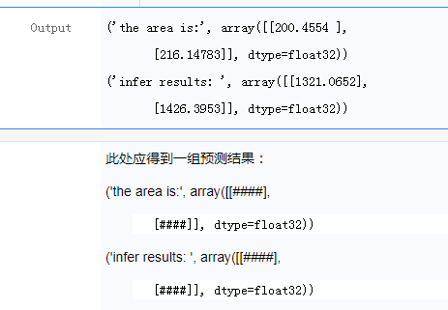

10. Compute the output formula and calculate the values of a and b according to the principle of the linear model
- Tip: Know two points to find the linear equation
- Note: the dimensions of results and raw_x
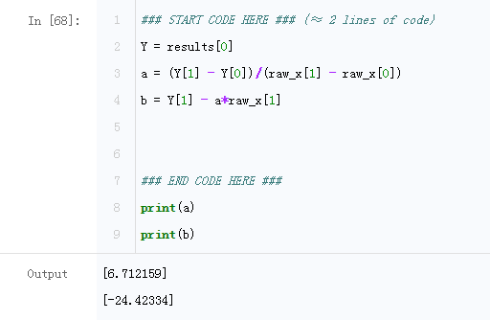

11. Compile the following code to draw your predicted image (the values of a and b should be the results of your network training).
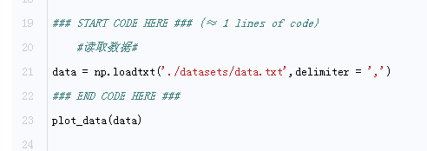
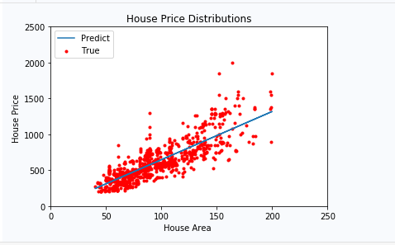

要求：
1. 请包含封面，封面应有姓名和学号。
2. 实现语言不限，提交内容包含源代码和报告两部分。报告应包含对相关算法的理论描述、实现的关键代码和相关的测试情况描述。源代码应包含完整的、可执行的代码。源代码应具有简单的界面（命令行或GUI）。
3. 电子版命名为“商务智能1-姓名-学号”， 请在课程网站提交。

期限：
10月21日 (星期日)

