2．Solution:

1. a. No, you can only transmit one packet at a time over a shared bus.
2. b. No, as discussed in the text, only one memory read/write can be done at a time over the shared system bus.
3. c. No, in this case the two packets would have to be sent over the same output bus at the same time, which is not possible.

3. Solution:

a. (n-1)D

b. (n-1)D

c. 0

4. Solution:

The minimal number of time slots needed is 3. The scheduling is as follows.

Slot 1: send X in top input queue, send Y in middle input queue.

Slot 2: send X in middle input queue, send Y in bottom input queue

Slot 3: send Z in bottom input queue.

Largest number of slots is still 3. Actually, based on the assumption that a non-empty input queue is never idle, we see that the first time slot always consists of sending X in the top input queue and Y in either middle or bottom input queue, and in the second time slot, we can always send two more datagram, and the last datagram can be sent in third time slot.

5. Solution:

a.

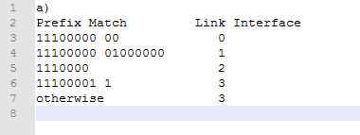

b. Prefix match for first address is 5th entry: link interface 3

Prefix match for second address is 3nd entry: link interface 2

Prefix match for third address is 4th entry: link interface 3

18. Solution:

It is not possible to devise such a technique. In order to establish a direct TCP connection between Arnold and Bernard, either Arnold or Bob must initiate a connection to the other. But the NATs covering Arnold and Bob drop SYN packets arriving from the WAN side. Thus neither Arnold nor Bob can initiate a TCP connection to the other if they are both behind NATs.