8．Solution:

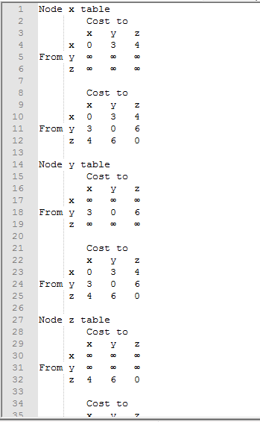

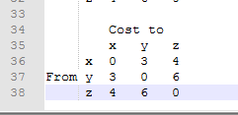

9. Solution:

NO, this is because that decreasing link cost won’t cause a loop (caused by the next-hop relation of between two nodes of that link). Connecting two nodes with a link is equivalent to decreasing the link weight from infinite to the finite weight.

14. Solution:

a. eBGP

b. iBGP

c. eBGP

d iBGP

19. Solution:

A should advise to B two routes, AS-paths A-W and A-V.

A should advise to C only one route, A-V.

C receives AS paths: B-A-W, B-A-V, A-V.

22. Solution:

Often, the time when network management is most needed is in times of stress, when the network may be severely congested and packets are being lost. With SNMP running over TCP, TCP's congestion control would cause SNMP to back-off and stop sending messages at precisely the time when the network manager needs to send SNMP messages.