**STI Suite User Manual**

(Version 2.01, Updated on June. 15, 2014)

Wei Li and Chunlei Liu

Brain Imaging & Analysis Center, Duke University, Durham, NC, USA

**Introduction**

Quantitative susceptibility mapping (QSM) and susceptibility tensor imaging (STI) are two recently developed imaging methods for quantifying tissue’s magnetic property. Magnetic susceptibility offers a new contrast for high-resolution anatomical imaging; it further provides important information on tissue’s chemical composition, especially myelin and iron, and white matter microstructures of the brain. However, processing QSM and STI still requires advanced technical expertise. The growing application and wider acceptance of this new technique has generated a need for a comprehensive software package that can easily perform all these analysis. Here, we have developed such a tool named “STI Suite”. This software is based on our previous works1-13. In this Matlab-based software package, we have implemented the essential algorithms for phase processing, QSM, STI, and related analysis tools. To facilitate the dissemination and evaluation of these methods, we make STI Suite freely available at http://people.duke.edu/~cl160/ for non-commercial academic use.

STI Suite contains both Matlab command-line functions and graphical user interfaces (GUIs) for phase processing, QSM, STI, and related visualization and ROI analysis tools. In this manual, we will not only include the introduction of the programs, but will also include the physical and mathematical basis for deriving these methods. Please feel free to let us know if you have any questions. We will appreciate the users’ comments and suggestions on STI Suite.

1. **Release notes:**

**Version 2.0**

1. Brian extraction is improved to enable more automatic operation.
2. HARPERELLA function is improved with the size of brain mask unchanged.
3. Variable inputs are enabled.
4. A quick estimation of susceptibility is added.
5. A weighting term is enabled in QSM_LSQR
6. A discussion of QSM pulse sequences was included, which was an accepted abstract for the 2nd QSM and phase contrast workshop.

**Version 2.0**

1. Multi-echo magnitude/phase or real/imaginary data loading.
2. iHAPERELLLA by pre-combine the Laplacian values to calculate the BG removal only one time.
3. Faster iLSQR method using optimized FFT operations.
4. User interface redesigned.
5. CPU time optimized.

**Testing data: Image matrix: 256x256x60**

**Spatial Resolution: 0.9x0.9x2 mm3**

**6 Echoes**

**MRI Scan time 5 min**

**Benchmark: Intel Core™ i7-4770 Processor, 3.40 GHz CPU, 4 cores**

**Brain extraction: 1 second**

**Laplacian and Combine: 12 seconds**

**iHARPERELLA: 35 seconds**

**Unwrapping: 1 second**

**V-SHARP: 26 seconds**

**QSM_iLSQR: 93 seconds**

Summary: With the optimization, we hope to make it available for routine application.

-- Wei Li

June 15, 2014

**2. Recommendations**

1. Multi-Core CPU: For the optimal performance, we recommend to use Intel Core™ i7 Processor, for 4 cores, you have a 4-fold gain of speed, and for 6 cores, you have a 6-fold gain of speed.
2. Sufficient RAM: 12G RAM is recommended. Minimum 8G RAM is required.
3. Display: Large screen, the size of text is 100% (default) are recommended. You can always customize the layout with Matlab guide.

**3. GUI customization**

1. Matlab command:

>> QSM_GUI

1. Click the small downward arrow to dock QSM-GUI to the Matlab window:

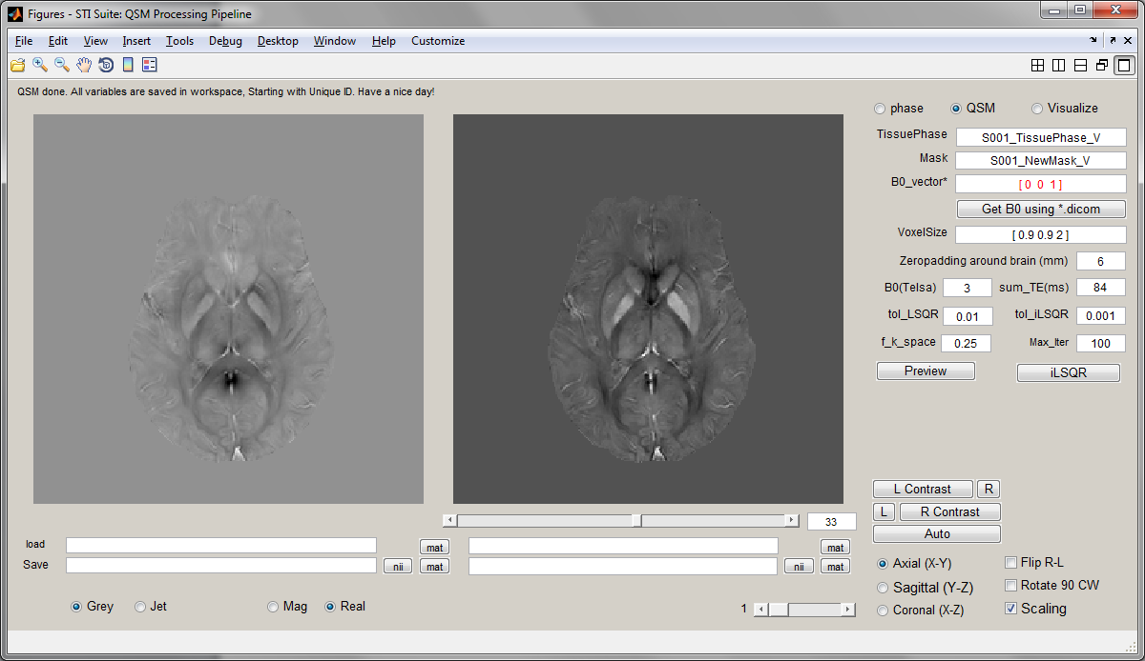

You get a user interface like this:

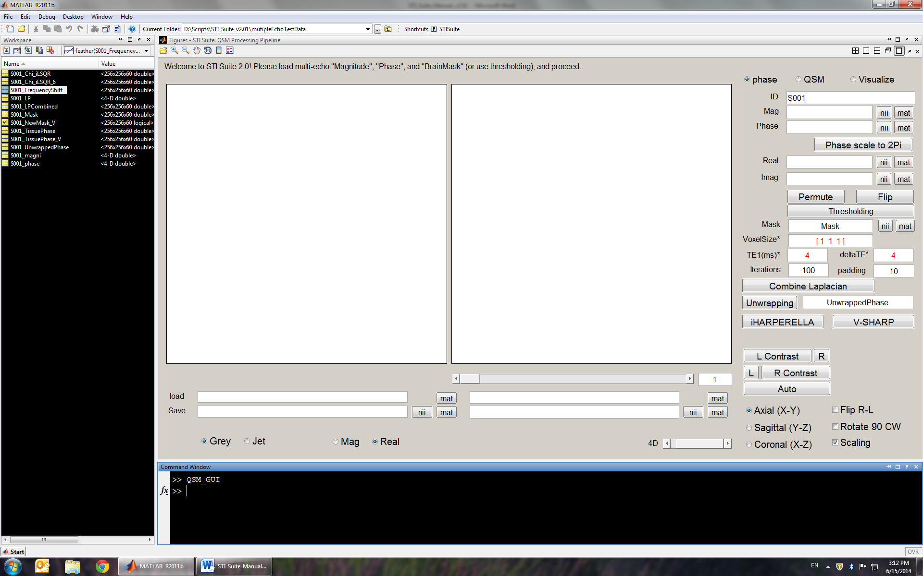

In this way, you can use the interface, while be aware of any output from the command window.

1. Customize the layout;

In the undocked GUI, there is a “customize” manual, click it and then play with the layout.

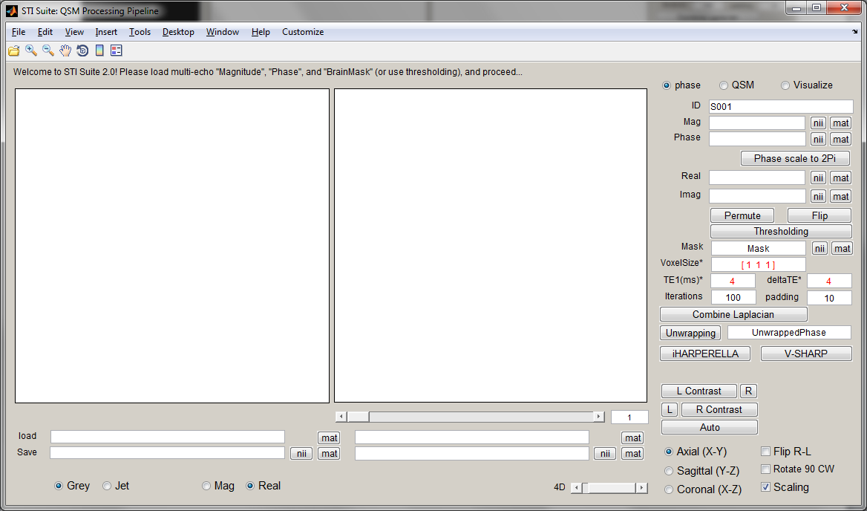

**4. Working with QSM_GUI**

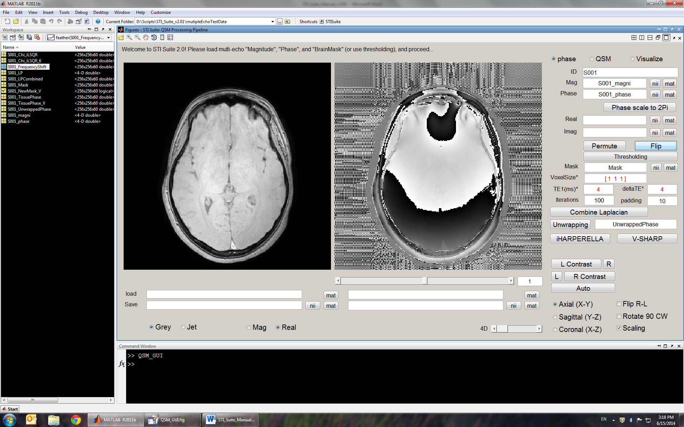

(1) For Multi-echo magnitude/phase data

4D Data are in the order of X, Y, Z, echo

3D single echo data is also OK.

Click “nii” or “mat” button to select magnitude

Click “nii” or “mat” button to select phase

If phase is out of range, scale it to 2*pi, otherwise skip.

(2) For real/imaginary data

Click “nii” or “mat” button to select real

Click “nii” or “mat” button to select imaginary

STI Suite will calculate magnitude and phase for you.

(3) Permute X-Y and flip the images, if needed.

(4) Move to the 3rd or 4th echo images, and perform “Thresholding”

(5) **Very important**: make sure the “Voxelsize”, “TE” and “delta_TE” is correct, otherwise all subsequent will be wrong.

(6) “Combine Laplacian”, calculate all Laplacian and combine them

(7) You can choose “iHARPERELLA” or “Unwrapping” + “V-SHARP”. Once background phase is removed, you will be automatically taken to the next step for QSM.

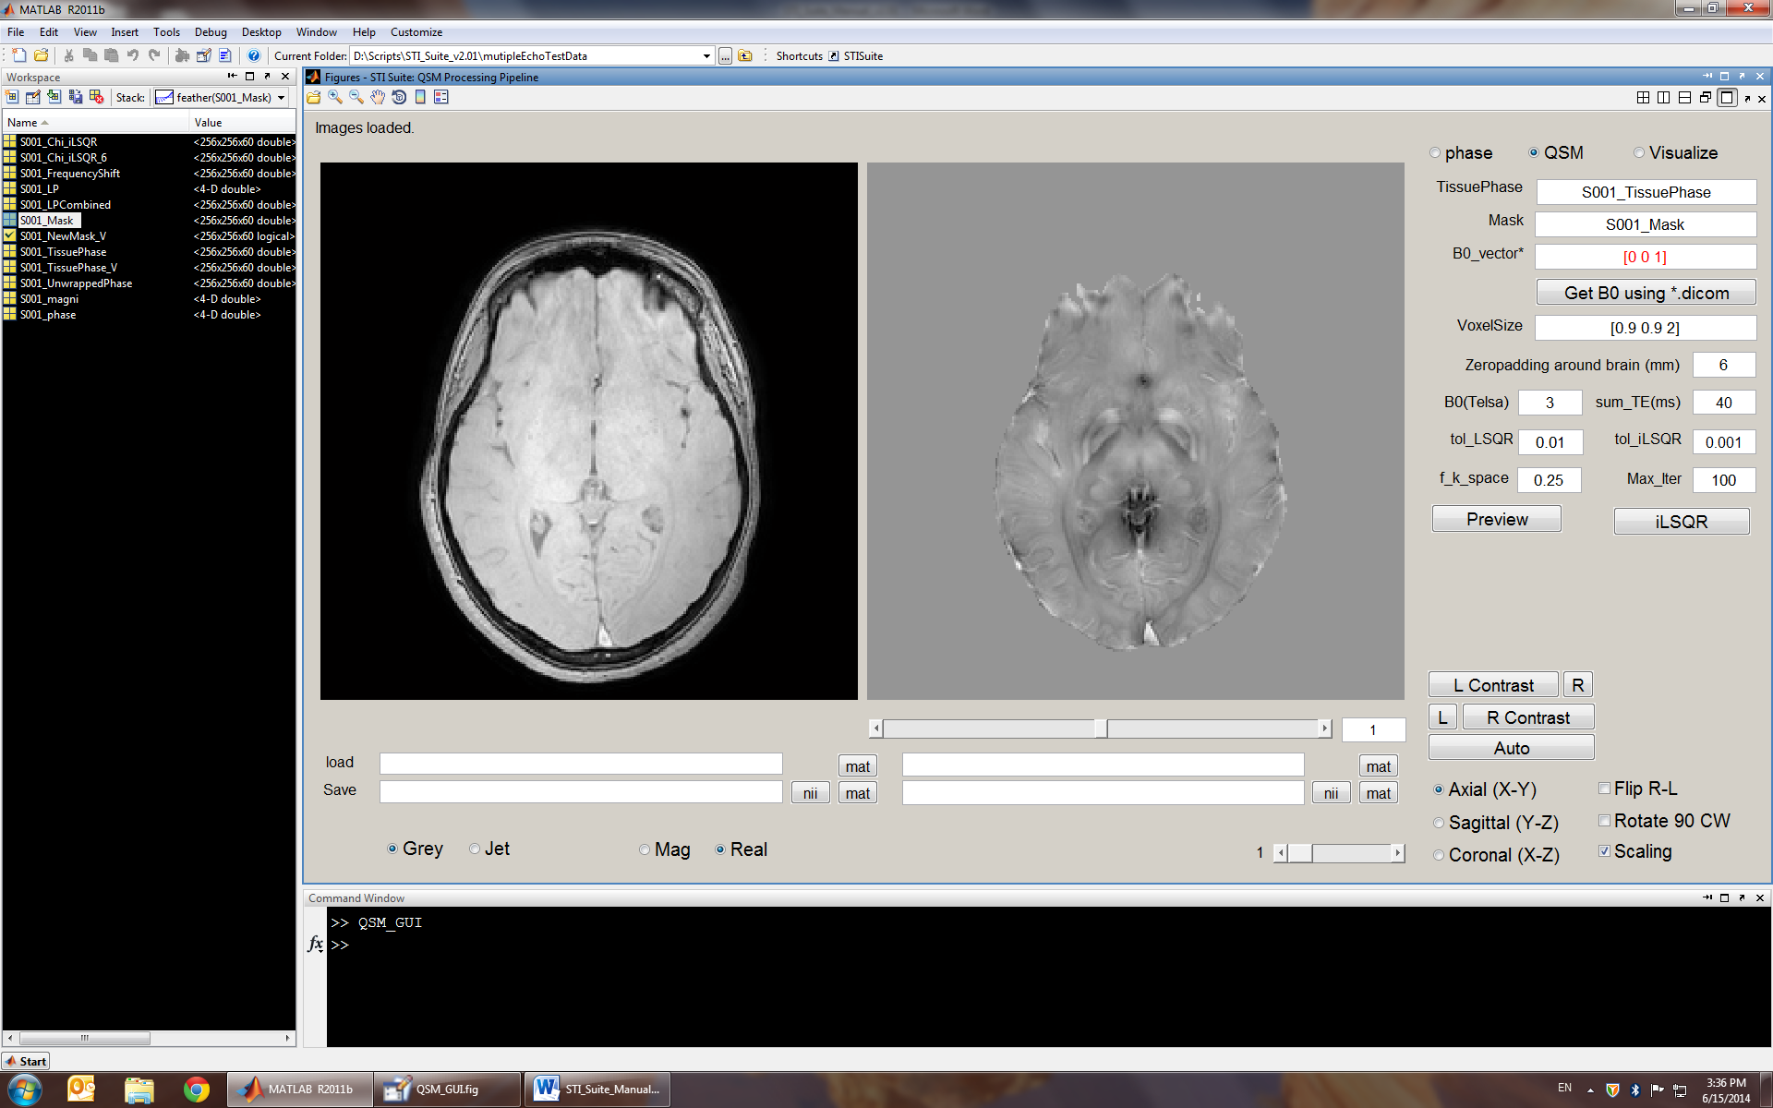

 (8) Please make sure B0_vector is correct.   
For axial scan, B0_vector=[0 0 1].

For oblique scan, B0_vector should be calculated from a dicom file associated with the multi-echo GRE scan. To request assistant, please contact [STI.Suite.MRI@gmail.com](mailto:STI.Suite.MRI@gmail.com).

(9) All default parameters are pretty much good for all reconstructions, so all you need to do is to click “iLSQR”.

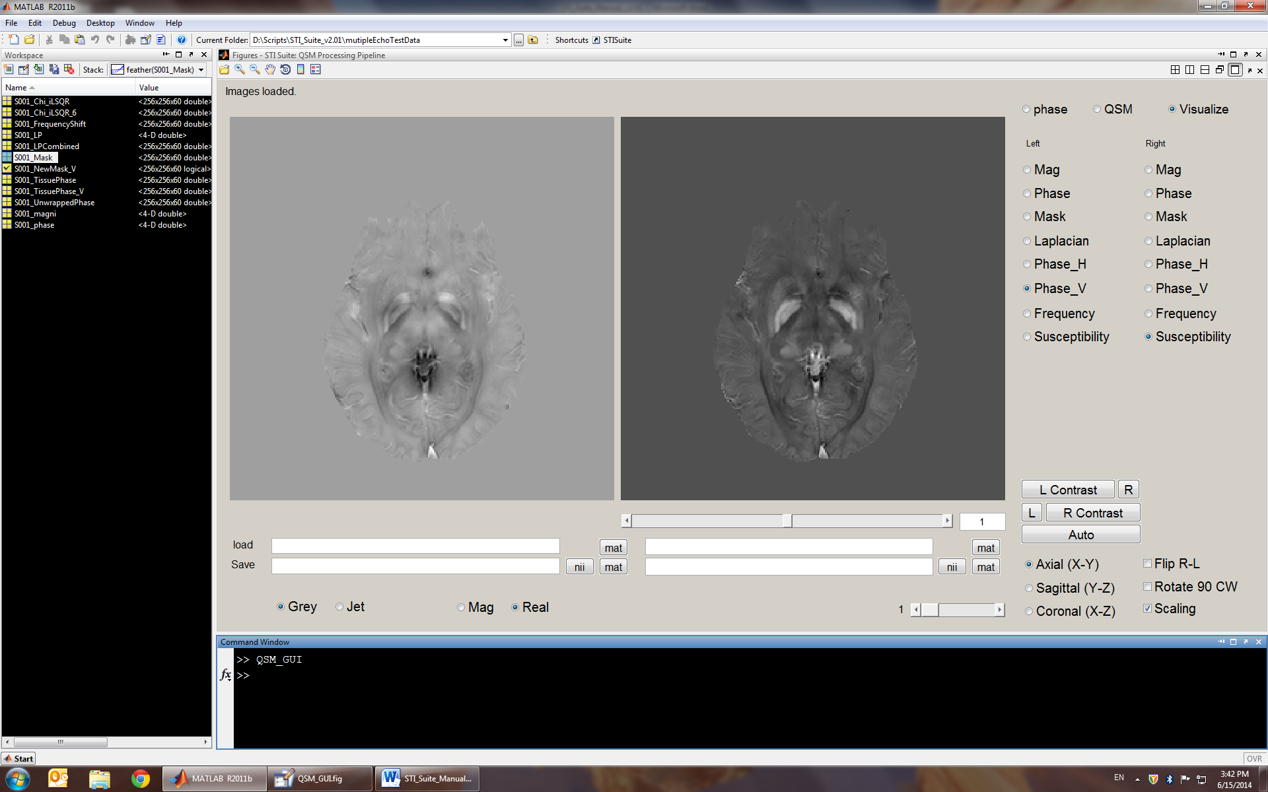

All you results are in the listed in the Visualize menu, you can display them as you want.

If you want to same them, simply click the “nii” or “mat” button. Left correspond left image, right correspond to right image.

**5. Acknowledgments**

* **Important: This is beta version of the STI Suite 2.0. Wei Li and Chunlei Liu reserve all the rights to the methods and this software.**
* The scripts for *.nii files are based on the work of Jimmy Shen, downloaded from Matlab Central: http://www.mathworks.com/matlabcentral/fileexchange/8797-tools-for-nifti-and-analyze-image
* We acknowledge Dr. Bing Wu, former postdoc from Liu’s laboratory, for his contribution in developing some of the methods.
* We acknowledge Dr. Alexandru Avram, former PhD student from Brain Imaging and Analysis Center, for his contribution in the HARPERELLA method.
* Dr. Chunlei Liu is supported by National Institutes of Health (NIH) through grant [R00EB007182](http://www.sciencedirect.com/science/article/pii/S1053811911000164#gts0005), grant R01 MH096979, and by National Multiple Sclerosis Society through grant RG4723 for performing the research that generated these softwares.
* Dr. Wei Li, former postdoc from Liu’s Laboratory, developed this software under the supervision of Dr. Liu. He is currently a research assistant professor at University of Texas Health Science Center at San Antonio and will continue to provide support to STI Suite.
* For questions regarding this software, please email: [STI.Suite.MRI@gmail.com](mailto:STI.Suite.MRI@gmail.com). We wish to keep a record of the users for improving the software.
* We appreciate the users’ comments and suggestions for improving **STI Suite**.

**6. References**

**1.** Li W, Avram AV, Wu B, Xiao X, Liu C. Integrated Laplacian-based phase unwrapping and background phase removal for quantitative susceptibility mapping. *NMR in Biomedicine.* 2013:n/a-n/a.

**2.** Li W, Wu B, Avram AV, Liu C. Magnetic susceptibility anisotropy of human brain in vivo and its molecular underpinnings. *Neuroimage.* 2012;59(3):2088-2097.

**3.** Li W, Wu B, Batrachenko A, et al. Differential developmental trajectories of magnetic susceptibility in human brain gray and white matter over the lifespan. *Human Brain Mapping.* 2013;doi: 10.1002/hbm.22360.

**4.** Li W, Wu B, Liu C. Quantitative susceptibility mapping of human brain reflects spatial variation in tissue composition. *Neuroimage.* 2011;55:1645-1656.

**5.** Liu C. Susceptibility tensor imaging. *Magn. Reson. Med.* Jun 2010;63(6):1471-1477.

**6.** Liu C, Li W. Imaging neural architecture of the brain based on its multipole magnetic response. *NeuroImage.* 2013;67:193-202.

**7.** Liu C, Li W, Johnson GA, Wu B. High-field (9.4 T) MRI of brain dysmyelination by quantitative mapping of magnetic susceptibility. *Neuroimage.* 2011;56(3):930-938.

**8.** Liu C, Li W, Wu B, Jiang Y, Johnson GA. 3D Fiber tractography with susceptibility tensor imaging. *Neuroimage.* 2012;59(2):1290-1298.

**9.** Liu C, Murphy NE, Li W. Probing white-matter microstructure with higher-order diffusion tensors and susceptibility tensor MRI. *Frontiers in Integrative Neuroscience.* 2013;7.

**10.** Wu B, Li W, Avram AV, Gho S-M, Liu C. Fast and tissue-optimized mapping of magnetic susceptibility and T2* with multi-echo and multi-shot spirals. *Neuroimage.* 2012;59(1):297-305.

**11.** Wu B, Li W, Guidon A, Liu C. Whole brain susceptibility mapping using compressed sensing. *Magn Reson Med.* 2012;67(1):137-147.

**12.** Li W, Liu C. Comparison of Magnetic Susceptibility Tensor and Diffusion Tensor of the Brain. *Journal of Neuroscience and Neuroengineering.* 2013;2(5):431-440.

**13.** Argyridis I, Li W, Johnson GA, Liu C. Quantitative magnetic susceptibility of the developing mouse brain reveals microstructural changes in the white matter. *NeuroImage.* (0).

**14.** Schofield MA, Zhu Y. Fast phase unwrapping algorithm for interferometric applications. *Optics Letters.* Jul 15 2003;28(14):1194-1196.

**15.** Schweser F, Deistung A, Lehr BW, Reichenbach JR. Quantitative imaging of intrinsic magnetic tissue properties using MRI signal phase: An approach to in vivo brain iron metabolism? *Neuroimage.* Oct 30 2010.