

BTC总结报告

卢冠男

一、完成的主要任务
1、读数据文件，了解其结构
2、利用网站提供的API获取信息
3、自己编程解析数据文件，当前实现了自动对block划分、提取和存储
（代码附最后）

- 文件结构
对于钱包下载的.dat文件，是一百个左右block的集合，每个block用神奇数f9beb4d9来分割，分割出来的blockfenwei2头部head的交易信息。都有固定的格式故而可以根据字节多少来提取所需要的信息。
80byte的头部+不定的交易部分，其中第一笔交易是奖励的比特币，coinbase交易。之后是记录了正常的交易信息
- 利用网站提供的API
一般通过GET方式返回json格式的数据。
部分API：

Single Block
- https://blockchain.info/zh-cn/rawblock/$block_index
- https://blockchain.info/zh-cn/rawblock/$block_hash
- https://blockchain.info/zh-cn/block-index/$block_index?format=json

Single Transaction
- https://blockchain.info/zh-cn/rawtx/$tx_index
- https://blockchain.info/zh-cn/rawtx/$tx_hash
- https://blockchain.info/zh-cn/tx-index/$tx_index?format=json

Chart Data
- https://blockchain.info/zh-cn/charts/$chart-type?format=json

Block Height
- https://blockchain.info/zh-cn/block-height/$block_height?format=json

Single Address
- https://blockchain.info/zh-cn/address/$hash_160?format=json
- https://blockchain.info/zh-cn/address/$bitcoin_address?format=json
- https://blockchain.info/zh-cn/rawaddr/$bitcoin_address

Multi Address
- https://blockchain.info/zh-cn/multiaddr?active=$address|$address (Multiple addresses divided by |)

Latest Block
- https://blockchain.info/zh-cn/latestblock

Blocks
- Blocks for one day: https://blockchain.info/zh-cn/blocks/$time_in_milliseconds?format=json
- Blocks for specific pool: https://blockchain.info/zh-cn/blocks/$pool_name?format=json

如https://blockchain.info/zh-cn/rawblock/$block_index返回：
{
"hash":"0000000000000bae09a7a393a8acded75aa67e46cb81f7acaa5ad94f9eacd103",
"ver":1,
"prev_block":"00000000000007d0f98d9edca880a6c124e25095712df8952e0439ac7409738a",
"mrkl_root":"935aa0ed2e29a4b81e0c995c39e06995ecce7ddbebb26ed32d550a72e8200bf5",
"time":1322131230,
"bits":437129626,
"nonce":2964215930,
"n_tx":22,
"size":9195,
"block_index":818044,
"main_chain":true,
"height":154595,
"received_time":1322131301,
"relayed_by":"108.60.208.156",
"tx":[--Array of Transactions--]
{
python代码如下：

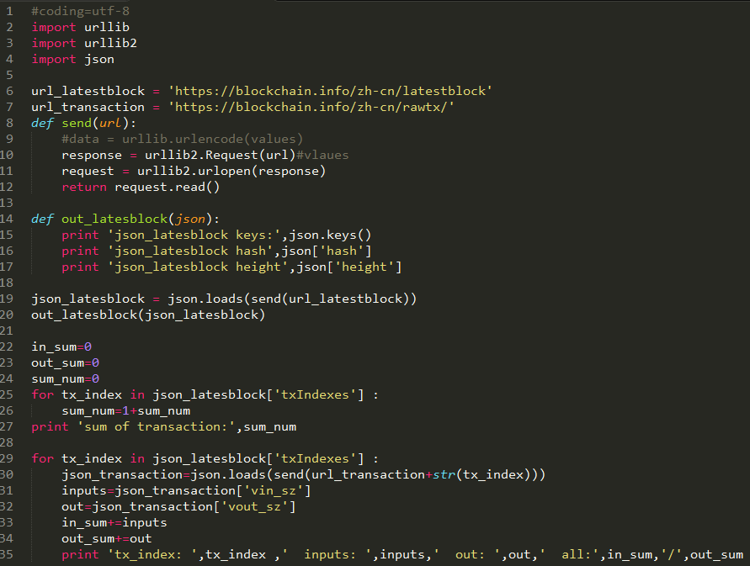

运行结果：获取当前最新block的json数据，统计每笔交易的输入账户和输出账户数，并作实时统计
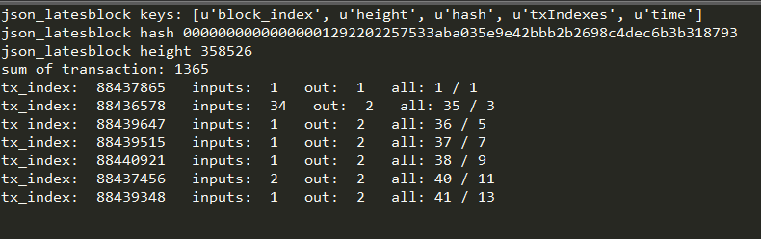

3编码解读文件
原理：blocks_list=blocks_hex.split('f9beb4d9')[1:]通过分割f9beb4d9得到一个存有block的list变量：blocks_list。之后，根据各个部分所占的字节大小来对应到相应的变量中，并可写入文件或者存入数据库。
注意点：1、read()出来的是二进制文件流，encode（’hex’）后得到组合后的16进制数据，并可以显示了。也就是平常看到的字母和数字的组合。2、注意电脑存储问题。大端小端存储！！如显示的神奇数是f9beb4d9，但真正的是d9 b4 be f9.这里需要转换。同时，部分如交易数等需要再转化为10进制数。
代码截图：
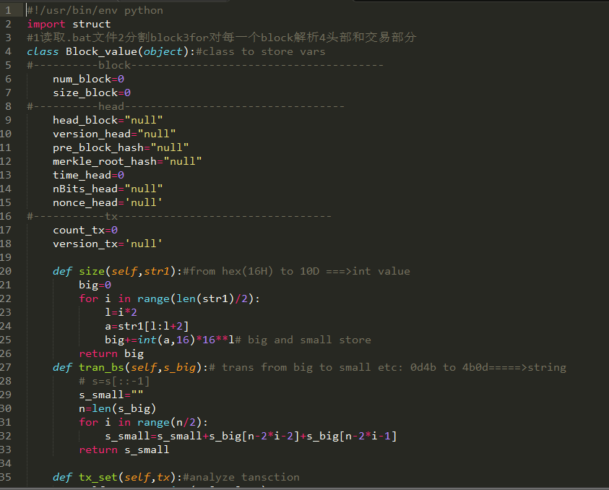

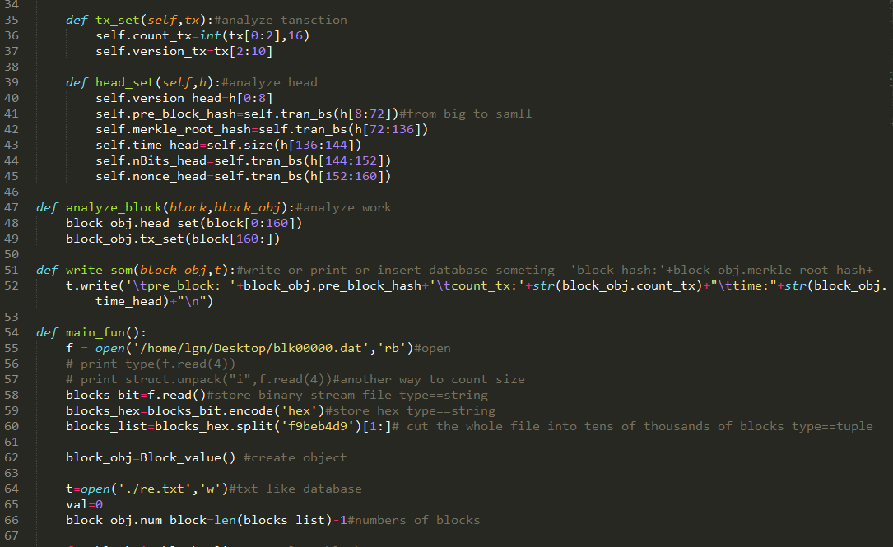
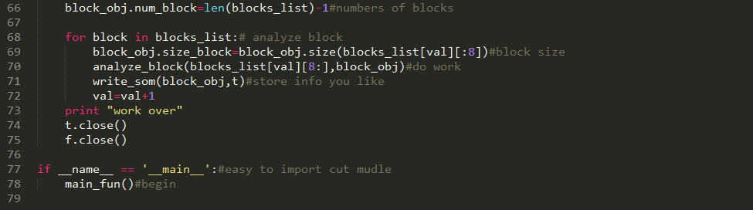

结果截图：
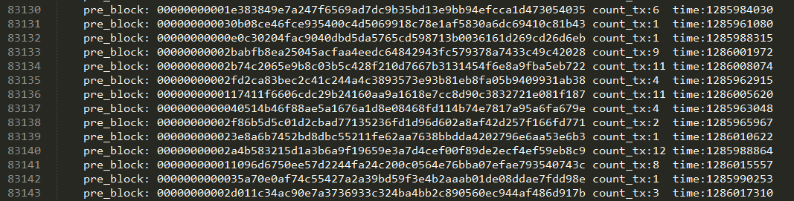

API代码：
#coding=utf-8
import urllib
import urllib2
import json

url_latestblock = 'https://blockchain.info/zh-cn/latestblock'
url_transaction = 'https://blockchain.info/zh-cn/rawtx/'
def send(url):
#data = urllib.urlencode(values)
response = urllib2.Request(url)#vlaues
request = urllib2.urlopen(response)
return request.read()

def out_latesblock(json):
print 'json_latesblock keys:',json.keys()
print 'json_latesblock hash',json['hash']
print 'json_latesblock height',json['height']

json_latesblock = json.loads(send(url_latestblock))
out_latesblock(json_latesblock)

in_sum=0
out_sum=0
sum_num=0
for tx_index in json_latesblock['txIndexes'] :
sum_num=1+sum_num
print 'sum of transaction:',sum_num
for tx_index in json_latesblock['txIndexes'] :
json_transaction=json.loads(send(url_transaction+str(tx_index)))
inputs=json_transaction['vin_sz']
out=json_transaction['vout_sz']
in_sum+=inputs
out_sum+=out
print 'tx_index: ',tx_index ,' inputs: ',inputs,' out: ',out,' all:',in_sum,'/',out_sum
print 'sum of inputs are : ',in_sum
print 'sum of out are :',out_sum

解析文件：

#!/usr/bin/env python
import struct
#1读取.bat文件2分割block3for对每一个block解析4头部和交易部分
class Block_value(object):#class to store vars
#----------block---------------------------------------
num_block=0
size_block=0
#----------head----------------------------------
head_block="null"
version_head="null"
pre_block_hash="null"
merkle_root_hash="null"
time_head=0
nBits_head="null"
nonce_head='null'
#-----------tx---------------------------------
count_tx=0
version_tx='null'

def size(self,str1):#from hex(16H) to 10D ===>int value
big=0
for i in range(len(str1)/2):
l=i*2
a=str1[l:l+2]
big+=int(a,16)*16**l# big and small store
return big
def tran_bs(self,s_big):# trans from big to small etc: 0d4b to 4b0d=====>string
# s=s[::-1]
s_small=""
n=len(s_big)
for i in range(n/2):
s_small=s_small+s_big[n-2*i-2]+s_big[n-2*i-1]
return s_small

def tx_set(self,tx):#analyze tansction
self.count_tx=int(tx[0:2],16)
self.version_tx=tx[2:10]

def head_set(self,h):#analyze head
self.version_head=h[0:8]
self.pre_block_hash=self.tran_bs(h[8:72])#from big to samll
self.merkle_root_hash=self.tran_bs(h[72:136])
self.time_head=self.size(h[136:144])
self.nBits_head=self.tran_bs(h[144:152])
self.nonce_head=self.tran_bs(h[152:160])

def analyze_block(block,block_obj):#analyze work
block_obj.head_set(block[0:160])
block_obj.tx_set(block[160:])

def write_som(block_obj,t):#write or print or insert database someting 'block_hash:'+block_obj.merkle_root_hash+
t.write('\tpre_block: '+block_obj.pre_block_hash+'\tcount_tx:'+str(block_obj.count_tx)+"\ttime:"+str(block_obj.time_head)+"\n")

def main_fun():
f = open('/home/lgn/Desktop/blk00000.dat','rb')#open
# print type(f.read(4))
# print struct.unpack("i",f.read(4))#another way to count size
blocks_bit=f.read()#store binary stream file type==string
blocks_hex=blocks_bit.encode('hex')#store hex type==string
blocks_list=blocks_hex.split('f9beb4d9')[1:]# cut the whole file into tens of thousands of blocks type==tuple

block_obj=Block_value() #create object

t=open('./re.txt','w')#txt like database
val=0
block_obj.num_block=len(blocks_list)-1#numbers of blocks

for block in blocks_list:# analyze block
block_obj.size_block=block_obj.size(blocks_list[val][:8])#block size
analyze_block(blocks_list[val][8:],block_obj)#do work
write_som(block_obj,t)#store info you like
val=val+1
print "work over"
t.close()
f.close()

if __name__ == '__main__':#easy to import cut mudle
main_fun()#begin

