Class 0: Acer (maple) 96



Class 1: Alnus (Alder) 48

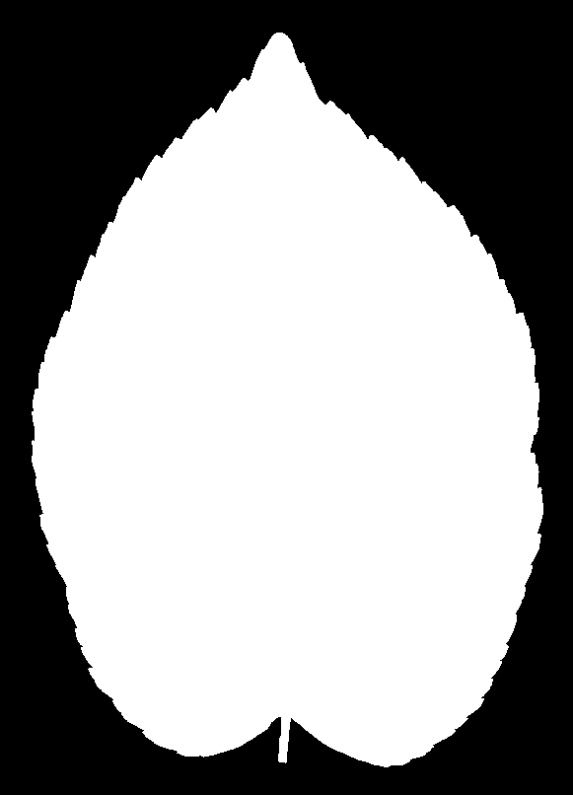

Class 2: Eucalyptus 48

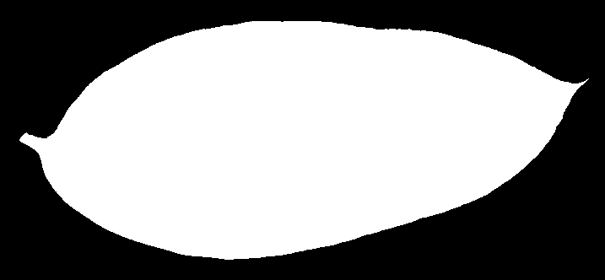

Class 3: Populus (poplar) 48



Class 4 : Quercus4 (oak) 96

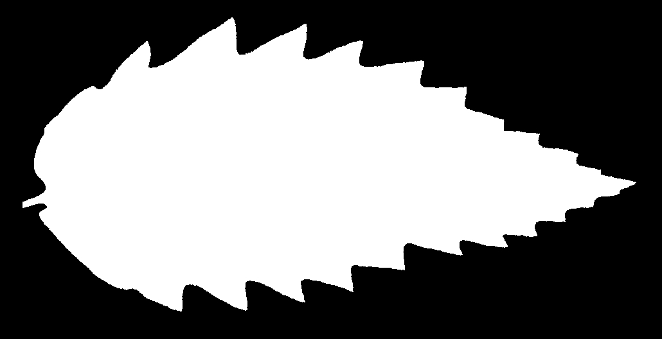

Class 5: Tilia 48

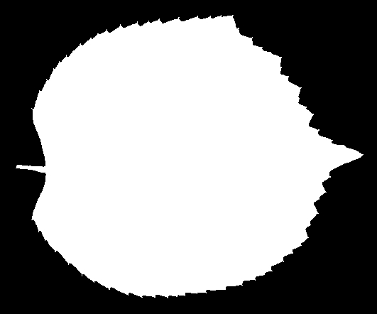

Map leave 16 to leave 6

{1,2}🡪0, {3}->1,{5}->2, {6}->3, {12, 13}->4, {15}->5