IRootLab - A MATLAB toolbox for vibrational spectroscopy

Manual

Release date: 24/August/2012

This document is licensed under a Creative Commons Attribution-NonCommercial-ShareAlike 3.0 Unported License.

Table of contents
1. Introduction 1
1.1. Conventions 1
1.1.1. Formatting styles 1
1.1.2. Terminology and abbreviations 2
2. Getting started 3
2.1. Installation 3
2.2. Starting IRootLab 3
2.2.1. System requirements 3
2.2.2. Platform-specific binaries 3
2.3. Documentation sources 3
3. Step-by-step tutorial 4
3.1. Open and visualize data 4
3.2. Simple analysis – differences between mean spectra 5
3.3. Principal component analysis (PCA) 6
4. Various topics 8
4.1. Graphical user interfaces (GUIs) 8
4.2. IRootLab setup file 8
4.3. Supported file types 8
4.3.1. Notes about file types 8
4.4. MATLAB command sheet 9
4.5. Automatic macro recording 9
4.6. Links to other topics 10

Introduction
IRootLab is an open-source project dedicated to providing a MATLAB framework for vibrational spectroscopy. The goal of the IRootLab project is to provide a comprehensive and user-friendly environment for analysis, whilst facilitating the development and validation of algorithms for biospectroscopy.

Project website: http://irootlab.googlecode.com

Conventions

Formatting styles
The following styles are used throughout this manual:

name of a file

MATLAB code

MATLAB code

Some option available in a graphical interface

Note

Terminology and abbreviations

The word “class” may be used meaning data class (related to patient, treatment group, disease etc), or object class (computer programming). The meaning should be clear from the context.

Getting started

Installation
Download the most recent ZIP file from http://irootlab.googlecode.com, and extract the file to a directory of your choice.

Starting IRootLab

Windows users only
- Open the Windows Explorer
- If you are starting a new project, create a directory for your project e.g., […]/My Documents/ brain_data_analysis
- Locate the directory created when the ZIP file was extracted
- Double-click on the file named startup_windows
- Change MATLAB Current folder to your own project directory.

All users
- If you are starting a new project, open Windows Explorer and create a directory for your project e.g., […]/My Documents/brain_data_analysis
- Start MATLAB
- Change MATLAB Current folder to the directory containing the IRootLab library extracted from the ZIP file (this directory should contain a file called startup.m)
- In MATLAB command line, enter startup
You should see a list of directories being added to the path, then a welcome message.
- Change MATLAB Current folder again, this time to your own project directory.
Note
Alternatively, you can use MATLAB "Set path..." (add with subdirectories). This will keep you from having to run startup every time you start MATLAB. However, make sure you remove the old directories from the path when you download a new version of IRootLab.

System requirements
IRootLab will run under MATLAB, which is ported for Windows, Linux, and MacOS. The oldest MATLAB version tested was r2007b.

MATLAB toolboxes:
- Recently, we have been using MATLAB Parallel Computing Toolbox (PCT) to paralellize certain algorithms, but there is always a choice to run the non-parallel version.
- We use the MATLAB Wavelet Toolbox for Wavelet de-noising.

Platform-specific binaries

This information is only relevant if you intend to use SVM or the MySQL database.
- SVM classifier (LibSVM): LibSVM was successfully compiled for Windows 32-bit/Windows 64-bit; Linux 32-bit/64-bit.
- MySQL connector (mYm): mYm was currently compiled Windows 32-bit; Linux 32-bit/64-bit. Linux 64-bit: libmysqlclient.so.16 and libmysqlclient.so.18.

Documentation sources
- On-line documentation: http://bioph.lancs.ac.uk/irootdoc
- Tutorials at official website: http://code.google.com/p/irootlab/downloads
- Demo files: directory irootlab-x.x.x-x/demo
- Getting help from MATLAB command line: iroothelp
- Getting help from IRootLab GUIs: press F1

Graphical user interfaces (GUIs)
GUI name | Purpose
datatool | Manage and visualize data
objtool | Manage and visualize all types of objects
mergetool | Assemble dataset from a batch of spectral files
irootlab | Launch other GUIs, get help, and view auto-generated macro

Step-by-step tutorial
To follow these steps, please download the Brain dataset at http://irootlab.googlecode.com/files/ketan_brain_atr_3classes.mat (673kB). Mode tutorials can be also found at this address.

Open and visualize data
- Run the steps on Section 2.2 to start IRootLab
- At MATLAB command line, enter datatool
- Click on Load…
- Open the file ketan_brain_atr_3classes.mat. Note that an entry named ds01 appears
- Click on Visualize… A green window appears.
- In the Search box, type “means” and press Enter
- Double-click on Class means. A figure should appear.

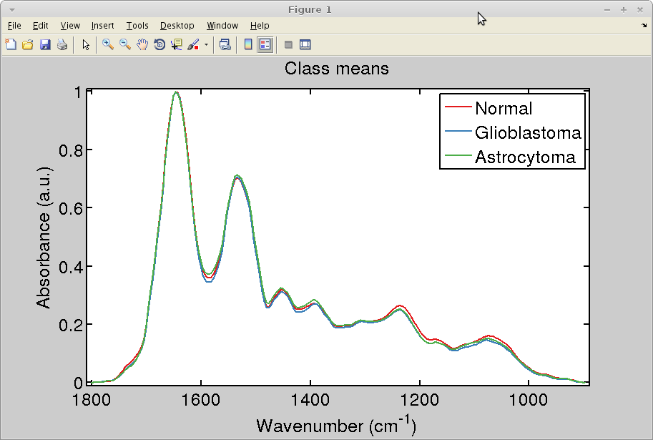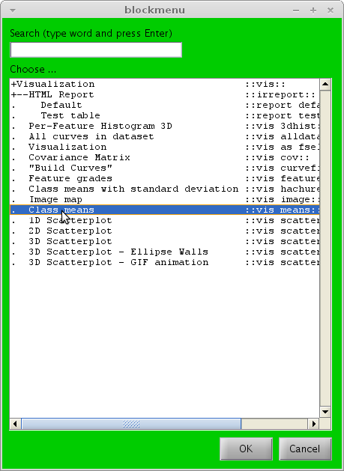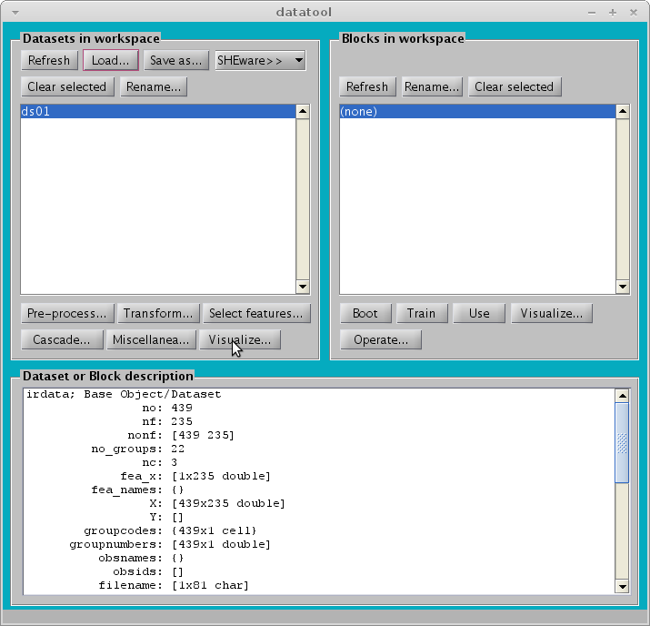

An overview of datatool
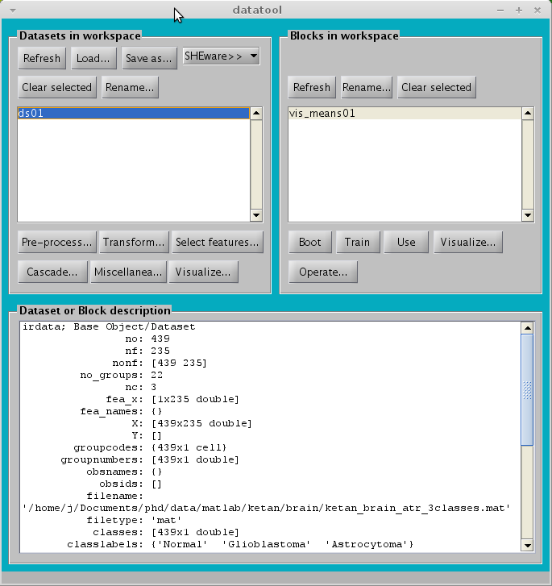
no: Number of observations (spectra)
nf: Number of
features wavenumbers)
Number of groups (e.g., patients)
nc: Number of classes
The labels of the classes
Dataset area
Name of a dataset
Block area
Name of a block

Simple analysis – differences between mean spectra

- Click on Pre-process…
- Double-click on Subtract mean of a reference class
- On the window that appears, click on OK. Basically, the reference class is the first one (“Normal”), so the box already has the right number.
- Now you are going to re-use a visualization block created previously. Click on the dataset ds01_refmean01; Click on block vis_means01; click on Use from the right panel.

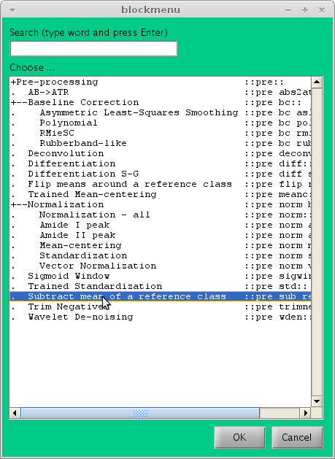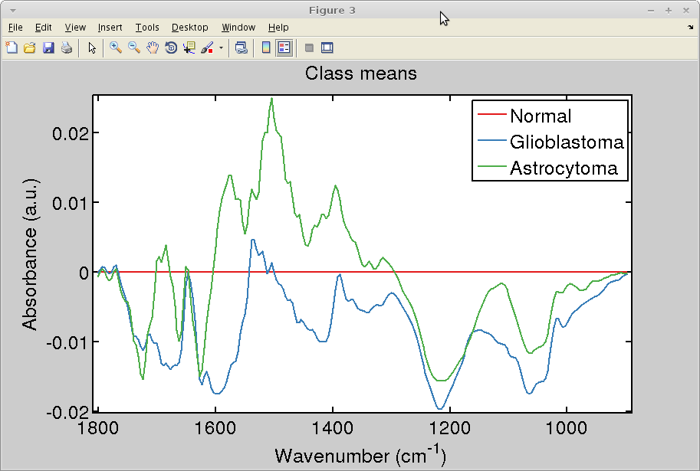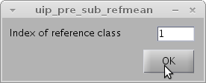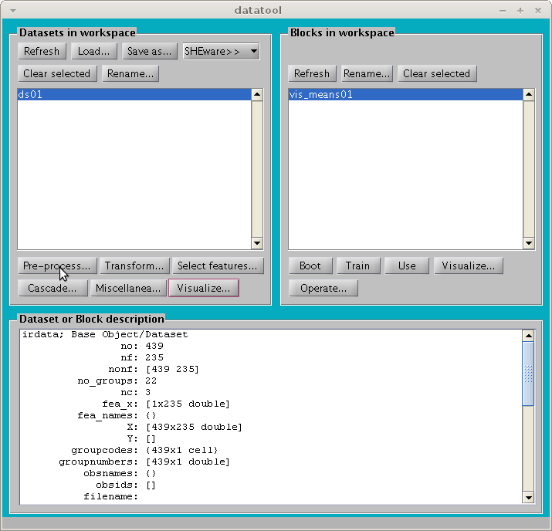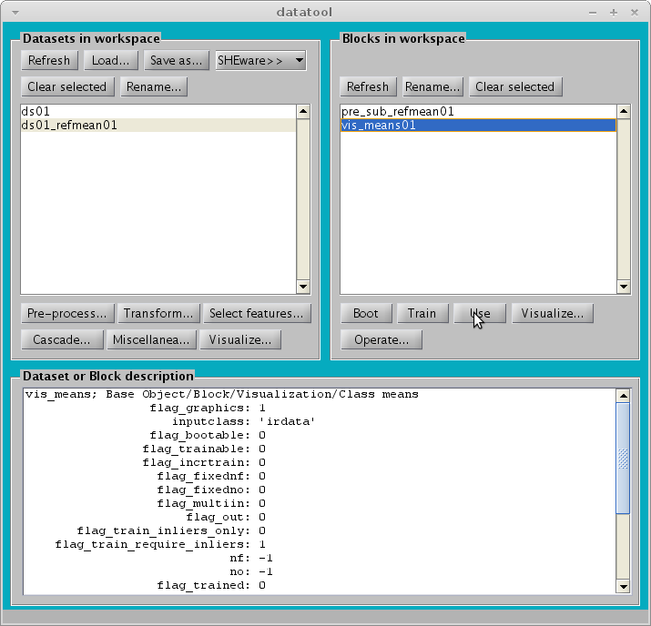
1
2
3

Principal component analysis (PCA)

- Click on dataset ds01; Click on Pre-process…
- Double-click on Mean-centering
- Click on the dataset ds01_meanc01; Click on Transform…
- Double-click on Principal component analysis (PCA)
- On the window that opens, click on OK. Basically you are accepting the default parameters 10 PCA factors, and no factor rotation.
- Click on the dataset ds01_meanc01_pca01; Click on left Visualize…
- Double-click on 2D scatterplot
- On the window that appears, enter [1, 2, 3] on the Indexes of variables to plot box. Click on
Well, PCA does not seem to segregate the classes
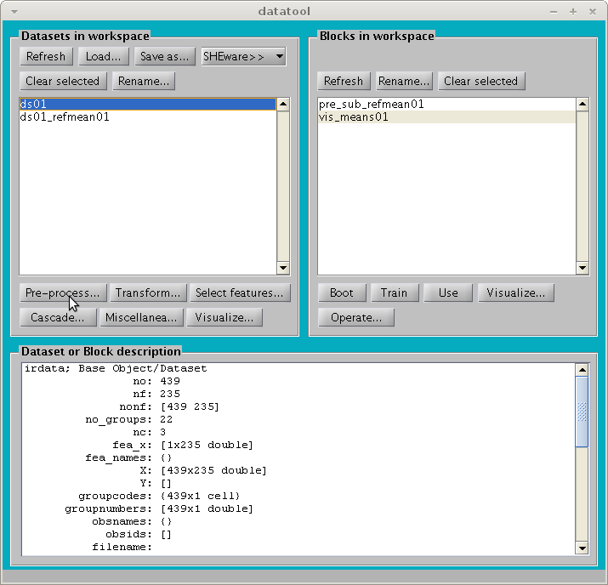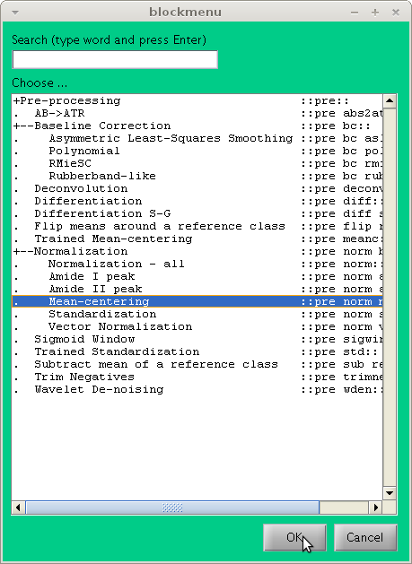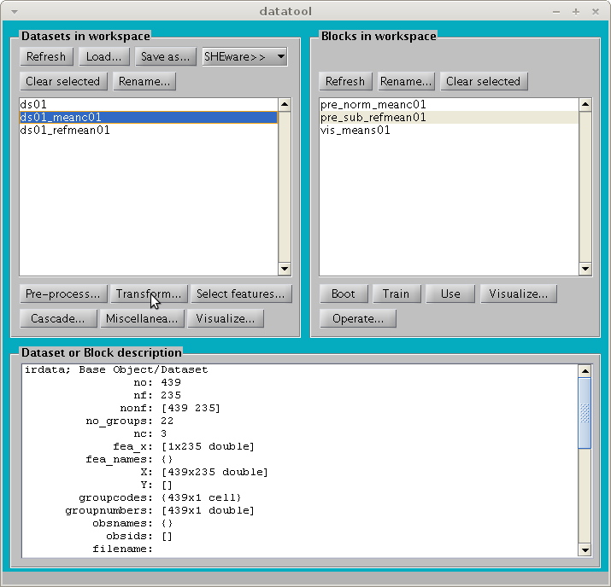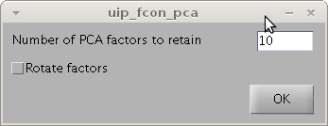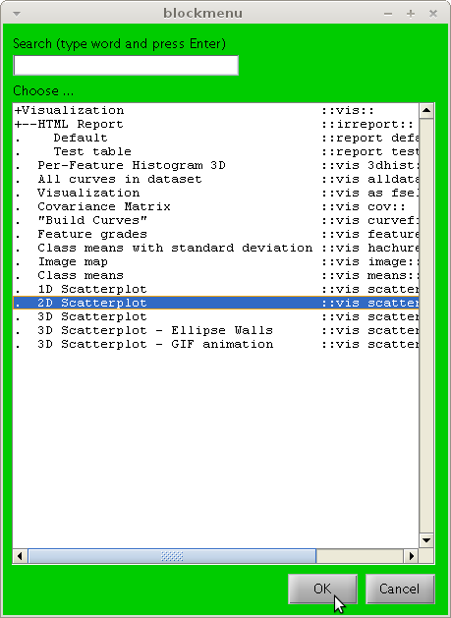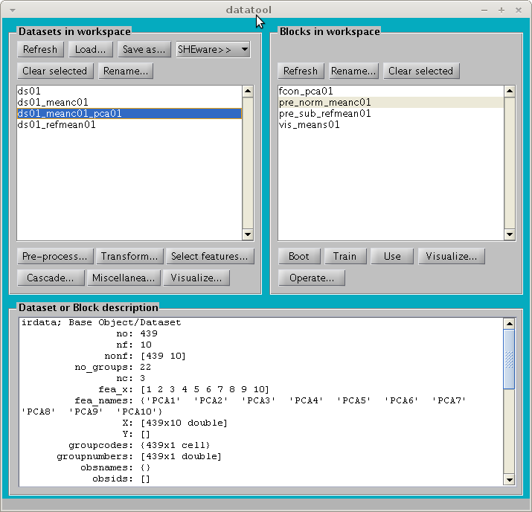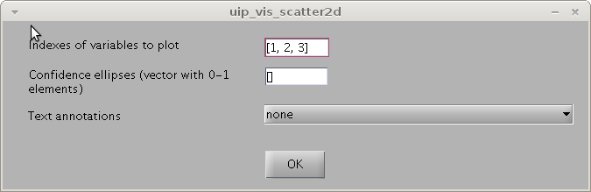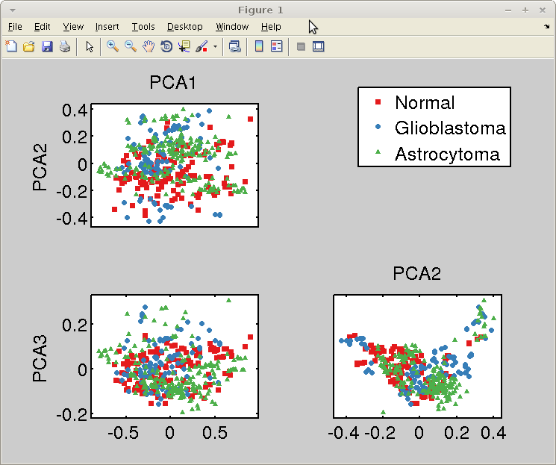
1
2
1
2
1
2

- Now the loadings plot. Click on block fcon_pca; Click on right Visualize…
- On the window that appears, enter [1, 2, 3] on the Indexes of loadings to plot box
- On the second window that appears, click on OK

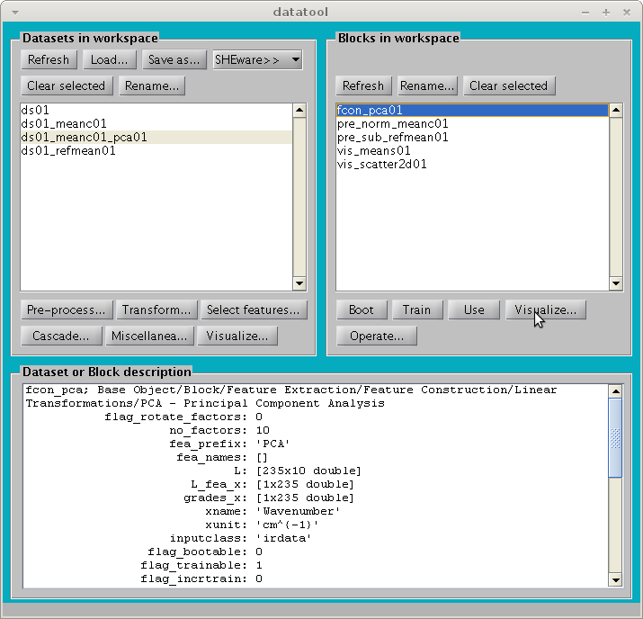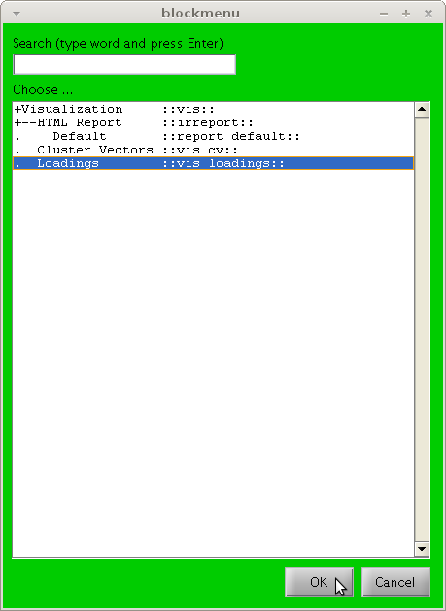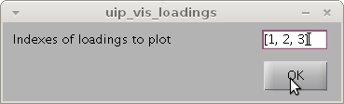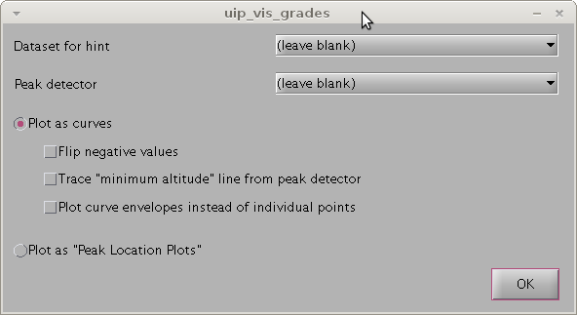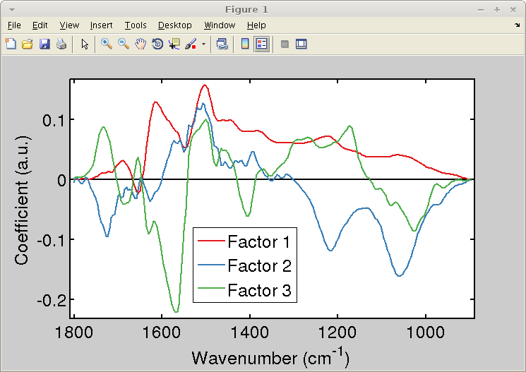
1
2
.
Datasets and blocks
Most data analysis can be described as a process where datasets are modified by blocks. Think of a block as a system with input and output. Some blocks are ready to be used when they are created; others require training.
Dataset
Block
Modified
dataset
Dataset
Visualization
Block
Figure
Training dataset
Block
1- Training stage
Trained
block
Dataset
(same or other)
Trained
block
2- Use stage
Modified
dataset
Blocks that don’t require training
Visualization blocks
Blocks that require training
Code example
% Rubberband baseline correction
block = pre_bc_rubber();
ds02 = block.use(ds01);
% Class means visualization
block = vis_means();
figure;
block.use(ds01);
% PCA-LDA
block = cascade_pcalda();
block.no_factors = 10; % PCA factors
block = block.train(ds01);
ds02 = block.use(ds01);
Code example
Code example

Various topics

IRootLab setup file
IRootLab comes with a set of default parameters, for example, colour scheme, font, scatterplot markers etc. It is possible to customize these options by editing the irootsetup.m. If this file does not exist in your project directory, you can force its creation by entering setup_write at MATLAB command window.
To open the setup file, enter edit irootsetup at MATLAB command window. Here’s a description of some setup options:

Variable name | Purpose
SCALE | Controls the relative size of text, markers, and line widths.  Tip: Increase the SCALE if you want a figure to be small in a publication. For example, if SCALE = 1 looks fine when you create a full-width figure panel, you should use SCALE = 2 for a half-width panel.
COLORS | Defines a colour sequence to represent different data classes. Each colour is coded as a 3-element vector representing its [Red, Green, Blue] (RGB) composition. Each values ranges from 0 to 255. For example, [255, 0, 0] is red, [0, 0, 0] is black, and [255, 255, 0] is yellow (red+green).  Tip: There is a good website at http://www.colourlovers.com with lots of nice colour palettes!
MARKERS | Sequence of markers (triangles, circles, squares etc) to represent different data classes in scatterplots.  Tip: For a list of available marker symbols, enter help plot at MATLAB command window.
FONT | Font name
FONTSIZE | Font size

Once you are done with editing the file, press F5, or click on the green “Play” button at MATLAB editor, to update MATLAB workspace with the new setup.

Supported file types
The following file types are supported within datatool:
File type | Read? | Write? | Comment | Related OOP-class file
TXT (basic) | Yes | Yes | Figure 1 | dataio_txt_basic.m
TXT ("Pirouette-like") | Yes | Yes | Figure 1 | dataio_txt_pir.m
TXT (IRootLab) | Yes | Yes | Figure 2; Currently very slow, but more flexible than other TXT formats | dataio_txt_iroot.m
MAT | Yes | Yes | MATLAB compressed binary: short file size; opens fast | dataio_txt_mat.m
OPUS image maps | Yes | No |  | dataio_opus_nasse.m

Notes about file types
Currently, the best TXT format to export/import to/from Excel is the TXT (Pirouette-like). This format does not save all the properties of the dataset (for example, the spectrum file name is lost). The TXT (IRootLab) format is complete, but not very well designed. We are currently working on a new text format that will be complete, fast, and easy to edit in Excel.
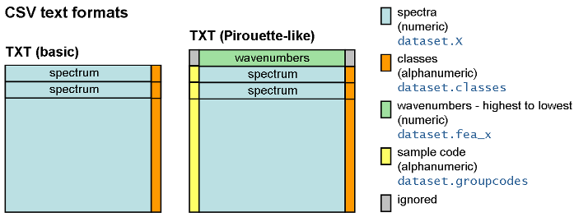
Figure 1 - "Basic" and "Pirouette-like" text formats
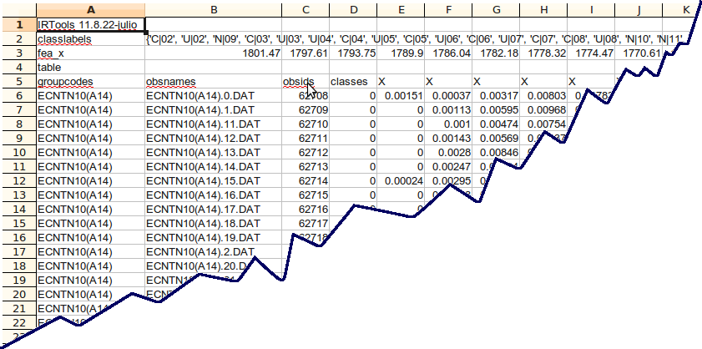
Figure 2 - Basic and Pirouette-like text formats

MATLAB command sheet
IRootLab-specific
v_x2ind([1650, 1450, 1080], ds01.fea_x) | Converts wavenumbers to feature indexes for dataset ds01.
save_as_png([], "filename.png”, 300) | Saves current figure as a PNG file named filename.png at 300 dpi resolution.
edit_ircode | Opens the current auto-generated macro MATLAB editor
iroothelp | Opens main page of documentation in browser
iroothelp irdata | Opens help in browser for file irdata.m
datatool  objtool  mergetool | Opens respective GUIs
ds01.classlabels’ | Shots class labels from dataset ds01
MATLAB basics
1:5 | Same as [1, 2, 3, 4, 5]
xlim([900, 1800]) | Sets current figure x-axis limits to 1800-900 cm-1 region. Note that the lower value comes first in the command.
ylim([0, 1]) | Sets current figure y-axis limits between 0 and 1.

Automatic macro recording
datatool and objtool activities are always recorded as MATLAB code. User operation can be therefore reproduced afterwards. These automatically generated MATLAB scripts can be also used as a starting point for writing your own code.

You can view this code anytime by typing ircode_edit in MATLAB command window. To force IRootLab to continue logging into a new file, type ircode_reset.

Links to other topics
This is a list of relevant documented officially on-line:
- Classes and class levels: http://bioph.lancs.ac.uk/irootdoc/html/classirdata.html
- Verbose levels: http://bioph.lancs.ac.uk/irootdoc/html/irverbose_8m.html

To be expanded

