EECS494 Winter 2017

Project 2 Justification Document

Qinye Li

**Basic Info**

* Title: GuruGuru
  + It’s グルグル in Japanese, which means rotation
* Genre: Action platformer with a little puzzle

**Creative Process**

* The inspiration comes from a PSP game called LocoRoco, where the player use edge keys to tile the environment to roll the jelly-ball-like characters around. I liked the idea of gravity change, and so I decided to play around with it.

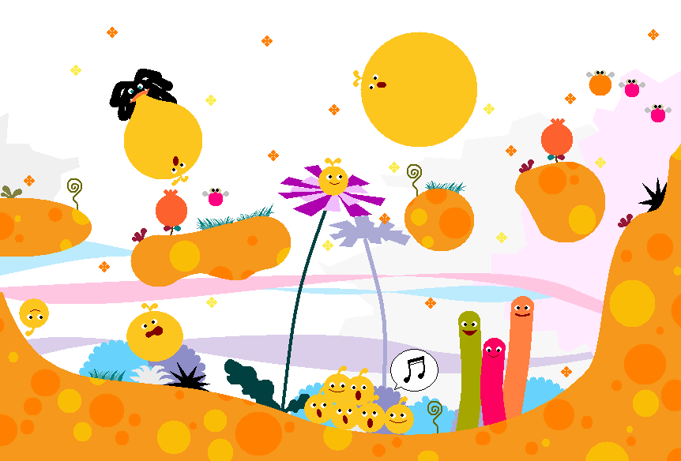

* Then I talked to Mitchell about making a game based on similar concept, which was quite helpful. He advised me to give the player more freedom in control.
* I thought: why not give the hero the magical ability to rotate the ground? The players can choose to move around and rotate whenever they want!

**Development and Playtesting**

Rotating mechanism

* 0th iteration: In the original version of the game, the hero needed to jump up higher than the threshold and hit the wall to rotate. Then I got a feedback from the instructor and my friends that it is confusing until they realized how it works.
* 1st iteration: Then I enabled hitting to rotation whenever in dash jump mode. The player need to run while pressing S (works in a similar way as is in Super Mario) and jump after he reaches a speed threshold enter dash jump mode.
* 2nd iteration: The players do not have to jump to rotate the ground now; they can hit to rotate whenever dashing or dash-jumping. I also added a halo to indicate when it can rotate. However, my teammate told me it is confusing when he dash-hits a wall, rotate the ground, tries to rotate back, but realized he can’t (Because he is not “dashing” when he stays at the corner even if he presses S).
* 3rd iteration: The players can press S to dash now. No need for arrow keys! The hero simply dashes in the direction he is facing. This time, to indicate the facing direction, I changed the hero’s sprite from a symmetric one.

Moving Mechanism

* 0th iteration: Set the speed and direction to a constant when arrow keys are pressed. The velocity gradually changes because of the friction.
* 1st iteration: Friction disabled because the hero would stick on the wall. Speed set to zero when arrow keys are not pressed.
* 2nd iteration: Pressing the arrow keys would give the hero an acceleration which change the velocity gradually.

Visuals

I spent a bunch of time trying to find a suitable sprite for my hero. I wanted a hero with action that looks natural when hitting the wall (jump-kicking or a creature that looks like Kirby), but I could not find one. I ended up with a hero I drew on my own. (like this -> ../../../../../Desktop/Hero.png) Because my hero does not have an animation itself, I added juiciness to the game through splashing little cubes.

* The hero splashes colorful cubes when rotating the ground
* The hero splashes red cubes (blood) when dying
* The hero splashes little transparent cubes when hitting the ground without rotating